Nicholas Soucy Computer Vision HW 3 Due: 11/5/20

**Making a Model Using Photogrammetry**

I used Meshroom as I am a windows user and have a Nvidia GTX 1080Ti GPU with CUDA support installed so I can run these point cloud calculations quickly!

I ended up doing this three times, first time sucked so I redid it a second time, then I was so happy with the results from the second trial, that I did a new third “object” due to my excitement. I will therefore break down this document into three parts to document my experience.

**Part 1: Pinecone**

I decided to do an old pinecone as my object. I felt that it had a lot of edges/points and was therefore a good fit for the point cloud.

I found that my first try at the Pinecone sucked! I did 49 photos on my Samsung Galaxy Note9 (which is a pretty good camera) and moved the object on the table instead of the camera (like you did with the turn table in the microwave). I found that my point cloud was nonsense, it had no depth and barely any points to report! I believe it only captured the background and nothing else. Here are two pictures of the pinecone below:

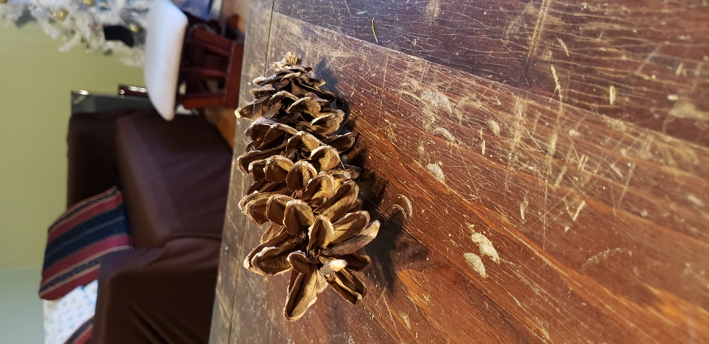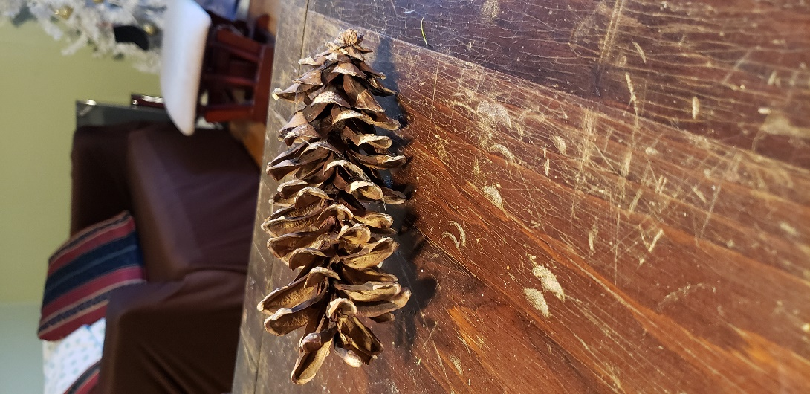

As you can see, I moved the object, not the camera. I wanted to try again, and this time, I wanted to move my camera around the object rather then move the object itself.

**Part 2: Pinecone Take 2!**

This time I wanted to take more pictures of the pinecone, move my camera around the pinecone, and go to a place with better lighting. I also went around in a half sphere around the object rather than just going left or right around the object, I went over the object.

I took 111 photos of the pinecone on my kitchen island with my Samsung Galaxy Note9 Camera. Here are two example photos below.

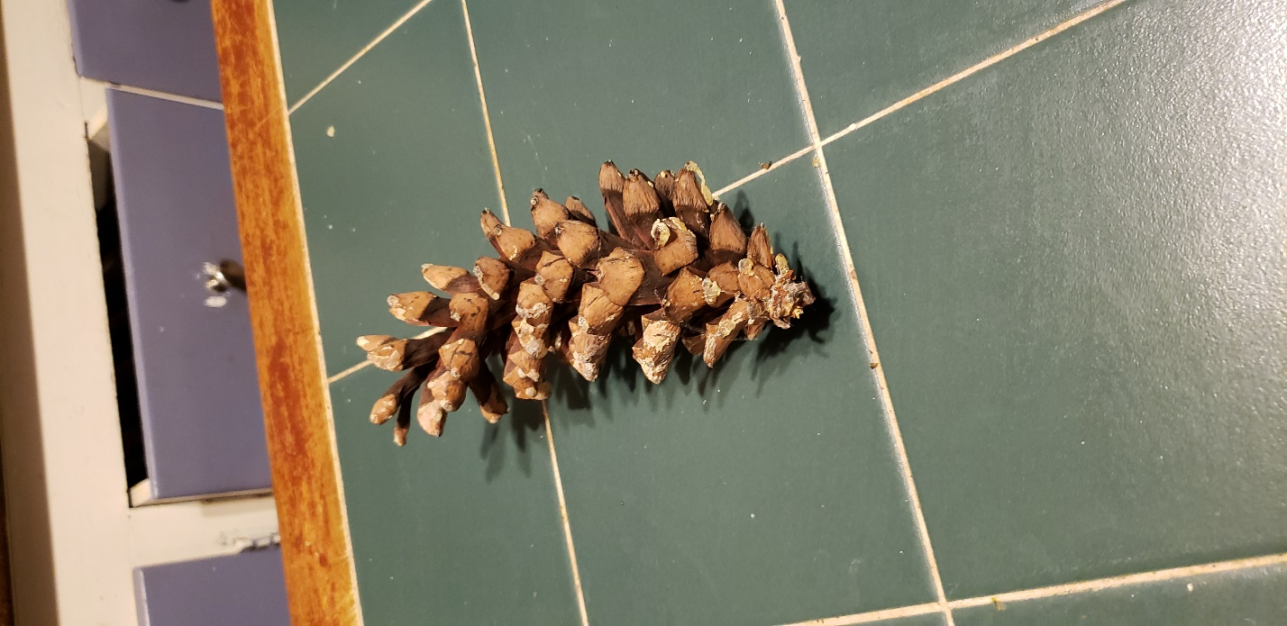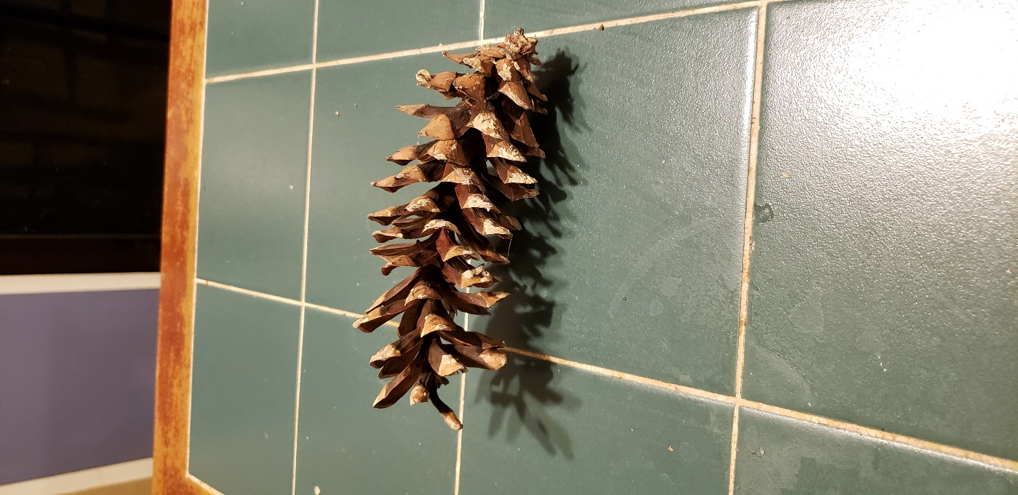

The point cloud was beautiful! When I put more effort into matching points, better lighting, more pictures, and moving the camera instead of the object, it was a smashing success! Here is a photo of the point cloud. I also put the two point cloud .abc alembic files into a zip file for you that I uploaded along with this pdf. You can’t use MeshLab on Meshroom exports, you are going to have to use Blender to import and mess with the alembic file, but it is so worth it! Here is a snapshot:

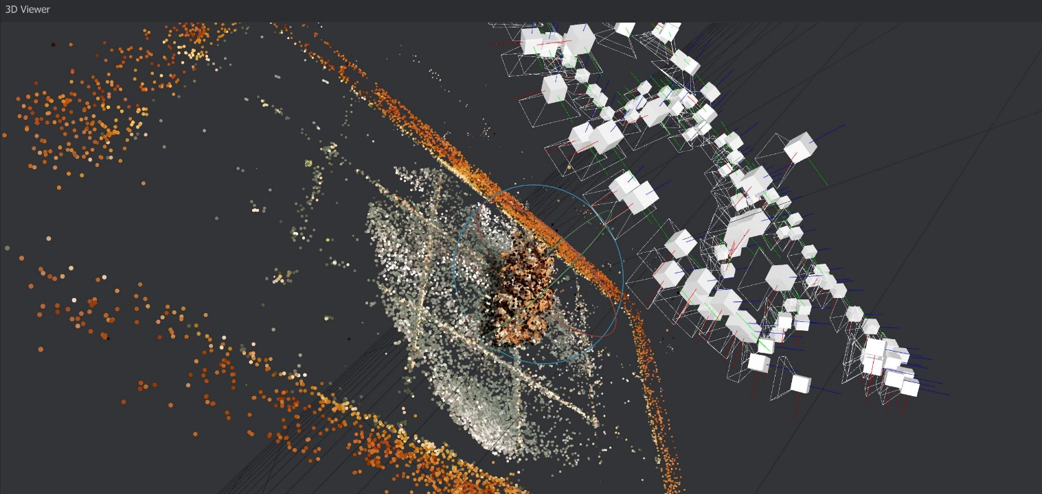

I got so excited seeing the results of the pinecone, I wanted to do it again on something harder and more interesting.

**Part 3: My Partner Paige**

I like my girlfriend Paige, so I wanted to see if I can make a point cloud of her.

I ended up having her sit cross-legged in the living room and took a total of 138 pictures with my Samsung Galaxy Note 9 of her face. Here are two example pictures below:

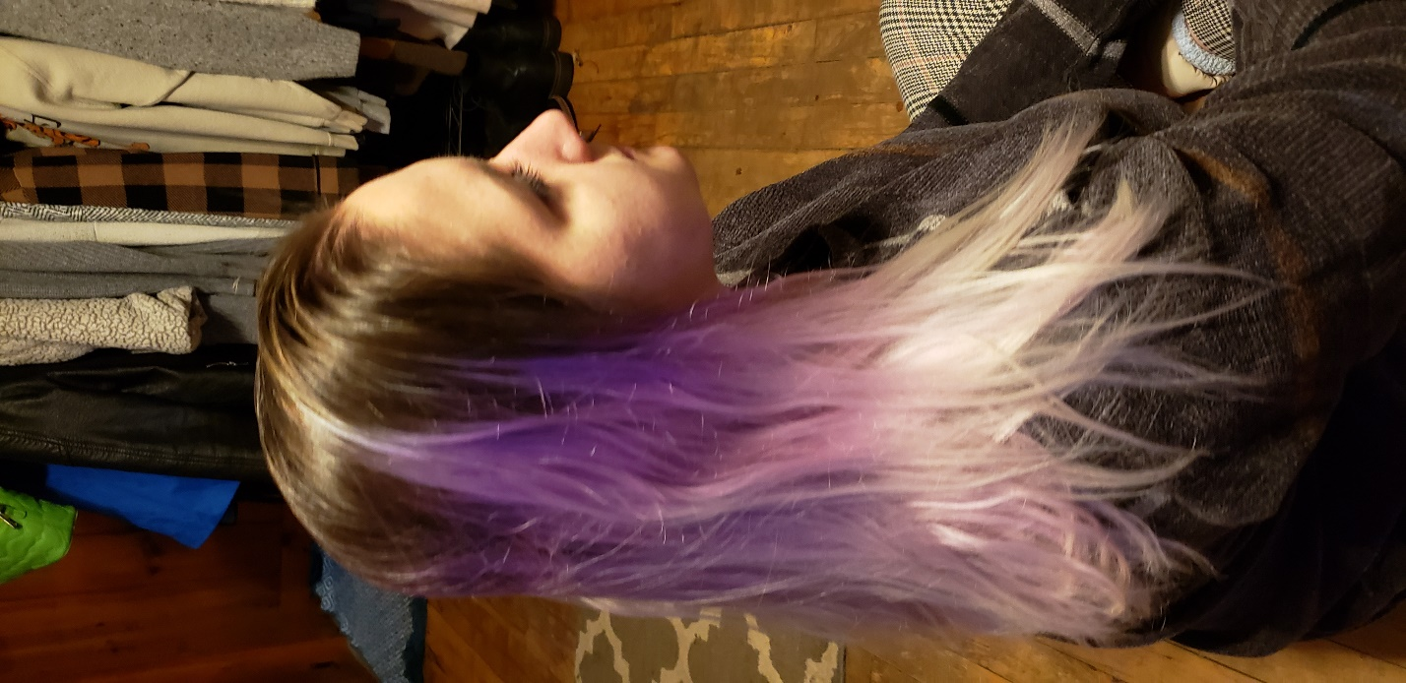

Then I made the point cloud again (included in the zip folder as an alembic file), here is the snapshot:

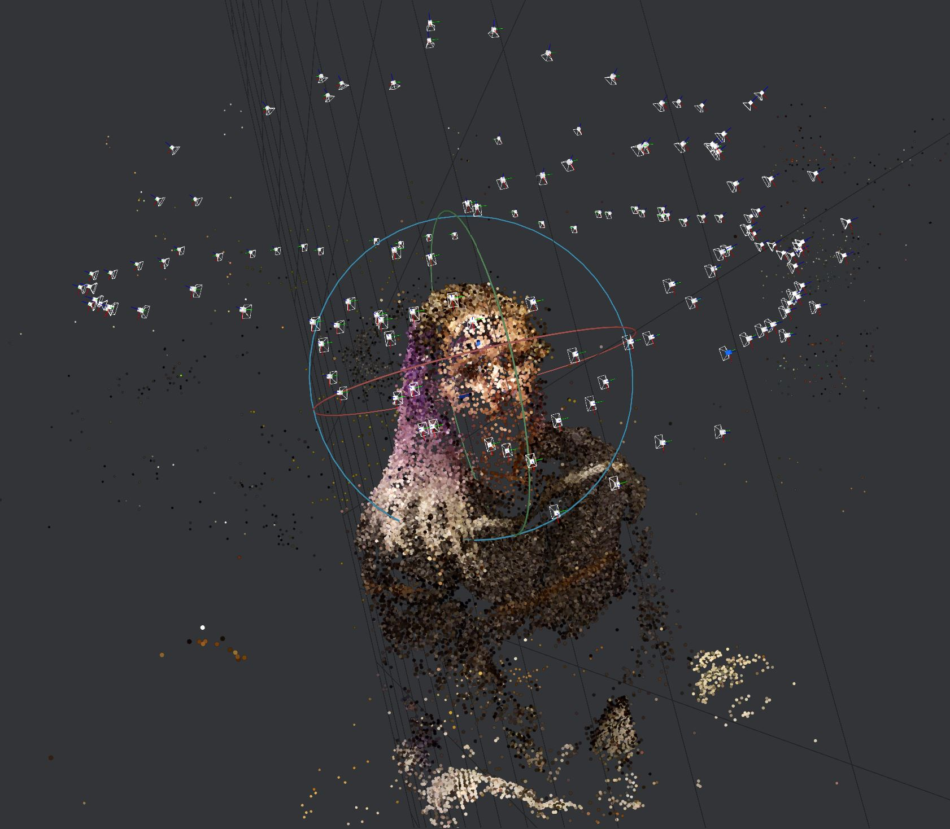

I was very excited with these results too! It looked super cool and captured a lot of features! I noticed that she doesn’t have a chin though, and that is probably because the lighting was only coming from above her and her chin was constantly in shadow.

**Conclusion**

I got better overtime using Meshroom, and I improved my picture taking technique between each part. I think the Part 2 pinecone is the most complete point cloud, though I am super excited to get better lighting and work on making a new point cloud with Paige. I believe this homework assignment awoken a new hobby for me!

The zip file submitted along with this pdf includes the two point cloud screenshots and the two point cloud alembic files. You can’t use MeshLab on Meshroom exports, you are going to have to use Blender to import and mess with the alembic file.