Visit London
London Tourism Office
2026-10-30
Welcome to London, a city where centuries of history sit side by side with modern life. Whether you’re wandering along the Thames, exploring world-class museums, or simply enjoying a pint in a cosy pub, you’ll find that there is something for every traveller around each corner.

Five sights to start with
- British Museum
- Natural History Museum
- Tate Modern
- National Gallery
- Tower of London
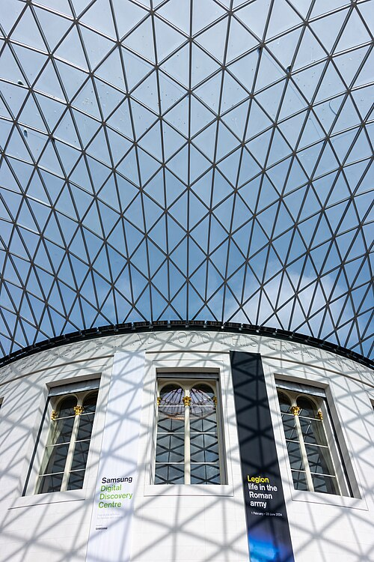
The glass roof of the Great Court above the Reading Room at the British Museum
British Museum, Great Court. Photo: Mike Peel (www.mikepeel.net), CC BY-SA 4.0, via Wikimedia Commons.
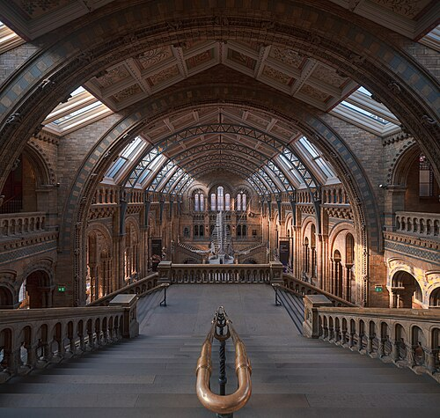
The empty Central Hall of the Natural History Museum, looking towards the blue whale skeleton
Natural History Museum, Central Hall. Photo: Julian Herzog, CC BY 4.0, via Wikimedia Commons.
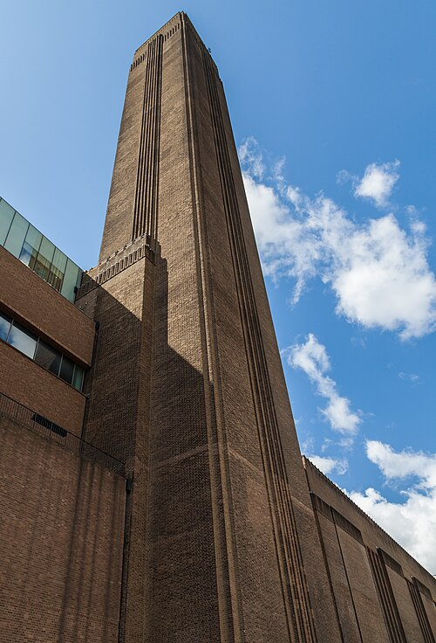
The tall brick chimney of the former Bankside Power Station, now Tate Modern
Tate Modern, the former Bankside Power Station. Photo: Diego Delso, CC BY-SA 4.0, via Wikimedia Commons.
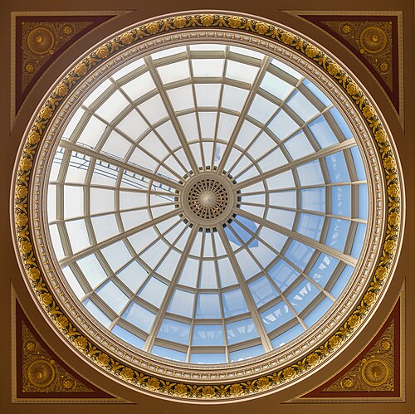
The glass dome above the entrance hall of the National Gallery
National Gallery, entrance hall dome. Photo: Diego Delso, CC BY-SA 4.0, via Wikimedia Commons.
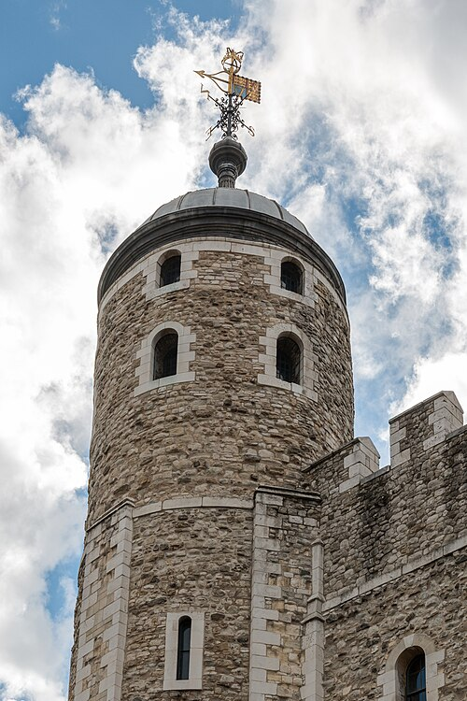
A turret and weathervane of the White Tower at the Tower of London
Tower of London, the White Tower. Photo: Dietmar Rabich, CC BY-SA 4.0, via Wikimedia Commons.

Sights at a glance
Photo | Sight | Area | Price band | Nearest tube | More
 | British Museum | Bloomsbury | Free (special exhibitions extra) | Tottenham Court Road | Read more
 | Natural History Museum | South Kensington | Free (special exhibitions extra) | South Kensington | Read more
 | Tate Modern | Bankside | Free (special exhibitions extra) | Blackfriars | Read more
 | National Gallery | Trafalgar Square | Free (special exhibitions extra) | Charing Cross | Read more
 | Tower of London | Tower Hill | Paid ticket | Tower Hill | Read more
Photo credits: British Museum, Mike Peel, CC BY-SA 4.0; Natural History Museum, Julian Herzog, CC BY 4.0; Tate Modern and National Gallery, Diego Delso, CC BY-SA 4.0; Tower of London, Dietmar Rabich, CC BY-SA 4.0. All via Wikimedia Commons; details in images/ATTRIBUTION.md.

Visitor numbers
import csv
with open("data/attractions.csv", newline="", encoding="utf-8") as f:
rows = list(csv.DictReader(f))
top = max(rows, key=lambda r: int(r["visits_2025"]))
top_name = top["attraction"]
top_visits = int(top["visits_2025"])
total_visits = sum(int(r["visits_2025"]) for r in rows)
The most visited attraction in 2025 was the Natural History Museum (South Kensington), with 7,116,929 visits, out of 39,692,434 visits in total across the ten attractions listed.
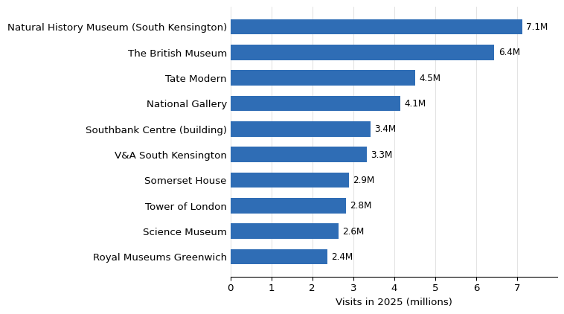
Figure 1: Visits in 2025 to London’s ten most-visited ALVA attractions. Source: ALVA.

Getting around
- 🚇 Tube
- 🚌 Bus
- 🚲 Santander Cycles

Plan your visit
Use the TfL Journey Planner to map out each day’s route by Tube, bus or bike.
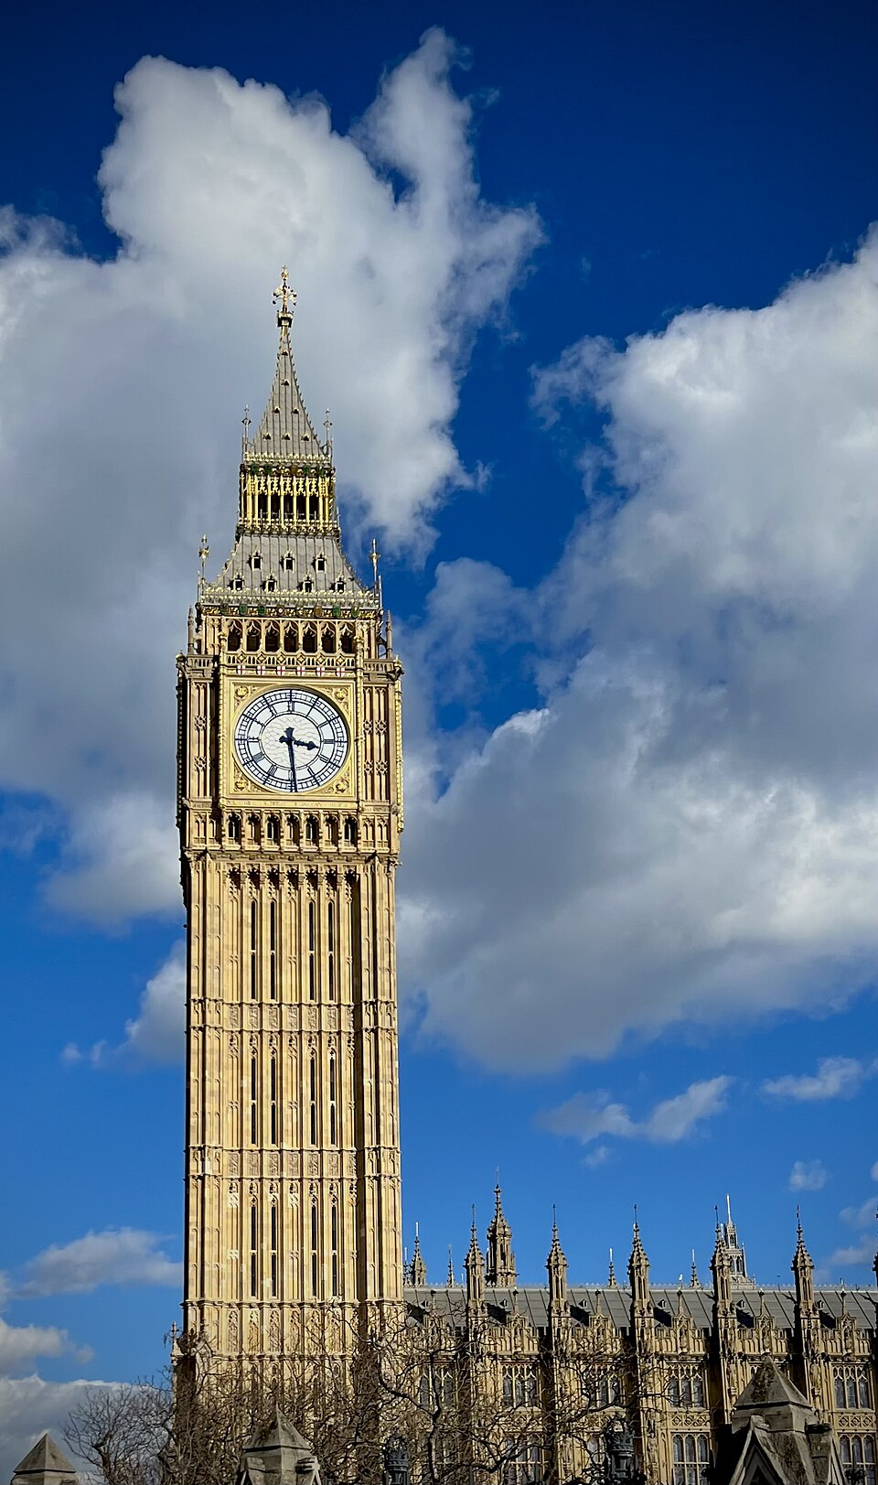
Big Ben and the Elizabeth Tower rising against a bright sky, with the Palace of Westminster below
Big Ben in the sun (Elizabeth Tower). Photo: John Dillenbeck, CC0, via Wikimedia Commons.
Tip from a local: Stand on the right on Tube escalators and leave the left side clear for people in a hurry.

Before you go
[ ] Check opening times and book any timed tickets
[ ] Bring a contactless card or Oyster for the Tube and buses
[ ] Pack a light waterproof jacket

