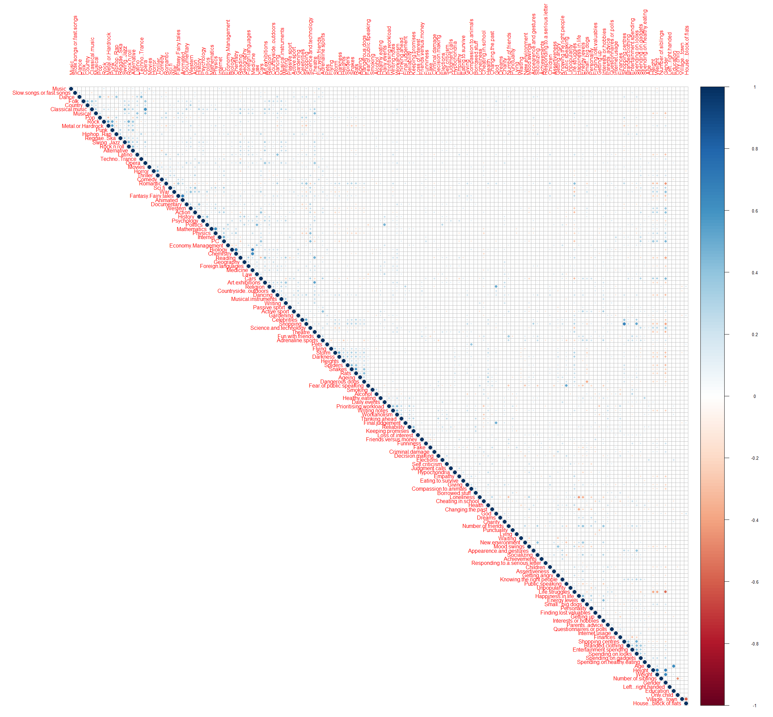

Correlation Matrix over 150vs150 columns in responses.csv

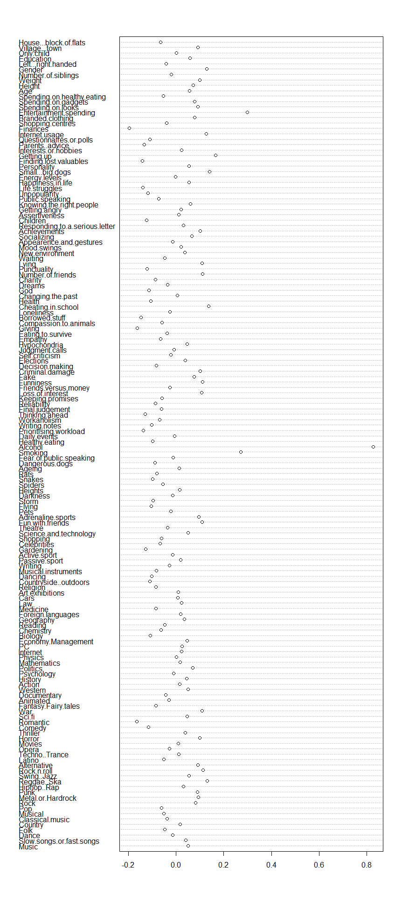

Correlation between Alcoholics and other columns of responses.csv

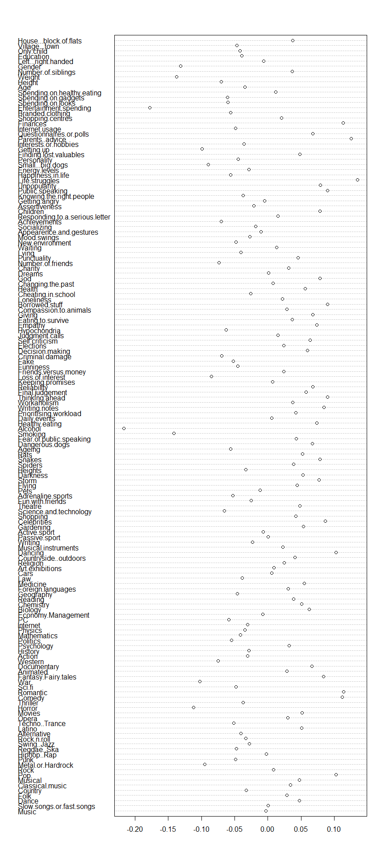

Correlation between social drinkers and other columns of responses.csv

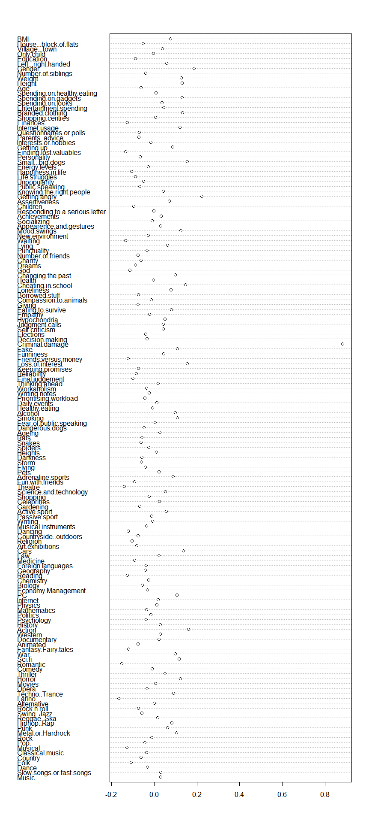

Correlation between people dealing damage when angry and all other columns

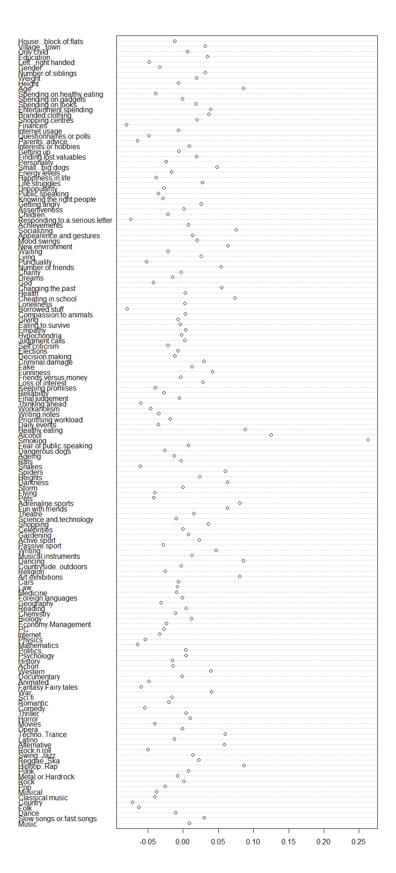

Correlation between people who smoke and all other columns