# Grandpa

This time I am going to do a writeup/walkthrough of a retired hackthebox.eu machine “Grandpa”. The difficulty on this machine is set to Easy.

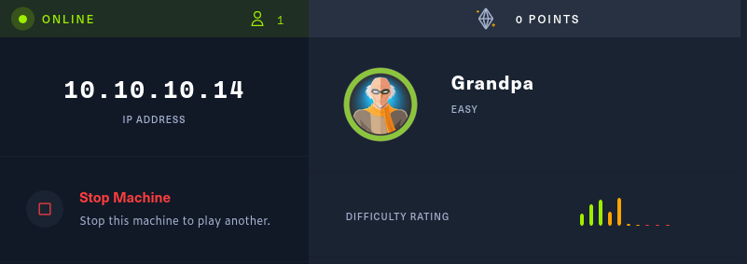

After firing up the machine a good place to start is doing a Nmap scan for it. The method I use to scan is something I have found to be good and sufficient.

# Nmap -A -T4 -p- 10.10.10.14

-A is for finding all the services behind the ports

-T4 as for the amount of threads from scale of 1-5.

-p- to scan all the ports

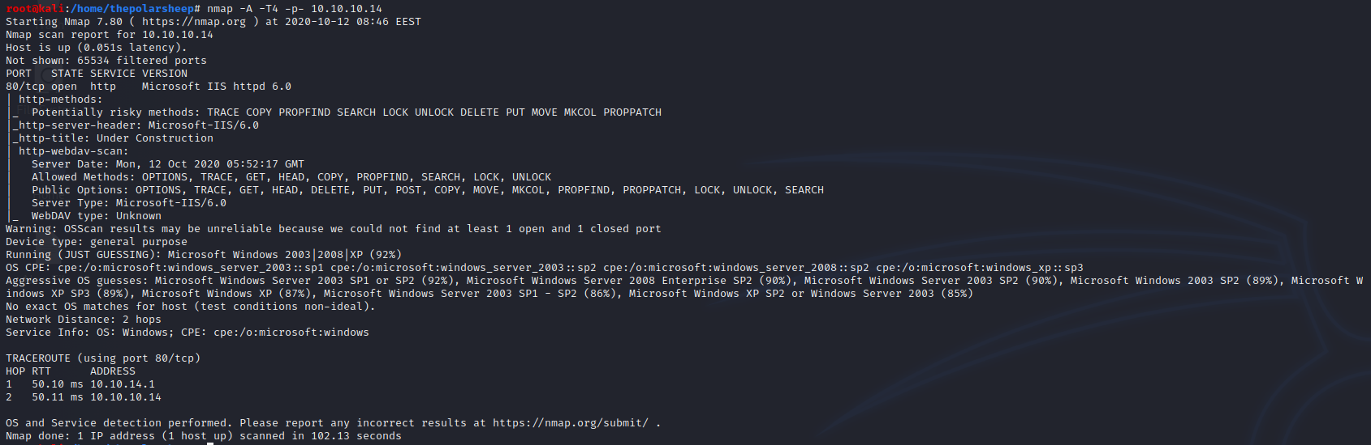

Now that the results are back, we can analyze the findings. Looking at the result there is only a port 80 open with a Microsoft IIS httpd 6.0 server behind it. Therefore, this must be our attack surface. First off, I will just navigate to the address and see what is behind the port 80.

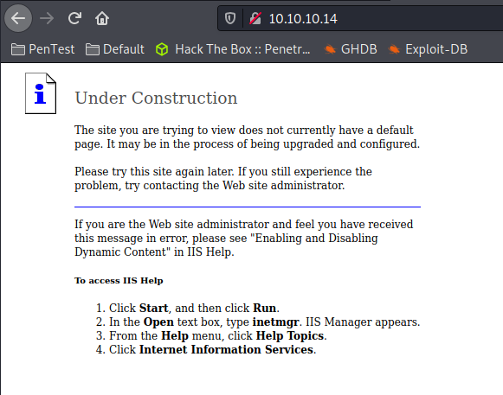

Seems that there is an unconfigured IIS server with the default index page and from here you cannot really do anything. So, using Google to find some possible exploits for the given IIS server I found this one that seems good. It was listed on rapid7 page and I can see that there is a ready module for this exploit in Metasploit.

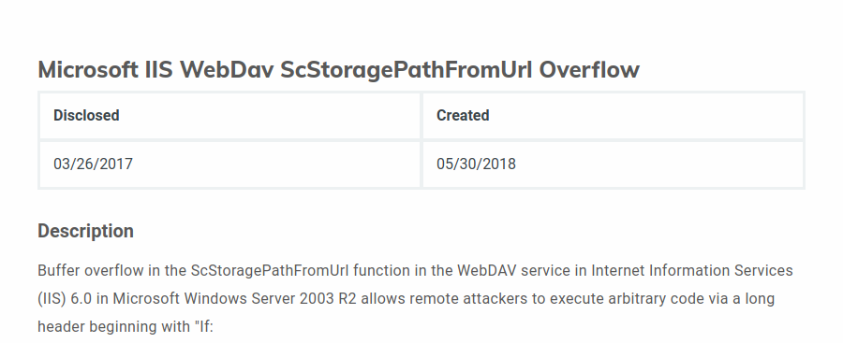

Firing up the Metasploit console and using the exploit/iis/iis_webdav_scstoragepathfromurl module to try breaching the web server.

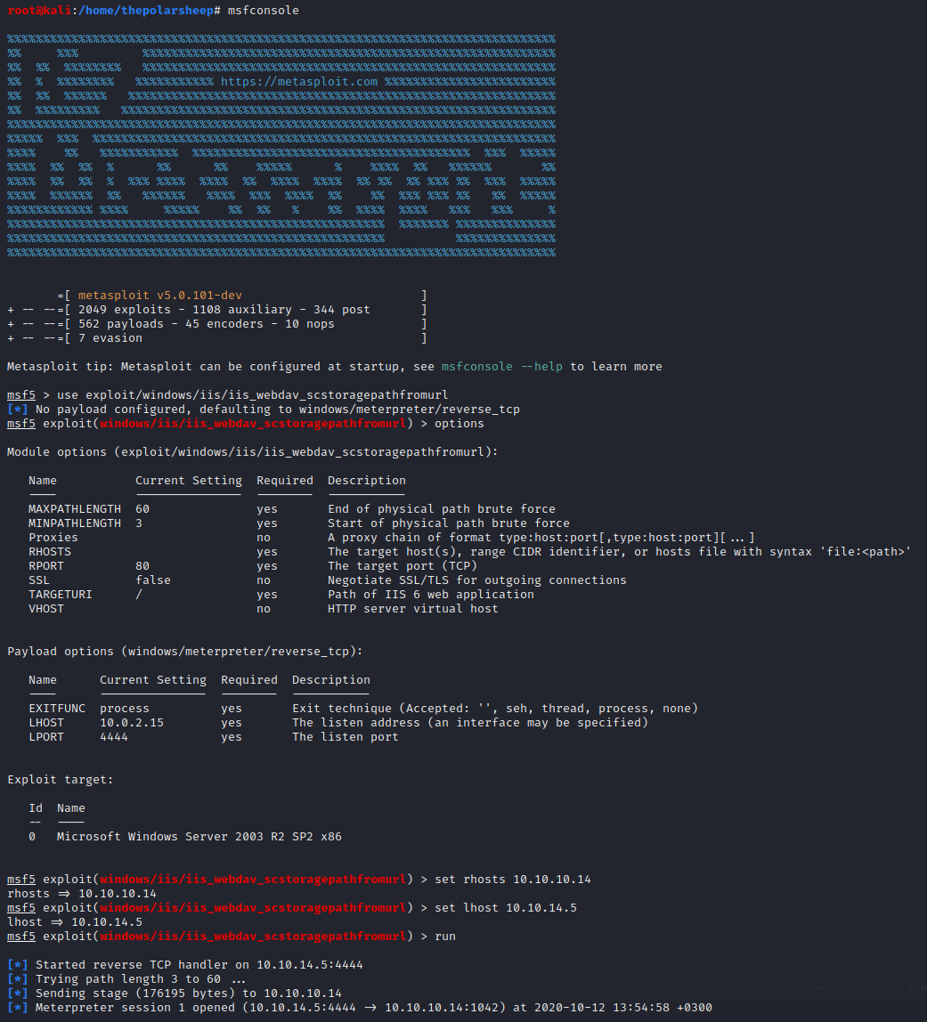

After setting up all the options as needed (in this module only the rhosts and lhosts), it is time to fire up the exploit and see what happens.

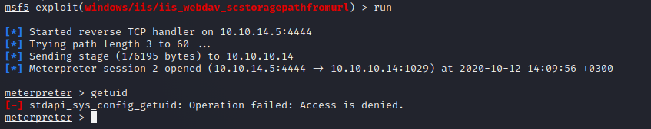

Seems that the exploit worked, and we got a meterpreter shell on the server. But when typing the command “getuid”, we see that we do not have admin. So, at this point let us list the processes with the command “ps”. And it is now confirmed that we do not have system rights for the server. Let us try to migrate the process to another one.

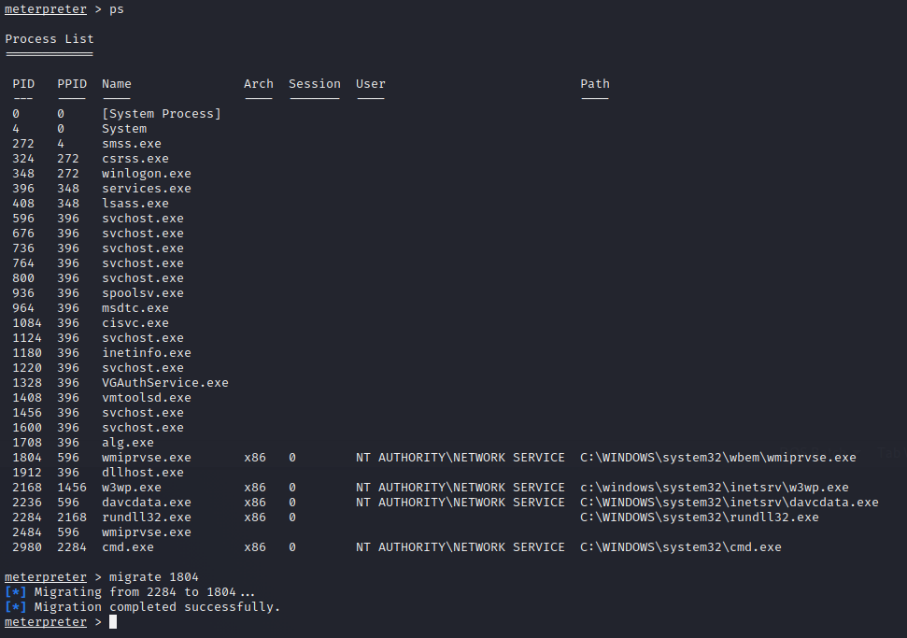

And seems that we could migrate the process to an active one. Now we can just set the session in the background with the “background” command.

Now that the session is in the background and it was given a session number, lets use suggester to find what kind of possible exploits there could be for this machine.

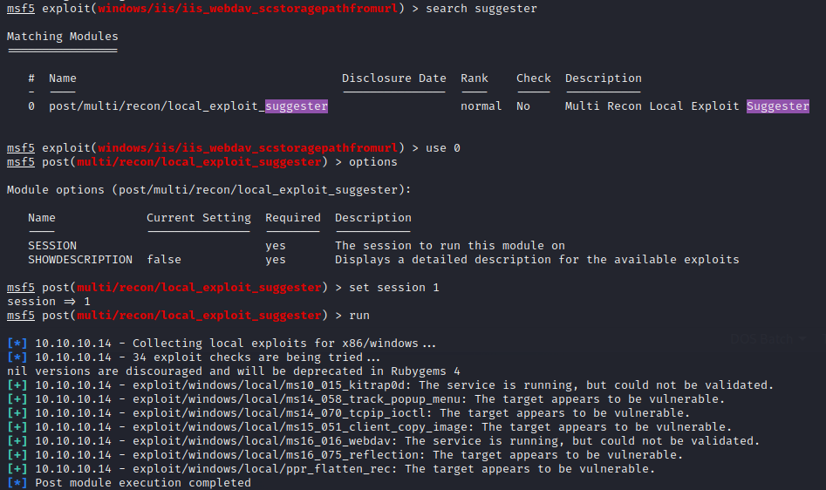

Looking at the suggesters we get a bunch of different possible exploits for this session. I decided to go with the ms14_070_tcpip_ioctl, but I know that at least ms16_016_webdav works just as fine for this and ms10_015_kitrap0d should work also.

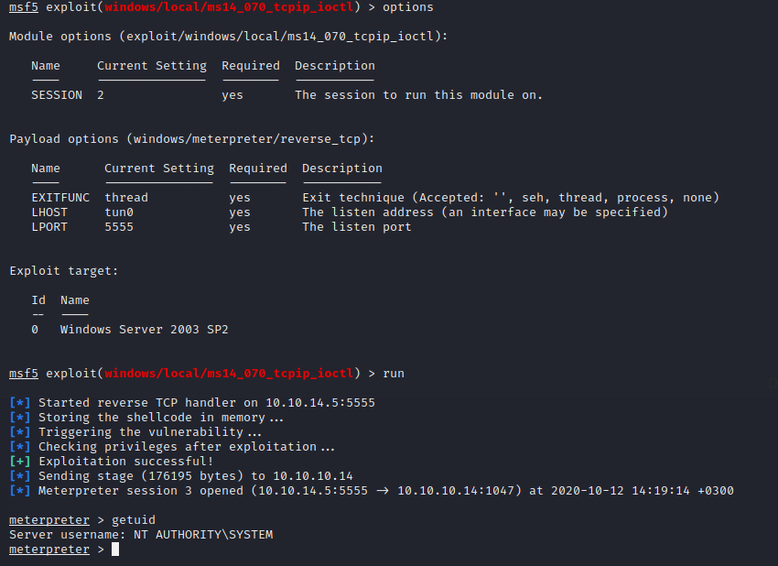

After setting the options for the exploit and running it, getting the getuid we can see that we have an elevated shell for the machine. Now we can fetch the flags.