Ashish Ramnath

11552859

Assignment 1

Unique No: 830138

Question 1

#include <iostream>

using namespace std;

int main()

{

// Pancakes easy and YUM!

// initilise mFactor

int mFactor;

// Create base recipe

string recipeName = "Pancakes" ;

// Ingredients

int flour = 1;

int whitesugar = 2;

int bakingPowder = 2;

int salt = 1;

int egg = 1;

int milk = 1;

int vegetableOil = 2;

// method

string step1 = "In a large bowl, mix flour, sugar, baking powder and salt. Make a well in the center, and pour in milk, egg and oil. Mix until smooth." ;

string step2 = "Heat a lightly oiled griddle or frying pan over medium high heat. Pour or scoop the batter onto the griddle, using approximately 1/4 cup for each pancake. Brown on both sides and serve hot.";

// Main Code

cout << "Please enter the factor to multiply the Ingredients with: " ;

cin >> mFactor ;

cout << " " << endl ;

cout << recipeName << endl ;

cout << " " << endl ;

cout << "Ingredients " << endl;

cout << flour * mFactor << " Cups of flour" << endl ;

cout << whitesugar * mFactor << " Tablespoons of sugar" << endl ;

cout << bakingPowder * mFactor << " Teaspoons of bakingPowder" << endl;

cout << salt * mFactor << " Teaspoons of salt" << endl ;

cout << egg * mFactor << " eggs beaten" << endl ;

cout << milk * mFactor << " cup milks" << endl ;

cout << vegetableOil * mFactor << " Tablespoons vegetableOil" << endl ;

// Now method

cout << " " << endl ;

cout << "Method" << endl ;

cout << step1 << endl ;

cout << step2 << endl ;

// end with message and blank line

cout << "Congrats! You made yourself Pancakes." << endl ;

cout << " " << endl ;

return 0;

}

Output: 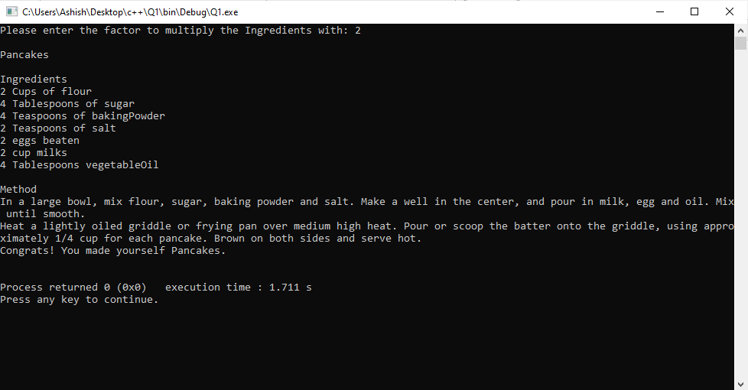

Question 2

#include <iostream>

using namespace std;

int main()

{

// initilise variables

int nrPupils = 56 ;

int nrGroups ;

int nrLeft ;

int groupSize ;

// Ask for group size

cout << "Please enter the size of each group " ;

cin >> groupSize ;

// set nrGroups and nrLeft if any

nrGroups = nrPupils / groupSize ;

nrLeft = nrPupils % groupSize ;

cout << "There are " << nrGroups << " groups consisting of " << groupSize << endl ;

cout << "pupils. " << "There are " << nrLeft << " remaining pupils" << endl ;

return 0;

}

Output: 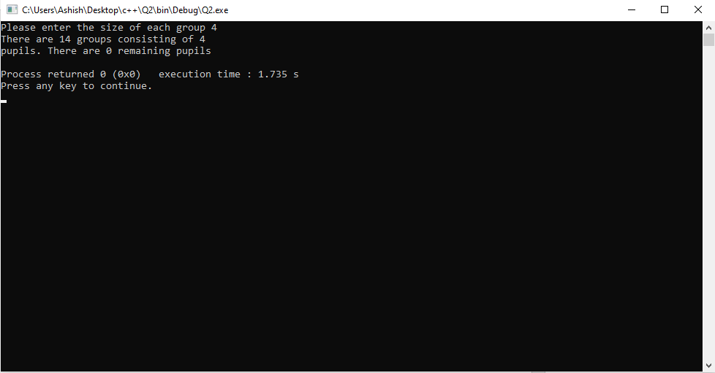

Question 3

#include <iostream>

using namespace std;

int main()

{

// initialize variables

float var1, var2 ;

char operation;

// set values via keyboards

cout << "Please enter the first float value: " ;

cin >> var1 ;

cout << "Please enter the second value: " ;

cin >> var2 ;

cout << "Please enter the operation: " ;

cin >> operation ;

// if block to determine output

if (operation == '+' ) {

cout << "The sum of " << var1 << " and " << var2 << " is " ;

//cout.precision(2); if added value is rounded off

cout << var1 + var2 ;

}

if (operation == '-') {

cout << "The subtraction of " << var1 << " and " << var2 << " is " ;

cout.precision(2) ;

cout << var1 - var2 ;

}

if (operation == '*') {

cout << "The multipliaction of " << var1 << " and " << var2 << " is " ;

cout.precision(2) ;

cout << var1 * var2 ;

}

if (operation == '/') {

cout << "The division of " << var1 << " and " << var2 << " is " ;

cout.precision(2) ;

cout << var1 / var2 ;

}

if (operation == '%') {

// % does not work on floats, therfore we typecast int var1 and var2

cout << "The modulus of " << var1 << " and " << var2 << " is " ;

cout.precision(2) ;

cout << int(var1) % int(var2) ;

}

return 0;

}

Output:

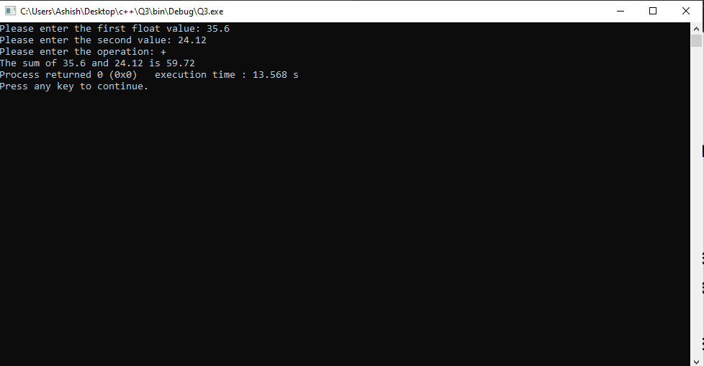

Question 4

#include <iostream>

using namespace std;

int main()

{

// Requirements mark >= 50% and programRuns >= 5

// Therefore stop at 50 , programRuns > 5

int programsDone = 0 ;

int result = 0 ;

// start loop which will run a total of 50 times, both programsDone and result = 50

while (programsDone < 5 || result < 50 ) {

// increment by 1

programsDone += 1 ;

result += 1 ;

// check 50 loops

// cout << result << endl;

}

cout << "Congrats!, You can now proceed to the next exercise" << endl ;

return 0;

}

Output:

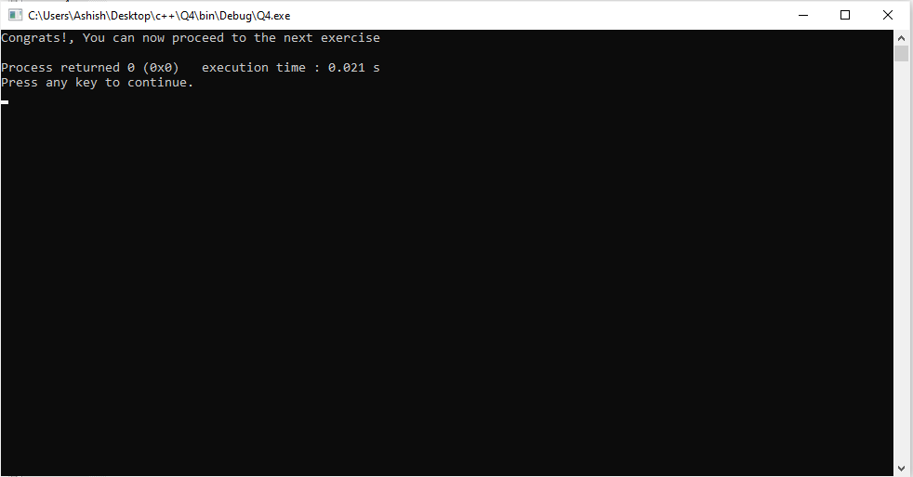

Question 5

#include <iostream>

using namespace std;

int main()

{

/*

Code given, should run 10 times

for (int i = 1; i <= n; i++ )

cout << i * i ;

Error, n is not declared in the scope :(

I will fix

*/

// my loop will run 10 times and will give the square of the first 10 integers, 0 is not considered.

int n = 1 ;

while (n < 11 ) {

cout << n * n << endl ;

n += 1 ;

}

cout << "Above is the square of the first 10 integers" ;

return 0;

}

Output:

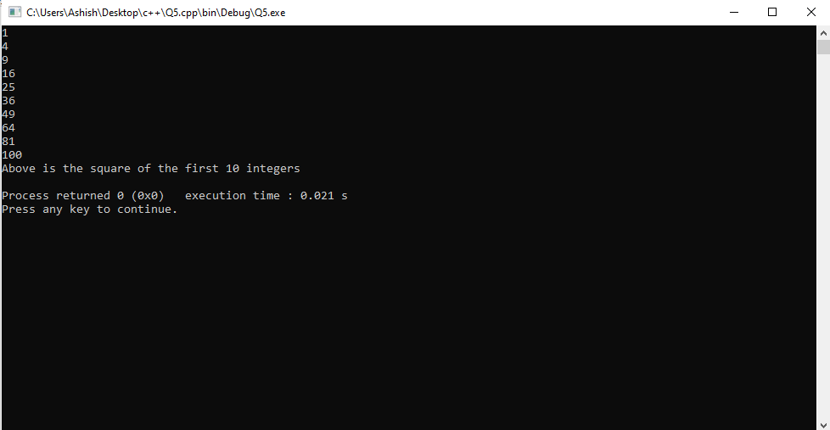

Question 6 V1

#include <iostream>

using namespace std;

int main()

{

/*

Discount list

Student = 10%

BookDealer = 12%

Pensioner = 15%

regularCustomer > R200 = 10%

*/

// VERSION 1 Switch statement

float amount ; // amount before Discount

char customerType ; // customerType

float finalamount ; // amount after Discount

// assuming all enteries will be via user = cin

// Assume all input will be UPPERCASE

// get amount

cout << "Enter amount in R: " ;

cin >> amount ;

// get customerType

cout << "What customer are you? " ;

cin >> customerType ;

// determine Discount

switch (customerType) {

case 'S':

finalamount = amount - (amount * 0.10) ;

cout << "R"<< finalamount ;

break ;

case 'D':

finalamount = amount - (amount * 0.12) ;

cout << "R"<< finalamount ;

break ;

case 'P':

finalamount = amount - (amount * 0.15) ;

cout << "R"<< finalamount ;

break ;

case 'O':

if (amount > 200) {

finalamount = amount - (amount * 0.10) ;

cout << "R"<< finalamount ;

}

else {

finalamount = amount ;

cout << "R"<< finalamount << endl ;

}

break ;

}

return 0;

}

Output:

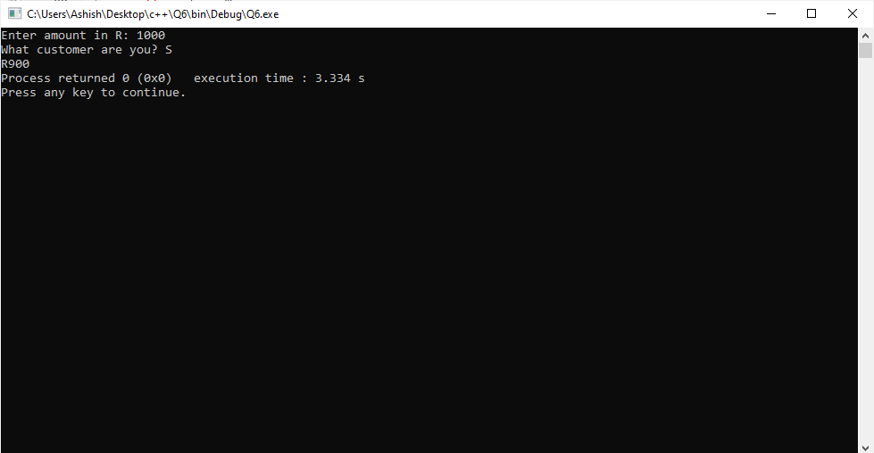

Question 6 V2

#include <iostream>

using namespace std;

int main()

{

/*

Discount list

Student = 10%

BookDealer = 12%

Pensioner = 15%

regularCustomer > R200 = 10%

*/

// VERSION 2 nested (if) statement

float amount ; // amount before Discount

char customerType ; // customerType

float finalamount ; // amount after Discount

// assuming all entries will be via user = cin

// assume all input will be UPPERCASE!

// get amount

cout << "Enter amount in R: " ;

cin >> amount ;

// get customerType

cout << "What customer are you? " ;

cin >> customerType ;

// determine Discount

if (customerType == 'S') {

finalamount = amount - (amount * 0.10) ;

cout << "R"<< finalamount ;

}

if (customerType == 'D') {

finalamount = amount - (amount * 0.12) ;

cout << "R"<< finalamount ;

}

if (customerType == 'P') {

finalamount = amount - (amount * 0.15) ;

cout << "R"<< finalamount ;

}

if (customerType == 'O') {

if (amount > 200 ) {

finalamount = amount - (amount * 0.10) ;

cout << "R"<< finalamount ;

}

else {

finalamount = amount ;

cout << "R" << finalamount ;

}

}

return 0;

}

Output:

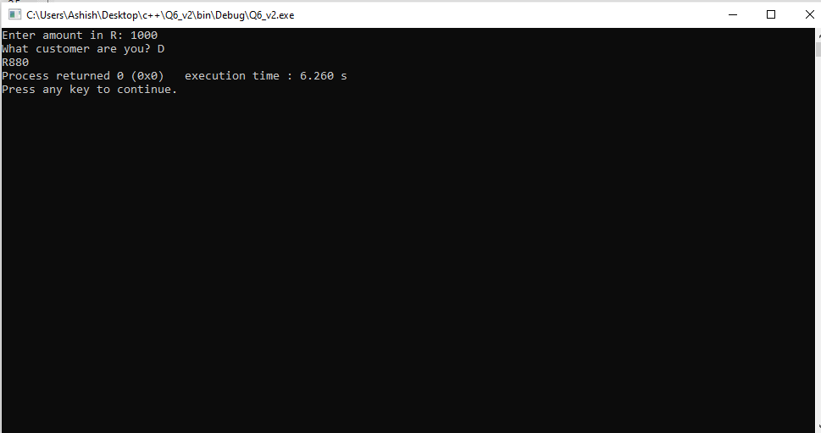

Question 7

#include <iostream>

using namespace std;

int

main ()

{

/*

CODE GIVEN

int x = 1;

while (x != 12)

{

cout << x << endl;

x = x + 2;

}

Issue, While loop terminates when x == 12 BUT x will never be 12 as x = x + 2

x = 1 + 2 = 3

x = 3 + 2 = 5

x = 5 + 2 = 7

x = 7 + 2 = 9

x = 9 + 2 = 11

x = 11 + 2 = 13 ----------------------------> Not 12

This shows x will not be 12 and run forever!

*/

// My program

int x = 2 ;

while (x != 12) {

cout << x << endl ;

x += 2 ;

}

return 0;

}

Output: 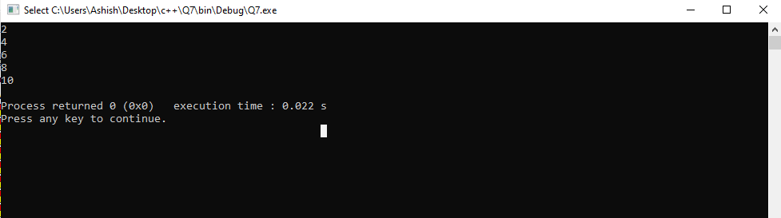

Question 8

#include <iostream>

using namespace std;

int

main ()

{

int numberOfItems;

int count; //loop counter for the loop

int caloriesForItem;

int totalCalories;

/* ISSUE + 120 + 60 + 150 + 600 + 1200 + 300 + 200 = 2630 not 2631*/

cout << "How many items did you eat today? ";

cin >> numberOfItems;

cout << "Enter the number of calories in each of the " << numberOfItems << " items eaten: " << endl;

// My code FOR LOOP

// set totalCalories to 0

totalCalories = 0;

for (int count = 0; count < numberOfItems ; count++) {

cout << "Enter calories: " ;

cin >> caloriesForItem ;

totalCalories = totalCalories + caloriesForItem ;

}

cout << "Total calories eaten today = " << totalCalories;

return 0;

}

Output:

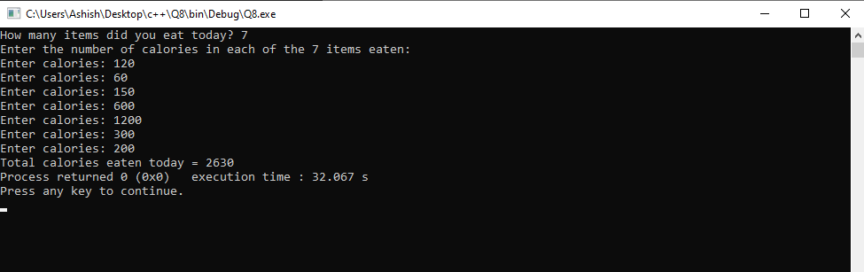

Question 9

#include <iostream>

using namespace std;

int main()

{

// BASICS variables

const int NR_VOTING_STATIONS = 4;

int votesForA, votesForB, votesForC, spoiltVotes;

char vote;

// initialise totals, coulf set earlier but made clear

votesForA = 0;

votesForB = 0;

votesForC = 0;

spoiltVotes = 0;

//initialise votes!

vote = '0';

// loop over the voting stations

for (int i = 1 ; i <= NR_VOTING_STATIONS ; i++ )

{

// loop over voters

while (vote != 'X')

{

cout <<"Enter your voting Choice A,B,C: ";

cin >> vote;

//IMPORTANT BREAK

if (vote == 'X')

break;

//INCREMENT

else if (vote == 'A')

votesForA += 1;

//INCREMENT

else if (vote == 'B')

votesForB += 1;

//INCREMENT

else if (vote == 'C')

votesForC += 1;

//INCREMENT

else

spoiltVotes += 1;

}

}

// display results

cout << endl << endl;

cout << "Total candidate A: " << votesForA << endl;

cout << "Total candidate B: " << votesForB << endl;

cout << "Total candidate C: " << votesForC << endl;

cout << "Total spoilt votes: " << spoiltVotes << endl;

return 0;

}

Output:

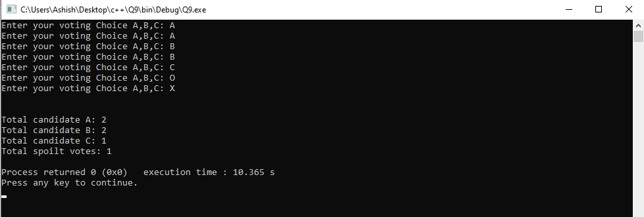

Question 10

Output:

year code

?

?

Line 6:

year code book discount

0.20

true

?

?

Line 7:

year code book discount

0.20

true

t

2010

Line 8:

year code book discount

0.20

false

t

2010

Line 20:

year code book discount

0.20

false

g

2010

Line 21:

year code book discount

0.35

false

g

2010

Line 33: