Ashish Ramnath

11552859

Assignment 2

Unique No: 830199

Question 2

#include <iostream>

using namespace std;

int main()

{

// initilise variables

int nrPupils = 56 ;

int nrGroups ;

int nrLeft ;

int groupSize ;

// Ask for group size

cout << "Please enter the size of each group " ;

cin >> groupSize ;

// set nrGroups and nrLeft if any

nrGroups = nrPupils / groupSize ;

nrLeft = nrPupils % groupSize ;

cout << "There are " << nrGroups << " groups consisting of " << groupSize << endl ;

cout << "pupils. " << "There are " << nrLeft << " remaining pupils" << endl ;

return 0;

}

Question 1

(i)

void check (int x, float y) {}



(ii)

float mult(float x, float y) {

return x \* y;

}



(iii)

#include <iostream>

using namespace std;

// create function

void time(int & secondsP, int & minutesP, int & hoursP) {

cin >> secondsP ;

cin >> minutesP ;

cin >> hoursP ;

}

// call in main function

int main()

{

int seconds;

int minutes;

int hours;

time(seconds, minutes, hours);

// int main() now has access to seconds, minutes and hours with new values

return 0;

}

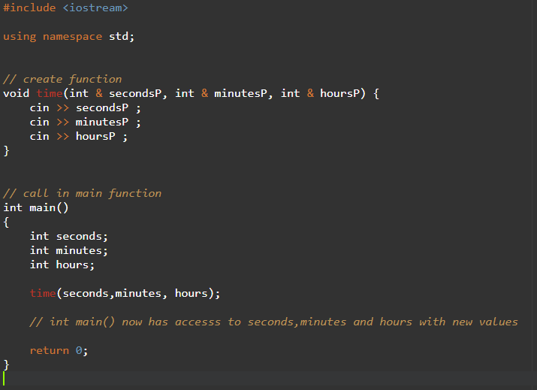

(iiii)

#include <iostream>

#include <string>

using namespace std;

int countChar(string x, char occurence) {

int count = 0;

for (int i = 0; i < x.size(); i++) {

if (occurence == x[i]) {

count += 1;

}

}

return count;

}

int main()

{

string name = "My name is Charles Xhavier and I am Professor X" ;

char x = 'a' ;

// string slicing and count occurence

cout << countChar(name, x) ;

return 0;

}

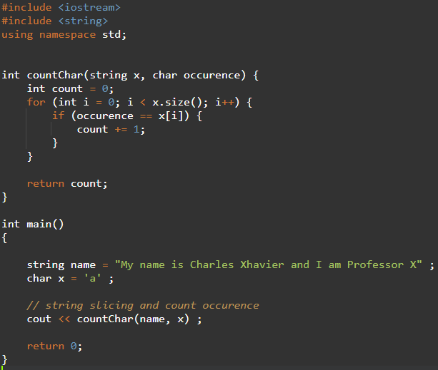

Question 2

(i)

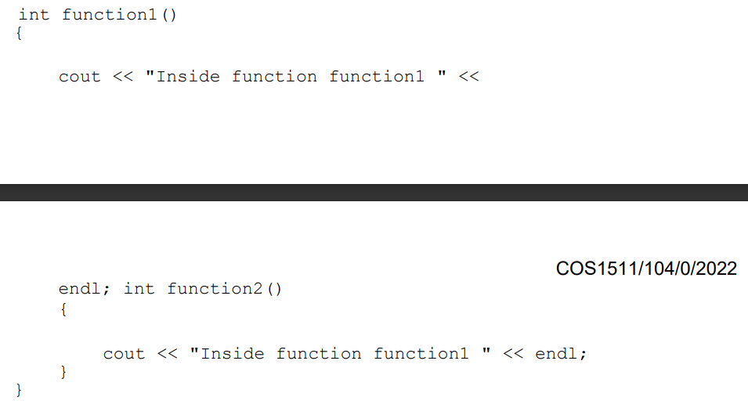

No return statement

Cannot have a function created in another function

Function2() is incorrectly placed

TO FIX

Add return statement

Remove function2 and make it its own.

(ii)

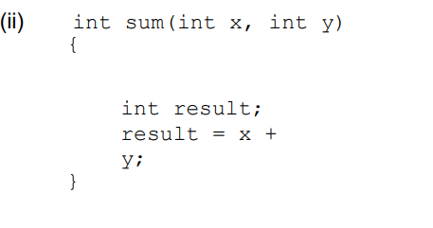

No return statement in function

TO FIX

Add return statement of type int

(iii)

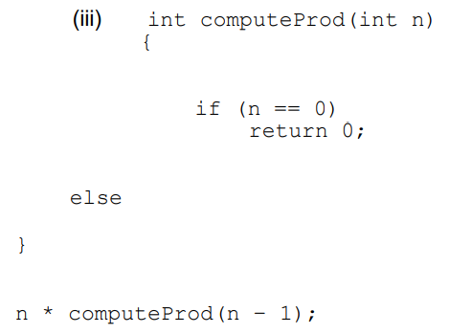

No return statement for else

Else loop is incomplete

n \* computeProd(n-1); should be within else block

computeProd variable not initialised

TO FIX

Complete else block

Initialise computeProd

Add return statement to else block

n \* computeProd(n-1); within else block

(iv)

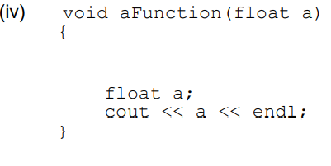

Declaration of float a, shadows the parameter of aFunction

TO FIX

Rename declaration a or remove it completely.

(v)

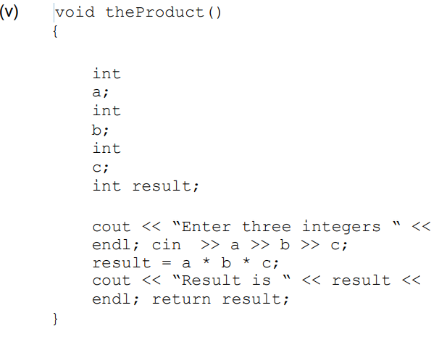

You cannot have a return statement in a void function

TO FIX

Remove return statement

(vi)

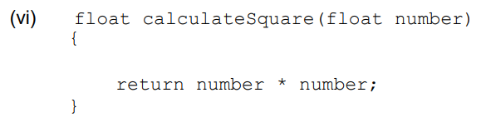

NO ERRORS

Question 3

(i)

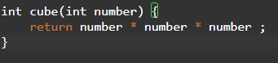

(ii)

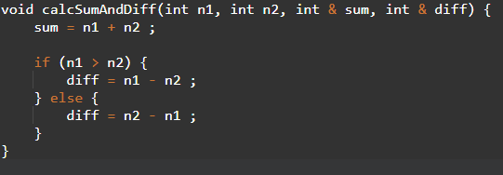

(iii)

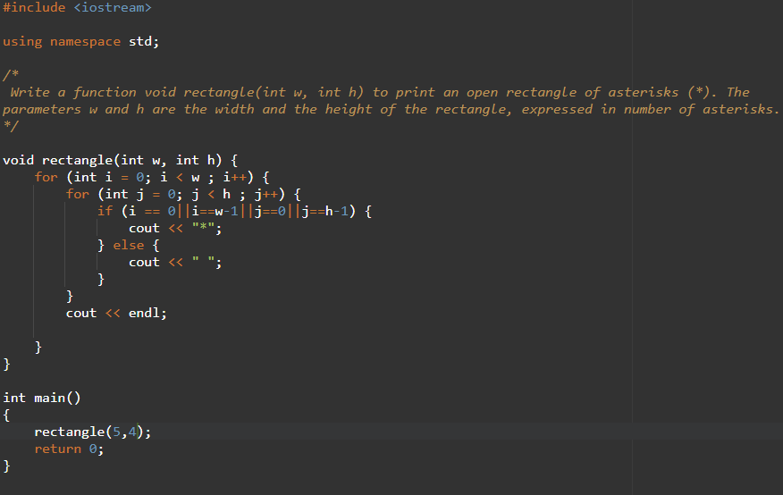

(iv)

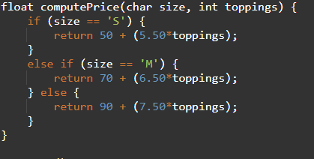

Question 4

Input

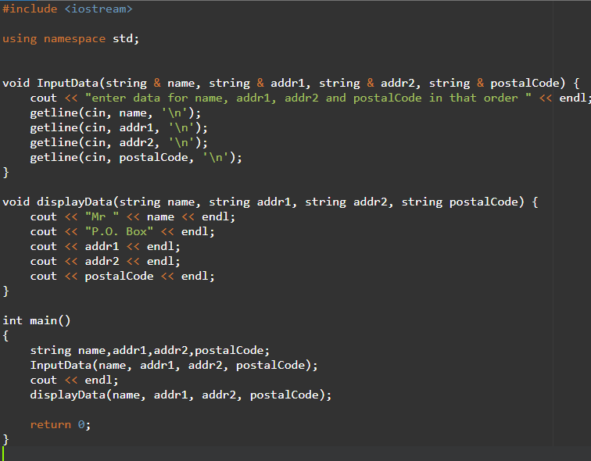

Output

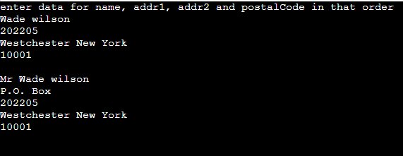

Question 5

Input

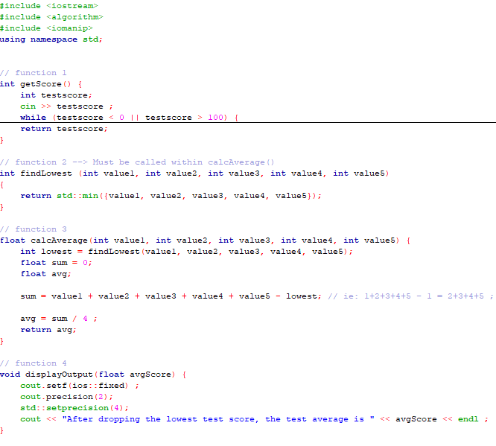

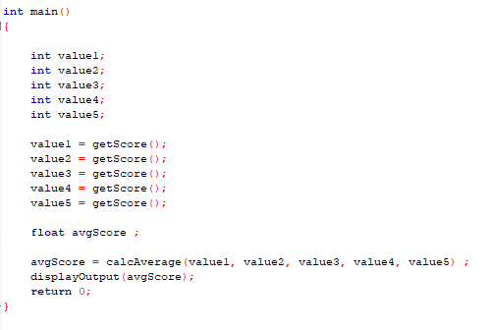

Output

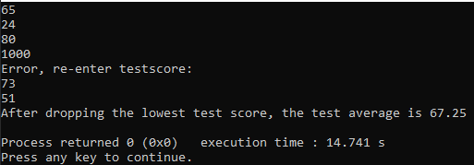

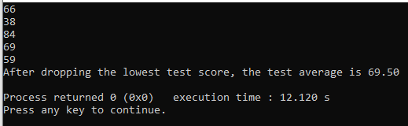

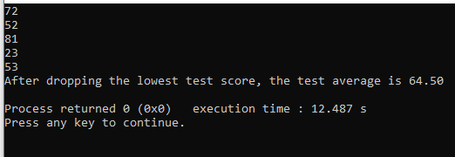

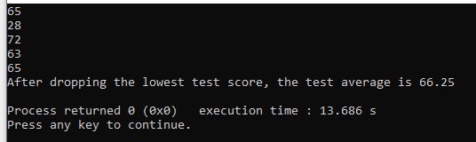

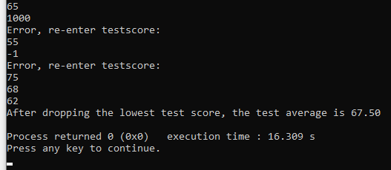

Question 6

Input

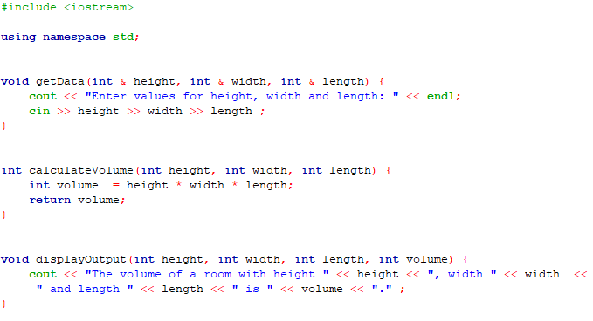

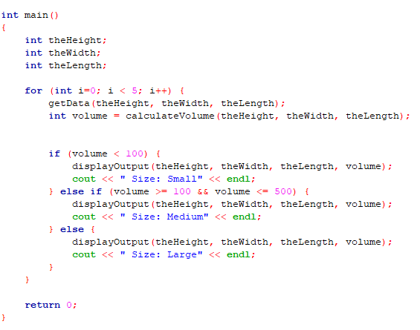

Output

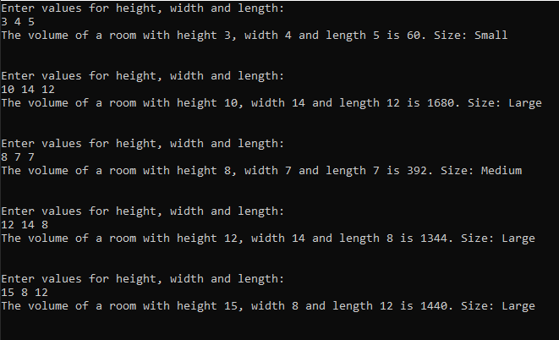

Question 7

