**Exercise :1 Singleton Pattern Example**

public class Logger {  
 private static Logger log;  
 private Logger(){  
 System.out.println("Logger");  
 }  
 public static Logger getLogger(){  
 if(log == null){  
 log = new Logger();  
 }  
 return log;  
 }  
 public void log(String message){  
 System.out.println(message);  
 }  
}

public class Main {  
 public static void main(String[] args) {  
 Logger log1 = Logger.getLogger();  
 Logger log2 = Logger.getLogger();  
 log1.log("First Log message");  
 log2.log("Second Log message");  
 if(log1 == log2) {  
 System.out.println("both instances are the same");  
 }  
 else{  
 System.out.println("both instances are not the same");  
 }  
 }  
}

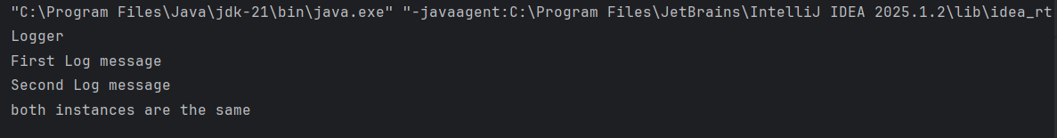

**2.FactoryMethodPattern Example**

public interface Document {  
 void open();  
  
}

public abstract class DocumentFactory {  
 public abstract Document createDocument();  
}

public class ExcelDocument implements Document {  
 @Override  
 public void open() {  
 System.*out*.println("open excel document");  
 }  
}

public class ExcelFactory extends DocumentFactory{  
 @Override  
 public Document createDocument() {  
 return new ExcelDocument();  
  
 }  
}

public class Main {  
 public static void main(String[] args) {  
 DocumentFactory wordFactory = new WordFactory();  
 Document word = wordFactory.createDocument();  
 word.open();  
  
 DocumentFactory pdfFactory = new PdfFactory();  
 Document pdf = pdfFactory.createDocument();  
 pdf.open();  
  
 DocumentFactory excelFactory = new ExcelFactory();  
 Document excel = excelFactory.createDocument();  
 excel.open();  
 }  
 }

public class PdfDocument implements Document {  
 @Override  
 public void open() {  
 System.*out*.println("open pdf document");  
 }  
}

public class PdfFactory extends DocumentFactory{  
 @Override  
 public Document createDocument() {  
 return new PdfDocument();  
 }  
}

public class WordDocument implements Document{  
 @Override  
 public void open() {  
 System.*out*.println("open word document");  
 }  
}

