**Exercise 1: Configuring a Basic Spring Application**

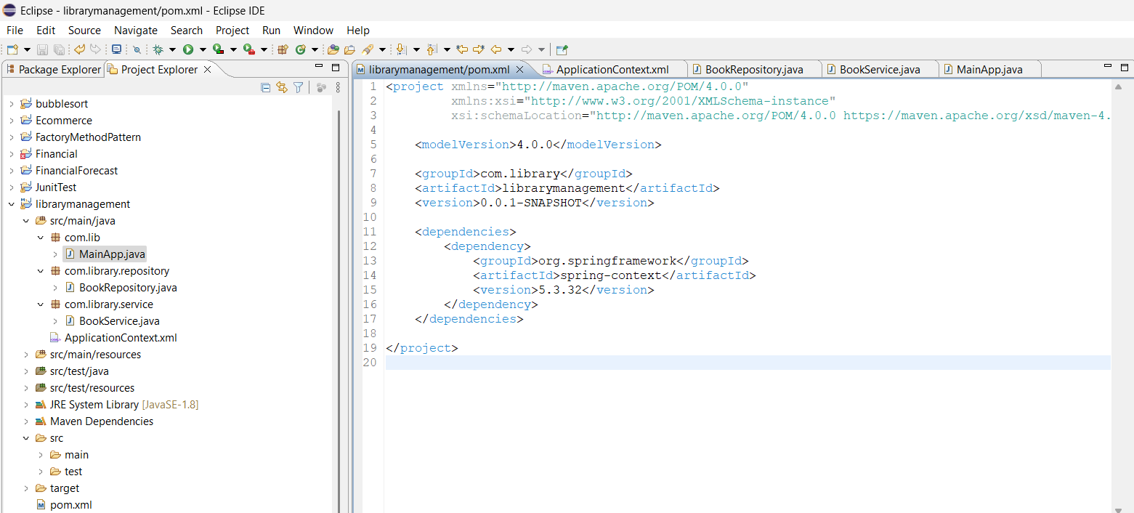

**OUTPUT**

**Exercise 2: Implementing Dependency Injection**

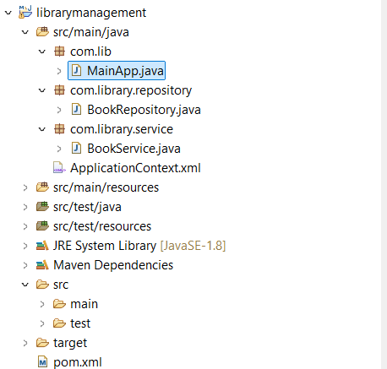

**OUTPUT**

**Exercise 4: Creating and Configuring a Maven Project**

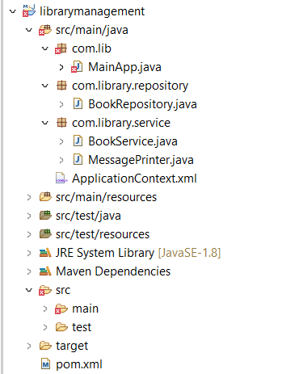

**OUTPUT**

**Exercise 5: Configuring the Spring IoC Container**

**OUTPUT**

**Exercise 7: Implementing Constructor and Setter Injection**

**OUTPUT**

**Exercise 9: Creating a Spring Boot Application**

**Application.process.context**

**Book.java**

**Bookrepository.java**

**LibraryManagement**

**OUTPUT**

**Localhost:8082/books**

**Localhost:8082/h2-console**

