**Hands on 1**

**Create a Spring Web Project using Maven**

**OUTPUT**

**Hands on 4**

**Spring Core – Load Country from Spring Configuration XML**

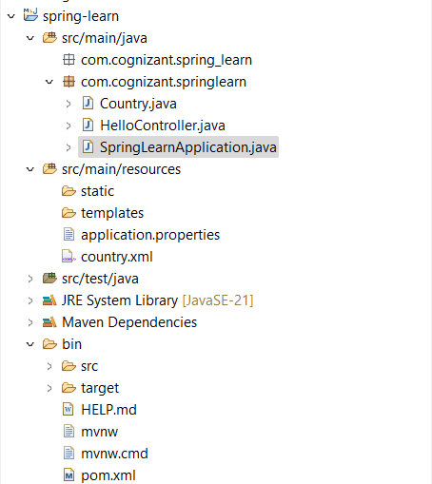

**OUTPUT  
**

**Hello World RESTful Web Service**

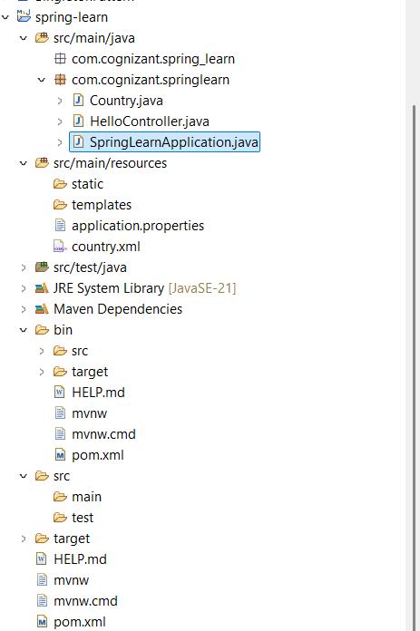

**OUTPUT**

**REST - Country Web Service** 

**OUTPUT**

**REST - Get country based on country code** 

**OUTPUT**

**Create authentication service that returns JWT** 

**OUTPUT**

