**Microservices with API gateway**

**Creating Microservices for account and loan**

**Account Microservice:**

**//running**

**//output**

**//Loan Microservice**

**// running**

**Assignment 2: Eureka Discovery Server and Microservice Registration**

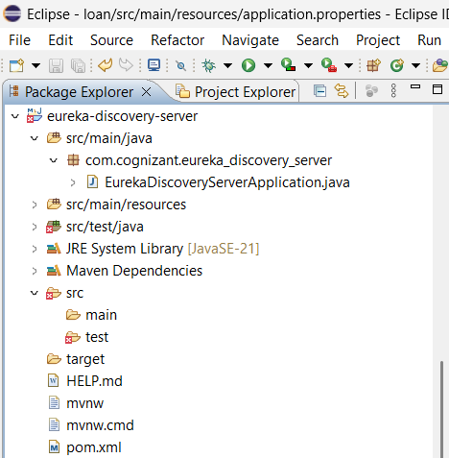

**Account – pom.xml**

**Loan – pom.xml**

**//running eureka application**

**//running account application**

**//running loan application**

**Accessing http:localhost//8765**

**Account and loan microservice registered with eureka**

**//accessing account microservice**

**//accessing loan microservice**

