HandsOn 1

**OUTPUT**

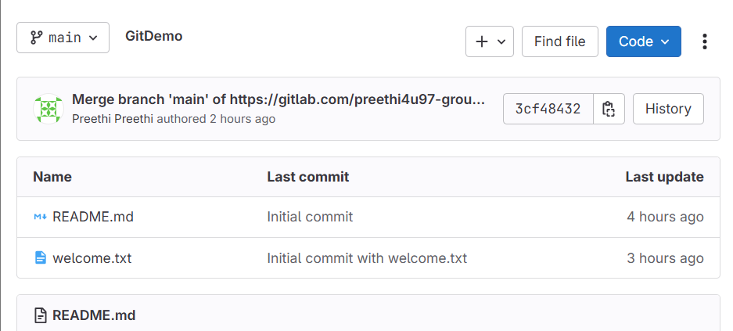

**HandsOn 2**

OUTPUT

**HandsOn 3**

**OUTPUT**

**HandsOn 4**

**HandsOn 5**

OUTPUT

