# Screenshots

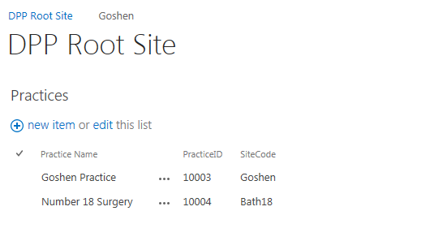

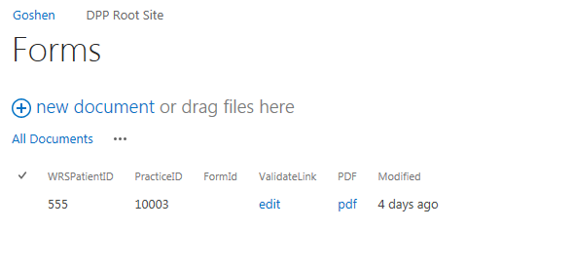

## WORKFLOWS

### Update Form PDF

Updates pdf link in form and moves PDF to subsite.

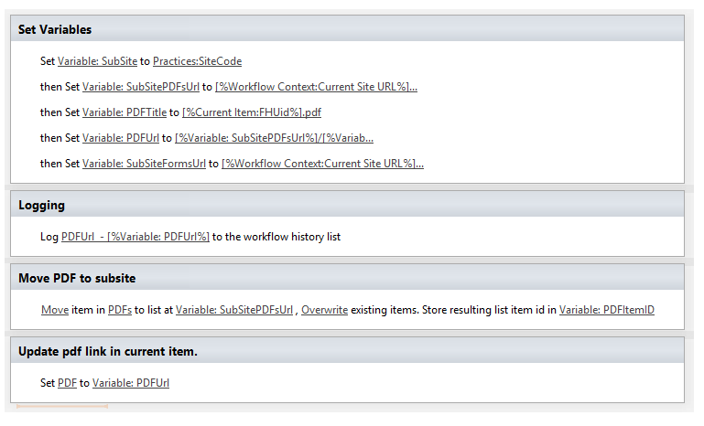

### Move Form

Called on Update to item in the Forms document library. Moves Form to subsite.

Note: Update is fired by Update PDF workflow.

