DETERMINISTIC TIME-VARYING VOLATILITY IN BLACK-SCHOLES: IMPROVED HISTORICAL FIT WITHOUT CONSISTENT GAINS IN SPX OPTION PRICING

A THESIS

Presented to

The Faculty of the Department of Economics and Business

The Colorado College

In Partial Fulfillment of the Requirements for the Degree

Bachelor of Arts

By

Wes Vorley

April 2026

DETERMINISTIC TIME-VARYING VOLATILITY IN BLACK-SCHOLES: IMPROVED HISTORICAL FIT WITHOUT CONSISTENT GAINS IN SPX OPTION PRICING

Wes Vorley

April 2026

Mathematical Economics

Abstract

This paper looks at an extension of the Black Scholes model for call option prices, specifically examining how changes in pricing accuracy respond to a deterministic, time-varying volatility specification. The thesis analyzes volatilities of the S&P 500 index (SPX) from April 27 to July 29 of 2024 and models monthly trends through linear, quadratic, and exponential regression. It then uses integrated variance and the Black-Scholes model to calculate theoretical call prices based on future volatilities predicted from each model and compares them with true SPX call prices from May 27 to August 29 of 2024. The findings suggest that quadratic and exponential models best fit historical volatility over month-long timeframes, but no specification showed superior accuracy over the constant-volatility assumption with regard to true call prices.

KEYWORDS: (Option, Call, Model, Historical Volatility, Implied Volatility)
JEL CODES: (G13, G12, C58)

ON MY HONOR, I HAVE NEITHER GIVEN NOR RECEIVED
UNAUTHORIZED AID ON THIS THESIS


Signature

TABLE OF CONTENTS

ABSTRACT

1 INTRODUCTION

2 LITERATURE REVIEW 6

3 THEORY
3.1 Monte Carlo Simulation........................................................................... 8
3.2 Binomial Pricing....................................................................................... 9
3.3 Black Scholes Model................................................................................ 10
3.4 BSM Extensions........................................................................................ 11
4 MODELS
4.1 Linear Volatility........................................................................................ 12
4.2 Quadratic Volatility.................................................................................. 13
4.3 Exponential Volatility................................................................................ 13
5 DATA
5.1 Dataset Description................................................................................. 14
5.2 Calculation of Deterministic Volatility..................................................... 15
5.3 Choosing Calls to Obtain.......................................................................... 17
5.4 Obtaining Call Data.................................................................................. 20
6 RESULTS & ANALYSIS
6.1 Results Summary..................................................................................... 23
6.2 Volatility vs. Option Modelling................................................................ 23
6.3 Limitations & Interpretation.................................................................... 26
7 CONCLUSION
7.1 Summary & Contribution......................................................................... 29
7.2 Limitations & Future Research................................................................. 30
8 REFERENCES 32
9 APPENDIX A 35
Section 1 – Introduction

In 1973, the Chicago Board Options Exchange (CBOE) was founded, becoming the first ever exchange to allow the trading of options contracts. An “option” or “options contract” is a type of security that allows its buyer the right, but not the obligation, to buy or sell an asset at a given price point, denoted the “strike price”, in a given period. The final date in which the buyer can exercise the option is the “expiration date”. Options are considered a type of “derivative", also called a “contingent claim”, as they are based on the value of their underlying stock. They are also the simplest contingent claim used to hedge risk, and it has been shown that combinations of options can be used to express stocks, bonds, and countless other securities (Asay, 1976; Black & Scholes, 1973; Hull, 2022; Merton, 1973; Shreve, 2004). However, unlike a stock share, an options contract can be traded at a fraction of the price of its underlying asset, allowing for greater returns. The primary two option types are “call” and “put” options. A call option gives the buyer the option to buy a security for the strike price at expiration, and a put option gives the option to sell one for the strike price. Options are further categorized by style. There are two primary styles of options: “American-style” and “European-style”. An American-style option can be exercised at any point before or on the expiration date. A European-style option can only be exercised on the expiration date.
Financial derivatives, and options in particular, play a key role in today’s financial markets. The flexibility of options allows investors to better manage risk, bet on future price movements, and develop complex investment strategies. For example, many investment firms buying an asset will also buy put options on that asset to hedge their risk and protect against large adverse price swings. Traders, on the other hand, may use options to take advantage of large price swings in a security or market. Due to the close relation between options and expectations of potential movements in underlying assets, it is critical that investors maintain reliable models for pricing these contracts. Indeed, the development of reliable models for option pricing is arguably one of the most important advancements in financial economics. Since its introduction in 1973, the Black-Scholes Model (BSM) is still the most popular framework used to price European options, and it remains a crucial tool for both academics and investors.
The same year that the CBOE was first listed, a paper by Fischer Black and Myron Scholes (1973) titled “The Pricing of Options and Corporate Liabilities” was published. This paper developed a revolutionary model that could be used to price options in this exchange based on 5 other known variables (Black & Scholes, 1973). However, since the B-S work, there has been a vast amount of literature examining its limitations when pricing options (Asati et al., 2024; Asay, 1976; Macbeth & Merville, 1979; Merton, 1973; Singh & Kumar, 2024). This thesis hypothesizes that using the BSM with time-varying deterministic volatility as opposed to constant volatility is significantly more accurate than the original BSM. It will begin with a review of the literature on the BSM as well as two other prominent options pricing models. It will then explain the intuition behind the BSM and its shortcomings before analyzing the accuracy of model estimates with true call option prices from the S&P 500 index (SPX). It will examine linear, quadratic, and exponential functions for volatility as a function of time and will demonstrate that the quadratic volatility function can be used to most accurately represent historical volatility, while constant, quadratic, and exponential functions can best estimate option prices given all other variables being constant.
Section 2 – Literature Review
While there was previous literature treating the option price as a function of its underlying stock’s price (Andrew, 1970; Samuelson, 1965), the BSM soon became one of the most widely used models for pricing options (Asati et al., 2024; Hull, 2022). The paper derived a set of equations used to price an option based on the underlying security’s stock price, the strike price, the risk-free rate, the time to maturity, and the stock’s volatility (Black & Scholes, 1973). While Black & Scholes’ 1973 paper showed a rigorous proof for this model, there were many assumptions made and variables that needed to be held constant for the model to work. One of the BSM’s primary issues was in its assumption of constant volatility, as in this same paper it is mentioned that “the relative volatility of the option is not constant, however. It depends on both the stock price and maturity,” (Black & Scholes, 1973, p. 639). Following this derivation came a paper by Robert Merton deriving the formula with weaker assumptions including changing interest rates (Merton, 1973, p. 168). Merton’s work illustrated that while the BSM was a great starting point for options pricing models, there was room for further generalization.
While mathematical rigor may be helpful in practice, only empirical studies are able to show the accuracy of a model. In 1976, Michael Asay compared the BSM-calculated values of options with their actual prices on the CBOE. In his findings, “the results demonstrated a systematic underestimation of market prices by the model,” (Asay, 1976, p. 33). A study by James Macbeth and Larry Merville (1979) comparing the BSM with real market options prices came to similar results. They found that in the money options were again underestimated by the model and concluded that a part of the issue was the result of a non-stationary variance rate (Macbeth & Merville, 1979, p. 1186). Since the variance rate is the square of the volatility, this implies that the volatility would also be non-stationary. The findings by Merton, Asay, and Macbeth & Merville show that while constant volatility allows for a more simplistic model, it is also a reason for bias in pricing call options.
In contrast to calculating an option price from its volatility, implied volatility is calculated based on the value of an option. It was first derived by Henry Latané and Richard Rendleman, Jr. (1976), and used the BSM to reverse-engineer the volatility given a priced option. Their findings, based on 24 companies traded over 38 weeks on the CBOE, concluded that “the market’s standard deviation estimates tend to be inconsistent over time,” (Latané & Rendleman, 1976, p. 379). As described by Roger W. Lee, “implied volatility is the market’s expectation of future volatility, time-averaged over the term of the option,” (2002, p. 2). If implied volatility is seen as the market’s assumptions for future volatility (Mayhew, 1995), then having volatility as a function of time can consistently corporate implied volatility into pricing an option (Lee, 2004).
Section 3 – Theory
3.1 – Monte Carlo Simulation
The Monte Carlo valuation method came 4 years after the BSM (Boyle, 1977). Just like the BSM, returns are assumed be risk-neutral and to follow a normal distribution (Black & Scholes, 1973; Boyle, 1977). As opposed to Black and Scholes’ method of using direct integration, this method estimates the integral solution by averaging $n$ sample values chosen at random from a probability density function (Boyle, 1977, p. 325). Through this method of valuation, it is easy to see the approximate range for our final option value. Additionally, if one assumes the distribution as normal for large values of $n$, confidence intervals may be created showing the likelihood of any given price point occurring at expiration (Boyle, 1977, p. 326). One of the primary issues with this method noted in the paper is that “the standard error of the estimate is inversely proportional to the square root of the number of simulation trials,” (Boyle, 1977, p. 324). In other words, we must repeat 4x as many simulations to reduce the standard error by 2x, and 100x as many to reduce the error by 10x (Boyle, 1977). Boyle’s primary solution to reducing error without computing millions of values is by introducing the control variate method (Boyle, 1977). As Boyle writes, “the basic idea underlying this method is to replace the problem under consideration by a similar but simpler problem which has an analytic solution. The solution of the simpler problem is used to increase the accuracy of the solution to the more complex problem,” (1977, p. 326). The most common analytic solution used to increase accuracy, however, is the Black Scholes mode, which points to a major limitation in using this numerical method alone.
3.2 – Binomial Pricing
The binomial pricing strategy was originally published in 1979 by John Cox, Stephen Ross, and Mark Rubinstein in a paper titled “Option Pricing: A Simplified Approach”. Like the Monte Carlo method, the binomial pricing approach uses a discrete-time model. Since the model uses discrete values as opposed to continuous ones, this approach was significantly more simplified than the BSM, allowing for understanding by a broader audience. However, while Monte Carlo calculates many possible future values (Boyle, 1977), binomial pricing calculates the current value using future values (Cox et al., 1979). The model splits the call price into $n$ columns of branches, with the price going either up or down at each branch (Cox et al., 1979). For each additional period added, $n$ more branches are added to the model (Cox et al., 1979). However, authors show that “…option values approximated by the binomial method approach the corresponding limiting Black-Scholes values given by $n=∞$. At $n=5$, the values differ by at most $0.25, and at $n=20$, they differ by at most $0.07. Although not shown, at $n=50$, the greatest difference is less than $0.03, and at $n=150$, the values are identical to the penny,” (Cox, 1979, p. 258). If a greater number of branches means a higher degree of accuracy, the most accurate version of the binomial pricing strategy is the BSM. While both the Monte Carlo Valuation Method and binomial pricing Strategy are useful when there are computational restrictions to an analytic solution, they both preserve the assumption of constant volatility that is present in the BSM. The surrounding literature shows that while the BSM is based on strong theory and rigorous mathematics, it assumes constant volatility. However, this assumption is not consistent with market behavior, motivating the use of time-varying volatility as a natural extension.
3.3 – Black Scholes Model
In Black and Scholes’ paper, they assume that percentage changes in a given stock follow Brownian motion, also known as a Wiener process, with constant mean and variance. This is shown by the equation:
$dS=μSdt+σSdW_{t}$ Equation 1
where: ​
$$S=current stock price$$
$$μ=stock mean$$
$$σ=stock variance$$
$$W_{t}=standard Wiener process$$
(Black & Scholes, 1973). Since trading is taking place continuously and we assume that the pricing of the option moves as a function of the price of the stock, our strategy is to continuously adjust our long stock position in accordance with that function. This leaves us with a portfolio with no market risk, or a beta value of zero, which they prove to “have an expected return equal to the risk-free rate,” (Merton, 1973). This hypothetical trading strategy can eliminate the random effects of the market, as our option price is now perfectly correlated with the underlying stock price. This results in the black-Scholes PDE:
$rS_{t}\frac{∂C(S,T)}{∂S}+\frac{∂C(S,T)}{∂t}+\frac{1}{2}σ^{2}S^{2}\frac{∂^{2}C(S,T)}{∂S^{2}}-rC\left(S,T\right)=0$ Equation 2
where: ​
$$T=the option^{'}s expiration date$$
$$C\left(S, T\right)=the final value of the call option$$
$$r=constant rate of interest.$$
(Haugh, 2016).
However, this does not account for the boundaries of this model. Namely that a person won’t exercise an option if the strike price of the option is higher than the ending stock price. This gives us the boundary conditions that $C\left(S,T\right)=\max\left(S-K,0\right), C\left(0,t\right)=0 ∀t, and \lim_{S→∞}{C\left(S,t\right)=S}$, (Haugh, 2016). Solving for this case, we are left with only one solution set of equations that are referred to as the Black-Scholes model:
$C=SN\left(d_{1}\right)-Ke^{-rt}N\left(d_{2}\right)$
where $d_{1}=\frac{ln\left(\frac{S}{K}\right){+}\left(r+\frac{σ_{v}^{2}}{2}\right)t}{σ_{s}\sqrt{t}}$
and $d_{2}=d_{1}-σ_{s}\sqrt{t}$ Equation 3

and where:
$$C=Call option price$$
$$S=Current stock price$$
$$K=Strike price$$
$$R=Risk-free interest rate$$
$$t=Time to maturity$$
$$N=A normal distribution$$
3.4 – BSM Extensions
Following Black and Sholes’ original model was a paper by Robert Merton (1973) elaborating on their original assumptions. The three main assumptions were that “trading takes place continuously in time; (2) the market rate of interest, $r$, is known and fixed over time; and (3) there are no dividends or exercise price changes over the life of the contract,” (Merton, 1973). Additionally, Black and Scholes assume that “There are no transaction costs in buying or selling the stock or option,” and that “it is possible to borrow any fraction of the price of a security to buy it or to hold it,” (Black, 1973, p. 640). Given these lemmas, we can create a hedging strategy where we take a long position in the stock and a short position in the option. More specifically, “Writing $w(S,t)$ for the value of the option… the number of options that must be sold short against one share of long stock is: $1/w_{S}\left(S,t\right)$,” (Black, 1973).
While many more variations of BSM have come out in recent years, one of the large issues with it is in $σ$, the standard deviation of the stock. The model assumes that $σ$ does not change as a factor of time (Black, 1973; Merton, 1973; Haugh, 2016). In other words, it assumes that $σ\left(t\right)=σ$ for all $t$. However, when looking at implied volatility surfaces, we can see that implied volatility changes both as a function of the strike price, K, and as a function of the time to maturity, t (Haugh, 2016).
Section 4 – Models
4.1 – Linear Volatility
We will first look at volatility as a linear function of time. This is representative of steadily increasing uncertainty within the market, and gradual accumulation of information (Hull, 2022; Wilmott, 2009). Assuming risk-neutrality (stocks are just as likely to increase as to decrease from drift alone),
$ds=μSdt+σ\left(t\right)SdW_{t}$, $σ\left(t\right)=a+bt$ Equation 4
This is very similar to our original equation of $dS=μSdt+σSdW_{t}$, there is just the extra condition that the volatility, $σ$, changes with respect to time. We can then define the total variance, defined as V:
$$V=\int_{0}^{T}{{\left(at+b\right)}^{2}dt}=\int_{0}^{T}{\left(a^{2}t^{2}+2abt+b^{2}\right)}dt$$
$$V={\left[\frac{1}{3}a^{2}t^{3}+abt^{2}+b^{2}t\right]}_{0}^{T}$$
$V=\frac{1}{3}a^{2}T^{3}+abT^{2}+b^{2}T$ Equation 5
where
$a=$ $some constant coefficient$
$$b=volatility at time t=0$$
As a result, we end up with the following value of our call price:
$C=SN\left(d_{1}\right)-Ke^{-rt}N\left(d_{2}\right)$
where $d_{1}=\frac{ln\left(\frac{S}{K}\right){+}rT+\frac{1}{2}V}{\sqrt{V}}$
$d_{2}=d_{1}-\sqrt{V}$
and $V=\frac{1}{3}b^{2}T^{3}+abT^{2}+a^{2}T$ Equation 6
4.2 – Quadratic Volatility
Next, we will look at volatility as a quadratic function of time. This is representative of volatility that accelerates as it approaches maturity, in turn increasing option price sensitivity to uncertainty (Hull, 2022; Derman & Kani, 1994).
$ds=μSdt+σ\left(t\right)SdW_{t}, σ\left(t\right)=at^{2}+bt+c$ Equation 7
Defining variance as before, we get
$$V=\int_{0}^{T}{{\left(at^{2}+bt+c\right)}^{2}dt}=\int_{0}^{T}{\left(a^{2}t^{4}+2abt^{3}+\left(2ac+b^{2}\right)t^{2}+2bct+c^{2}\right)}dt$$
$$V={\left[\frac{1}{5}a^{2}t^{5}+\frac{1}{2}abt^{4}+\left(\frac{2}{3}ac+\frac{1}{3}b^{2}\right)t^{3}+bct^{2}+c^{2}t\right]}_{0}^{T}$$
$V =\frac{1}{5}a^{2}T^{5}+\frac{1}{2}abT^{4}+\left(\frac{2}{3}ac+\frac{1}{3}b^{2}\right)T^{3}+bcT^{2}+c^{2}T$ Equation 8
where
$a, b=$ $some constant coefficient$
$c=volatility at time t=0$.
As a result, we end up with the following value of our call price:
$$C=SN\left(d_{1}\right)-Ke^{-rt}N\left(d_{2}\right)$$
where $d_{1}=\frac{ln\left(\frac{S}{K}\right){+}rT+\frac{1}{2}V}{\sqrt{V}}$
$$d_{2}=d_{1}-\sqrt{V}$$
and $V=\frac{1}{5}a^{2}T^{5}+\frac{1}{4}abT^{4}+\left(\frac{2}{3}ac+\frac{1}{3}b^{2}\right)T^{3}+bcT^{2}+c^{2}T$ Equation 9
4.3 – Exponential Volatility
For our final model, we will look at volatility as an exponential function of time. This can be seen as a simplified interpretation of market stress and volatility clustering, both of which have been well documented in volatility literature (Wilmott, 2009).
$ds=μSdt+σ\left(t\right)SdW_{t}, σ\left(t\right)=ae^{bt}$ Equation 10
Defining variance as before, we get
$$V=\int_{0}^{T}{{\left(ae^{bt}\right)}^{2}dt}=\int_{0}^{T}{a^{2}e^{2bt}dt}$$
$V={\left[\frac{a^{2}}{2b}(e^{2bt}-1)\right]}_{0}^{T}=\frac{a^{2}}{2b}\left(e^{2bT}-1\right)$ Equation 11
where
$$a=volatility at time t=0,$$
$b=$ $some constant coefficient$
As a result, we end up with the following value of our call price:
$$C=SN\left(d_{1}\right)-Ke^{-rt}N\left(d_{2}\right)$$
where $d_{1}=\frac{ln\left(\frac{S}{K}\right){+}rT+\frac{1}{2}V}{\sqrt{V}}$
$d_{2}=d_{1}-\sqrt{V}$
and $V=\frac{a^{2}}{2b}\left(e^{2bT}-1\right)$ Equation 12
Section 5 – Data
5.1 – Dataset Description
The empirical analysis starts with European-style call option prices for the S&P 500 index (SPX). These prices span over 10 distinct trading dates from May 27, 2024 to July 29, 2024. For each date, all options with an expiration date within one month of the observation date, and only options with the closest strike price to the spot price (at the money options) were selected. For each option selected, the dataset includes the option’s ticker/identification, observation date, expiration date, strike price, and closing price. It also includes the spot price of the SPX on the observation date, and how close the option is to being at-the-money. The observation date, expiration date, strike price, and closing price variables are needed to evaluate the Black-Scholes model. Therefore, these variables are necessary under the assumption of deterministic time-varying volatility.
5.2 - Calculation of Deterministic Volatility
For each option observation date, a daily value of volatility was calculated up to a month later. For example, the May 27 option had an associated plot of volatility values from May 27, 2024 to June 27, 2024. The tidyquant package in R was used to get historical price data from the S&P 500 index. The price data was then used to calculate daily continuously compounded returns, computed as $r_{t}=\ln\left(\frac{S_{t}}{S_{t-1}}\right)$. A rolling volatility was calculated by finding standard deviation of the previous 21-trading days of log returns. This standard deviation was then multiplied by $\sqrt{252}$ to annualize the value, as there are approximately 252 trading days in 1 year. Each date in the plot then gathered the previous 21 trading days of annualized volatility to estimate a historical rolling volatility. 21 trading days approximates 1 calendar month$(252/12=21),$and so this amount was used to be consistent with the 1-month option price maturity date. Figure 1 below shows a plot of all volatility observations, and Table 1 below shows the summary statistics of all volatility observations gathered during the given time frame.

Figure 1
21-Trading-Day Volatility: Apr 27 – Jul 29, 2024
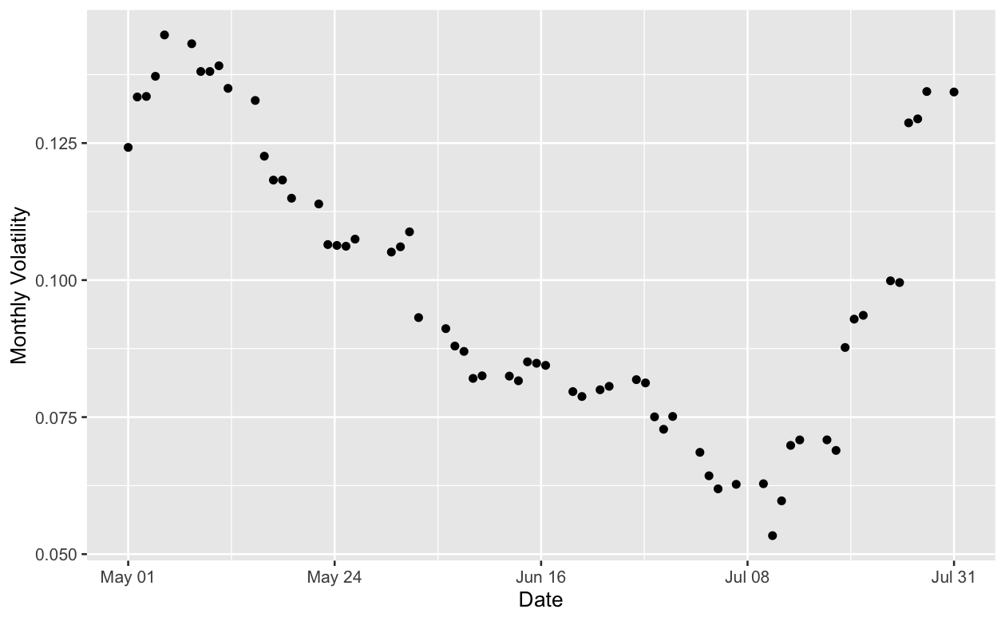
Table 1
Volatility Summary Statistics: Apr 27 – Jul 29, 2024
Obs | Min | Max | Mean | Median | Std Dev
63 | 0.0534 | 0.1447 | 0.0983 | 0.0929 | 0.0258

After the data was gathered, linear, quadratic and exponential regressions were then fitted to the volatility for each given time period, as well as a constant volatility used as a control. Tables 2 and 3 show the error between the models and the true volatilities using the Root Mean Squared Error (RMSE) and Mean Absolute Error (MAE), and Table 4 shows which model was the best fit for the historical volatility on each given date.
Table 2
Mean RMSE Error of Volatility Models
Date | RMSE_const | RMSE_lin | RMSE_quad | RMSE_exp
2024-05-27 | 0.0223 | 0.0080 | 0.0049 | 0.0082
2024-06-03 | 0.0317 | 0.0046 | 0.0041 | 0.0042
2024-06-10 | 0.0275 | 0.0044 | 0.0044 | 0.0044
2024-06-17 | 0.0196 | 0.0044 | 0.0043 | 0.0043
2024-06-24 | 0.0128 | 0.0052 | 0.0039 | 0.0049
2024-07-01 | 0.0143 | 0.0027 | 0.0027 | 0.0027
2024-07-08 | 0.0158 | 0.0038 | 0.0025 | 0.0040
2024-07-15 | 0.0089 | 0.0053 | 0.0050 | 0.0052
2024-07-22 | 0.0284 | 0.0114 | 0.0052 | 0.0114
2024-07-29 | 0.0556 | 0.0139 | 0.0069 | 0.0115
Mean | 0.0237 | 0.0064 | 0.0044 | 0.0061

Table 3
Mean MAE Error of Volatility Models
Date | MAE_const | MAE_lin | MAE_quad | MAE_exp
2024-05-27 | 0.0186 | 0.0066 | 0.0040 | 0.0070
2024-06-03 | 0.0274 | 0.0038 | 0.0035 | 0.0035
2024-06-10 | 0.0227 | 0.0035 | 0.0035 | 0.0034
2024-06-17 | 0.0155 | 0.0038 | 0.0035 | 0.0036
2024-06-24 | 0.0083 | 0.0043 | 0.0029 | 0.0040
2024-07-01 | 0.0131 | 0.0023 | 0.0023 | 0.0023
2024-07-08 | 0.0139 | 0.0031 | 0.0020 | 0.0033
2024-07-15 | 0.0075 | 0.0042 | 0.0042 | 0.0041
2024-07-22 | 0.0258 | 0.0102 | 0.0042 | 0.0102
2024-07-29 | 0.0491 | 0.0118 | 0.0056 | 0.0093
Mean | 0.0202 | 0.0054 | 0.0036 | 0.0051

Table 4
Best Fit Volatility Models
Date | RMSE_Best_Fit | RMSE | MAE_Best_Fit | MAE
2024-05-27 | Quadratic | 0.0049 | Quadratic | 0.0040
2024-06-03 | Quadratic | 0.0041 | Quadratic | 0.0035
2024-06-10 | Quadratic | 0.0044 | Exponential | 0.0034
2024-06-17 | Quadratic | 0.0043 | Quadratic | 0.0035
2024-06-24 | Quadratic | 0.0039 | Quadratic | 0.0029
2024-07-01 | Quadratic | 0.0027 | Exponential | 0.0023
2024-07-08 | Quadratic | 0.0025 | Quadratic | 0.0020
2024-07-15 | Quadratic | 0.0050 | Exponential | 0.0041
2024-07-22 | Quadratic | 0.0052 | Quadratic | 0.0042
2024-07-29 | Quadratic | 0.0069 | Quadratic | 0.0056

5.3 - Choosing Calls to Obtain
The initial design examined option maturities which extended up to a year after the observation date. However, the available options data only provided consistent daily option prices up to a one-month maturity, so it was decided that only volatilities 1 month prior to the quote date, and call options with expiration dates 1 month after the quote date, would be obtained. This revision ensures more consistency across observation dates.
The analysis is intentionally limited to the summer of 2024 in order to balance recency and data consistency. While a longer sample period would have allowed for more observations, this thesis focuses on the deterministic volatility assumption under recent market conditions. Later datapoints in 2024 were originally considered as well, but the U.S. presidential election in November of 2024 introduced external factors that may have affected volatility and are not representative of U.S. market dynamics in general. Restricting the sample to the summer period allows for market relevance while avoiding major events that can produce major changes in the S&P. It should also be noted that the analysis is limited to before 2025 due to inconsistent volatilities during this time period.

Figure 2
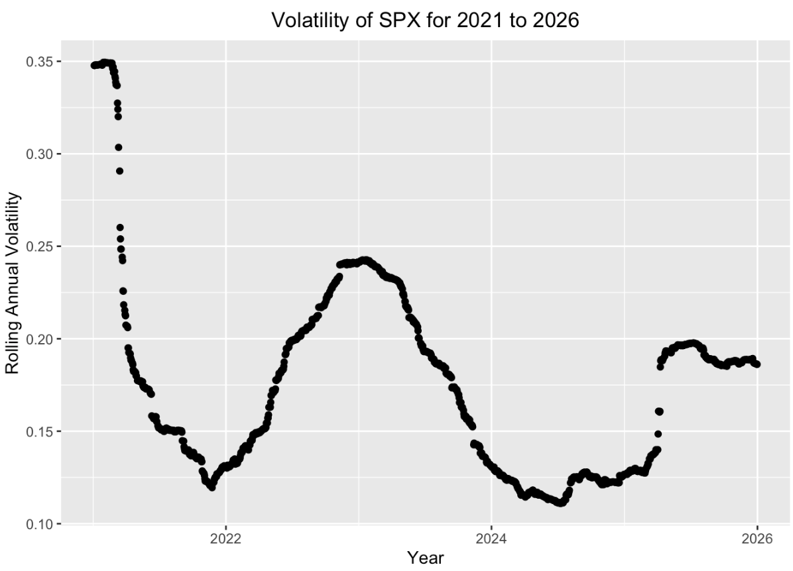
SPX Annual Volatility 2021 - 2026
As one can observe in Figure 2 above, annualized volatility continuously oscillates from 2021 to 2025 but appears to stabilize around 0.19 from 2025 to 2026. This is an example of volatility clustering, where volatility stays in the same range for a prolonged period of time. However, a period of generally similar volatilities would lead to less distinction between linear, quadratic, and exponential models of the plot. Therefore, it was more appropriate to analyze the year of 2024, where the previous year is trending down while the following year is trending up.

Figure 3
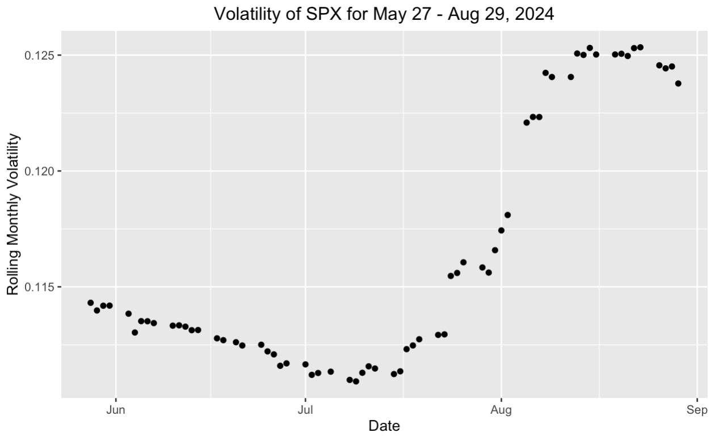
SPX Monthly Volatility May – Sep, 2024
A similar pattern emerges over the time period in which the data was gathered, seen in Figure 3 above, where a period of decline is followed by a period of incline. This pattern would allow for a comparison of different observation dates, to see if there was a consistent trend in regression accuracy rather than a coincidence.
5.4 – Obtaining Call Data
The call data was obtained through a custom data-processing script. Since volatility is known to change as the strike price varies (Derman & Kani, 1994), the script used a list of closing prices for each observation date to find its closest strike price. The script then compiled a list of the ticker, observation date, expiration date, strike price, spot price, at-the-money closeness, and closing call price for all calls within 1 month of the data and with a strike price within $5, or about 0.1%, of the spot price. Figure 4 below shows a plot of all closing call prices, and Table 5 below shows the summary statistics for the closing call prices gathered during the given time period.
Figure 4
Closing Call Prices Expiring May 28 – Aug 23, 2024
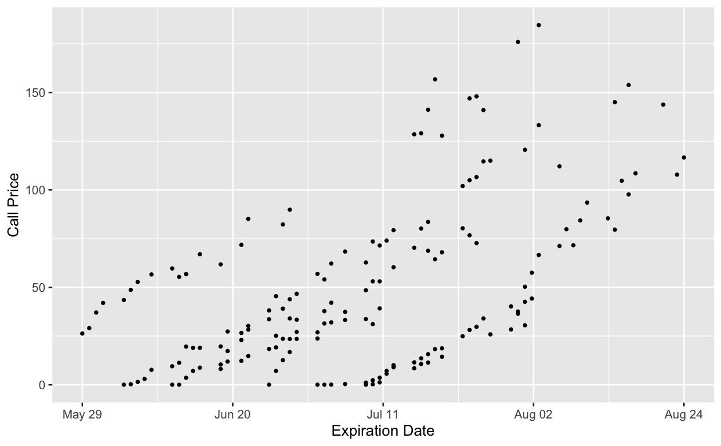
Table 5
Call Price Summary Statistics: May 28 – Aug 23, 2024
Obs | Min | Max | Mean | Median | Std Dev
167 | $0.05 | $184.60 | $49.95 | $37.60 | $42.75

After the call data was gathered, each date then used the models of integrated variance as described under Section 2 – Models for the linear, quadratic, and exponential volatility regression models, and plugged the obtained values into the Black-Scholes model for each date, along with the constant-volatility model that was used in their original paper (Black & Scholes, 1973). For each date quoted for call prices, the real call prices from each date were then compared with each model, and the means of both the root mean square error (RMSE) and mean absolute error (MAE) were calculated, as seen in Tables 6 and 7 below. Finally, the model with the lowest average RMSE and MAE was found for each date, as shown in Table 8.
Table 6
Mean RMSE Error of Call Models
Date | RMSE_const | RMSE_lin | RMSE_quad | RMSE_exp
2024-05-27 | 12.99 | 15.77 | 31.64 | 193.86
2024-06-03 | 19.76 | 16.41 | 20.23 | 11.25
2024-06-10 | 20.35 | 14.91 | 16.02 | 9.83
2024-06-17 | 16.62 | 21.20 | 18.74 | 44.80
2024-06-24 | 13.92 | 20.15 | 11.88 | 43.38
2024-07-01 | 22.58 | 23.20 | 22.86 | 4.20
2024-07-08 | 7.02 | 6.80 | 6.48 | 16.01
2024-07-15 | 127.07 | 130.68 | 128.89 | 144.33
2024-07-22 | 88.04 | 93.74 | 77.98 | 117.40
2024-07-29 | 29.64 | 29.61 | 19.40 | 73.60
Mean | 35.80 | 37.25 | 35.41 | 65.87

Table 7
Mean MAE Error of Call Models
Date | MAE_const | MAE_lin | MAE_quad | MAE_exp
2024-05-27 | 12.12 | 15.09 | 29.94 | 193.26
2024-06-03 | 18.75 | 15.71 | 19.24 | 9.31
2024-06-10 | 19.27 | 14.32 | 15.38 | 8.44
2024-06-17 | 15.34 | 19.28 | 17.17 | 41.80
2024-06-24 | 11.07 | 16.60 | 9.23 | 38.97
2024-07-01 | 21.38 | 22.00 | 21.68 | 3.62
2024-07-08 | 6.08 | 5.83 | 5.67 | 13.19
2024-07-15 | 126.51 | 130.11 | 128.38 | 143.50
2024-07-22 | 87.49 | 93.40 | 74.90 | 116.79
2024-07-29 | 28.97 | 28.86 | 17.12 | 70.74
Mean | 34.70 | 36.12 | 33.87 | 63.96

Table 8
Best Fit Call Models
Date | RMSE_Best_Fit | RMSE | MAE_Best_Fit | MAE
2024-05-27 | Constant | 12.99 | Constant | 12.12
2024-06-03 | Exponential | 11.25 | Exponential | 9.31
2024-06-10 | Exponential | 9.83 | Exponential | 8.44
2024-06-17 | Constant | 16.62 | Constant | 15.34
2024-06-24 | Quadratic | 11.88 | Quadratic | 9.23
2024-07-01 | Exponential | 4.20 | Exponential | 3.62
2024-07-08 | Quadratic | 6.48 | Quadratic | 5.67
2024-07-15 | Constant | 127.07 | Constant | 126.51
2024-07-22 | Quadratic | 77.98 | Quadratic | 74.90
2024-07-29 | Quadratic | 19.40 | Quadratic | 17.12

Section 6 – Results & Analysis
6.1 – Results Summary
The empirical results reveal a clear distinction between historical volatility model fit and option model performance. Table 4 indicates that the quadratic and exponential volatility models consistently showed the strongest fit curves for historical monthly volatility, with mean RMSE values ranging from 0.002 to 0.007, and mean MAE values ranging from 0.002 to 0.006. However, strong fits to historical volatility did not translate to option pricing accuracy. Table 7 shows that across the ten sampled dates, the best-performing models for call prices were distributed across constant (three dates), quadratic (four dates), and exponential (three dates) volatility specifications. The near-even distribution of the best performing models implies that there is no time-varying deterministic specification of volatility that outperforms the constant-volatility assumption when calculating call prices with the BSM. However, it should be noted that the linear model was the least accurate, likely because call prices do not scale linearly with volatility, and since linear models cannot be used to describe periods with curving trajectory. Additionally, the mean RMSE and MAE values were substantially larger, with RMSE ranging from 4 to 128, and MAE ranging from 3 to 127. There is a large range of errors in price approximations, as well as a discrepancy of best fit models for volatility vs. call price. These observations indicate that volatility modelling success and pricing success should be treated as two distinct outcomes.
6.2 - Volatility vs. Option Modelling
The results of the regression analysis on short-term historical volatility show that the assumption of constant volatility is invalid as an approximation of real volatility. A t-test on the errors between volatility models, shown in Table 9 below, found statistically significant differences for all three models, ranging from 0.0077 to 0.283 (0.77% to 2.83%) improved accuracy when compared with the constant volatility assumption. However, across all sampled dates, only the quadratic and exponential models produced the lowest error metrics for volatility. The low magnitude of the errors in Table 4 also shows that time-varying quadratic and exponential functions can approximate short-horizon historical volatility to a high degree of accuracy. This suggests that volatility paths generally exhibit curvature and non-linear decay and acceleration, even over short time periods.
Table 9
Differences in Volatility Model Errors from Constant Volatility
Model | Metric | Mean_Diff | t_stat | p_value | CI_lower | CI_upper
Linear | RMSE | -0.0173 | -5.0011 | 0.0007 | -0.0251 | -0.0095
Quadratic | RMSE | -0.0193 | -4.8541 | 0.0009 | -0.0283 | -0.0103
Exponential | RMSE | -0.0176 | -4.8095 | 0.001 | -0.0259 | -0.0093
Linear | MAE | -0.0148 | -4.6963 | 0.0011 | -0.022 | -0.0077
Quadratic | MAE | -0.0166 | -4.5707 | 0.0013 | -0.0249 | -0.0084
Exponential | MAE | -0.0151 | -4.4959 | 0.0015 | -0.0227 | -0.0075

While the quadratic and exponential volatility models were very accurate, the call pricing models for these fits were not more accurate than the constant volatility assumption over the ten sampled dates. A t-test on the errors between call price models, shown in Table 10 below, found no statistically significant difference between any model and the constant volatility model. Furthermore, the scale of errors in call prices remains materially large. Even after excluding the two outliers from late July, errors range from 4.2 to 19.4. Given the mean call price of $49.95 (see Table 5), this correlates with an error range from 8.4% to 38.8% of the price.
Table 10
Differences in Call Price Model Errors from Constant Volatility
Model | Metric | Mean_Diff | t_stat | p_value | CI_lower | CI_upper
Linear | RMSE | 1.4463 | 1.1883 | 0.2651 | -1.3070 | 4.1995
Quadratic | RMSE | -0.3860 | -0.1516 | 0.8829 | -6.1467 | 5.3748
Exponential | RMSE | 15.0383 | 2.2478 | 0.0512 | -0.0963 | 30.1729
Linear | MAE | 1.4213 | 1.2483 | 0.2434 | -1.1544 | 3.9970
Quadratic | MAE | -0.8267 | -0.3110 | 0.7629 | -6.8407 | 5.1872
Exponential | MAE | 14.0446 | 2.1591 | 0.0592 | -0.6702 | 28.7594

The large discrepancy between volatility fit and call price fit is theoretically expected. While errors in volatility are measured in decimal units of annualized variance, errors in option prices are measured in dollar amounts. Previous literature shows that option prices are sensitive to volatility in a non-linear manner, captured by an option’s Vega, $∂C/∂σ$(Hull, 2022). A linear relationship between option price and volatility would be shown through a constant Vega over time. However, Figure 5 shows us that this is clearly not the case. Due to this non-linear relationship between call price and volatility, even small changes in volatility can rapidly expand when used to calculate theoretical call prices. These comparisons also serve as a robustness check on the thesis’ central finding, as the lack of a consistently dominant volatility specification remains across multiple functional forms and across both RMSE and MAE error criteria.

Figure 5
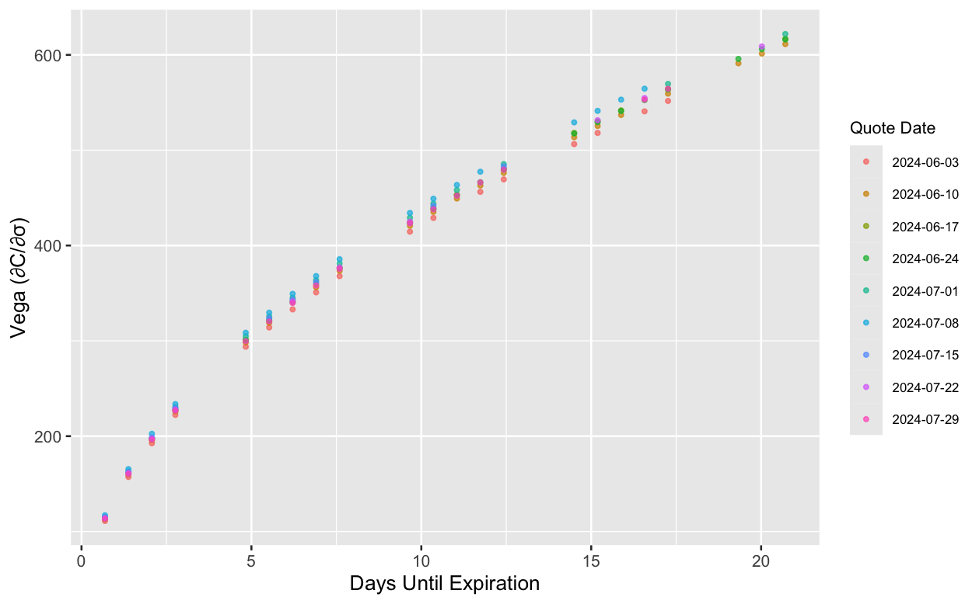
Effect of Days Until Expiration on Vega for SPX Options

6.3 – Limitations & Interpretation
Rather than treating July 15 and July 22 as problematic outliers, these dates should be interpreted as periods where the structural limitations of short-term deterministic analysis become most pronounced. In both Figures 3.1 and 4.1, volatility is nearing a local minimum. While this is normally associated with lower call prices, it is also based on the assumption that volatility will continue to flatten out rather than rebound. Due to the oscillating nature of volatility, though, investors will expect an increasing volatility in the future, leading to higher call prices and an increased implied volatility compared to recent historical data. This is also why the quadratic model in Figure 4.1 more closely approximates call prices than any other model; its curvature allows for a model predicting large upswings in future volatility.

Figure 3.1
July 15 Volatility Models
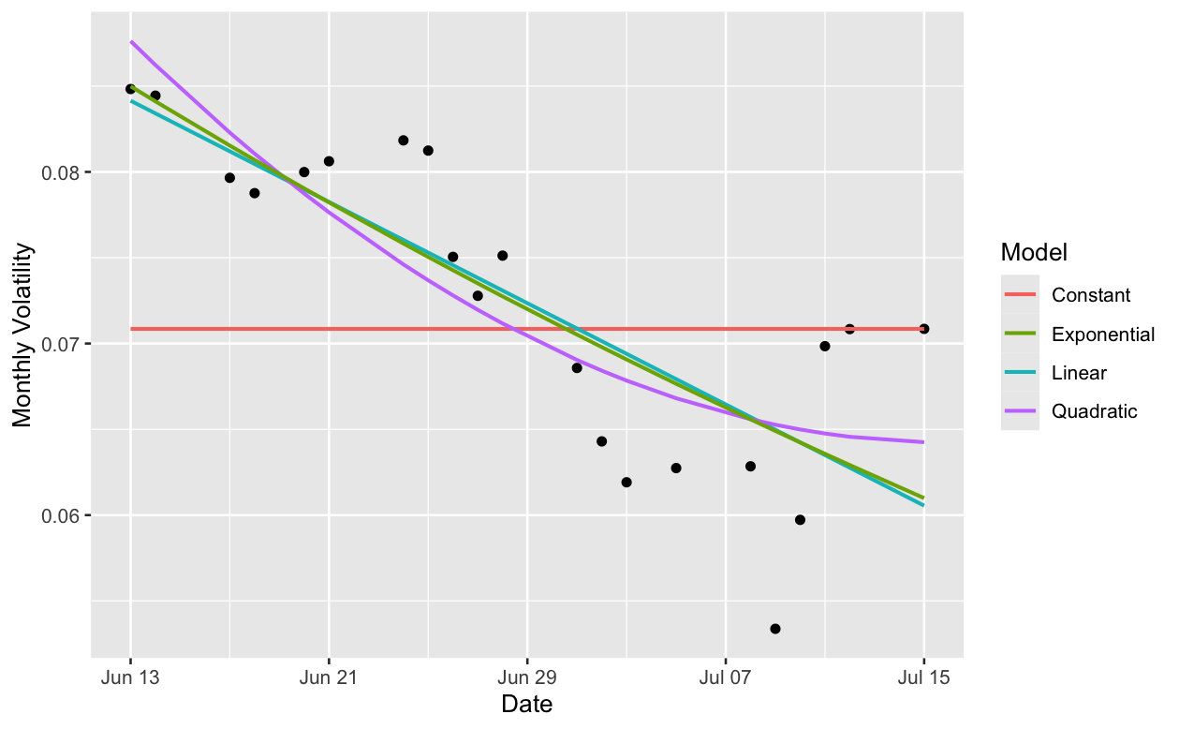

Figure 3.2
July 15 Call Price Models
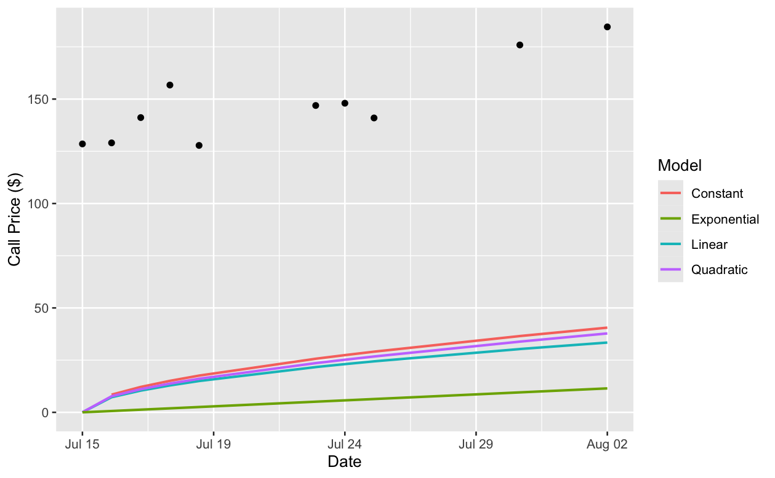

Figure 4.1
July 22 Volatility Models
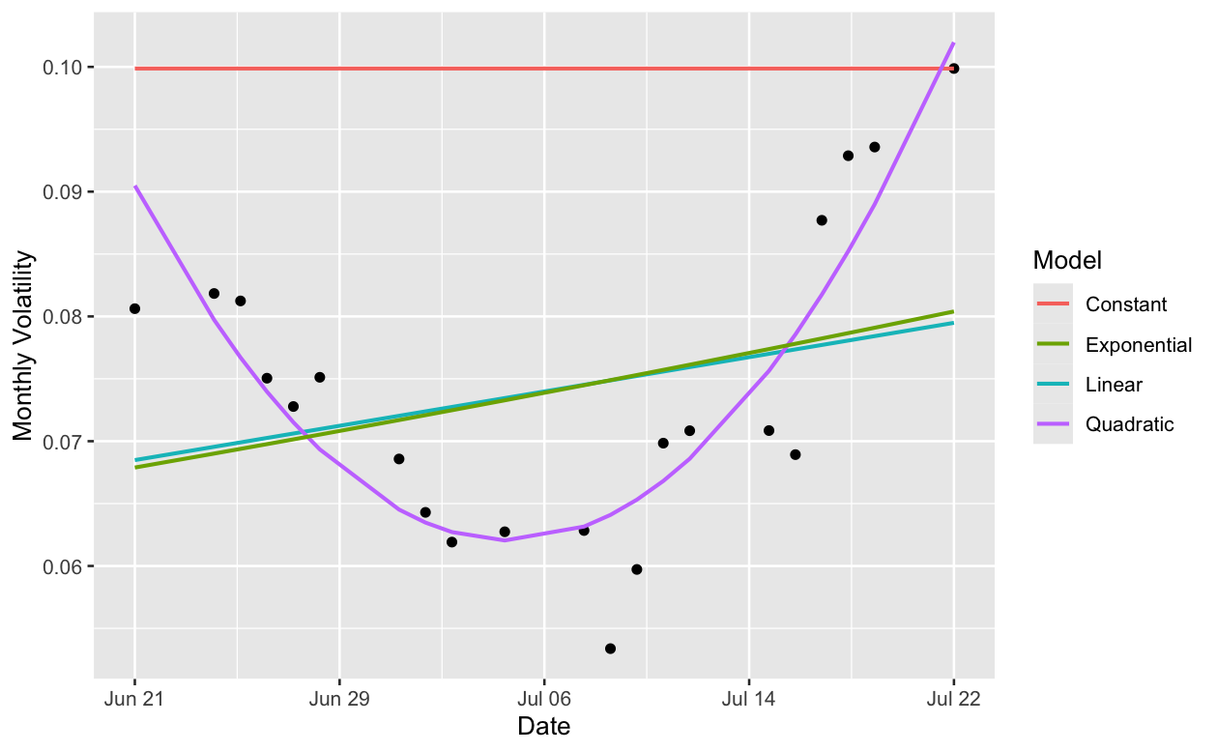

Figure 4.2
July 22 Call Price Models
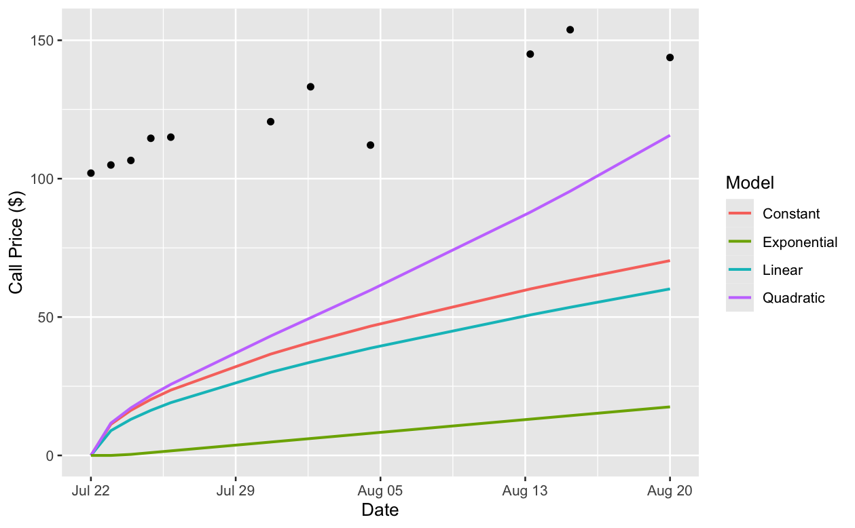
Empirically, these results exemplify a clearer separation between statistical precision and call price relevance. Put simply, the quadratic and exponential models increase the realism of volatility approximations, but the option pricing errors remain large. In practice, modest gains in volatility fit are frequently overshadowed by option sensitivity, integrated variance effects, and market factors other than deterministic $σ\left(t\right)$.
Section 7 – Conclusion
7.1 – Summary & Contribution
The purpose of this thesis was to test whether extending the Black-Scholes model to allow deterministic time-varying volatility improves option pricing over the BSM’s original constant-volatility assumption. It specifically looked at ATM options prices for short time periods, looking only at expiration dates within one calendar month. The results provide a more nuanced answer than originally hypothesized. The quadratic and exponential forms significantly improved the accuracy of short-term historical volatility and showed statistical significance in comparison to the constant volatility assumption. However, this did not translate to the same improvements over constant volatility with regard to call prices. Across the ten observation dates, no deterministic model was found to be objectively better in pricing accuracy, with the best-performing call models nearly evenly split across constant, quadratic, and exponential forms. The evidence therefore suggests that the original hypothesis is only partially supported by the data. The extension of deterministic volatility can improve the statistical accuracy of historical volatility modelling, but no extension modelled produced consistently superior option valuation over a short time frame.
The broader contribution of this thesis is to distinguish between improvements in volatility modelling and improvements in derivative valuation. Even highly accurate models of short-term historical volatility can generate large pricing errors due to the difference between historical and implied volatility, and due to the nonlinear changes in call prices with respect to volatility as measured with Vega. Practically, this means that small discrepancies between historical and implied volatilities can lead to larger changes in call prices, especially as time increases and differences are exacerbated. The distinction between volatility and call price modelling is notable both academically and in applied trading, as it shows that even solid models for volatility may still fail to produce accurate prices in a short time window.
7.2 – Limitations & Future Research
Several limitations qualify these findings. The central limitation of this thesis is the structural mismatch between historical volatility used for estimation and implied volatility calculated from market option prices. The deterministic models were fitted using historical volatility, while option prices fundamentally determine implied volatility, reflecting the market’s expectations of future uncertainty. Since these two variables ultimately measure different concepts, highly accurate fits to historical volatility may still result in large pricing errors, especially when the market expects future uncertainty to deviate from recent historical patterns. This was shown best during July 15 and July 22, when observed call prices, and consequently implied volatility, were much higher than predicted by the models, and showed a market expectation of future rebounds as opposed to continued flattening. This shows the limitations of using historical data to predict future results, specifically with reference to volatility and option pricing. Next, the analysis intentionally focused on near ATM SPX options with maturities capping out at one calendar month. This was done to reduce distortions from the smile effects (Derman & Kani, 1994; Hull, 2022), and to decrease uncertainty and variations in call prices over longer expiration dates. However, this also meant that the analysis was limited to short-term, ATM options, making it difficult to generalize these results more broadly.
Future research should extend the framework beyond deterministic volatility and focus on complex models more finely tuned to the impacts of volatility changes on call price changes. One natural next step would be a local volatility model that allows it to vary with both time and strike price. This would better incorporate the smile and skew documented by Derman and Kani (1994) and may have better accounted for the curvature visible in the July pricing errors. An even stronger extension would be a stochastic volatility model, such as the Heston model, where volatility is assumed to vary randomly in the same way that stock price varies. The July 15 and July 22 observations from Figures 3.1, 3.2, 4.1, and 4.2 provide a clear motivation for this extension. During these local volatility troughs, market prices implied expectations of a major rebound that deterministic historical paths were unable to capture. Because the Heston model allows volatility to evolve as a random process, it could better capture the market’s anticipation of volatility reversals than historical modelling did. These results suggest that the next methodological step is not simply a better deterministic fit, but a framework capable of modelling uncertainty about the volatility path itself. More broadly, these findings suggest that improvements in historical volatility models does not necessarily imply improvements in derivative valuation, particularly in markets that are driven more by forward-looking expectations than by historical patterns. The central takeaway is that in pricing derivatives, better descriptions of past volatility do not necessarily translate into better forecasts of option prices, because option markets price the expectations of future uncertainty rather than recent realized patterns.
References
Andrew, H. Y. C. (1970). A Model of Warrant Pricing in a Dynamic Market. The Journal of Finance, 25(5), 1041–1059. https://10.2307/2325578
Asati, S., Gangele, R. K., & Kumar, B. (2024). The Black-Scholes Model: A Comprehensive Analysis. International Journal on Emerging Technologies, 15(2), 13–18. https://www.researchtrend.net/ijet/pdf/The-Black-Scholes-Model-A-Comprehensive-Analysis-Bhagwan-Kumar-3.pdf
Asay, M. (1976). Testing the Black and Scholes Model of Call Option Valuation. The American Economist, 20(2), 27–34. http://www.jstor.org.coloradocollege.idm.oclc.org/stable/25603071
Black, F., & Scholes, M. (1973). The Pricing of Options and Corporate Liabilities. Journal of Political Economy, 81(3), 637–654. http://www.jstor.org.coloradocollege.idm.oclc.org/stable/1831029
Board of Governors of the Federal Reserve System (US). (n.d.). Market yield on U.S. Treasury securities at 10-year constant maturity, quoted on an investment basis [DGS10]. FRED, Federal Reserve Bank of St. Louis. Retrieved April 3, 2026, from https://fred.stlouisfed.org/series/DGS10
Boyle, P. P. (1977). Options: A Monte Carlo approach. Journal of Financial Economics, 4(3), 323–338. 10.1016/0304-405X(77)90005-8
Cox, J. C., Ross, S. A., & Rubinstein, M. (1979). Option pricing: A simplified approach. Journal of Financial Economics, 7(3), 229–263. 10.1016/0304-405X(79)90015-1
Derman, E., & Kani, I. (1994). Quantitative Strategies Research Notes: The Volatility Smile and Its Implied Tree. https://www.cmat.edu.uy/~mordecki/hk/derman-kani.pdf
Haugh, M. (2016). IEOR E4706: Foundations of Financial Engineering – The Black-Scholes Model [PDF]. https://martin-haugh.github.io/files/FoundationsFE/BlackScholes.pdf
John C. Hull. (2022). Options, Futures, and Other Derivatives (11th ed.). Pearson Education Limited.
Latané, H. A., & Rendleman, R. J. (1976). Standard Deviations of Stock Price Ratios Implied in Option Prices. The Journal of Finance, 31(2), 369–381. 10.2307/2326608
Lee, R. W. (2005). Implied Volatility: Statics, Dynamics, and Probabilistic Interpretation. In R. Baeza-Yates, J. Glaz, H. Gzyl, J. Hüsler & J. L. Palacios (Eds.), Recent Advances in Applied Probability (pp. 241–268). Springer US. 10.1007/0-387-23394-6_11
Macbeth, J. D., & Merville, L. J. (1979). An Empirical Examination of the Black-Scholes Call Option Pricing Model. The Journal of Finance, 34(5), 1173–1186. 10.2307/2327242
Mayhew, S. (1995). Implied Volatility. Financial Analysts Journal, 51(4), 8–20. http://www.jstor.org.coloradocollege.idm.oclc.org/stable/4479853
Merton, R. C. (1973). Theory of Rational Option Pricing. The Bell Journal of Economics and Management Science, 4(1), 141–183. 10.2307/3003143
Paul Wilmott. (2007). Paul Wilmott Introduces Quantitative Finance (2nd ed.). John Wiley & Sons, Ltd.
Samuelson, P. A. (1965). Rational Theory of Warrant Pricing. Industrial Management Review, 6(2), 197–232. https://www.unisalento.it/documents/20152/615543/Samuelson+Rational+Theory+of+Warrant+Pricing.pdf
Singh, V., & Kumar, P. (2024). Effectiveness of deterministic option pricing models: new evidence from Nifty and Bank Nifty Index options. Journal of Asset Management, 25, 1–18. 10.1057/s41260-024-00348-1
Steven Shreve. (2004). Stochastic Calculus for Finance I: The Binomial Asset Pricing Model. Springer Nature.

Appendix A
Figure A1
Volatility Model Fits – May 27, 2024
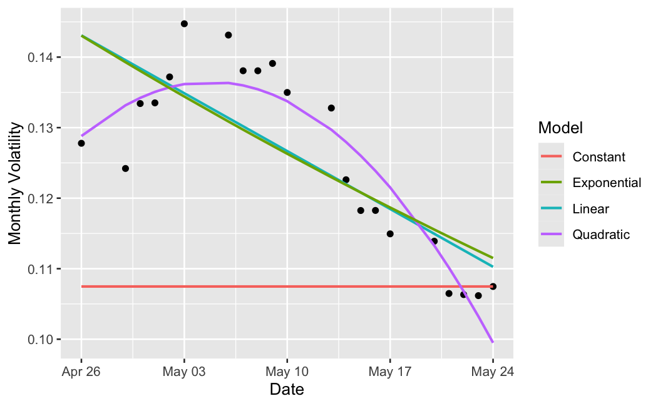

Figure A2
Call Price Model Fits – May 27, 2024
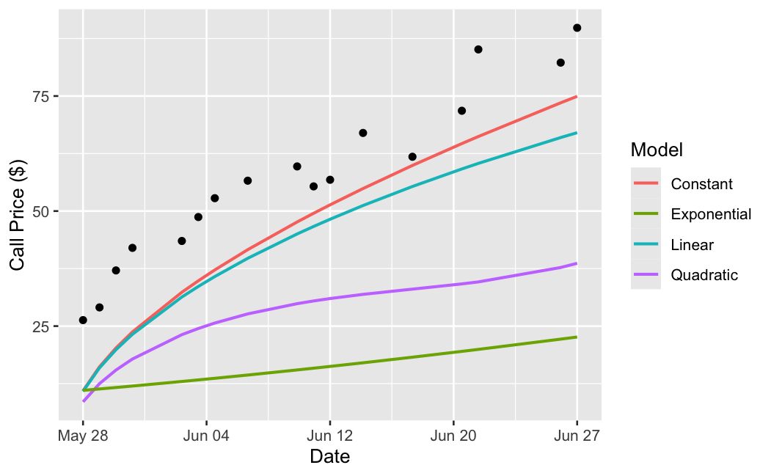

Figure B1
Volatility Model Fits – June 3, 2024
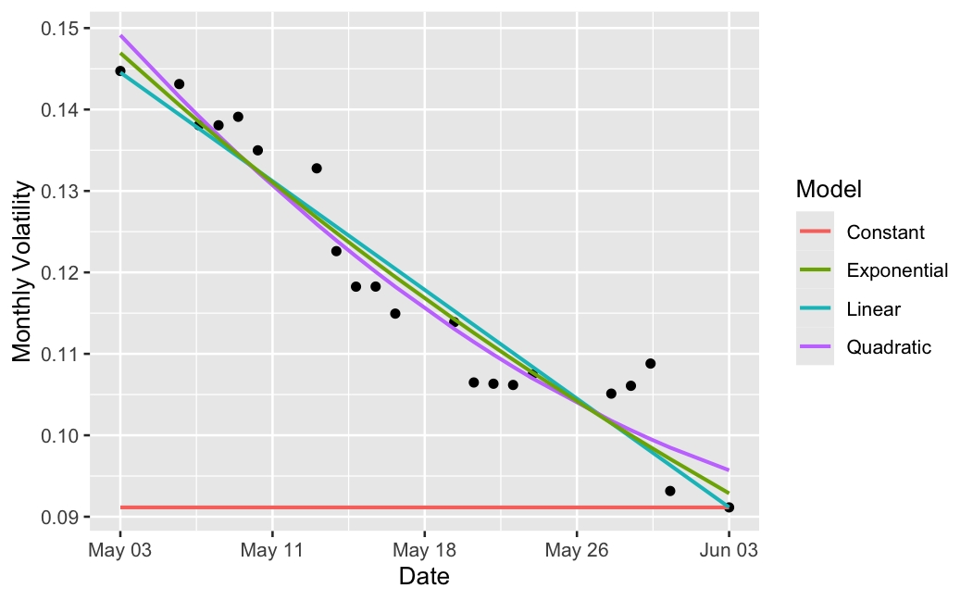

Figure B2
Call Price Model Fits – June 3, 2024
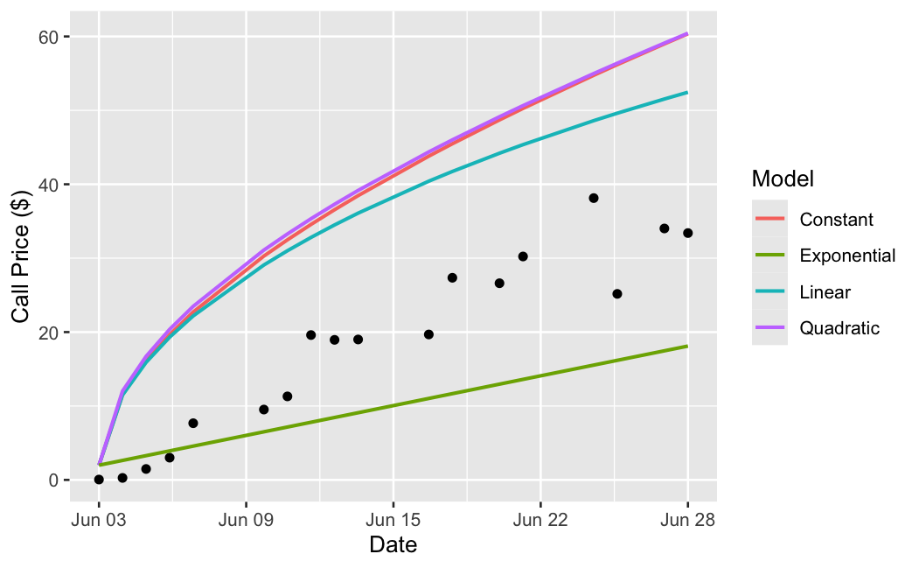
Figure C1
Volatility Model Fits – June 10, 2024
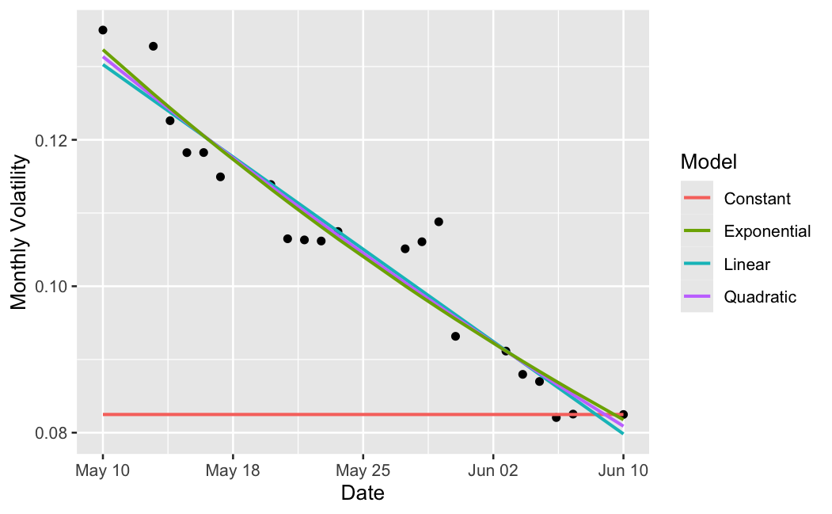

Figure C2
Call Price Model Fits – June 10, 2024
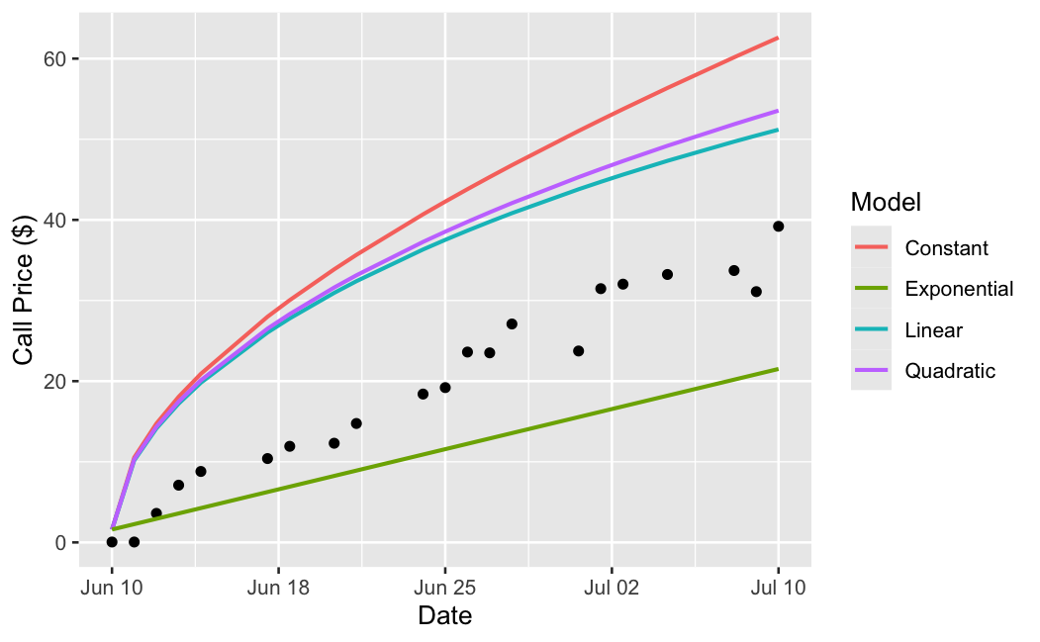

Figure D1
Volatility Model Fits – June 17, 2024
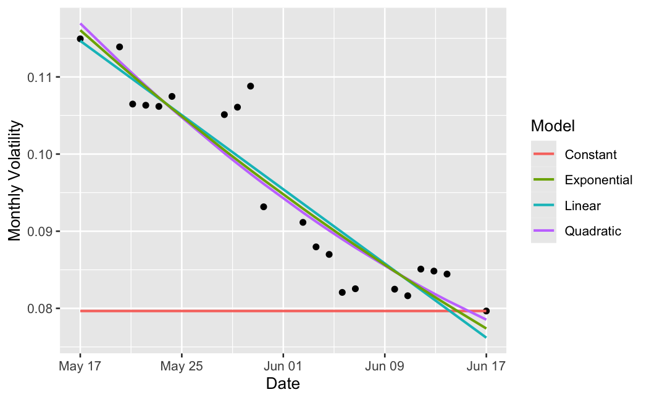

Figure D2
Call Price Model Fits – June 17, 2024
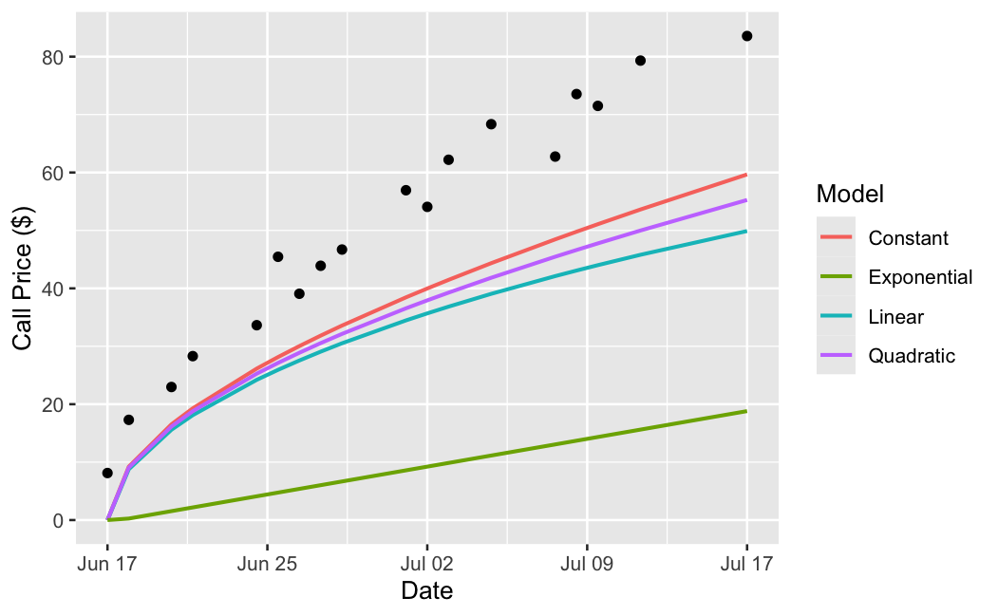
Figure E1
Volatility Model Fits – June 24, 2024
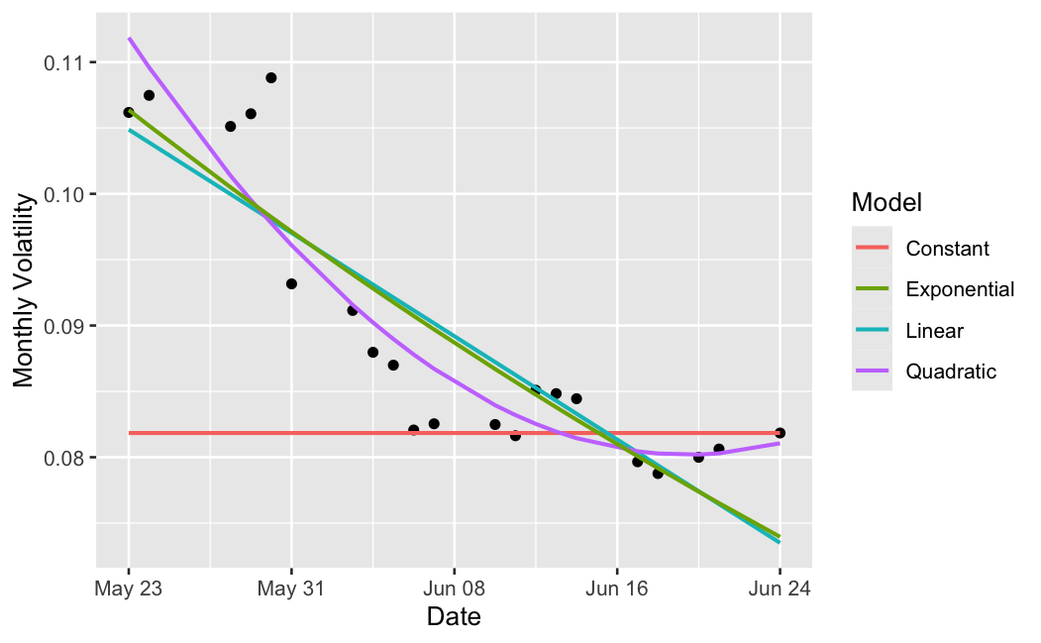

Figure E2
Call Price Model Fits – June 24, 2024
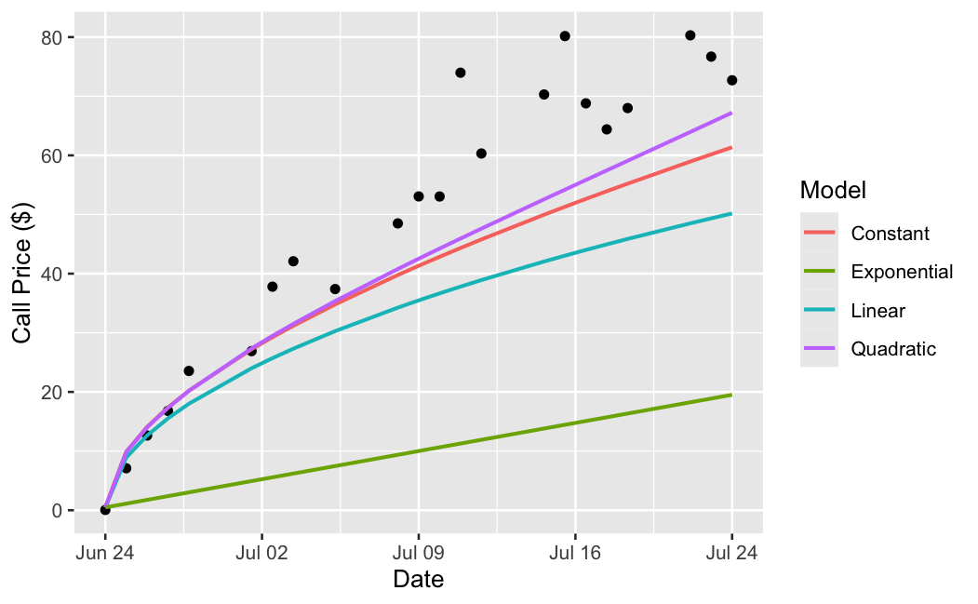
Figure F1
Volatility Model Fits – July 1, 2024
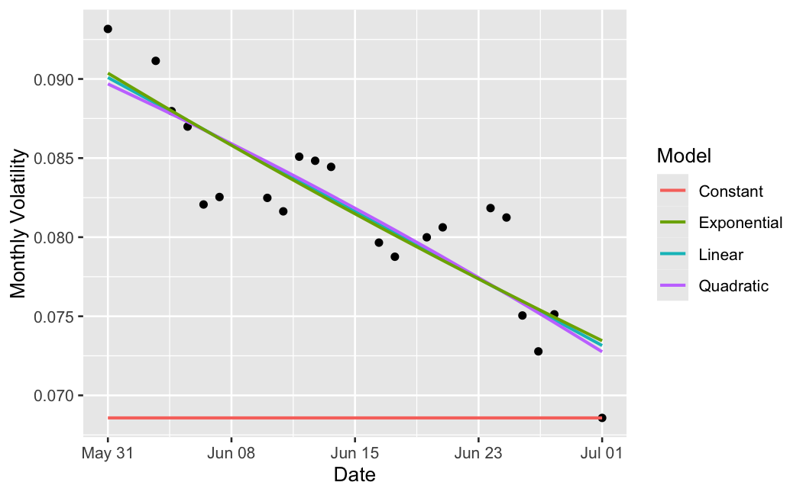

Figure F2
Call Price Model Fits – July 1, 2024
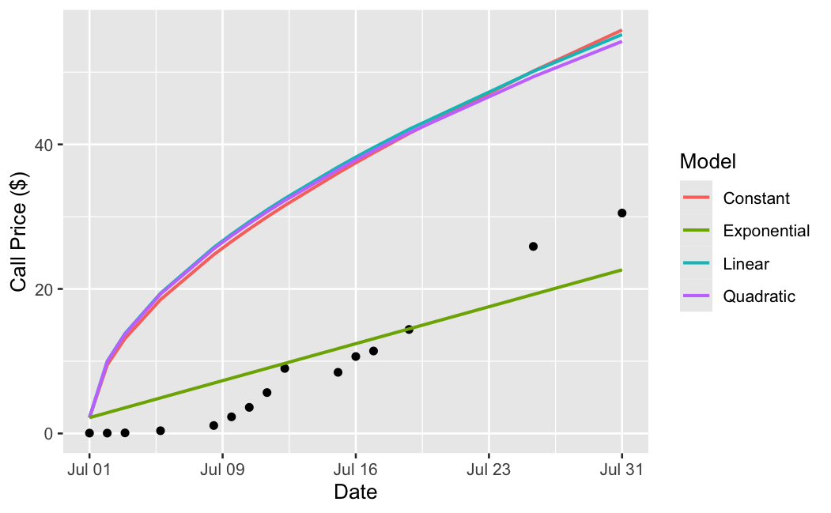
Figure G1
Volatility Model Fits – July 8, 2024
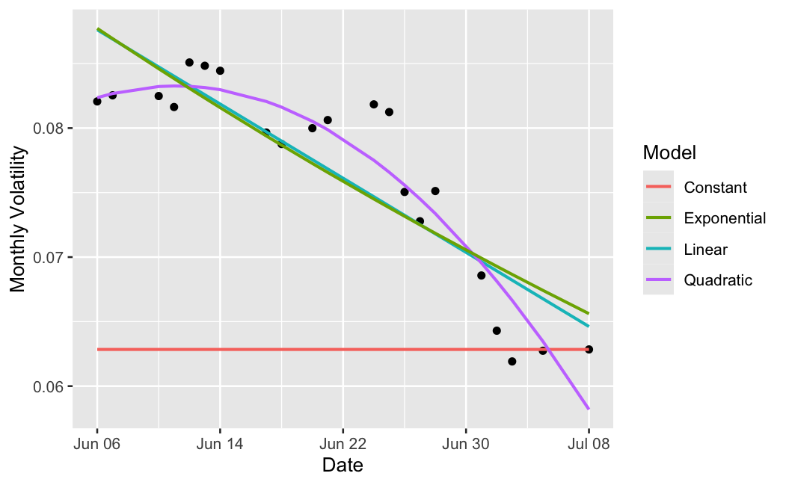

Figure G2
Call Price Model Fits – July 8, 2024
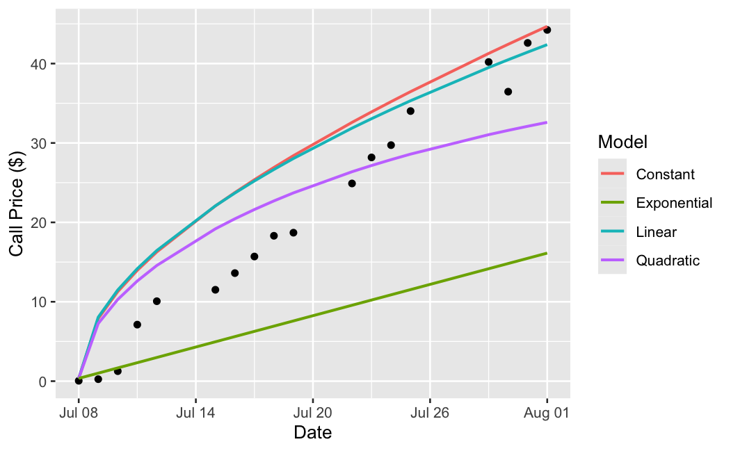
Figure H1
Volatility Model Fits – July 15, 2024
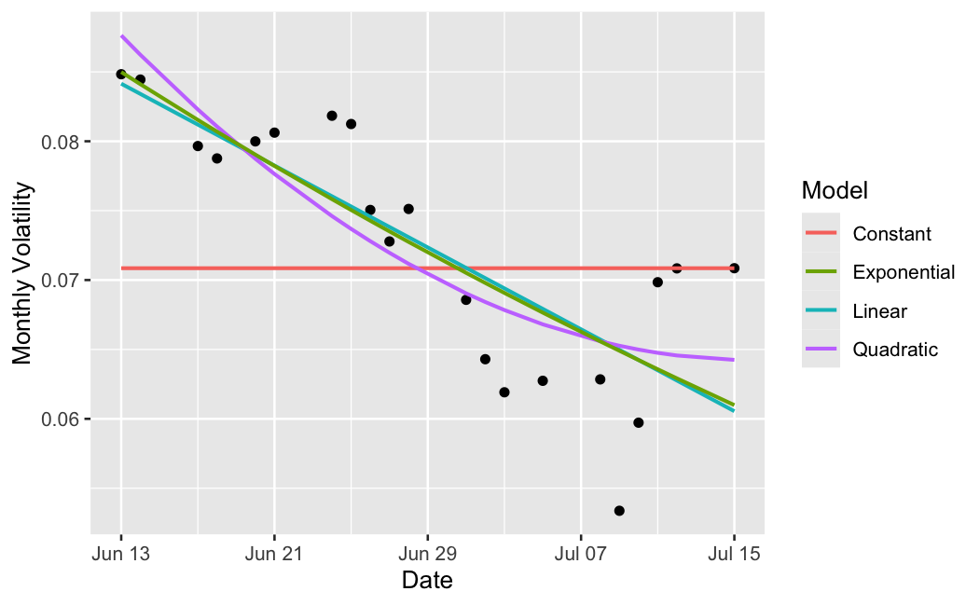

Figure H2
Call Price Model Fits – July 15, 2024
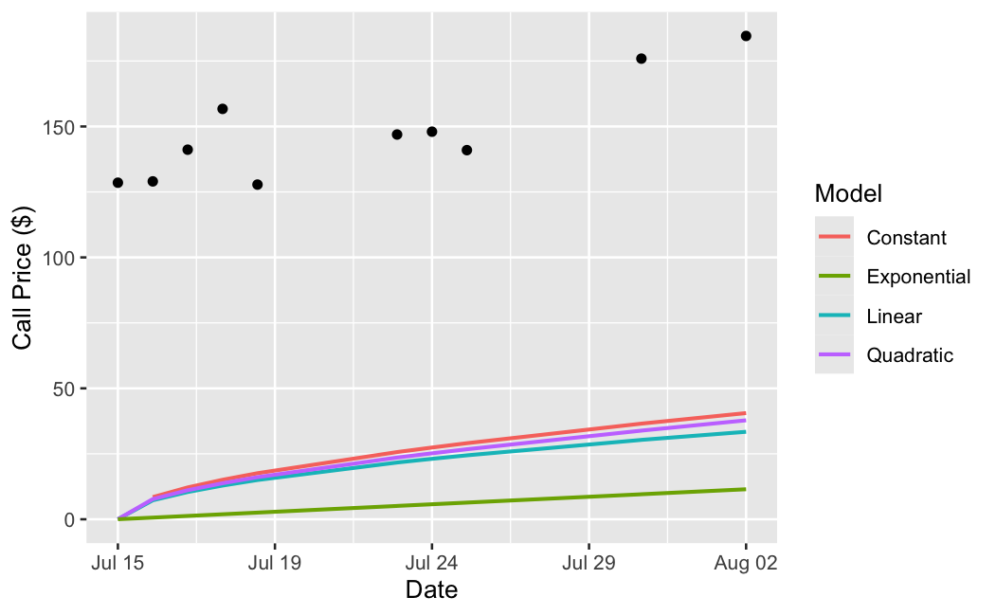
Figure I1
Volatility Model Fits – July 22, 2024
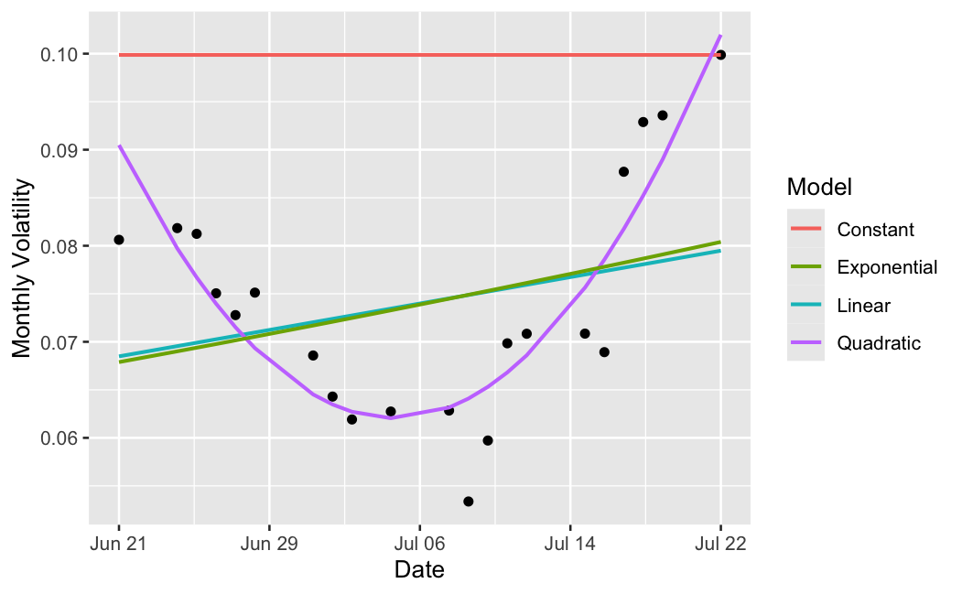

Figure I2
Call Price Model Fits – July 22, 2024
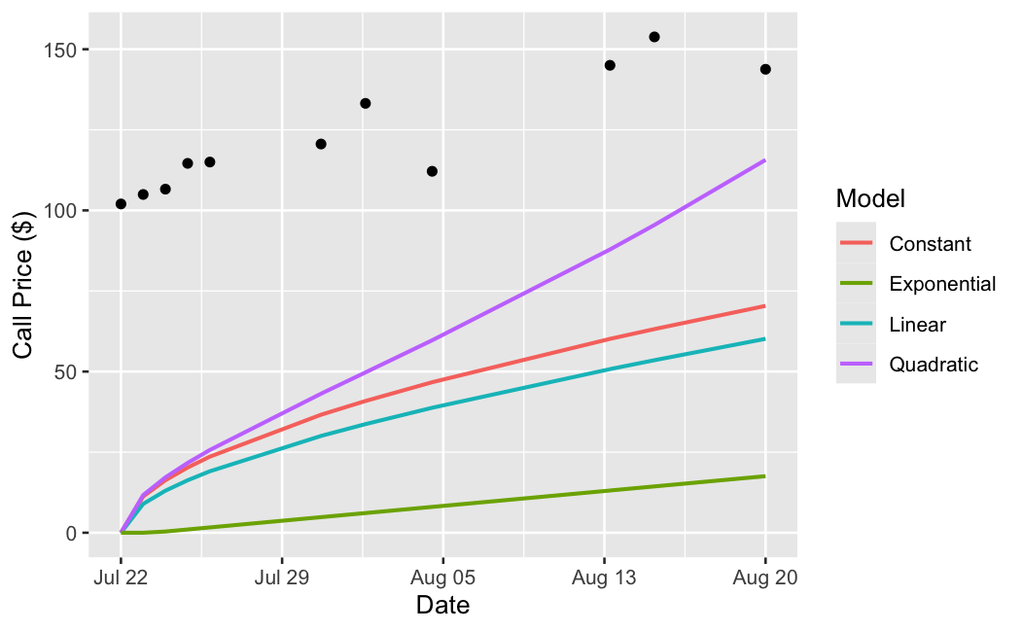
Figure J1
Volatility Model Fits – July 29, 2024
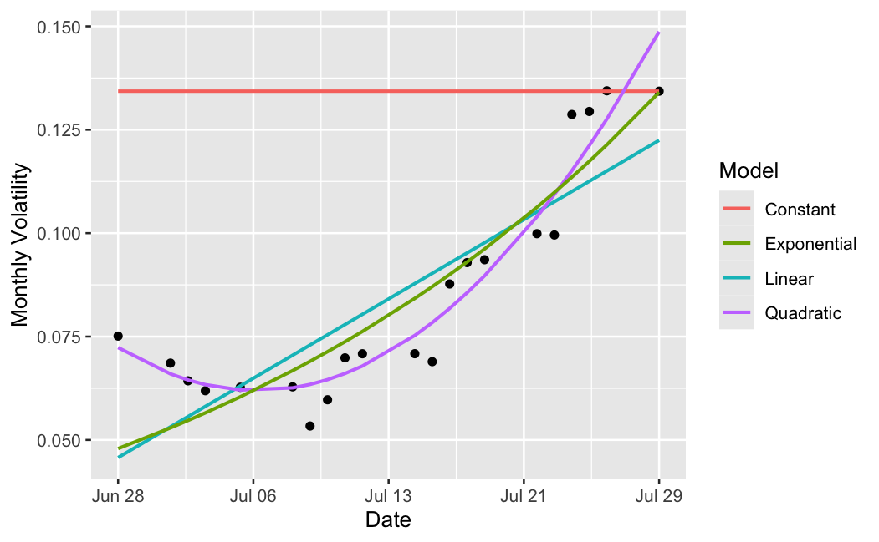

Figure J2
Call Price Model Fits – July 29, 2024
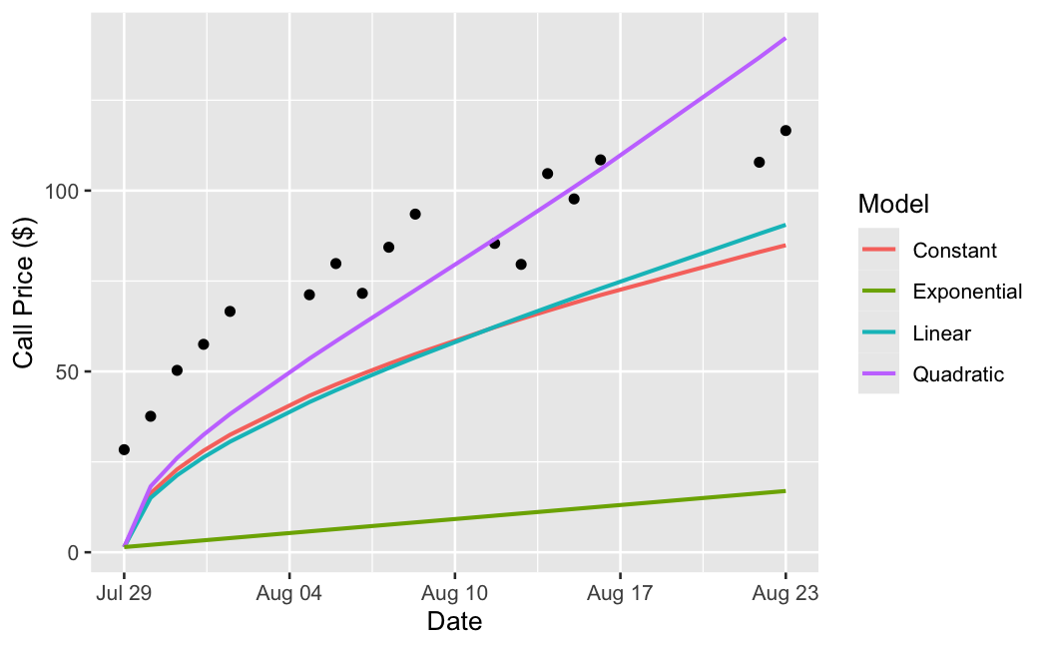

While there are a multitude of other option types such as binary and exotic options, they have more complex aspects which make them beyond the scope of this thesis.
It should be noted that the BSM and its extension accounts for options that can only be exercised on the expiration date. Therefore, this paper will only discuss European options.
It should be noted that Figure 2 and the data analyzed depicts rolling monthly volatility, while the longer-term trends seen in Figure 1 are calculated with rolling annual volatility.
Also presented as Figure 3.1 on page 20
Also presented as Figure 3.2 on page 21
Also presented as Figure 4.1 on page 21
Also presented as Figure 4.2 on page 22

