Jdbc Emitter Plug-in for BIRT
User Guide
V 1.0

Author: Sandhya R

Version History

Date | Version No | Comments
30-Apr-2013 | 1.0 | First version of JDBC Emitter Plugin for BIRT

Table of Contents

Overview: 4
How to deploy: 5
Render Options: 5
Sample Test Program 6
Major TODO List 6

Overview:

I do remember sometime back one of our customers was asking for BIRT functionality to store data in the DB rather than storing in any physical file, because it will simplify their data validation job. Unfortunately we had to say NO.
Later I realized the importance of that kind of functionality as it comes handy when we are working on a very complicated report where it’s difficult to put all logic together. It’s always better to divide the logic into reports, store the intermediate results in DB and query everything in the final. It’s simplifies our debugging efforts.
These things forced me to take up JDBC emitter implementation. Kindly notice the below mentioned key points.
- This JDBC emitter is quite flexible and configurable.
- It supports many relational data bases. All we have to do is, provide DB details in properties file. No code change or recompilation is required.
- This emitter respects your security as it uses internally Base64 algorithm to decrypt the passwords.
- We can use a standalone program (Base64 algorithm implementation) to get encrypted password by passing actual password as an argument.
- Enter Base64.bat ‘your password’ in command prompt.
- Make sure that Base64.class is added to your class path.
- Output will be encrypted password and put this password in properties file.
- This emitter is capable of creating the tables on the fly so that you can change table columns dynamically without worrying about table structure.
- Emitter supports multiple tables.
- Emitter takes data types of table columns from user so that there won’t be any ambiguity.
- If you want to append new data to already existing table, you can achieve this by setting ‘Append Data’ value to true in properties file.
- To address performance issue, JDBC emitter will do batch insertions.
- Emitter takes table name from designer.
- Designed and implemented in very simple manner so that everybody can understand easily and modify.

How to deploy:

Follow the below steps

- Download the Jdbc Emitter org.eclipse.birt.report.engine.emitter.jdbc_1.0.0.201305030152.jar
- Copy the jar to your plug-in folder.

Configuration:

- Make sure name field is not empty.
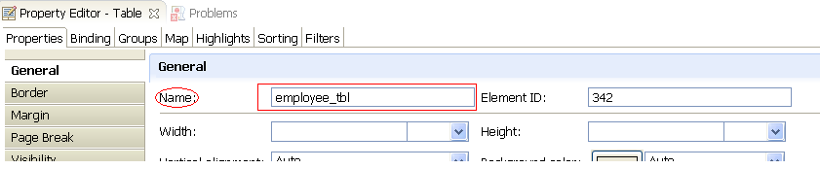

- Add properties file in resource section and make sure that properties file name is ‘DataBaseDetails.properties’ .
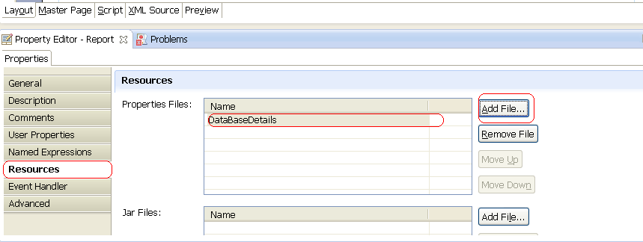

- Inside properties file define following properties.
jdbcDriver , connectionURL, UserName, Userpassword, AppendData, DataTypes
- Run Base64.bat ‘your password’ to get encrypted password and mention only encrypted password in properties file.
- While giving values for DataTypes property make sure that starting value is table name which you mentioned in the name property of table.
employee_tbl,INTEGER,VARCHAR2(200),REAL,VARCHAR2(200),VARCHAR2(40),REAL,VARCHAR2(40);
- Make sure that number of columns in table and number of datatypes in property file are same.
- Emitter supports multiple tables so that data types can be entered by using continuation mark ‘\’. For example

CUSTOMERS_TABLE,INTEGER,VARCHAR2(200),VARCHAR2(200),VARCHAR2(200),VARCHAR2(200),VARCHAR2(200),VARCHAR2(200),VARCHAR2(200),VARCHAR2(200),VARCHAR2(200),VARCHAR2(200),INTEGER,REAL;\
EMPLOYEE_TABLE,INTEGER,VARCHAR2(200),VARCHAR2(200),VARCHAR2(200),VARCHAR2(200),VARCHAR2(200),INTEGER,VARCHAR2(200);\

Sample Properties File

