Porting of the NRL’s Flux-Corrected Transport (FCT) Algorithm to an FPGA
Mabel Xu
Quince Orchard High School
June 2007 – August 2007
Center for Computational Sciences
Code 5593
Mentor: Dr. Robert Rosenberg
Table of Contents
Abstract 2
Introduction 2
Why FPGAs? 2
What are FPGAs? 2
Programming Languages for FPGAs 2
Handel-C and Mitrion-C 2
Handel-C vs. Mitrion-C 2
C-like languages vs. VHDL 2
Body 2
What is LCPFCT? 2
The Muzzle Flash Problem 2
Porting LCPFCT to the FPGA 2
LCPFCT performance 2
Process of porting LCPFCT to the FPGA 2
Using the FPGA 2
Conclusion 2
Acknowledgements 2
Appendices 2
How many different companies are there? Who did what? 2
Bibliography 2

Abstract

The NRL’s Flux-Corrected Transport (FCT) algorithm is one of NRL’s hallmark algorithms in Computational Fluid Dynamics (CFD) that has been used to solve contaminant transport problems, among other things. In this project, this algorithm is ported to Xilinx’s Virtex II Pro FPGA (Field Programmable Gate Array) located on a Cray XD1 supercomputer. In general, applications ported to the FPGA typically see a speed increase by a factor of 10 to 100 times.[9] The CFD problem we are currently working with comes from a standard test case developed by the NRL’s Laboratory for Computational Physics (LCP), the Muzzle Flash problem.[1]

Introduction

Why FPGAs?
In order to model more and more complex problems, computer scientists have an interest in possible speed increases, whether through optimization of the software or performance boosts in hardware. One of the main methods to increase performance hardware-side is to increase the speed at which CPUs can perform calculations. However, higher clock rates lead to more stress on the hardware.[1] Heat dissipation problems caused by super fast CPUs have caused computer scientists to turn towards other solutions to improve performance, such as application accelerators including GPUs, cell processors, multi-core processors, and FPGAs.

What are FPGAs?
FPGAs, or Field Programmable Gate Arrays, are computer chips that contain programmable logic components, or logic blocks, and programmable interconnects. Logic blocks can be programmed to perform the function of basic logic gates or more complex combinatorial functions such as decoders or simple mathematical functions.[1] Using programs written in VHDL, FPGAs can be reconfigured to suit the particular computational needs of any algorithm. By implementing all instructions as hardware, there is a significant speed increase.[9][12][18] In addition, FPGAs are designed to run instructions in parallel. Therefore, a series of assignments that might have taken 10 clock cycles on a regular processor can be accomplished in only one somewhat slower clock cycle. Originally, FPGAs were small and only able to hold very small and simple programs, but with recent advances in size and complexity, FPGAs are gaining in popularity as an alternate solution to the quest for faster processing.[1][9][12] In addition, easier ways to program for FPGAs have dramatically reduced development time for programs run on the FPGA.

Programming Languages for FPGAs
There are several languages available for programming FPGAs, including one of FPGAs’ native languages, VHDL (VHSIC Hardware Description Language). Here is a simple example a Fibonacci series generator in VHDL:

--------------------------------------------------------------------------------
-- Company:
-- Engineer:
--
-- Create Date: 08:12:08 02/13/07
-- Design Name:
-- Module Name: top - Behavioral
-- Project Name:
-- Target Device:
-- Tool versions:
-- Description:
--
-- Dependencies:
--
-- Revision:
-- Revision 0.01 - File Created
-- Additional Comments:
--
--------------------------------------------------------------------------------
library IEEE;
use IEEE.STD_LOGIC_1164.ALL;
use IEEE.STD_LOGIC_ARITH.ALL;
use IEEE.STD_LOGIC_UNSIGNED.ALL;

---- Uncomment the following library declaration if instantiating
---- any Xilinx primitives in this code.
--library UNISIM;
--use UNISIM.VComponents.all;

entity top is
Port ( fclk : in std_logic;
rst_btn : in std_logic;
anode : out std_logic_vector(3 downto 0);
cathode : out std_logic_vector(7 downto 0));
end top;

architecture Behavioral of top is

COMPONENT fib
PORT(
clk : IN std_logic;
rst : IN std_logic;
digits : OUT std_logic_vector(15 downto 0)
);
END COMPONENT;

COMPONENT seven_seg
PORT(
digit : IN std_logic_vector(3 downto 0);
cathode : OUT std_logic_vector(6 downto 0)
);
END COMPONENT;

signal clk, sclk, disp_clk, rst, rst_deb : std_logic;

signal digit, anode_int : std_logic_vector(3 downto 0);
signal digits : std_logic_vector(15 downto 0);

begin

-- instantiate Fib Generator

Inst_fib: fib PORT MAP(
clk => clk,
rst => rst,
digits => digits
);

-- instantiate 7-seg display decoder

Inst_seven_seg: seven_seg PORT MAP(
digit => digit,
cathode => cathode(6 downto 0)
);

clk <= sclk; rst <= rst_deb;

cathode(7) <= '1'; -- DP off

anode <= anode_int;

-- select digit to display

with anode_int select
digit <= digits(15 downto 12) when "1000", -- left-most digit
digits(11 downto 8) when "0100",
digits(7 downto 4) when "0010",
digits(3 downto 0) when others;

process (disp_clk)
variable anode_vector: std_logic_vector(1 to 4);
begin
if rising_edge(disp_clk) then
if (rst = '1') then anode_vector := "1000";
else anode_vector := anode_vector(4) & anode_vector(1 to 3);
end if; -- if rst
anode_int <= anode_vector;
end if; -- if rising_edge
end process;

-- debounce rst_btn

process(sclk)
variable rst_reg : std_logic_vector(3 downto 0);
begin
if rising_edge(sclk) then
if (rst_reg="1110") then rst_deb <= '1'; else rst_deb <= '0'; end if;
rst_reg := rst_btn & rst_reg(3 downto 1);
end if; -- if rising_edge(sclk)
end process;

-- divide down fclk by 2^24 to product slow clock (sclk)
-- If fclk=50 MHz then sclk=3 Hz

process (fclk)
variable sreg : std_logic_vector(1 to 23); -- 23-bit LFSR
begin
if rising_edge(fclk) then
if (conv_integer(sreg) = 0) then
sclk <= not sclk; -- toggle
end if; -- equals zero
sreg := (sreg(18) xnor sreg(23)) & sreg(1 to 22);
end if; -- rising_edge
end process;

-- divide down fclk by 2^10 to product display clock (disp_clk)
-- If fclk=50 MHz then disp_clk=49 kHz

process (fclk)
variable sreg : std_logic_vector(1 to 9); -- 9-bit LFSR
begin
if rising_edge(fclk) then
if (conv_integer(sreg) = 0) then
disp_clk <= not disp_clk; -- toggle
end if; -- equals zero
sreg := (sreg(5) xnor sreg(9)) & sreg(1 to 8);
end if; -- rising_edge
end process;

end Behavioral;

Source: Digital Systems Engineering class online materials[10]

As shown in this example, even a simple program takes many lines of code, since all hardware is explicitly defined. As a result, software programmers now need a high awareness of the underlying hardware behind how the programs work: AND gates, Flip-Flops, etc.[1] In order to simplify the reconfiguration of FPGAs, several other higher-level languages were developed, including Celoxica’s Handel-C and Mitrionic’s Mitrion-C. Both of these languages are based on C, and have significant similarities with C. As a result, the learning curve was lowered into a more acceptable range.

Handel-C and Mitrion-C
Both Handel-C and Mitrion-C have special commands and structures to deal with writing code in parallel. Handel-C takes the “similar to C” approach, by adding a simple par {} structure to let the programmer define explicit parallelism.[8] Mitrion-C, although similar to both Handel-C and C, deals with parallelism in a different manner. All commands in Mitrion-C are inherently parallel, and errors result if the programmer is not careful to ensure that statements do not have undesired side effects.[15]

An example of Handel-C code:
#include <cray_xd1.hch>

#define CLOCK_RATE 185000000

#define MEG (1024 * 1024)

#define TOP ( 128 * MEG )
#define ADDONE_TOP ( TOP - 1 )
#define ADDONE_BASE ( 0 * MEG )

#ifdef SIMULATE
set clock = external;
#else
interface port_in (unsigned 1 user_clk) user_clk_if ();
interface port_in (unsigned 1 reset_n) reset_n_if ();
set clock = internal user_clk_if.user_clk with { rate = (CLOCK_RATE / 1000000) };
set reset = internal !reset_n_if.reset_n;
#endif

unsigned 64 addoneregister;

macro proc AddOneWrite(addr, data, byteMask ) {
addoneregister = data + 1;
}

macro proc AddOneRead(addr, data ) {
data = addoneregister;
}

void main() {
par {
RunRTIf();
RunRTClient(ADDONE_BASE, ADDONE_TOP, AddOneRead, AddOneWrite);
}
}

An example of Mitrion-C code:
Mitrion-C 1.2;

int:16<100> mul_list(int:16<100> x, int:16<100> y)
{
product = foreach(e, f in x, y) e * f;
} product;

int:16<100> main(int:16<100>a, int:16<100> b)
{
result = mul_list(a, b);
} result;

Mitrion-C is a much stricter language than Handel-C, since it is designed more with compatibility to FPGAs in mind and less with ease of porting from C in mind. However, the extra rules and distinct look of Mitrion-C actually helps the programmer stay in the correct mindset for working with FPGAs. It ensures that programmers are constantly aware of the fact that they are programming on a parallel computer, and thus rework the program’s structure and flow to take full advantage of the benefits available on an FPGA (instead of simply programming like on a regular computer).

Handel-C vs. Mitrion-C
In the course of this project, working with Handel-C has been, at the very least, aggravating. Celoxica is still struggling to provide support for the Linux version of their Integrated Development Environment (IDE).[6] Mitrion-C, on the other hand, was a joy to work with. Despite its odd appearance and dissimilarity to C at first glance, the Mitrion-C IDE actually worked like it was supposed to, and self-written examples were easy to fix and get running.[14][17][18] In addition, the user manuals for Mitrion-C were much clearer on how FPGAs are normally programmed. For people who have never worked with FPGAs before, such sweeping generalities helps the user get a handle on the language much more quickly. Instead of saying “the memory can be placed anywhere on the FPGA” like the Handel-C manual does[6][7], the Mitrion-C manual gives a simple, yet easy to understand table that beginners can follow as a general guideline until they are proficient with FPGAs and contain enough of an understanding of the hardware to make their own changes:

Hardware details
The mitrion generated hardware present a memory of a few control registers and the four QDR SRAMS.[17]

Memory Offset | Size | Function
0x0 |  | Memory mapped control registers
0x4000000 | 0x800000 | QDR SRAM 0
0x4800000 | 0x800000 | QDR SRAM 1
0x5000000 | 0x800000 | QDR SRAM 2
0x5800000 | 0x800000 | QDR SRAM 3

In spite of Mitrion-C being the language less similar to C, it is easier to use because of the care and thought that the people who write manuals at Mitrionic have put into their user manuals.

C-like languages vs. VHDL
After the programmer has written the desired program in either Handel-C or Mitrion C, a Xilinx tool called xst can be used to generate appropriate VHDL hardware instructions targeted at the particular FPGA board being used. Compiling with Handel-C or Mitrion-C, and then synthesizing the VHDL as needed has several advantages. First, code takes much less time to develop, since using a higher-level language makes everything more intuitive to the programmer.[18] The user also does not have to modify any code in order to target a different or newer hardware, whereas user-written VHDL would require a complete rewrite, often a month-long effort.[1] Unfortunately, synthesizing the VHDL file often takes a long time, especially for more complicated problems, and the resulting synthesized code is not as efficient as user-written VHDL. However, the conveniences and advantages that come with synthesizing a VHDL file using C-like source code weighs more heavily than the advantages of using directly written VHDL.

Body

What is LCPFCT?
LCPFCT is a public domain FORTRAN implementation of the Flux-Corrected Transport Algorithm for solving generalized continuity equations. According to the original report on LCPFCT, “Flux-Corrected Transport has proven to be an accurate and easy to use algorithm to solve nonlinear, time-dependent continuity equations of the type which occur in fluid dynamics, reactive, multiphase, and elastic plastic flows, plasma dynamics, and magneto hydrodynamics.”[2] LCPFCT is used in combination with calls to a number of helper subroutines for defining the computational grid, the velocity dependent factors, the various givens in the equation being solved, and the boundary conditions. LCPFCT implements an explicit solution of the general one-dimensional continuity equation:

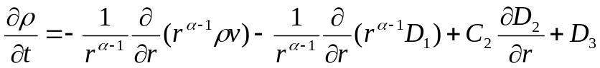

where ρ is density, t is time, r is interface position, v is velocity, α is a numerical value representing the coordinate system to use, D₁, D₂, D₃, and C₂ are additional source terms that can be included.[2]

The FORTRAN LCPFCT was designed to include support for a spatially variable and moving grid, additional source terms, and different one-dimensional geometries (by selecting different input integers for α, where α = 1 selects a Cartesian or planar geometry, α = 2 selects a cylindrical geometry, α = 3 selects a spherical geometry, and α = 4 enables the user to makeup their own coordinate system using problem specific code to define cell interface areas and volumes).[2]

The Muzzle Flash Problem
The Muzzle Flash problem used in this project demonstrates how time step splitting is used to solve ideal two-dimensional equations of gas dynamics with the FCT algorithm.[16] It describes these initial conditions:

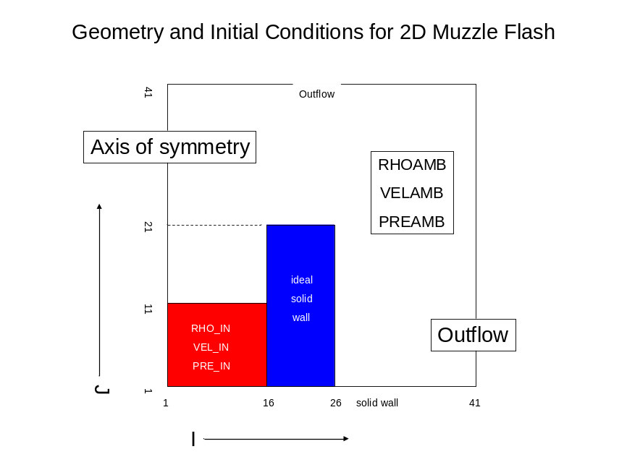
In this setup, there is a high-density wall (in blue), forming one of the boundaries for the compressed gas (in red). RHO_IN is initial density, VEL_IN is initial velocity, and PRE_IN is initial pressure of the gas. RHOAMB, VELAMB, and PREAMB are ambient density, velocity, and pressure respectively. The horizontal axis uses the variable I while the vertical axis uses J. The bottom boundary is a solid wall, the left boundary is a reflective boundary (to simulate half of a symmetrical muzzle flash, and the top and right boundaries are outflows where particles can freely move outwards.[2]

This problem uses variable time steps. The time step Δt is limited by requiring

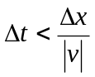

where |v| is the largest characteristic velocity in the system and Δx is the computational cell size. [11][16] Here are some pictures of the simulation being run.

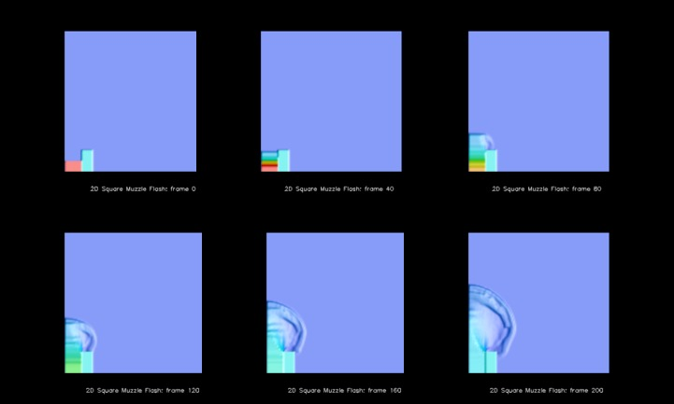

From left to right, the simulation stages pictured here are the 2D Square Muzzle Flash at frames 0, 40, 60, 120, 160, and 200. It simulates a gas being released from behind a diaphragm affixed inside a muzzle. The problem is greatly simplified using cylindrical coordinates, thus reducing the three-dimensional problem into two-dimensions.

Porting LCPFCT to the FPGA

LCPFCT performance
The LCPFCT algorithm was originally written in FORTRAN 77.[2] In order to facilitate the ease of porting to either Handel-C or Mitrion-C, the code was first ported to C. Since the original program used several FORTRAN built-in functions, replacements had to be written, and as a result, the performance of the algorithm decreased slightly. However, the change was not significant (from 59.9% to 67.1% of the computational time), and the slight loss in speed could easily be regained after porting to the FPGA.

FORTRAN profiling results:
% time | name | # of calls
59.9 | lcpfct_ | 459264
16.3 | velocity_ | 114816
9.88 | gasdyn_ | 57408
8.79 | MAIN__ | 1
5.12 | sources_ | 229632
0.01 | zeroflux_ | 123032
0 | makegrid_ | 52
0 | fctblk_init__ | 26
0 | zerodiff_ | 106600
0 | residiff_ | 26

C profiling results:
% time | name | # of calls
48.2 | lcpfct_ | 459264
12.9 | velocity_ | 114816
8.7 | gasdyn_ | 57408
7.1 | MAIN__ | 1
6.5 | sign | 4.33E+08
5.3 | amin1 | 4.33E+08
4.6 | float_abs | 8.66E+08
3.8 | sources_ | 229632
2.5 | amax1 | 4.33E+08
0 | makegrid | 52
0 | zeroflux | 123032
0 | fctblk_init_ | 26
0 | zerodiff_ | 106600
0 | residiff_ | 26

Note: the C subroutines sign, amin1, float_abs, and amax1 are methods within lcpfct.c created to mimic the functions of the appropriate implicit functions.

Process of porting LCPFCT to the FPGA
Unfortunately, there were some challenges with the porting of the LCPFCT algorithm to the FPGA, chief of which was the management of memory. Since the FPGA does not have enough hardware to support the entire Muzzle Flash problem, only the most time intensive portion of the code should be ported, which, as the code timing profile shows, is obviously the LCPFCT algorithm portion. However, it is difficult to have memory from the main problem act in sync with memory for the LCPFCT algorithm, since many of the computational values were stored in memory constructs that are shared and can be easily accessible to both LCPFCT and the problem itself. On the FPGA, memory has to be especially prepared with the data necessary to run the program.[1][5][6][7][13][14][17][19]

The Cray API
The Cray API was developed by Cray for the XD1 FPGA, and handles the “prepping” of the memory before the Handel-C or Mitrion-C portion of the code is called. Unfortunately, the Cray API is the most difficult portion of the entire project, due to a lack of relevant examples.[3][4][5][19] It also sets up a specific hierarchy of files that can be used to generate binary files than can run on the FPGA.[19] The Cray supercomputer is made up of many parts, as can be seen from the figure below:

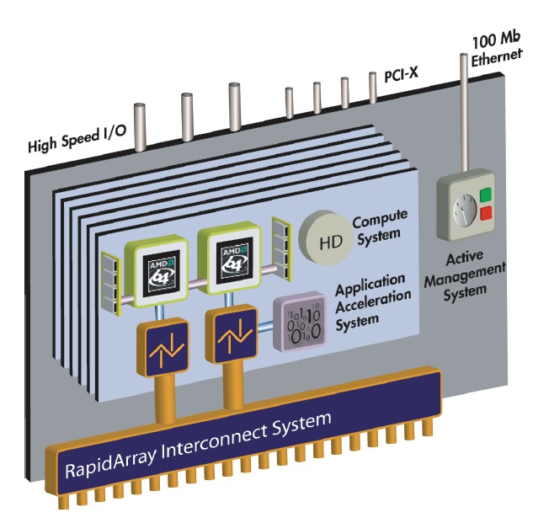

A schematic representation of a Cray XD1 node[3]

The Cray XD1 blade setup consists of several parts: two 64-bit AMD Opteron processors, 2 GB of DDR SDRAM per compute processor providing a maximum of 8 GB of DDR SDRAM per SMP, a RapidArray processor (which provides two 2-GBps RapidArray links to the switch fabric), and a connector for an expansion module through the HyperTransport Interconnect. It is on the expansion module that the FPGA resides. Through the RapidArray Interconnect System, the FPGA can communicate with the Opteron processors and access memory attached to the regular processors.[3]

In order for the C portion of the code to prepare the memory for use by the FPGA, the memory has to be mapped and accessed correctly, then stored with the correct information.[5]

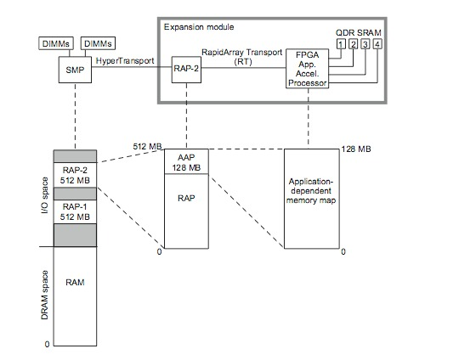

Physical components of a node and related address spaces[19]

On the software side, the structure of the VHDL files to access the FPGA goes like this:

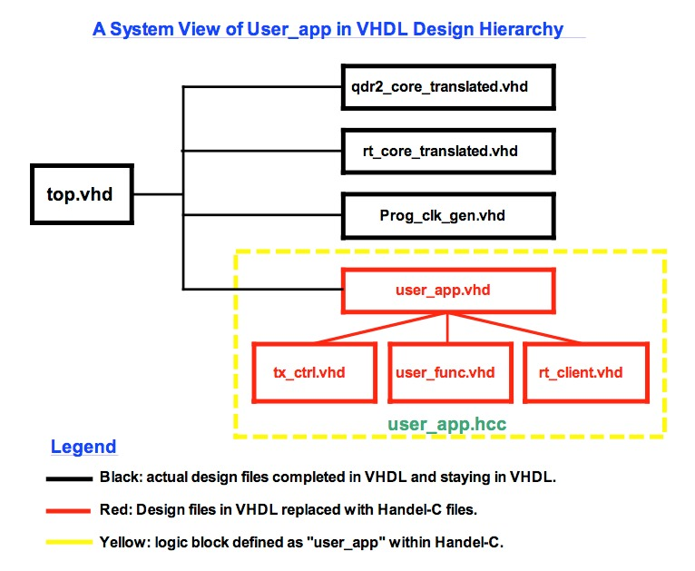

System View of user_app Logic Block[7]

Note: Mitrion-C hooks into the Cray API file structure in a similar manner.

Handel-C and Mitrion-C work by hooking into the user_app portion of the structure; the synthesized VHDL file replaces the entire user_app branch of the file structure. Here is an example of some Mitrion-C code that actually works.[17]

C portion of the code:
#include <einlib.h>

int main()
{
u_64 val;
err_e e;

int fp_id = fpga_open("/dev/ufp0", O_RDWR|O_SYNC, &e);
if (e != NOERR error();
num_bytes = fpga_load(fp_id, "top.bin.ufp", &e);
if (e != NOERR) error();

fpga_reset(fp_id, &e);
fpga_start(fp_id, &e);
reg_write(fp_id, 0x01, 0x00000000000000001ULL);
reg_write(fp_id, 0x02, 0x00000000000000001ULL);
reg_write(fp_id, 0x01, 0x00000000000000001ULL);

val = reg_read(fp_id, 0x02);
while((val & 1) == 0)
{
sleep(1);
val = reg_read(fp_id, 0x02);
}

reg_write(fp_id, 0x01, 0x00000000000000001ULL);
}

Mitrion-C portion of the code:
Mitrion-C 1.2;
// Options: -cpp

#define ExtRAM mem uint:64[0x100000]

(ExtRAM, ExtRAM, ExtRAM, ExtRAM, uint:64) main(ExtRAM Am0, ExtRAM Bm0, ExtRAM Cm0, ExtRAM Dm0, uint:64 inReg0)
{
(AmDone, BmDone, CmDone, DmDone) = foreach(i in <0 .. 0xfffff>)
{
(a, Am1) = _memread(Am0, i);
(b, Bm1) = _memread(Bm0, i);
(c, Cm1) = _memread(Cm0, i);

d = a & b | c;

Dm1 = _memwrite(Dm0, i, d);
} (Am1, Bm1, Cm1, Dm1);

outReg = 3 * inReg0;

AmFinished = _wait(AmDone);
BmFinished = _wait(BmDone);
CmFinished = _wait(CmDone);
DmFinished = _wait(DmDone);
} (AmFinished, BmFinished, CmFinished, DmFinished, outReg);

Using the FPGA
The top.bin file is used to configure the FPGA. After creating the Handel-C or Mitrion-C code, the source code is compiled using compilers provided by Celoxica or Mitrionic respectively to synthesize the user_app.vhd file as well as the ufphdr header file.[4][6][7][14] These two files are then run through Xilinx’s xst file, which generates a top.bin. In the process, all the information necessary to reconfigure the FPGA is written into the top.bin file, including anything that a specific piece of hardware needs. Finally, the top.bin file is run through Cray’s fcu tool that loads the generated configuration onto the FPGA. The results from the entire program, when run in batch mode, are stored in a text file that the user specifies in the submitted job file.

Conclusion

There were several objectives in this project. First, the LCPFCT algorithm had to be ported from Fortran 77 to C. Next, the code was to be ported to the FPGA using Handel-C. Eventually, the code was supposed to be ported to the FPGA using Mitrion-C, so that the performance between Handel-C and Mitrion-C could be compared. So far, however, Mitrion-C has proved to be much easier to work with than Handel-C. In addition, the underlying structure of Mitrion-C vs. Handel-C (inherently parallel vs. explicitly parallel) suggests that although it may be more difficult to write the code in Mitrion-C than in Handel-C (less similarity to C), the resulting algorithm will end up faster, cleaner, and/or more efficient than code written in Handel-C.

Although the algorithm was not ported in the time allotted during the summer, future work on porting the LCPFCT algorithm to the FPGA was eased by the work completed: the algorithm was translated from FORTRAN 77 to C, a language more similar to Handel-C and Mitrion-C, and template / example code was written for the FPGA that should facilitate the porting of the LCPFCT algorithm to the FPGA.

Acknowledgements

Dr. Robert Rosenberg, Mentor
Marco Lanzagorta, Computational Scientist
Raymond Yee, Cray Systems Administrator

and many other people who wrote about FORTRAN, FPGAs, Handel-C, Mitrion-C, and on the topic of Computational Fluid Dynamics.

Appendices

How many different companies are there? Who did what?
On the hardware side, Cray created the XD1 supercomputer using commercial parts. For example, the FPGA board came from Xilinx, the Opteron processor came from AMD, etc. Cray, using a special super-fast interface (the RapidTransport Interconnect interface), connected all the components together so that many XD1s can be used at the same time and also so that the FPGA could work together with the Opteron. Xilinx, the company that made the FPGA boards, created a tool called xst that takes VHDL files and creates binaries that can be loaded onto the FPGA to reconfigure it for whatever program the user wishes to run. Cray, on the other hand, wrote the Cray API that enables users to manage and work with the XD1 through commands that can be run on the C program that the user runs on the Opteron processors.

On the software side, Celoxica created the Handel-C language. When designing the language, Celoxica used the Cray API to make sure that the synthesized VHDL file can hook into the existing Cray file structure. Mitrionic created the Mitrion-C language, which also hooks into the existing Cray file structure through a synthesized VHDL file. As a result, the user can choose to use either Handel-C or Mitrion-C, whichever is the easier.

Bibliography

- Barr, Michael. “How Programmable Logic Works”. Accessed July 14, 2007. <http://www.netrino.com/Articles/ProgrammableLogic/index.php>

- Boris, Jay, Landsberg, Alexandra, Oran, Elaine, and Gardner, John. 1993. LCPFCT – A Flux-Corrected Transport Algorithm for Solving Generalized Continuity Equations. NRL Report, NRL/MR/6410-93-7192.

- Cray XD1 Architecture. Cray Private, S-6400-131.

- Cray XD1 FPGA Development. Cray Private, S-6400-131.

- Cray XD1 Programming. Cray Private, S-2433-131.

- Celoxica DK4.0 SP1 Beta for Cray XD1 FPGA on Linux. Celoxica Confidential, Revision 1.0, 2006.

- Celoxica DK4.0 SP1 for Cray XD1 FPGA. Celoxica and Cray Canada Confidential, Revision 1.4, 2006.

- Celoxica DK4.0 Handel-C Language Reference Manual. For DK 4.0. Celoxica RM-1003-4.2.

- Dellson, Anders, Sandberg, Göran, and Möhl, Stefan. Turning FPGAs into Supercomputers, Debunking the Myths About FPGA-based Software Acceleration. 2006.

- Frenzel, James F. “Fibonacci Sequence Generator”. <http://www.mrc.uidaho.edu/mrc/people/jff/440/projects/fib/top.vhd>

- Griebel, Michael, Dornseifer, Thomas, and Neunhoeffer, Tilman. Numberical Simulation in Fluid Dynamics, A Practical Introduction. Society for Industrial and Applied Mathematicds (SIAM), Philadelphia, 1997.

- The Key to FPGA Supercomputing. George Washington University Mitrion-C Training, 2006.

- Mitrion-C and SDK Quick Reference. Mitrion, revision 1.0.

- The Mitrion Software Development Kit. Mitrion, 1.0.1-001.

- Möhl, Stefan. The Mitrion-C Programming Language. Mitrion, 1.0.1-001.

- Oran, Elaine and Boris, Jay. Numerical Simulation of Reactive Flow. 2001, 2nd Edition, Cambridge University Press.

- Running the Mitrion Virtual Processor on Cray XD1. Mitrionics, version 1.0.3.

- A True Software Approach to FPGA Programming, Deploying the Mitrion Virtual Processor. Mitrion White Paper, 2005.

- Using the FPGA Application Acceleration Processor. Cray Private, S-2433-131.

