Watercooler Content Distribution Engine

Design and Planning Document
04/27/10, Version 1.0

Document Revision History
Rev. 1.0 2010-04-27 – initial version

System Architecture
The Watercooler Content Distribution Engine contains three major design components: the user interface (website), the repository (database), and the backend (hereby referred to as the delivery path.) At this high level, the Watercooler takes on a repository architecture, where both the user interface and the backend interface with the central database. Though the overall system is built around the central database, each component has its own internal architecture.
The website is implemented as a model view controller. The webserver receives user input from forms on the website and updates the database as necessary. The webserver also generates dynamic webpages based on information gathered from the database and displays them to the user in an eye-pleasing and web-readable format.
The database is more straightforward, as it is not a subsystem but rather a single, large component of the overall design. The internals of our database are deliberately abstracted by mySQL, and as such, they do not bear mentioning in this report.
The backend is made up of several modular components that are connected in a layered topography via a system driver. The system driver essentially serves as an interface between each of the components in the backend of the system. Specifically, the feed retriever interfaces with the user scanner, which interfaces with the alert formatter, which interfaces with the email server (all via the system driver. ) Each module in the chain can access the database but cannot directly access any other layer in the backend.
We considered alternate architectures for the website and the backend of the system: The website could also be implemented as a repository (i.e. the webserver does not distinguish between analysis on information from the database and displaying webpages to the user.) This is a suboptimal strategy for our webserver because we anticipate performing fairly complex analysis on user and system data in order to provide meaningful feed suggestions to users. The backend could have operated as a pipe-and-filter system, but we wanted to make the interfaces as standardized as possible. Making changes to one interface in a pipe-and-filter backend architecture would require us to change two complex components, whereas the current architecture only requires a change to one component and the simple system driver.
The Sequence Diagram for the Watercooler system is given on the following page.
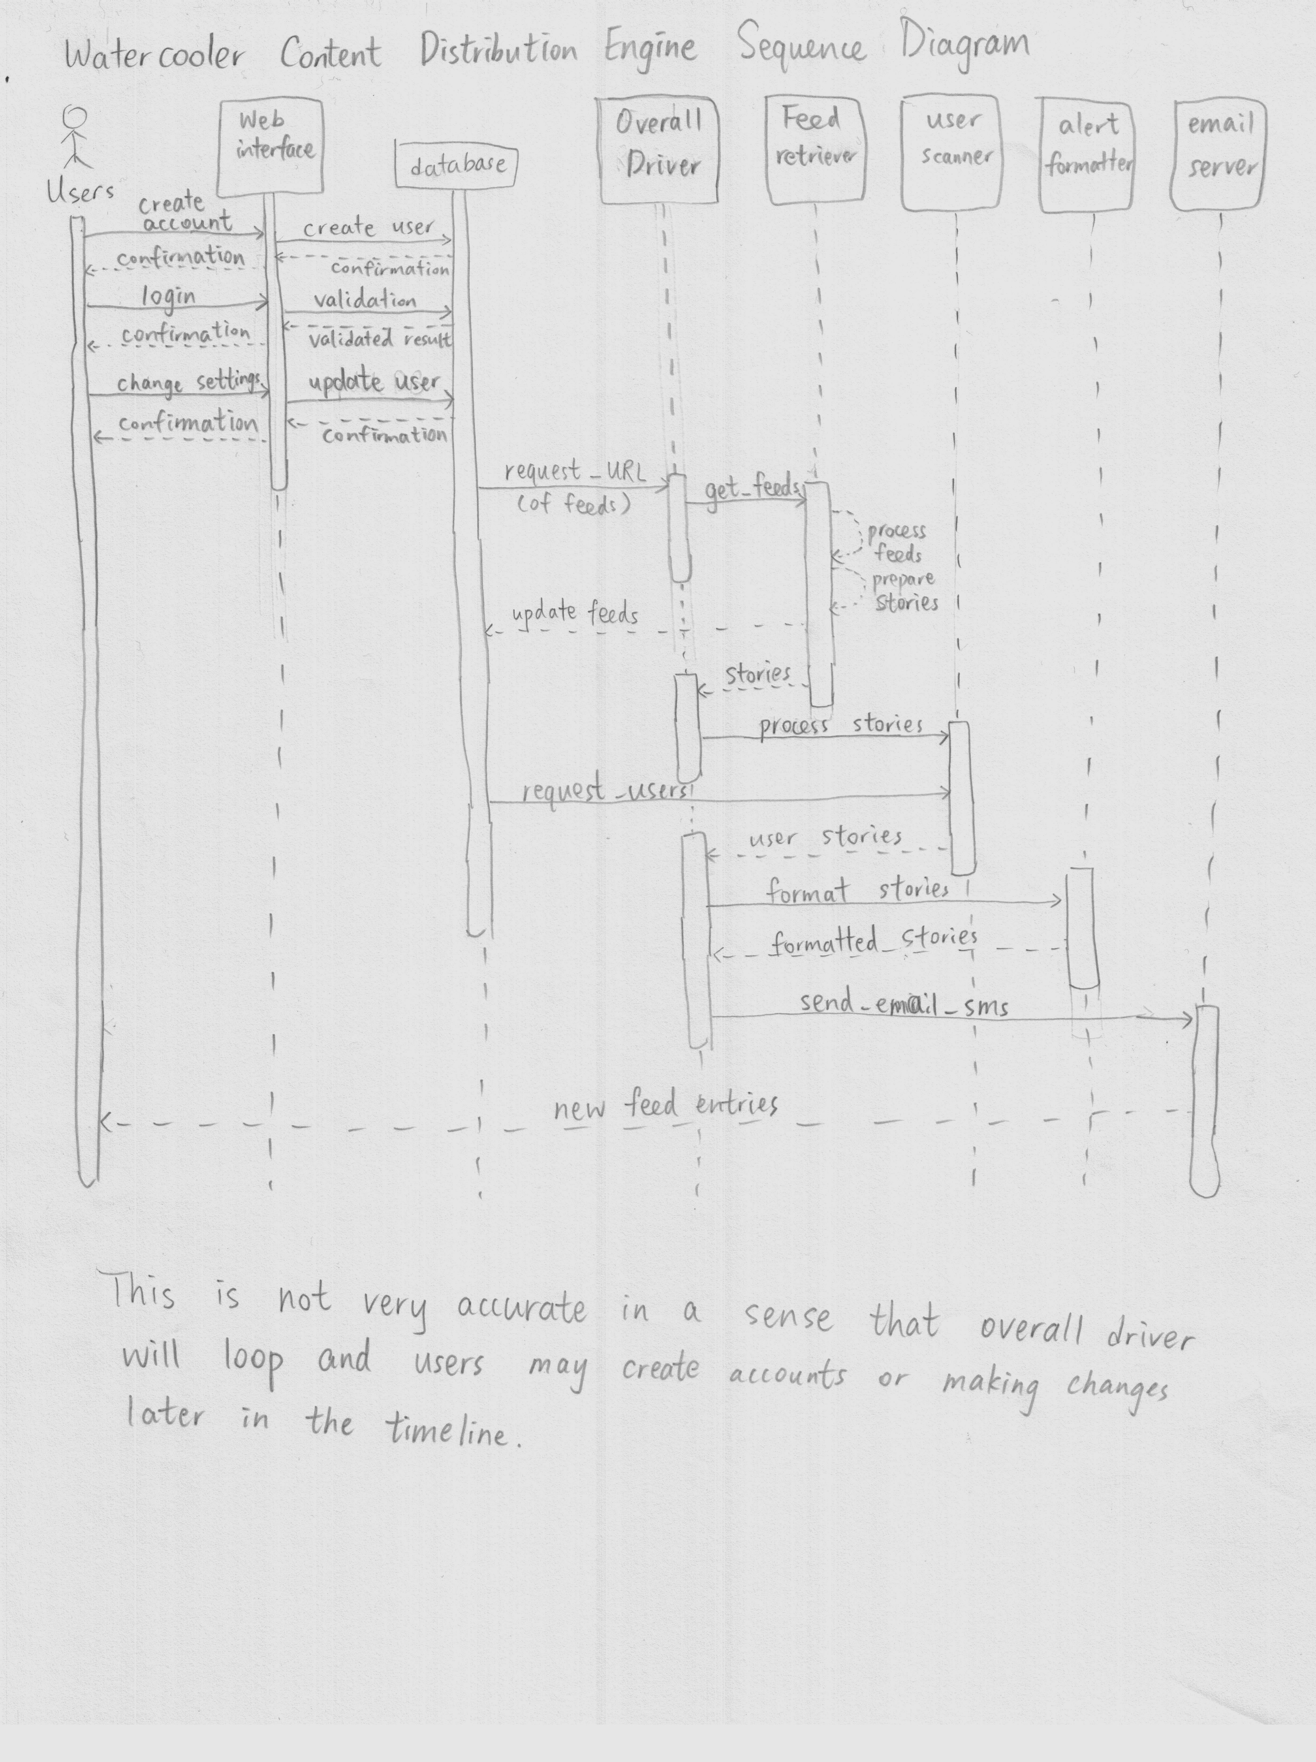

Design Details

Testing Plan

Plan

