Tumblekin: Adventurer’s Guide
A simple tabletop roleplaying game of heroes, monsters, magic, treasure, and adventure.
As written by: Joshua Bishop
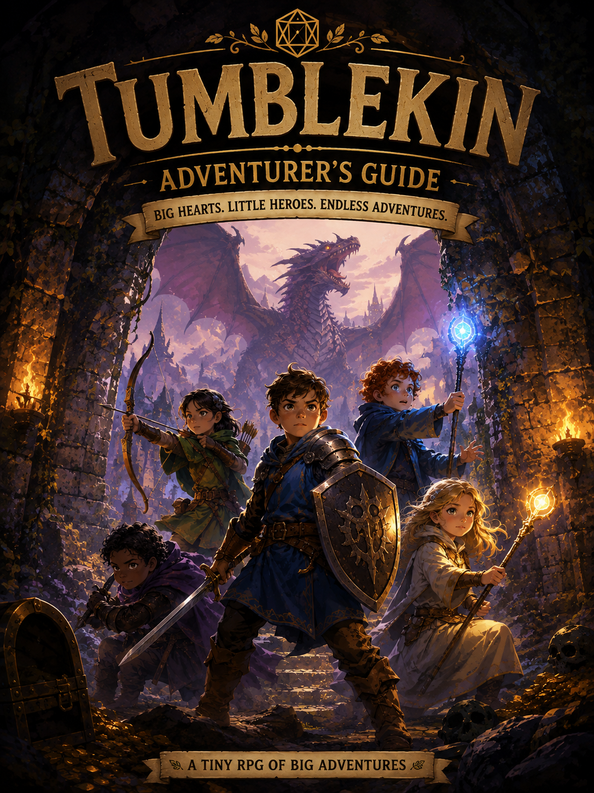
This was written with the intentions of introducing young players to the world of tabletop roleplaying games. Designed with a loose rule-set, simple character creation and near complete freedom to determine how the game is played at its core.

WELCOME ADVENTURER!

In Tumblekin, YOU are the hero.

You might be a brave warrior with a sword, a sneaky rogue, a powerful wizard, a wilderness ranger, or a magical healer.

Together with the other heroes, you will explore strange places, meet interesting characters, discover treasure, solve problems, and battle monsters.

One person does not play as a regular character though, they are called the Game Master, or GM.

The GM describes the world and plays the role of everyone in it who isn’t one of the heroes.

The GM might say:
“You enter an old stone room. There are three doors. You hear scratching behind the red door.”

Then you decide what your hero does. You can try almost anything you can imagine!

WHAT YOU’LL NEED

While your imagination is arguably the most important thing you can bring to the table, you will also need a handful of other materials as well:
- A Character Sheet
- A Pencil with an eraser
- At least one set of TTRPG dice
The dice used in this game are often called a shorter version of their name, for example the 20-sided die is the most important die in the game and is called a d20.

To play this game you need at least one of each: d4, d6, d8, d10, d12, and d20.

When the rules say 1d6 it means to roll one six-sided die.
When they say roll 2d6, roll two six-sided dice and add them together.

THE MOST IMPORTANT RULE

Whenever your hero tries something difficult, the GM will ask you to make a Difficulty Check, or DC. Roll a d20, then add your stat modifier(s) and any modifiers from training. If your total equals or beats the DC, you succeed!

For example: Bramble wants to climb the old castle wall. The GM says “That’s a DC 12 Might Check.” Bramble has +2 Might from his Stats and Training. He rolls a 13.
13+2=15 and he only needed 12. Bramble gets to successfully climb the wall.

DIFFICULTY CLASSES

DC tells you how hard a task is going to be to complete.

DIFFICULTY | DC
Easy | 8
Normal | 10
Tricky | 12
Hard | 15
Very Hard | 18

You don’t need to roll for everything. Walking across a room doesn’t need a check, but jumping across a giant hole probably does. It is up to the GM to decide when and what type of check is needed.

YOUR FOUR STATS

Every hero has four stats.
Might: Represents strength, toughness, and physical power.
Use might when you:
- Lift something heavy
- Break down a door
- Climb
- Wrestle
- Push Something
- Swing a heavy weapon
- Resist something physically

Agility: Represents speed, balance, accuracy, and sneakiness.
Use agility when you:
- Sneak
- Jump
- Balance
- Dodge danger
- Pick a lock
- Shoot a bow
- Throw something accurately

Mind: Represents knowledge, investigation, cleverness, and magical skill.
Use mind when you:
- Search for clues
- Remember something
- Solve a puzzle
- Understand magic
- Investigate something strange
- Cast many kinds of spells

Heart: Represents courage, kindness, personality, and understanding others.
Use heart when you:
- Convince someone
- Calm an animal
- Encourage a friend
- Resist fear
- Tell if someone is lying
- Make a new friend
- Perform for a crowd

CHOOSE YOUR STATS

Every new hero starts out with these four bonuses:
+3, +2, +1, +0

You can put one bonus into each of your four stats. If you want to be extremely strong you can put +3 in Might, if you want to be incredibly sneaky put +3 in Agility, and if you want to be a powerful magician you might put +3 in Mind.

There isn’t one correct choice, build the hero YOU want to play!

TRAINING

Every hero chooses three (3) things they are trained in. Training means your hero is especially good at that thing. When your training applies to a DC, add +2.

The base training’s are as follows:
- Animals
- Archery
- Athletics
- Climbing
- Cooking
- Healing
- History
- Investigation
- Magic
- Nature
- Performing
- Searching
- Sneaking
- Persuasion
- Tracking
- Traps
- Barter
You can also ask your GM about creating your own training!

For example, Willow has Agility +3 and is trained in Sneaking +2. When Willow sneaks:
d20+3+2, so she gets +5 added to whatever score her d20 lands on.

ADVANTAGE & DISADVANTAGE

Sometimes something makes a task easier and the GM may give you Advantage. When you have advantage your get to roll 2d20 and use the HIGHER number. Maybe your friend is helping you do something, maybe you have the perfect tool for the job, or maybe you just came up with a clever plan. All of these could give you advantage.

Alternatively sometimes something makes a task harder and the GM may give you Disadvantage. Similar to an Advantage roll you will be rolling 2d20, but will be using the LOWER number. You might have disadvantage because you can’t see very well, the floor is slippery, you’re trying something extremely awkward, or a monster is making things more difficult.

CHOOSE YOUR CLASS

Your hero’s class describes what kind of adventurer you are. Choose one when creating your character.
You can also ask your GM about creating your own custom class as well!

Warrior:
Warriors are strong, tough heroes who are excellent at fighting and can take more damage.
HEALTH (HP) | 14 | ARMOR (AC) | 14
SUGGESTED +3 STAT |  | Might
Mighty Blow
Once during each battle, when you hit an enemy, you may deal an extra 1d6 damage.
Warriors are great for players who want to charge into battle, protect their friends, and fight monsters face to face.

Rogue:
Rogues are quick, clever, and sneaky. A perfect addition to any adventure party.
HEALTH (HP) | 10 | ARMOR (AC) | 13
SUGGESTED +3 STAT |  | Agility
Sneak Attack
Once during your turn, if you attack an enemy that is distracted or doesn’t know you’re there, deal an extra 1d4 damage.
Rogues are great at sneaking, finding traps, stealing keys, climbing into strange places, and surprising enemies.

Wizard:
Wizards study magic and use spells to solve problems.
HEALTH (HP) | 8 | ARMOR (AC) | 11
SUGGESTED +3 STAT |  | Mind
Magic
You begin knowing 3 spells, some magic can be used whenever you want.
Powerful spells use spell charges.
You begin each adventure with 3 spell charges.
Wizards are perfect for players who want to cast spells, discover magical secrets, and solve problems in unusual ways.

Ranger:
Rangers are explorers, hunters, archers, and experts at surviving in dangerous places.
HEALTH (HP) | 11 | ARMOR (AC) | 13
SUGGESTED +3 STAT |  | Agility
Hunter
At the beginning of each battle, choose one enemy you can see.
You gain +2 to attacks against that enemy.
Rangers are excellent at tracking monsters, exploring forests, working with animals, and fighting from a distance.

Healer:
Healers use courage and magic to protect their friends.
HEALTH (HP) | 10 | ARMOR (AC) | 12
SUGGESTED +3 STAT |  | Heart
Healing
Three (3) times during each adventure, you can use your action to heal yourself or another hero.
The hero regains 1d6+2 HP
Healers are excellent for players who want to help their friends, use protective magic, and keep the whole party adventuring.

HIT POINTS

Hit Points or HP represents how much punishment your hero can take. When something hurts you, you lose HP. If you have 10 HP and a goblin deals 4 damage you now have 6 HP. Write your current HP on your character sheet.

ARMOR

Armor or AC tells you how difficult you are to hit. An enemy must roll equal to or higher than your Armor to hit you. Higher armor means you’re harder to hit.
Armor can represent:
- A Shield
- Magic Protection
- Tough Scales
- Any other protection your hero may have.

BATTLE

When a fight begins, the GM will tell everyone to: ROLL INITIATIVE!
Roll 1d20 + your Agility modifier. The hero or monster with the highest number goes first. Then everyone takes turns from highest to lowest. When everyone has taken a turn, a new round begins.

YOUR TURN

During your turn you can Move and take 1 Action. You might use your action to Attack, Cast a spell, Help Someone, Use an item, Pull a lever, or any other number of creative choices. You don’t have to attack on every turn. Sometimes the smartest move is doing something completely different.

ATTACKING

When you attack an enemy roll 1d20 + the correct stat. For most close-range weapons use Might, for bows and other ranged weapons use Agility, for magical attacks you will usually use Mind. Compare your total to the AC of the enemy and if your total equals or beats it YOU HIT! Now roll your weapon’s damage.

WEAPONS

Different weapons use different dice.
WEAPON | DAMAGE
Dagger | 1d4
Sword | 1d6
Bow | 1d6
Staff | 1d6
Big Axe | 1d8
Big Hammer | 1d8
Magic Bolt | 1d6
Your GM may allow other weapons too! Usually weapons that are small and quick deal less damage, while large weapons deal more.

CRITICAL HITS & MISSES

If your attack roll lands on a 20 that’s called a natural 20 or Nat 20, you score a critical hit! You get to roll your damage die twice. For instance, a sword normally does 1d6 damage, but with a critical hit you do 2d6. Critical His do no miss.

Alternatively, if your attack roll lands on a 1 it’s called a natural 1 or a Nat 1, This is a critical miss and will cause the target no damage.

SAVING THROWS

Sometimes danger comes after you, A dragon might breathe fire at you. A banshee might scream, or a trap might suddenly activate. When this happens the GM may ask you to make a Saving Throw. A saving throw is just a difficulty check using one of your four stats.

For the dragon fire, the GM might say they need you to make a DC 12 Agility save. Roll 1d20 and add your agility modifier to that roll. If you meet or exceed 12, you will avoid some or all of the damage.

In the case of the banshee scream, the GM may ask you to make a DC 12 Heart Save because your courage is being tested instead. Again roll 1d20, add your Heart modifier and compare that to the DC score for your result.

GETTING KNOCKED OUT

When your HP reaches 0 your adventure doesn’t necessarily have to be over. You cannot take your turns as usual while knocked out though. Your friends may decide to use their action to help you, when they do you will return to battle with 1 HP. Healing magic can also bring you back. Heroes don’t normally die simply because they reach 0 HP. The GM is the ultimate judge of what happens within the story.

If the whole party gets knocked out, the story may continue. You might wake up in a strange new place captured by monsters, Locked inside a dungeon, Missing some treasure, or any number of other scenarios.

One failure can create a completely new adventure.

MAGIC

Magic allows heroes to do incredible things. Some spells are Little Magic, and can normally be cast as often as you’d like. Other spells are Big Magic and cost 1 Spell Charge. A wizard begins each adventure with 3 Spell Charges. Your spell charges return when your adventure is over or when the GM says you’ve had enough time to fully rest.
EXAMPLE SPELLS
Ask your GM about creating your own spells!

Fire Bolt | Little Magic
Launch a small ball of magical fire from the palm of your hand.

Attack: d20 + Mind
Damage: 1d6 Fire

Magic Hand | Little Magic
Create a floating magical hand to do as you wish. The hand can pick up, move, push, pull, or carry small objects from a distance.

Magic Hand cannot make weapon attacks.

Light | Little Magic
Touch an object and make it glow brightly. The light lasts until you decide to end it.

Shield | Big Magic – 1 Spell Charge
Choose yourself or a nearby friend. That person gains +3 Armor until the beginning of your next move.

Sleep | Big Magic – 1 Spell Charge
Choose one creature you can see. That creature makes a DC 12 Heart save, If it fails, it magically falls asleep.

Taking damage wakes it up.

HELPING YOUR FRIENDS

Adventurers work better together, You can use your action to help another hero, just explain what you’re doing to help in their particular situation. If the GM agrees that your idea would help them they will gain Advantage on their next difficulty check. Teamwork can turn a nearly impossible situation into an easy one!

CREATIVE IDEAS

You are not limited to the actions written on your character sheet, you may try anything that makes sense in the story. The GM is the final judge of what happens.

If the result isn’t certain you may make a DC, sometimes a clever idea might give you Advantage, sometimes a really clever idea might work without a check at all!
ITEMS AND EQUIPMENT

Your hero can carry useful things such as rope, a lantern, a bedroll, food and drink, a hammer, a musical instrument among countless other things. Practically anything you can think up can be carried on you. Don’t worry too much about exactly how much everything weighs, if it seems reasonable for your hero to carry it, they probably can. If you’re unsure about it, ask your GM.

HEALING POTIONS

A healing potion restores 1d6 + 2 HP, drinking one during battle uses your action. You may also give a potion to another hero. You can never heal above your normal maximum HP.

RESTING

Heroes need breaks! A Short Rest is a chance to sit down, eat something, catch your breath, and patch up battle wounds.

During a Short Rest you regain 1d6 HP. You can only take a short rest when the GM says you are somewhere safe enough.

A Full Rest usually happens between adventures. During a Full Rest you restore all HP, restore all Spell Charges, and restore any Class Abilities.

Now you’re ready for another adventure!

MONSTERS

Monsters follow many of the same rules as heroes. They have Health Points (HP), Armor (AC), an Attack Modifier, and a Damage Roll. Some monsters may also have Special Abilities. Below are examples of simple monsters which can be used in your adventures and expanded upon. GM’s are free to create any monsters they see fit for their adventure. Keep your heroes and monsters balanced to keep the game fun for everyone involved.

Goblin
HP | 5 | ATK | +2 | DMG | 1d4 | AC | 11
Sneaky |  | Goblin gets +2 when trying to hide.

Skeleton
HP | 7 | ATK | +2 | DMG | 1d6 | AC | 12
Bony |  | Skeletons take +2 DMG when hit with hammers, maces, and other crushing weapons.

Ogre
HP | 20 | ATK | +4 | DMG | 1d8 | AC | 11
Huge Swing |  | If the Ogre rolls a Nat 20 on an attack, every hero standing directly beside the target also takes 2 damage.

TREASURE

A well put together adventure can be fun on its own, but finding treasures along the way can make it that much better. Treasures can include things like coins, gems, magical weapons, potions, strange keys, maps, talking objects, and anything else your mind can think up.

Some treasures are valuable, some are useful, and some might even start an entirely new adventure.

When a hero gains an item it should be written into the inventory section of their player sheet. Likewise when an item is used, traded, or sold it should be erased or crossed off of the character sheet.

MAGIC ITEMS

Sometimes you may find a special item which contains magic. The GM is free to create any magic item they see fit for the adventure while keeping game balance in mind. Below are a few examples of items.

FLAMING SWORD
A magical sword that deals 1d6 + 1 Fire Damage.

CLOAK OF SHADOWS
Gain advantage when hiding somewhere that is dark.

BAG OF ENDLESS SNACKS
Once each day, reach inside and pull out enough snacks for everyone. Nobody knows where the snacks come from, it’s probably best not to ask.

NEVER ENDING CHALK
This piece of chalk never gets smaller.

GOBLIN COMPASS
Points toward the nearest goblin.

HERO TOKEN

Every hero begins with a Hero Token It can be used once per adventure and can be used to Re-roll your last roll, or you can add one small, helpful detail to the scene. You cannot use your hero token to instantly defeat an enemy or completely solve an adventure. The GM decides if your idea is possible. Once you spend your hero token it is gone until the next adventure.

MAKING YOUR HERO

When you’re ready to start creating your hero simply follow these steps to fill out your character sheet:
- Choose a Name
  - What will your hero be called?
- Choose a Class
  - Warrior
  - Rogue
  - Wizard
  - Ranger
  - Healer
- Choose your Stats
  - Distribute these four bonuses among your four stats:
    - +3, +2, +1, +0
- Choose three Training’s
  - Pick 3 things your hero is especially good at.
  - Each Training gives your hero +2 to DC rolls when it applies.
- Choose your Equipment
  - Choose one weapon that makes sense for your hero.
  - Choose three useful items to carry with you during your adventure.
- Describe your hero, write down:
  - What they look like.
  - What they wear
  - Are they serious or funny, brave or grumpy. Describe their attitude
  - Do they have a pet?
  - Why did they become an adventurer?

There are no wrong answers here.

It is best to create your characters at the table with your adventuring party and game master so that you can ensure all your heroes work well together and form a cohesive party. It also make it easier to ask the GM about creating your own classes, weapons, spells, and other aspects and items of your hero.

THE MOST IMPORTANT RULE OF THEM ALL

Tumblekin is a game about imagining an adventure together. Sometimes you’ll roll high, sometimes you’ll roll terribly. Sometimes the attack you carefully planned will fail spectacularly, and sometimes someone will come up with an idea nobody ever expected! That’s part of the adventure.

There isn’t always a single correct solution. Explore, ask questions, help your friends and try ridiculous ideas. Talk to monsters, investigate suspicious statues, and open doors that you probably shouldn’t have.

Roll the dice, and find out what happens next. Your adventure begins now!

