| **Ex.No: 2** | **Add Multimedia and Interactivity to a Webpage** |
| --- | --- |
| **Date: 25-12-2024** |

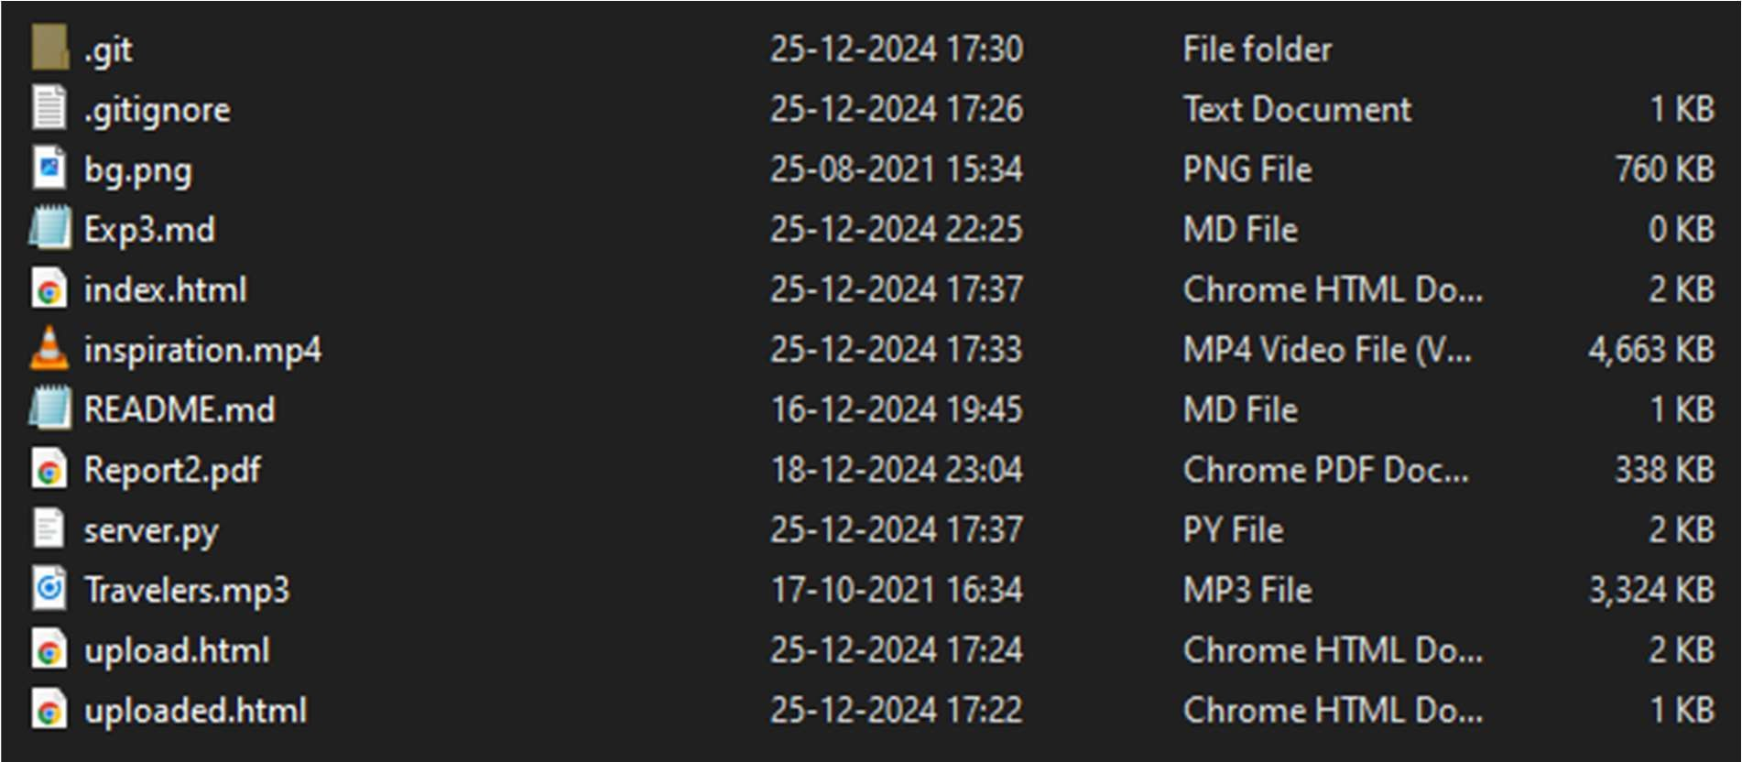File Structure

HTML Code index.html

<html>

<head>

<style>

body {

background-image: url('bg.png'); background-size: cover; background-attachment: fixed; color:white;

}

footer{

position: fixed; bottom: 0;

width: 100%;

text-align: center;

}

</style>

</head>

<h1 class = 'text'>Travelers Radio</h1>

<h2>Listen along to Travelers with everyone around the world</h2>

<audio controls src="<http://127.0.0.1:12345/stream>"></audio>

<ul>

Current Artists:

<li>TheRedWizard - <strong>Piano</strong></li>

<li>JohnDoe - <strong>Drums</strong></li>

<li>Pleg - <strong>Electric Guitar</strong></li>

</ul>

<p>

<a href="upload.html">Want to upload your cover?</a>

</p>

<p>

Inspiration:

</p>

<video controls src="inspiration.mp4"></video>

<footer>

<p>Created by: <a href="https://github.com/TheR3dWizard">Sreeraghavan R</a></p>

</footer>

</html>

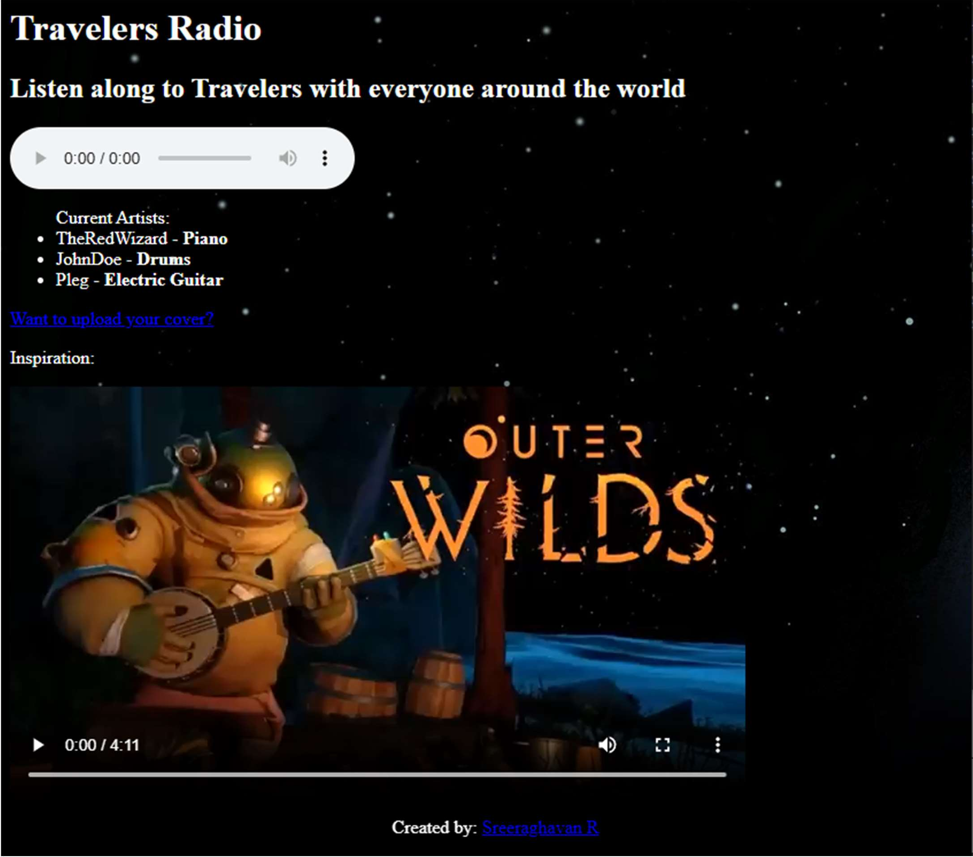

upload.html

<html>

<style>

body {

background-image: url('bg.png'); background-size: cover; background-attachment: fixed; color:white;

}

footer{

position: fixed; bottom: 0;

width: 100%;

text-align: center;

}

form{

/* display:table-column; */

margin: 0 auto;

}

</style>

<h1 class = 'text'>Upload your cover of the song here!</h1>

<form action="uploaded.html">

<input type="file" name="file" id="file">

<label for="name">Name:</label>

<input type="text" id="name" name=""name>

<label for="instrument">Instrument:</label>

<input type="text" id="instrument" name="instrument">

<input type="submit" value="Upload">

</form>

<h2>

<a href="index.html">Go back to radio</a>

</h2>

<footer>

<p>Created by: <a href="https://github.com/TheR3dWizard">Sreeraghavan R</a></p>

</footer>

</html>

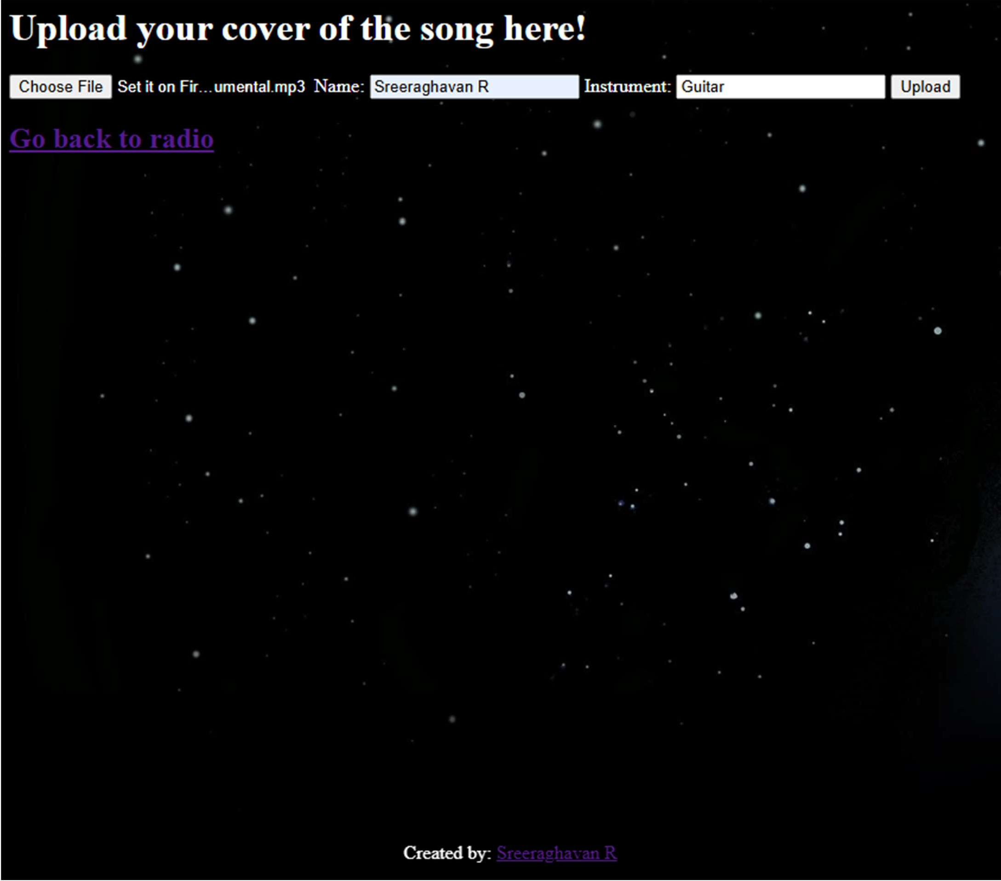

uploaded.html

<html>

<style>

body {

background-image: url('bg.png'); background-size: cover; background-attachment: fixed; color:white;

}

footer{

position: fixed; bottom: 0;

width: 100%;

text-align: center;

}

form{

/* display:table-column; */

margin: 0 auto;

}

</style>

<h1>

Thank you for uploading!

</h1>

<h2>

<a href="index.html">Go back to radio</a>

</h2>

<footer>

<p>Created by: <a href="https://github.com/TheR3dWizard">Sreeraghavan R</a></p>

</footer>

</html>

