| **Ex.No: 6** | **Practice Exercise : Servlets and Node.js** |
| --- | --- |
| **Date: 23/1/25** |

**Aim:**

To practice the given problems using Node.js and servlets.

**1) A web application that takes a name as input and on submit it shows a hello <name> page where name is taken from the request. It shows the start time at the right top corner of the page and provides a logout button. On clicking this button, it should show a logout page with Thank You <name > message with the duration of usage (hint: Use session to store name and time).**

Step 1: Installation of Node.js and verification by running the following commands

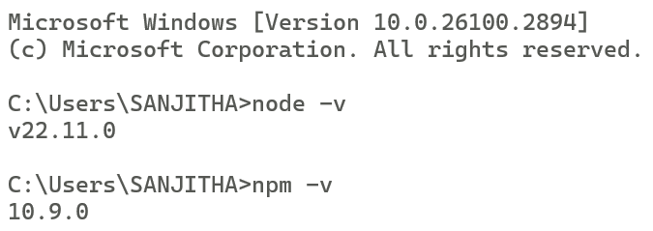

Step 2: Installation of Express.js (via npm) which is a web framework for Node.js that simplifies routing and handling HTTP requests.

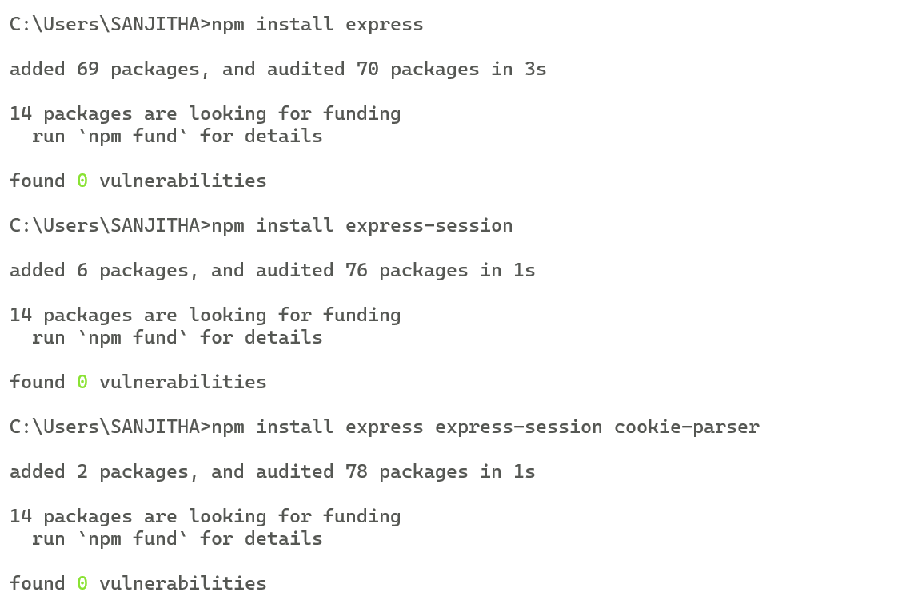

Step 3: Installation of other dependencies

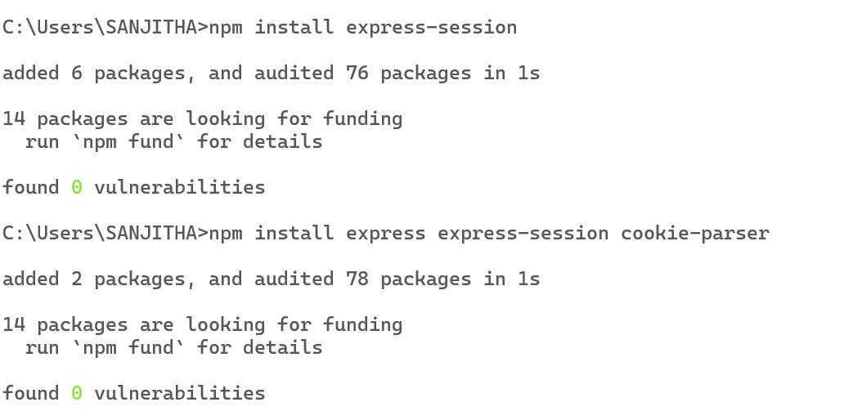

Step 4: Initializing the project

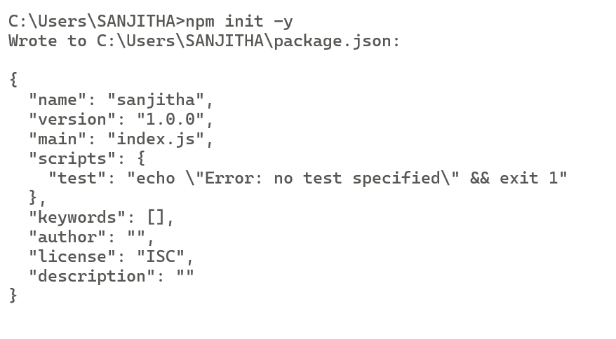

Step 5: Code in app.js

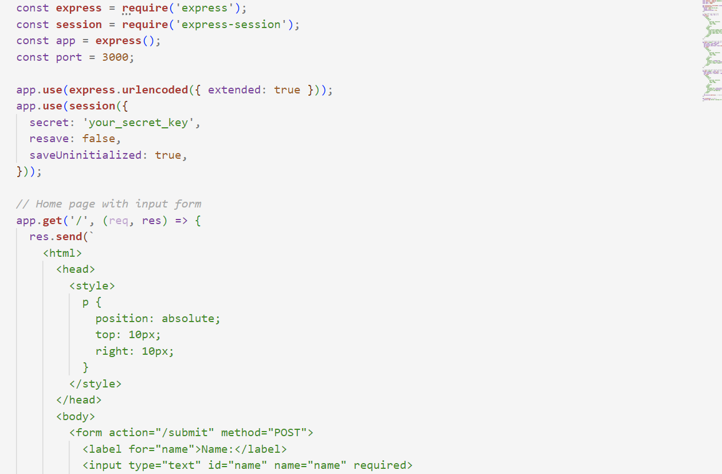

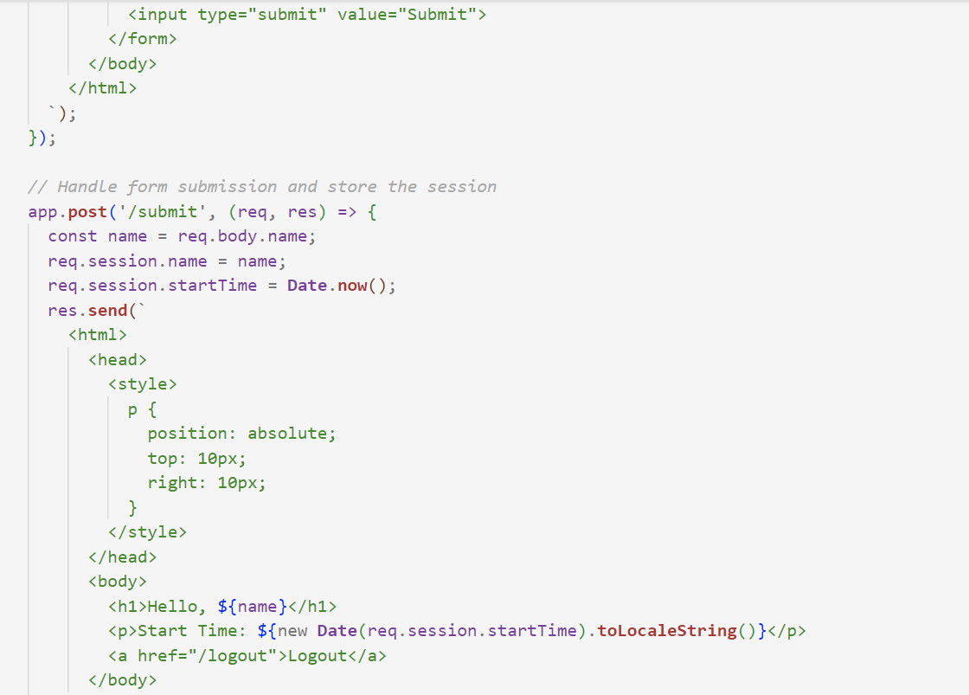

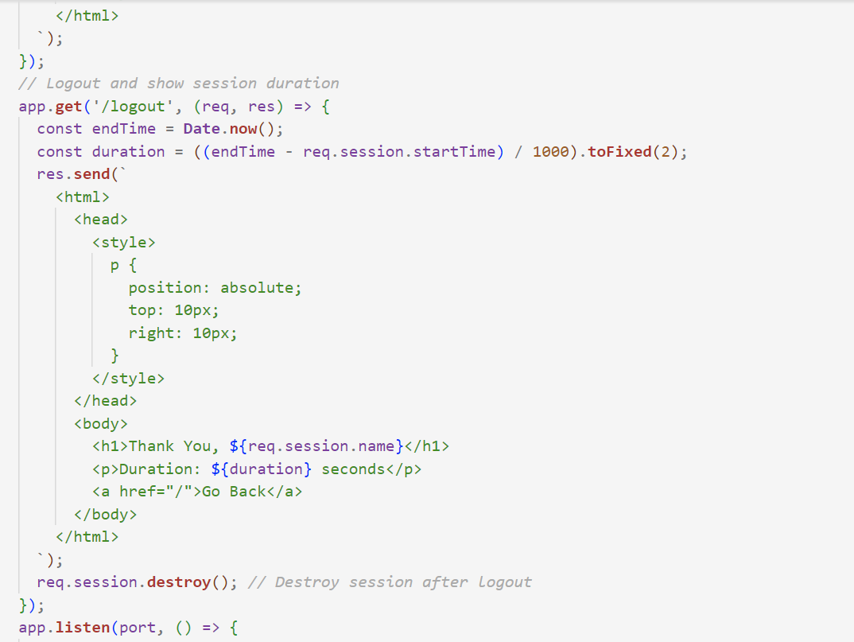



Step 6: Running the code



Output:

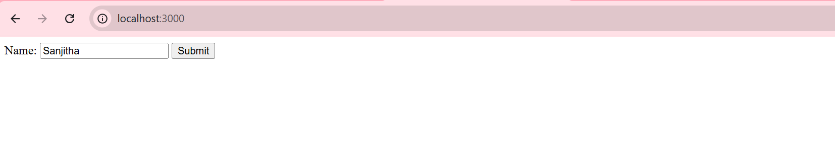 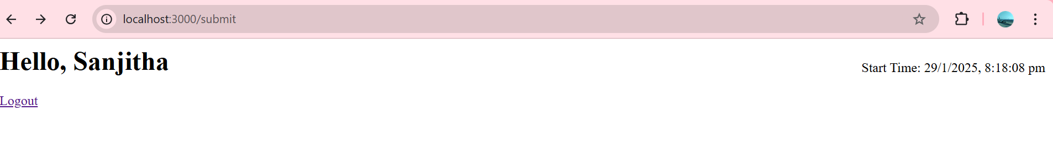

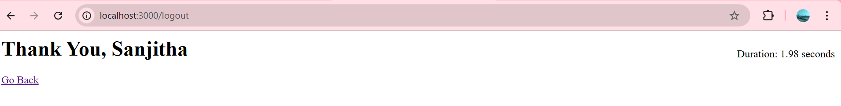

**2)Write a Servlet application to print the current date and time.**

Step 1:Initialize the project

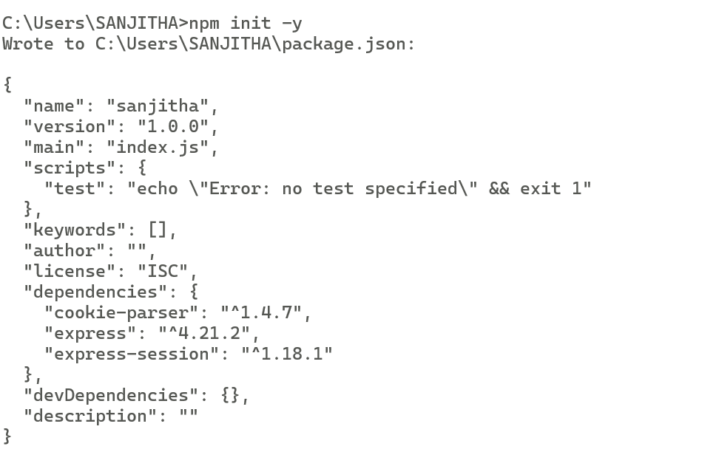

Step 2: Code in app1.js

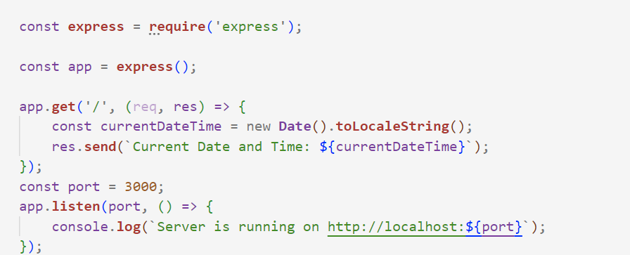

Step 3: Run the code using the command :

node app1.js

**Output:**



**3)** **A web application that takes name and age from an HTML page. If the age is less than 18, it should send a page with “Hello <name>, you are not authorized to visit the site” message, where <name> should be replaced with the entered name. Otherwise it should send “Welcome <name> to this site” message.**

**index.html**

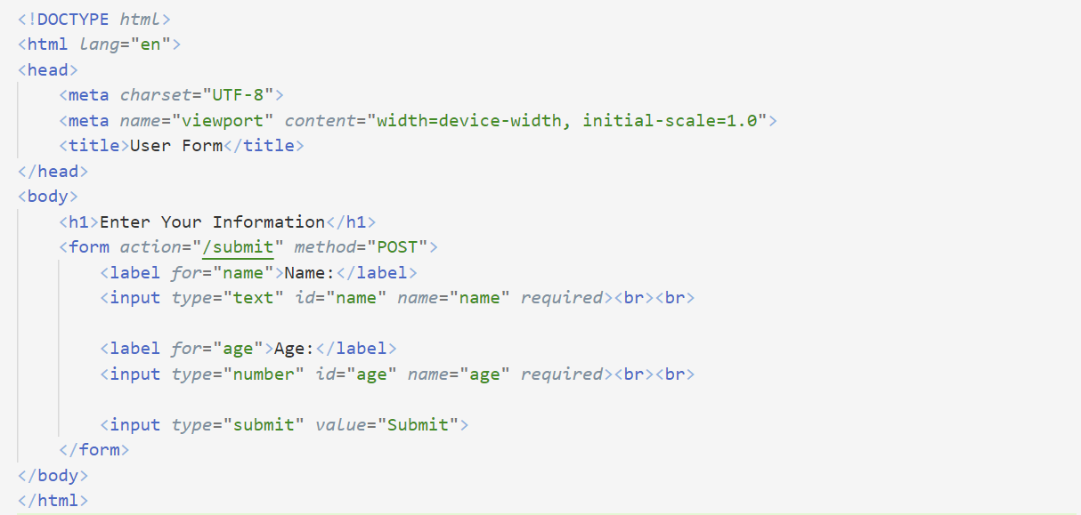

**app2.js**

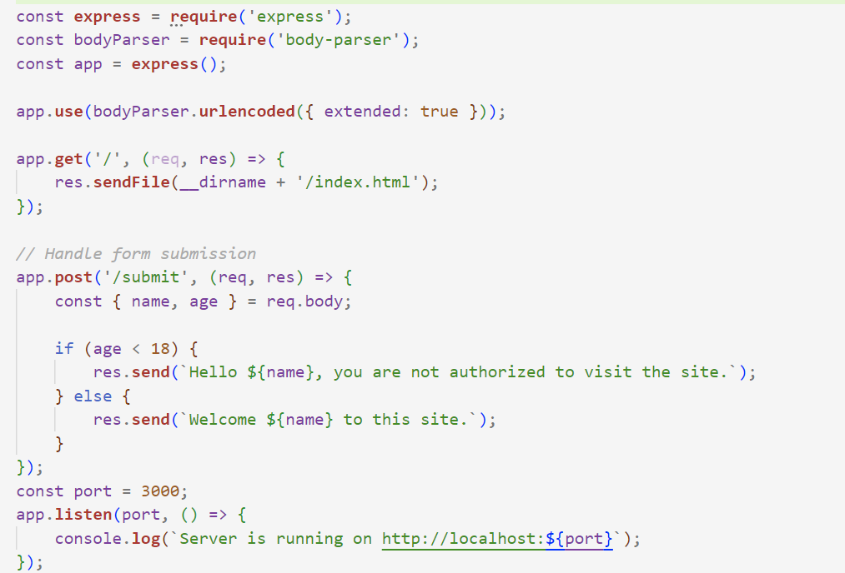

Output:

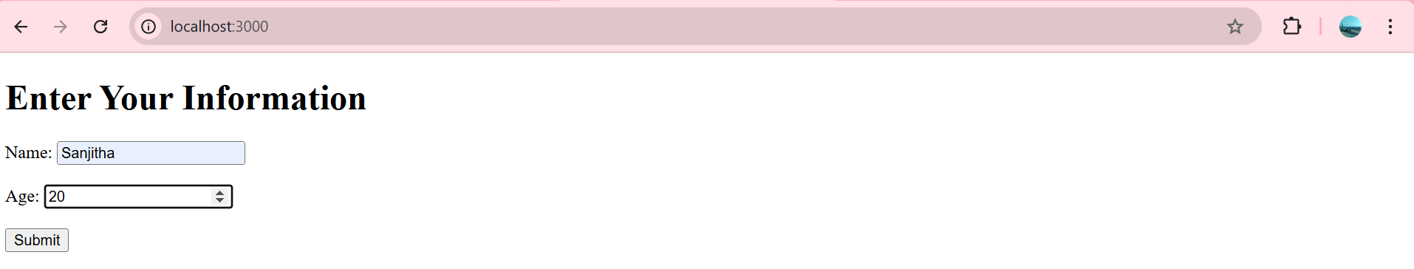

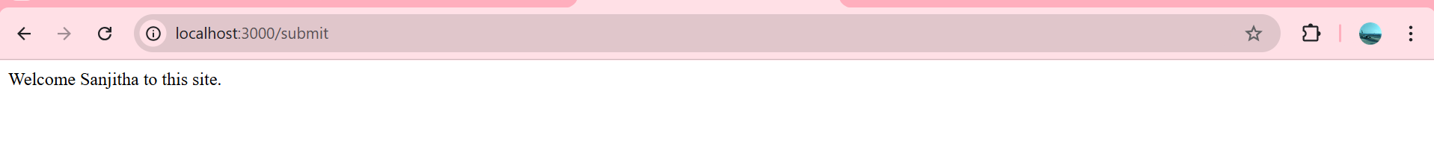

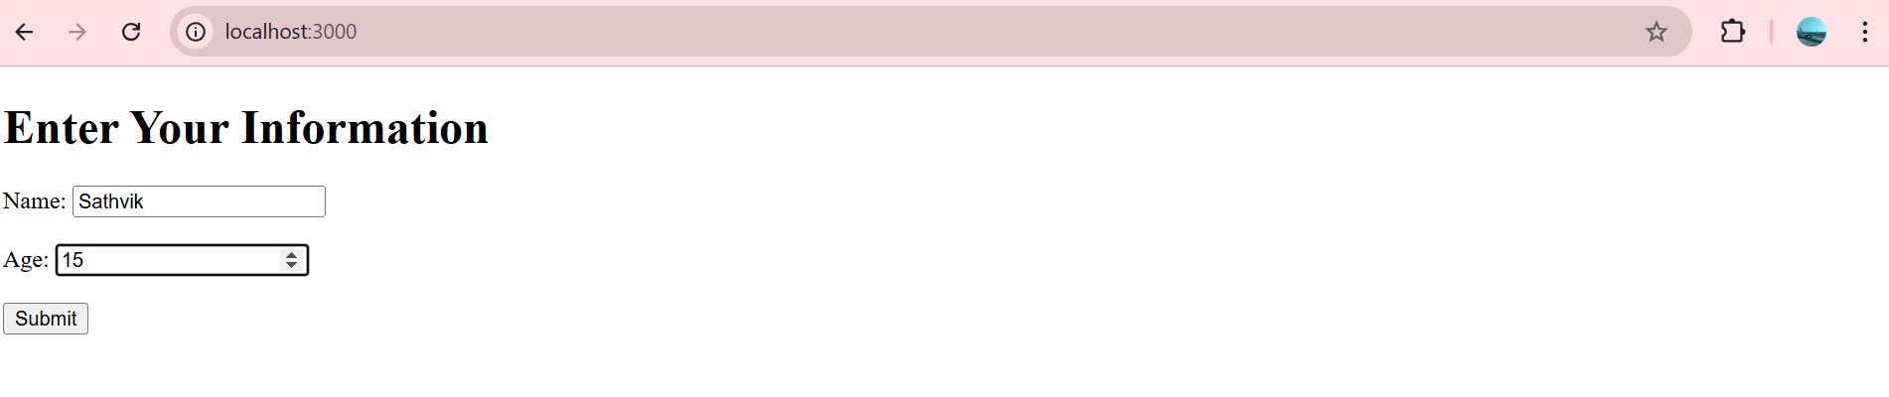 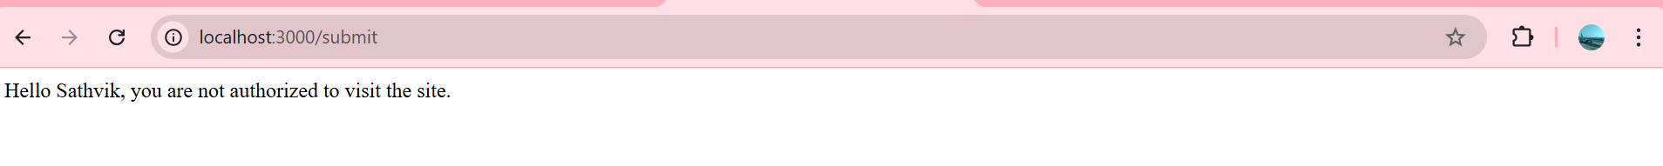

**4)** **A web application that lists all cookies stored in the browser on clicking “List Cookies” button. Add cookies if necessary.**

**app3.js**

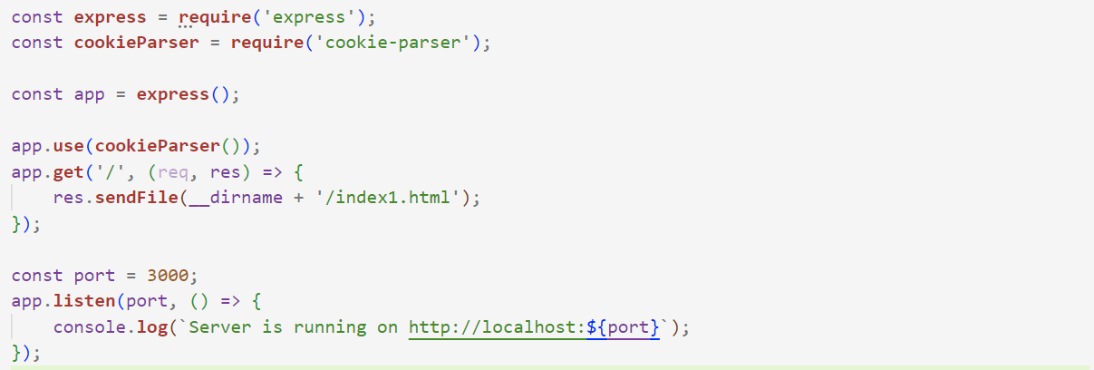

**index1.html**

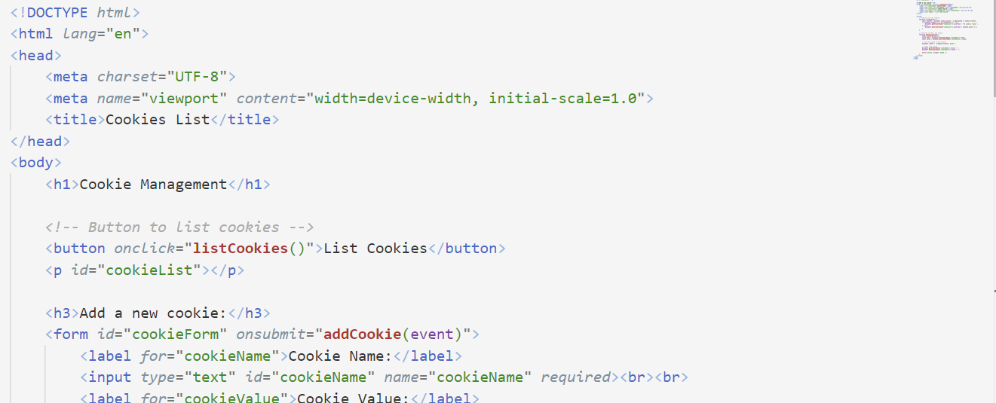

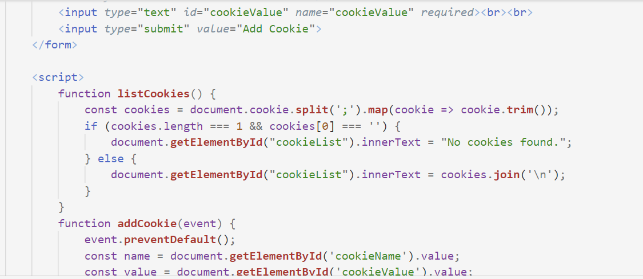

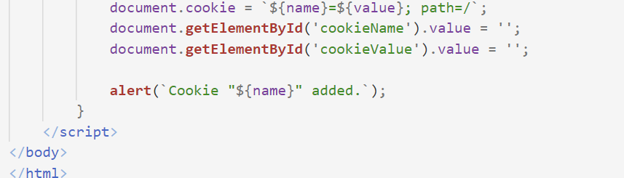

**Output:**

