| **Ex.No: 8** | **Develop an application that uses GUI Components, Fonts and Colours** |
| --- | --- |
| **Date: 13/2/25** |

**Aim:**

To develop an application that uses GUI components, fonts and colours using Android Studio.

**Steps:**

1. Install Android Studio
2. Create new project

1. Choose type of activity

1. Set project name and version

1. Run app with the button on top

1. Change layout at activity_main.xml

1. Change MainActivity.java

1. Install an android SDK to run the application

**Output:**

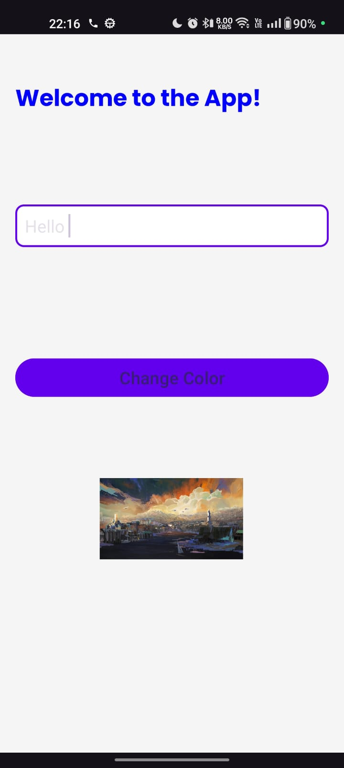 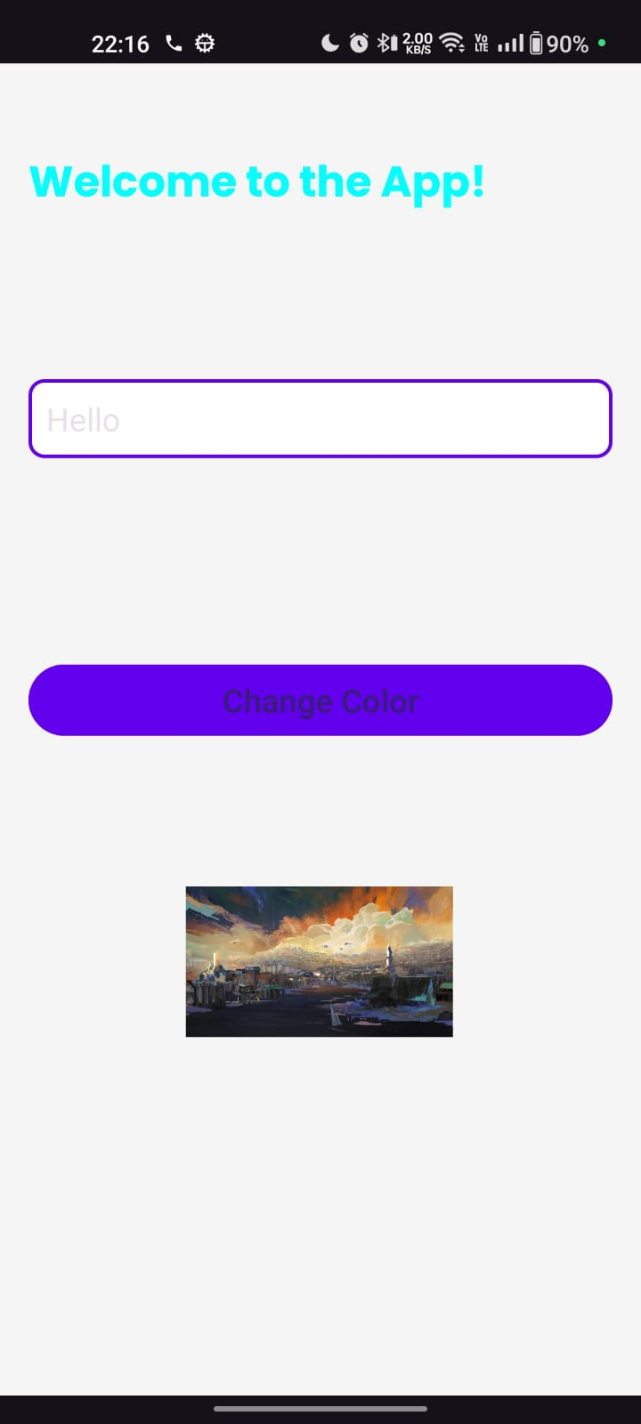

**Result:**

Android Studio was setup and an application was run