**Mobile eBilling – VMBillingWebApp Environment setup guide**

**Software Requirements**

**1. Eclipse IDE- KEPLER (4.2)**

Download link: <https://www.eclipse.org/downloads/packages/eclipse-ide-java-developers/keplersr2>

**2. Java JDK (1.7)**

Download link: <https://www.java.com/en/download/>

**3. MySQL (5.8)**

Download link: <http://dev.mysql.com/downloads/mysql/>

**4. Tomcat 7**

Download link: <http://tomcat.apache.org/download-70.cgi>

**5. Maven 3.0**

Download link: <http://maven.apache.org/download.cgi>

**6. Github**

Download link: <http://goo.gl/PHbqK> or <http://msysgit.github.io/>

Please refer the below document to setup your Github in detail.

[**GitHub_Presentation.docx**](GitHub_Presentation.docx)

Once GitHub setup is ready, clone an existing Github repository to your local repository.

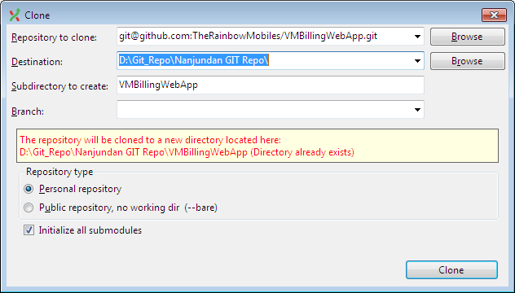

Now, you have done all the environment related activities to begin your work.

Checkput the code from Git to work with your IDE like below:

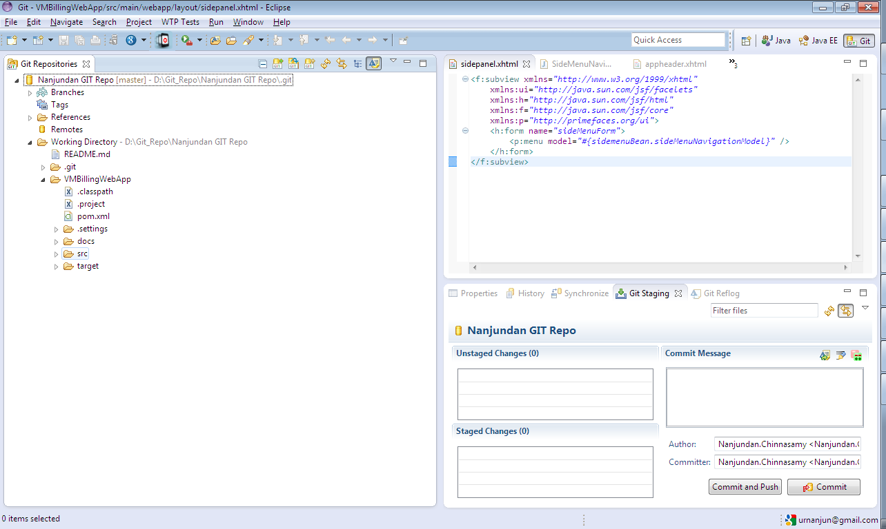

You should be able to get all the necessary codes into IDE to work with. You may have other issues like Class path variables settings and Maven repository configuration issues within IDE etc.. This can be easily resolved by doing the actions below:

1. Running the maven eclipse command against project pom.xml file
2. This will do the necessary configuration changes for your IDE
3. Run “mvn clean install” command to download the necessary artifacts
4. Repeat the step1 again if necessary

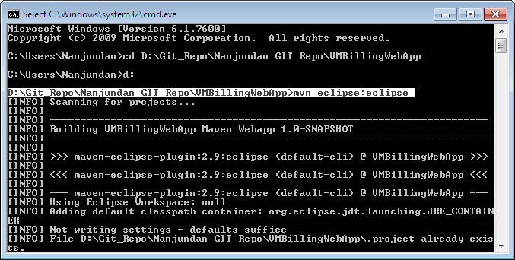

If all your settings are correct, you can run the application successfully using the local server configured.

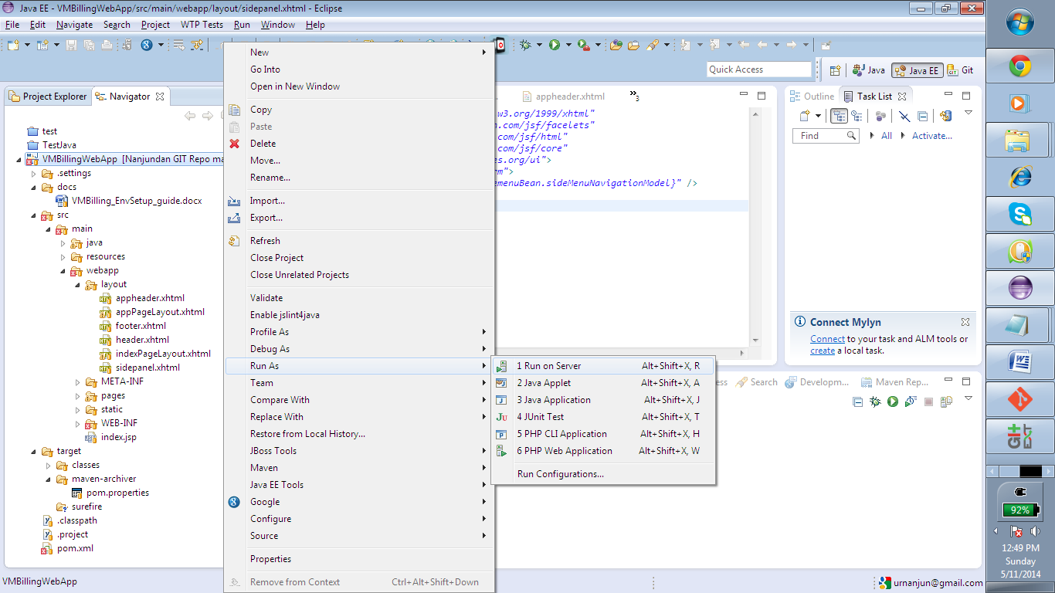

<http://localhost:8080/VMBillingWebApp/pages/master/mst_supplier.jsf>

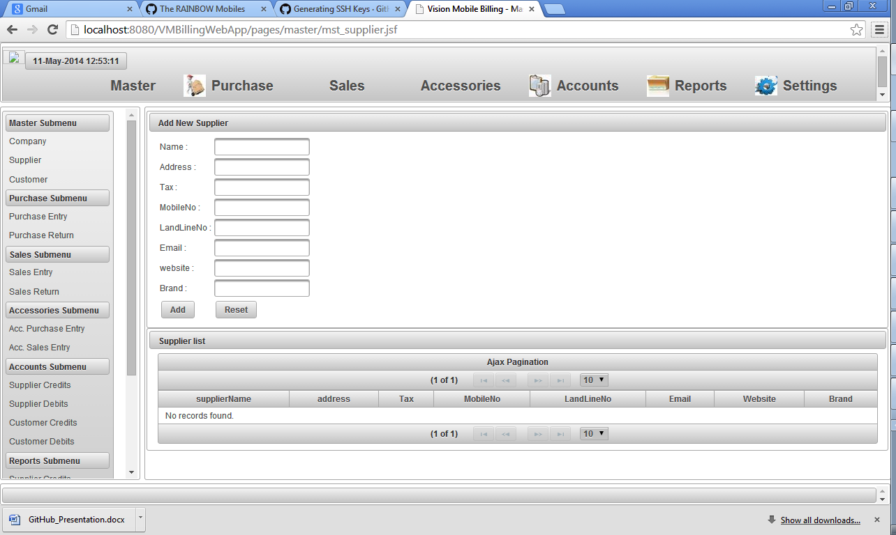

**Frameworks Used:**

1. JSF 2.2

2. Spring 3.0

3. Primefaces 4.0

4. Hibernate 4.0