UCN, University College of Northern Denmark

*IT-programme*

AP Degree in Computer Science

*Class: dmaj0920*

*Title: Workshop – Quality & Testing*

*Participants:*

*Mihail Gerginov*

*Teo Stanic*

*Antonio Kovacevic*

*Marko Veljkovic*

*Lucas Inaschwili-Hongre*

*Supervisors:   
Mogens Holm Iversen*

*Søren Krarup Olesen*

*Repository link:* [*https://github.com/TheRandomTroll/ucn-2-ws-quality-test*](https://github.com/TheRandomTroll/ucn-2-ws-quality-test)

Table of Contents

Introduction 2

Use cases and System Sequence Diagrams 2

Alternative flows and special conditions (Buy Ticket use case) 2

Use-Case Scenario (Buy Ticket) 3

Test cases 3

Test cases for buying a ticket 4

Test cases for database connectivity 4

Test cases for display reset 5

Implementation of tests cases (Writing unit tests) 5

JUnit 5

Test case priority 5

#1: Displaying the proper amount of time for the respective amount of money 5

#2: Ensuring invalid coins do not get accepted by the machine 7

#3: Ensuring illegal coins do not get accepted by the machine 7

#4: Processing the payments and saving them to the database 8

#5: Making sure that the prices per zone get fetched properly, both on database and controller level 10

#6: Ensuring the display gets reset after a payment has been completed/cancelled 10

Group Process 12

Conclusion 12

References 12

# Introduction

This workshop is a part of the 2nd semester curriculum for the Computer Science degree at UCN. The premise of the project is to design use-case scenarios, test cases, unit tests and integration tests for a pre-made project. Other tasks include refactoring the code to resolve issues or to improve code quality and performance.

We were contacted by the company Easy Parking A/S, which wants to replace their outdated parking meters. As members of the testing department, we were put in charge of testing the features which were created by the development department.

The company follows Unified Process as its development methodology and UML for the necessary diagrams. The code is written in Java, using Eclipse as an IDE. The framework used for testing is JUnit.

# Use cases and System Sequence Diagrams

All the use cases and system sequence diagrams were given in advance to us. However, some of the use cases missed additional information, such as alternate flows and special conditions for them. We had to fill in the blanks to make the use cases more descriptive.

# Alternative flows and special conditions (Buy Ticket use case)

One of the first things we immediately noticed is that there was a mismatch between the use case and what the notes from the interview conducted with the company were saying. The notes mentioned some specifications about the ticket machine which were not addressed for in the use case. We have extended the “Buy Ticket” use case to make the alternative flows and special conditions clearer. Figure 1 displays all the additional material that has been added to the use case. The entire use case can be found in the file ***[UC] Buy Ticket.docx***.

|  |  |  |  |
| --- | --- | --- | --- |
| Alternative flows |  |  | |
|  | **6a. The customer enters coins of different, but accepted currencies.** | |
|  |  | 1. Registers payment and updates the display which shows how much time he has bought so far. |
|  | **6b. The customer enters an illegal coin (not EUR or DKK).** | |
|  |  |  | 1. Does not register payment and returns the coin to the customer, not updating the display. |
|  |  | **9a. The customer presses the button CANCEL.** | |
|  |  |  | 1. Does not register the purchase in the central database.  2. Returns the coins to the customer.  3. The display is cleared to prepare for another transaction. |
| Special Requirements |  | The machine only accepts coins. The allowed currencies are EUR and DKK. | |
|  | The allowed coins are as follows:  Euro – 1, 2, 5, 10, 20 & 50 cents; 1 & 2€  DKK – 50 øre; 1, 2, 5, 10 & 20 DKK | |
|  | The response time to update the display should be as soon as the coin is validated. | |
|  |  | The display should display the BUY and CANCEL buttons after the first coin is inserted. | |

Figure 1. Added information to the “Buy Ticket” use case

# Use-Case Scenario (Buy Ticket)

A Use-Case Scenario is an instance of a use case. It displays different scenarios with the flows they take through the flows of the case. The following table and explanatory text show all use-case scenarios for the buy ticket use case.

|  |  |  |
| --- | --- | --- |
| **Scenario Name** | **Starting Flow** | **Alternate** |
| Scenario 1 – Successful transaction | Basic Flow |  |
| Scenario 2 – Different currency coins | Basic Flow |  |
| Scenario 3 – Invalid coin | Basic Flow | A1 |
| Scenario 4 – Interrupted transaction | Basic Flow | A2 |
| **Alternate flows** | | |
| A1 | The coin is rejected, and the display does not get updated. | |
| A2 | The coins are returned, and the display gets updated for a new transaction. | |

Table 1. Use-Case Scenarios for buying a ticket.

# Test cases

A test case is a set of test inputs, execution conditions, and expected results, developed for a particular objective. Its main purpose is to test a specific part of a program, to verify it is running properly and to identify conditions that will be implemented in the form of unit tests. In this project, a majority of the test cases were done using the **black box testing** principle. **Black box testing** is a software testing method in which the functionalities of software applications are tested without having knowledge of internal code structure, implementation details and internal paths. Black Box Testing mainly focuses on input and output of software applications and it is entirely based on software requirements and specifications. [1] For the failing tests that required additional comments, we had to browse through the code in order to specify the reason for the failure and, therefore, document it in the *Comments* column in the spreadsheet. **Unimplemented functionality is left as-is.**[1]

## Test cases for buying a ticket

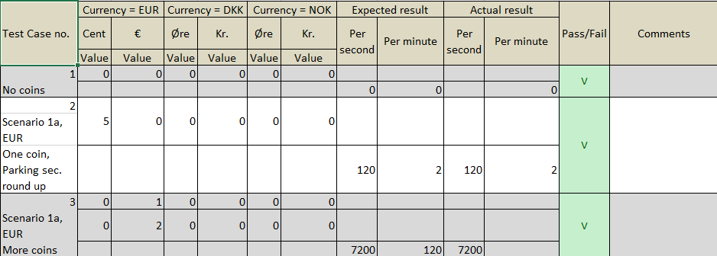

Table 2. Buy ticket test cases (found in ***[TC] Buy Ticket.xlsx***)

A small amount of the test cases for buying a ticket are shown on Table 2. The entirety of this table is located in the file ***[TC] Buy Ticket.xlsx***.

## Test cases for database connectivity

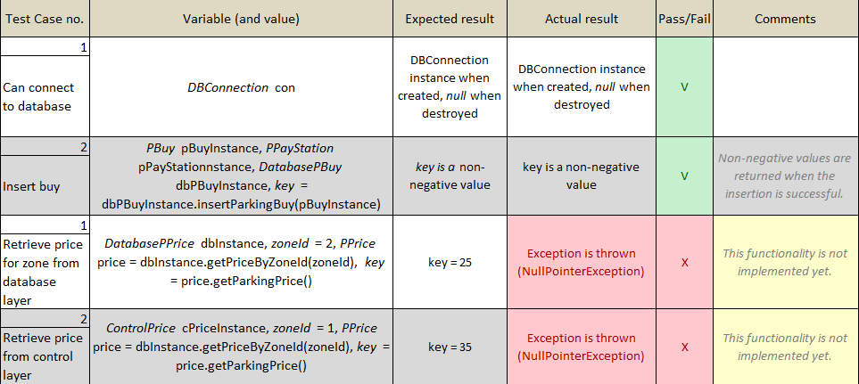

Table 3. Test cases for database connectivity (found in ***[TC] Database Connectivity.xlsx***)

## Test cases for display reset

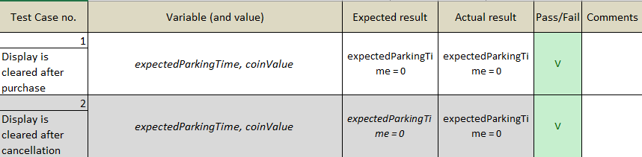

Table 4. Test cases for display reset (found in ***[TC] Reset.xlsx***)

# Implementation of tests cases (Writing unit tests)

## JUnit

**JUnit** is a unit testing framework for the Java programming language. JUnit has been important in the development of test-driven development and is one of a family of unit testing frameworks which is collectively known as xUnit that originated with SUnit. [2] A JUnit test fixture is a Java object. Test methods must be annotated by the **@Test** annotation. If the situation requires it, it is also possible to define a method to execute before (or after) each (or all) of the test methods with the **@BeforeEach** (or **@AfterEach**) and **@BeforeAll** (or **@AfterAll**) annotations. [3]

## Test case priority

Before the process of writing unit tests had begun, we had to prioritize the most important features first. This was done by discussion with the group and realization once a conclusion was reached. All test files are in the ***/src/test*** folder.

### #1: Displaying the proper amount of time for the respective amount of money

Our priority is to ensure that coins are processed and reflected properly on the display. The realization of the *Buy Ticket* test cases is realized in 4 separate files:

* ***TestCalculationCurrencyDkk.java;***
* ***TestCalculationCurrencyEuro.java;***
* ***TestCalculationCurrencyMixed.java;***
* ***TestIllegalCoin.java.***

These fixtures test all possible cases for currencies and combinations of them. For the sake of avoiding repetition, the first code snippet only shows one of the unit tests, including **@Before** and **@After** methods. The other 3 fixtures include the exact same **@Before** and **@After** annotated classes.

|  |
| --- |
| import org.junit.*;  public class TestCalculationCurrencyDkk {  ControlPayStation ps;   @Before  public void setUp() {  ps = new ControlPayStation();  }  @Test  public void shouldDisplay27MinFor5Dkk() throws IllegalCoinException {  // Arrange  int expectedParkingTime = 27;  int coinValue = 5;  Currency.ValidCurrency coinCurrency = Currency.ValidCurrency.DKK;  Currency.ValidCoinType coinType = Currency.ValidCoinType.INTEGER;   // Act  ps.addPayment(coinValue, coinCurrency, coinType);   // Assert  assertEquals("Should display 27 min for 5 DKK", expectedParkingTime, ps.readDisplay());  }   @After  public void cleanUp() {  ps.setReady();  } } |

Figure 2. Unit test for verification of properly displayed time

### #2: Ensuring invalid coins do not get accepted by the machine

The ticket machine software should make sure to return invalid coins or coins of invalid currency (e.g. Norwegian krone). The unit test displayed below ensures that invalid Euro coins (in this case - a 3 Euro coin) cannot be accepted. The way it signals an invalid coin has been entered is by throwing an **IllegalCoinException**. This can be caught if “**(expected = *ExceptionName*.class)**” is added immediately after the **@Test** annotation.

|  |
| --- |
| @Test(expected = IllegalCoinException.class)  public void shouldRejectIllegalEuroCoin() throws IllegalCoinException {  // Arrange  int coinValue = 3;  Currency.ValidCurrency coinCurrency = Currency.ValidCurrency.EURO;  Currency.ValidCoinType coinType = Currency.ValidCoinType.INTEGER;  // Act  ps.addPayment(coinValue, coinCurrency, coinType);  // No need for an assert, it is already done in the annotation.  } |

Figure 3. Unit test for verifying illegal coins are rejected

### #3: Ensuring illegal coins do not get accepted by the machine

The ticket machine software should make sure to return invalid coins or coins of invalid currency (e.g. Norwegian krone). The unit test displayed below ensures Norwegian krones cannot be accepted. The assertion is analogous to the previous unit test.

|  |
| --- |
| // Norwegian coin  @Test(expected = IllegalCoinException.class)  public void shouldRejectIllegalCurrencyNokCoin() throws IllegalCoinException {  // Arrange  int coinValue = 1;  Currency.ValidCurrency coinCurrency = Currency.ValidCurrency.NOK;  Currency.ValidCoinType coinType = Currency.ValidCoinType.INTEGER;  // Act  ps.addPayment(coinValue, coinCurrency, coinType);  } |

Figure 4. Unit test for verifying illegal currencies are rejected

### #4: Processing the payments and saving them to the database

Our second priority was to ensure that the records were successfully saved to the database. In general, the file ***TestDatabaseAccess.java*** handles all connectivity-related tests, but we are going to look at only one of the tests in it - the one for properly inserting the file in the database. Once the test file has been inserted and the test has passed, the entry is removed from the database in the **@AfterClass** fixture. The difference between **@After** and **@AfterClass** is that the former is executed after *every* test, whereas the latter is executed *only once* *- after all tests have been complete*. [4]

|  |
| --- |
| import org.junit.*;  public class TestDatabaseAccess {  DBConnection con = null;  static PBuy tempPBuy;   @Before  public void setUp() {  con = DBConnection.getInstance();  }    @Test  public void wasInsertedBuy() throws DatabaseLayerException {  // Arrange  LocalDate timeNow = java.time.LocalDate.now();  double payedCentAmount = 100;    tempPBuy = new PBuy();    PPayStation pStat = new PPayStation(1, "P-423E");  pStat.setAmount(payedCentAmount);  tempPBuy.setAssociatedPaystation(pStat);  tempPBuy.setBuyTime(timeNow);    DatabasePBuy dbPbuy = new DatabasePBuy();    // Act  int key = dbPbuy.insertParkingBuy(tempPBuy);    // Assert  assertTrue("Buy was inserted", key > 0);    }    @After  public void cleanUp() {  DBConnection.closeConnection();  }     @AfterClass  public static void cleanUpWhenFinish() {   // Arrange  DatabasePBuy dbPbuy = new DatabasePBuy();  int numDeleted = 0;    // Act  try {  numDeleted = dbPbuy.deleteParkingBuy(tempPBuy);  } catch(Exception ex) {   System.out.println("Error: " + ex.getMessage());  } finally {  DBConnection.closeConnection();  }    // Assert  assertEquals("One row deleted", 1, numDeleted );  }  } |

Figure 5. Unit test for verifying payments are inserted correctly

### #5: Making sure that the prices per zone get fetched properly, both on database and controller level

One of the company’s requirements is that each zone’s ticket price gets updated once per night, at 3AM. The tests for fetching the prices are in the same file as the former test. However, now the tests fail because the connection to the database has not been developed yet.

|  |
| --- |
| @Test  public void wasRetrievedPriceDatabaselayer() throws DatabaseLayerException {  // Arrange  PPrice foundPrice = null;  int pZoneId = 2;  DatabasePPrice dbPrice = new DatabasePPrice();  // Act  foundPrice = dbPrice.getPriceByZoneId(pZoneId);  // Assert  assertEquals("Price should be 25 for Zone 2", 25, foundPrice.getParkingPrice());   } |

Figure 6. Unit test for verifying that prices for zones are fetched properly

### #6: Ensuring the display gets reset after a payment has been completed/cancelled

After the user has decided if he wants to finalize his transaction, we have to make sure that the display gets reset properly. The unit tests for this case are realized in the file ***TestReset.java***. It follows the same procedure as the previous files of having **@Before** and an **@After** methods for preparing and cleaning-up the tests, respectively. The **shouldClearAfterBuy()** test is analogous to the one showed below, so it is omitted.

|  |
| --- |
| import org.junit.*; public class TestReset {  ControlPayStation ps;   /** Fixture for pay station testing. */  @Before  public void setUp() {  ps = new ControlPayStation();  }   /**  * Verify that cancel() clears the pay station  */  @Test  public void shouldClearAfterCancel() throws IllegalCoinException {  // Arrange  int expectedParkingTime = 2; // In minutes  int coinValue = 5;  Currency.ValidCurrency coinCurrency = Currency.ValidCurrency.EURO;  Currency.ValidCoinType coinType = Currency.ValidCoinType.FRACTION;   // Act  ps.addPayment(coinValue, coinCurrency, coinType);  // Assert  assertEquals("Should display 2 mins for 5 cents", expectedParkingTime, ps.readDisplay());  // Arrange  expectedParkingTime = 0;  // Act  ps.cancel();  // Assert  assertEquals("Should display 0 min when the CANCEL button is pressed", expectedParkingTime, ps.readDisplay());  }    @After  public void cleanUp() {  ps.setReady();  } } |

Figure 7. Unit test for verifying the display gets reset properly on purchase/cancel

# Group Process

We got the information about the mini project, met up on Discord and went through all of the materials together. We did all of the work together, for example the one doing it would share the screen to others while explaining what is seen and so on. The program we used to showcase the system development things was Microsoft Excel. We wrote the report using Google Docs so that everybody can be writing at the same time and at the end we error checked it one more time before handing the work in.

# Conclusion

With what was presented to us as a project, we were able to create unit tests for almost every edge case that the system could have run into. In terms of future expansion, we can use other Java libraries like Mockito to mock-up the database, which will allow us to test the product more safely when it gets pushed to production, because directly accessing the database in production is considered a serious mistake and a bad practice.

# References

[1]: [What is BLACK Box Testing? (guru99.com)](https://www.guru99.com/black-box-testing.html)

[2]: [JUnit (Wikipedia)](https://en.wikipedia.org/wiki/JUnit)

[3]: [Writing Tests (JUnit documentation)](https://junit.org/junit5/docs/current/user-guide/#writing-tests)

[4]: [AfterClass (JUnit documentation)](http://junit.sourceforge.net/javadoc/org/junit/AfterClass.html)

1. This decision was made after a consultation with the supervisors.