LocalLink Market User Manual
Customer and administrator guide for the LocalLink PHP/MySQL marketplace.
This manual explains the implemented LocalLink Market website, the technology used to build it, the main functions available to customers and administrators, and the exact steps required to use each core workflow.

1. System Overview
LocalLink Market is a simplified college ecommerce platform built around three main areas: a storefront for product browsing, a customer account area for ordering and order history, and a small administrator area for basic store oversight.
The current scope intentionally focuses on the implemented customer and administrator flows. A seller toggle remains visible in navigation, but the submission-ready feature set documented here is the streamlined storefront, checkout, dashboard, and admin toolset.

2. Access and Demo Accounts
Item | Value
Primary local URL | http://localhost/locallink-market/
Customer demo login | buyer@locallink.market / Buyer123!
Administrator demo login | admin@locallink.market / Admin123!
Database setup files | database/schema.sql and database/seed.sql
Local deployment helper | deploy-xampp.ps1

3. Technical Stack
The table below lists the technologies used in the LocalLink site and the purpose of each part of the stack.
Layer | Technology | How It Is Used In LocalLink
Backend language | PHP | Renders the pages, handles form submissions, manages login sessions, and processes checkout and admin actions.
Web server | Apache via XAMPP | Hosts the application locally under localhost for development and demonstration.
Database | MySQL / MariaDB | Stores users, categories, products, and orders in the locallink_market database.
Database access | PDO | Connects PHP to MySQL with prepared statements and exception-based error handling.
Frontend structure | HTML5 | Defines the page layouts for the home page, product pages, login/register screens, checkout, and dashboards.
Styling | CSS3 | Provides the LocalLink visual design through assets/css/styling.css, including layouts, cards, forms, and dashboard styling.
Client-side behaviour | Vanilla JavaScript | Handles the mobile navigation toggle and live checkout total updates in assets/js/app.js.
Authentication | PHP sessions + password hashing | Tracks signed-in users with session data and verifies passwords securely.
Data model | users, categories, products, orders tables | Supports the implemented marketplace flows for accounts, catalog browsing, and purchasing.
Media assets | Local SVG/JPG assets | Supplies product illustrations and images stored under assets/images/.

4. System Features
LocalLink provides separate feature sets for customers and administrators. The current version is intentionally smaller than the earlier multi-role concept so the implemented workflows remain clear and manageable.

4.1 Customer Features
Feature | Description
Homepage and category browsing | Customers can open the homepage, review the featured products, and move into the catalog by clicking category cards or Browse Products.
Product catalog search and filters | The products page supports keyword search, category filtering, and price/newest sorting.
Product detail page | Each product page shows the item image, category, description, stock status, and a direct Buy now action.
Customer registration | New users can create a customer account using name, email address, and password.
Secure login | Returning users sign in with email and password and are redirected to the correct dashboard.
Checkout flow | Customers choose quantity, delivery method, payment option, and optional notes before placing an order.
Order history dashboard | Signed-in customers can review order totals, order status, and account details from the buyer dashboard.

4.2 Administrator Features
Feature | Description
Admin-only dashboard access | Administrator accounts are protected and redirected to the admin dashboard after login.
Store statistics | The dashboard summarises total users, products, orders, and revenue.
Latest customer orders | Administrators can review a recent orders table showing order code, customer, quantity, status, total, and date.
Latest user signups | The dashboard lists recently created user accounts with role and joined date.
Add product form | Administrators can create new products by entering the product title, category, price, stock level, and short description.
Catalog management scope | The current admin scope is intentionally focused on product creation and reporting instead of advanced moderation or seller approval workflows.

5. Operational Guide
This section explains how to use each major workflow on the site. The screenshots were captured from the running LocalLink application hosted locally through XAMPP.

5.1 Open the Homepage and Browse the Storefront
Use the homepage to understand the project scope, move into the catalog, and jump into registration or login.
Step | Action
1 | Open the site in a browser using http://localhost/locallink-market/.
2 | Review the hero section to see the project summary and the main call-to-action buttons.
3 | Click Browse Products to open the catalog, or click Create Account if you are a new customer.
4 | Use the category cards lower on the page if you want to browse a specific product category immediately.
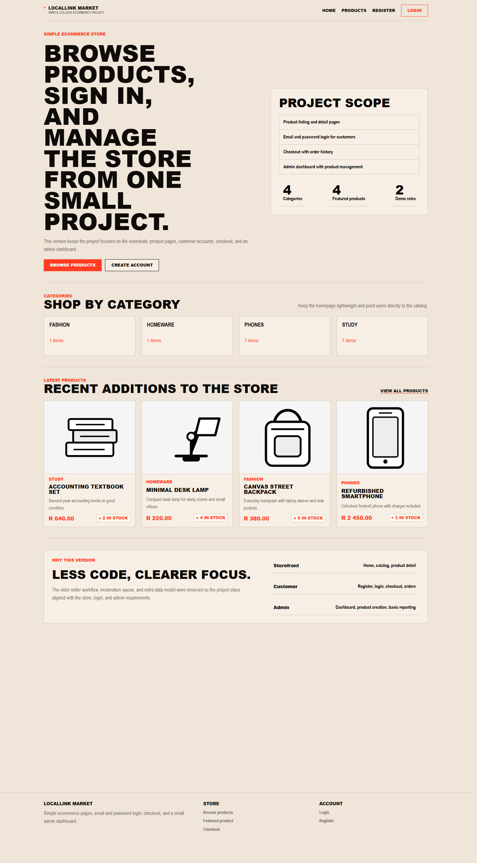
Figure 1. LocalLink homepage with category shortcuts, featured products, and account entry points.

5.2 Search, Filter, and Sort Products
The products page is the main catalog screen for finding the correct item quickly.
Step | Action
1 | Open Products from the top navigation bar or the homepage.
2 | Type a keyword in the Search field if you know part of the product name.
3 | Choose a category from the Category dropdown if you want to narrow the list.
4 | Use the Sort dropdown to arrange products by newest first or lowest price.
5 | Click Apply filters to refresh the list, or Clear to reset the catalog view.
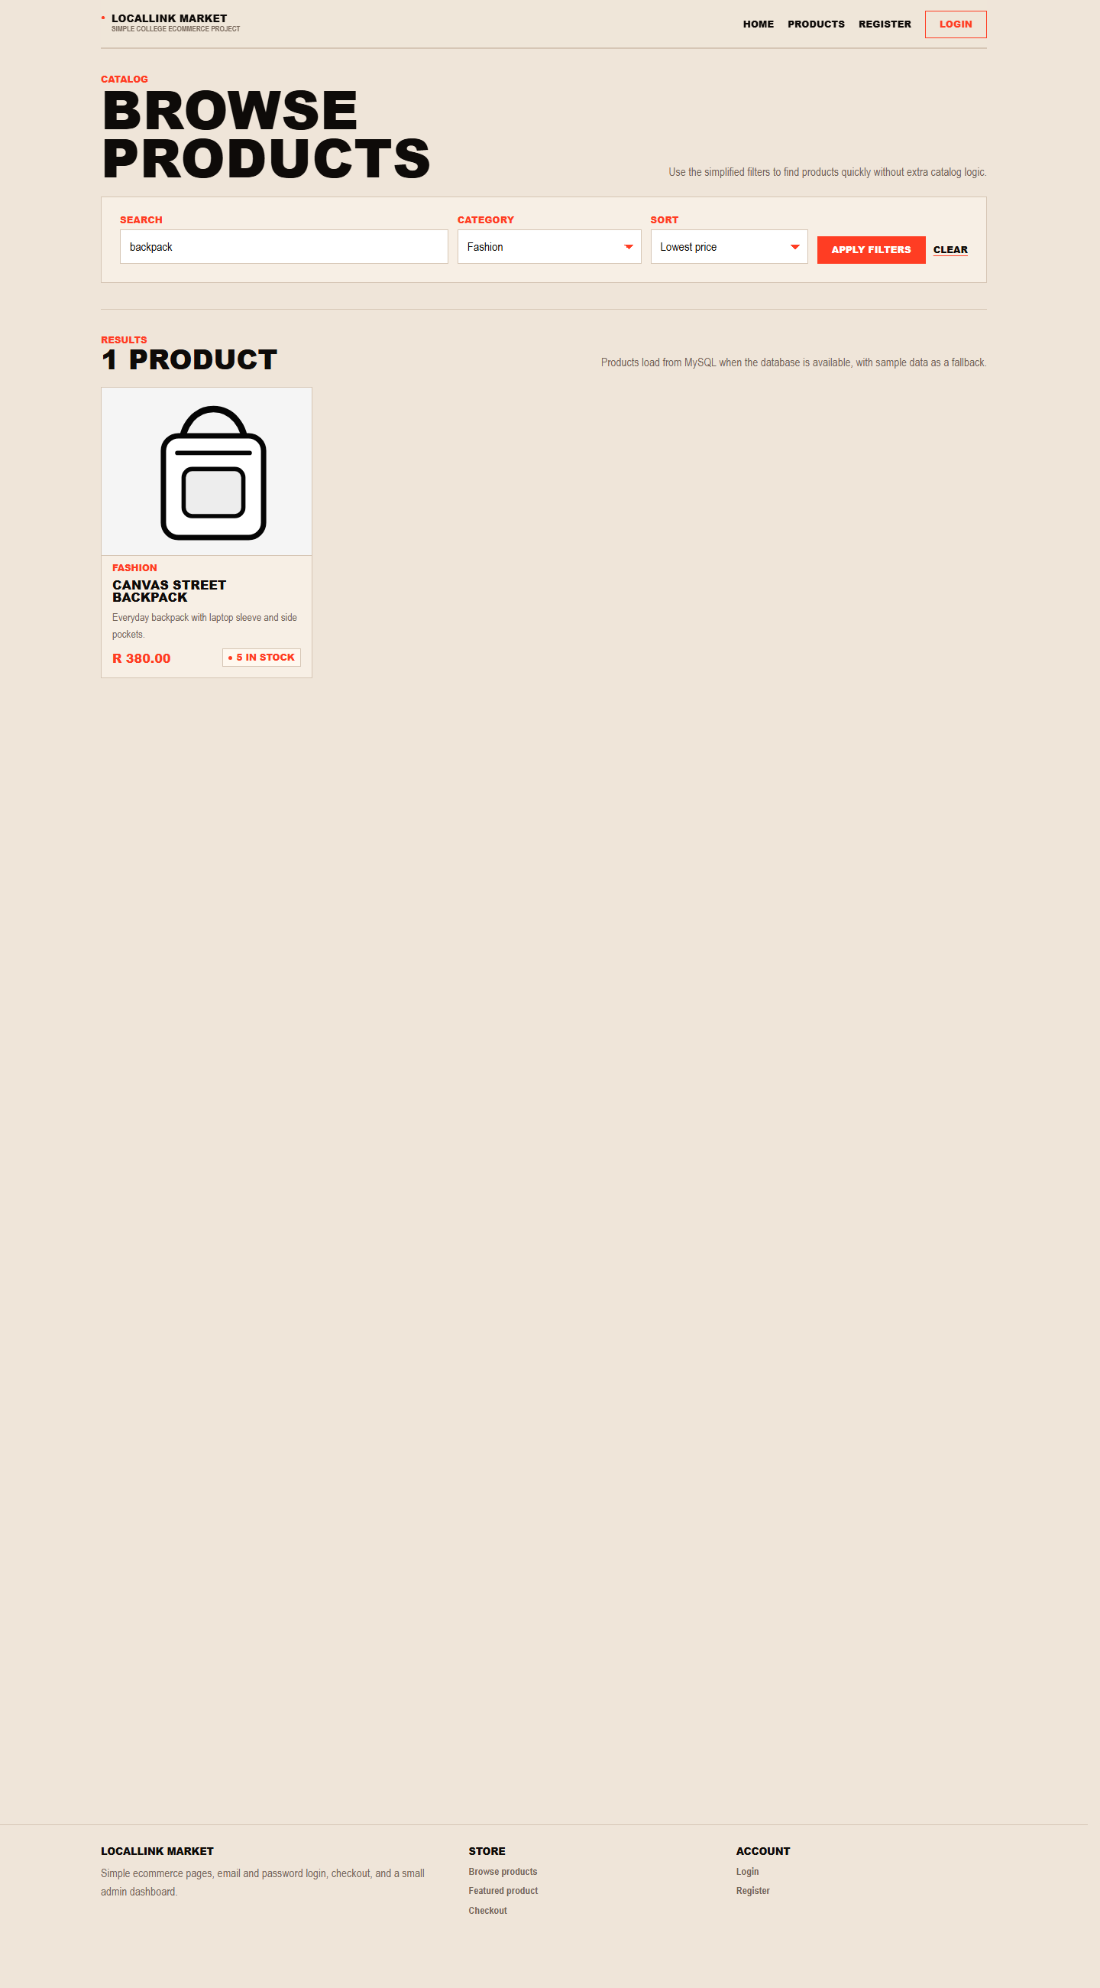
Figure 2. Product catalog with keyword search, category filter, and sorting controls.

5.3 View Product Details
Each product card links to a dedicated detail page where the customer can inspect the item before buying it.
Step | Action
1 | From the homepage or products page, click on a product card or product title.
2 | Review the product image, category label, price, stock level, and description.
3 | Use Buy now to move directly into checkout for that item, or Back to products to continue browsing.
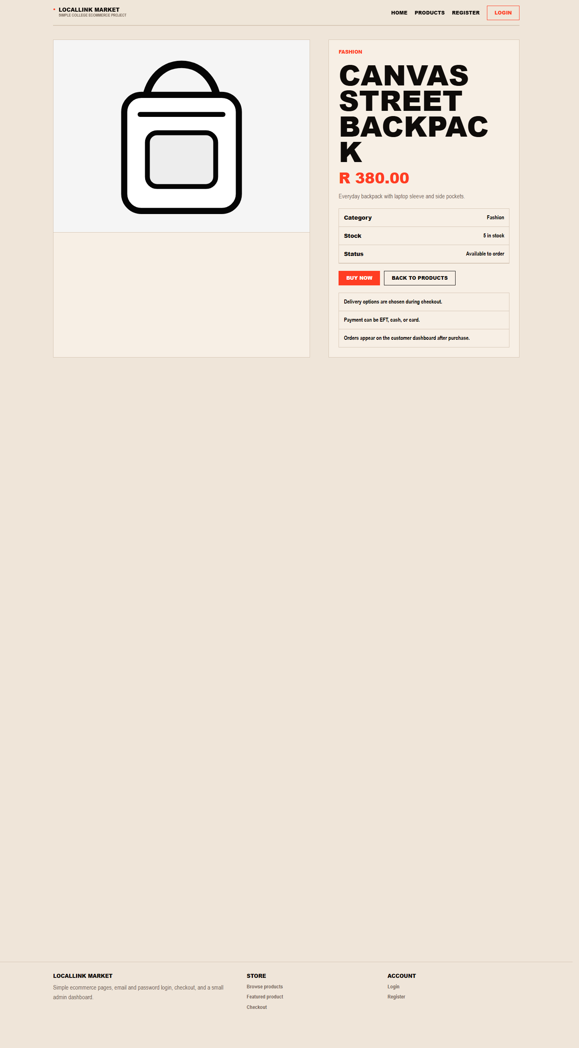
Figure 3. Product detail page with pricing, stock information, and the Buy now action.

5.4 Create a Customer Account
Public registration is available for customer accounts only. Administrator accounts are seeded directly through the database.
Step | Action
1 | Open Register from the top navigation or homepage.
2 | Enter your full name, valid email address, and a password with at least eight characters.
3 | Click Create account to submit the form.
4 | After a successful registration, continue to the login page and sign in with the new customer account.
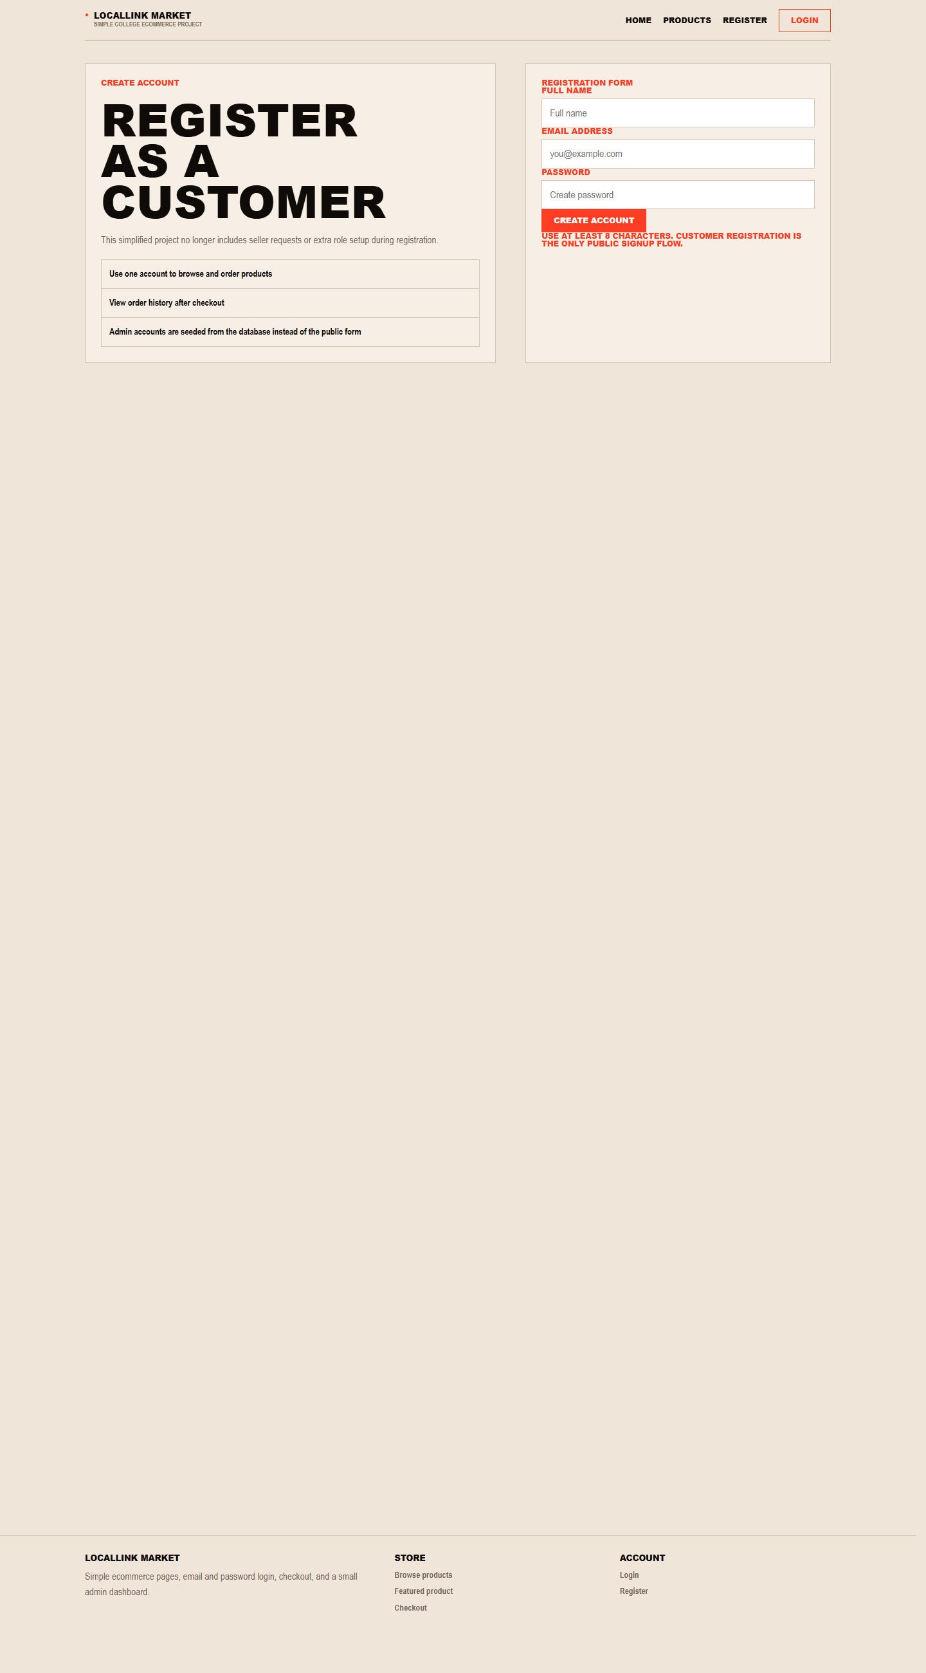
Figure 4. Customer registration form used to create a new public account.

5.5 Sign In to the Site
Both customers and administrators use the same login page. The system redirects each user to the correct dashboard based on the account role.
Step | Action
1 | Open the Login page from the top navigation.
2 | Enter your email address and password.
3 | Click Sign in.
4 | Customers are redirected to the buyer dashboard, while administrators are redirected to the admin dashboard.
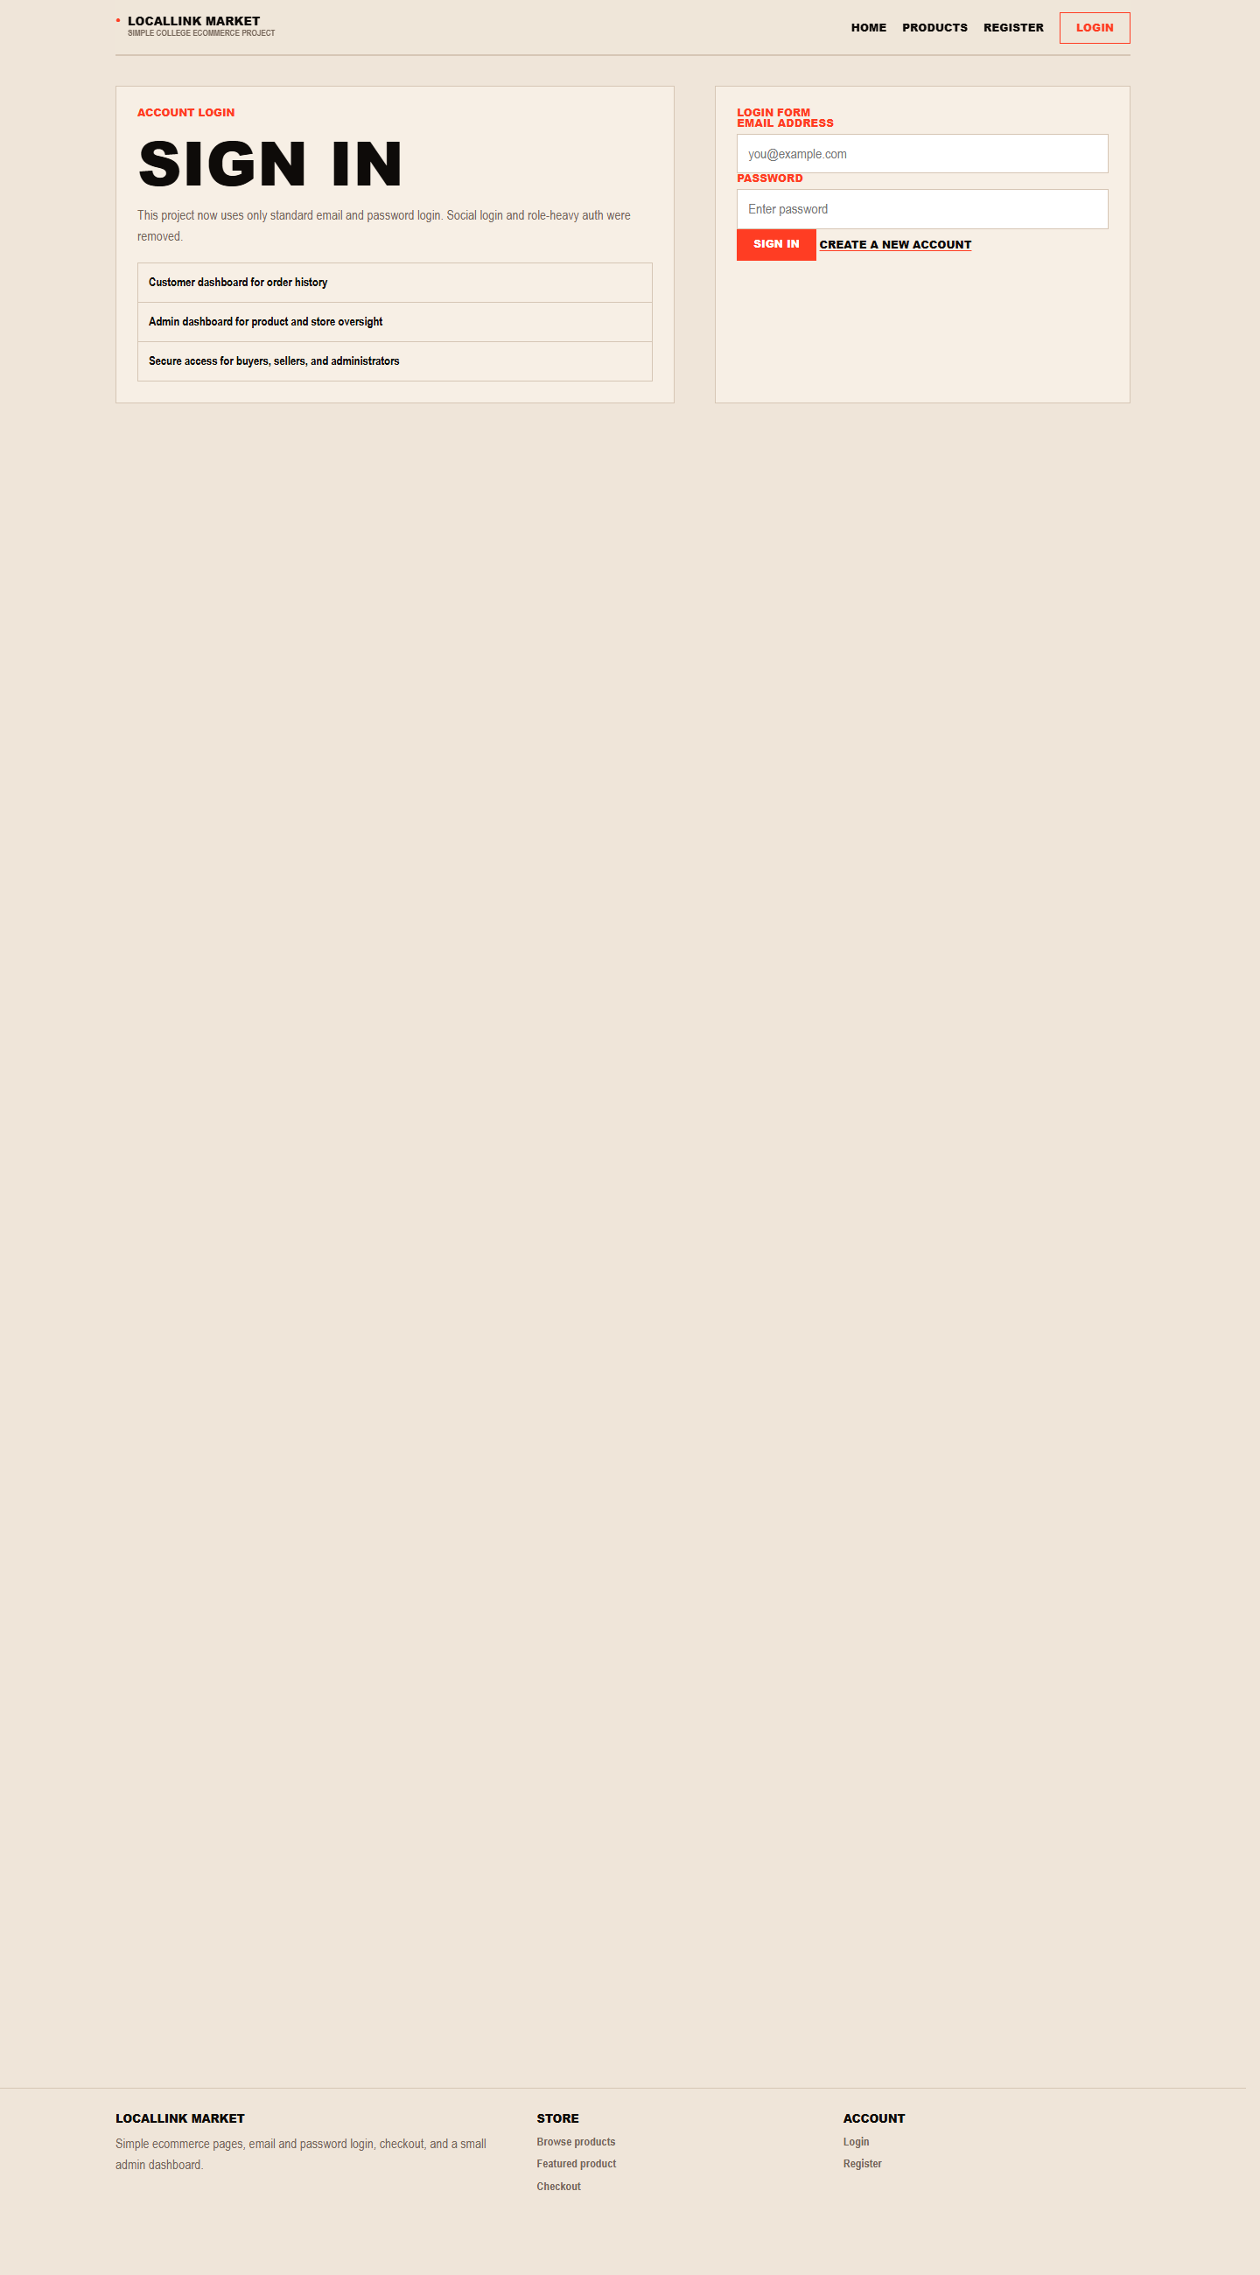
Figure 5. Shared login page for both customer and administrator accounts.

5.6 Complete Checkout
Checkout is only available to signed-in customers. The form captures order quantity, delivery, payment preference, and an optional note.
Step | Action
1 | Log in as a customer and open a product detail page.
2 | Click Buy now to open checkout for that specific item.
3 | Confirm the quantity in the Order details section.
4 | Choose a delivery method: standard delivery, express delivery, or collection.
5 | Choose the payment method. If card is selected, fill in the simulated card fields.
6 | Add any order note if needed, then click Pay and place order.
7 | After the order is created, the system redirects back to the buyer dashboard where the order appears in history.
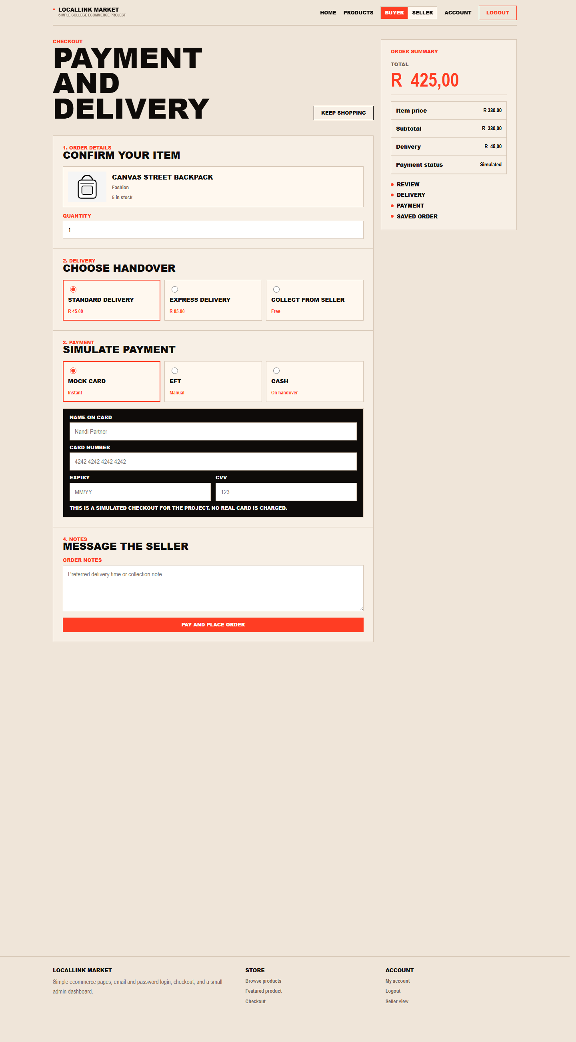
Figure 6. Checkout page showing quantity, delivery, payment, notes, and the live order summary.

5.7 Review the Buyer Dashboard
The buyer dashboard acts as the customer account area and provides a record of previous orders.
Step | Action
1 | Sign in with a customer account.
2 | Open My Account or allow the post-login redirect to take you to the dashboard.
3 | Review the summary cards for total orders, open orders, and total spent.
4 | Check the order history table for order number, product, quantity, status, total, and date.
5 | Use Browse products or Shop now if you want to return to the store.
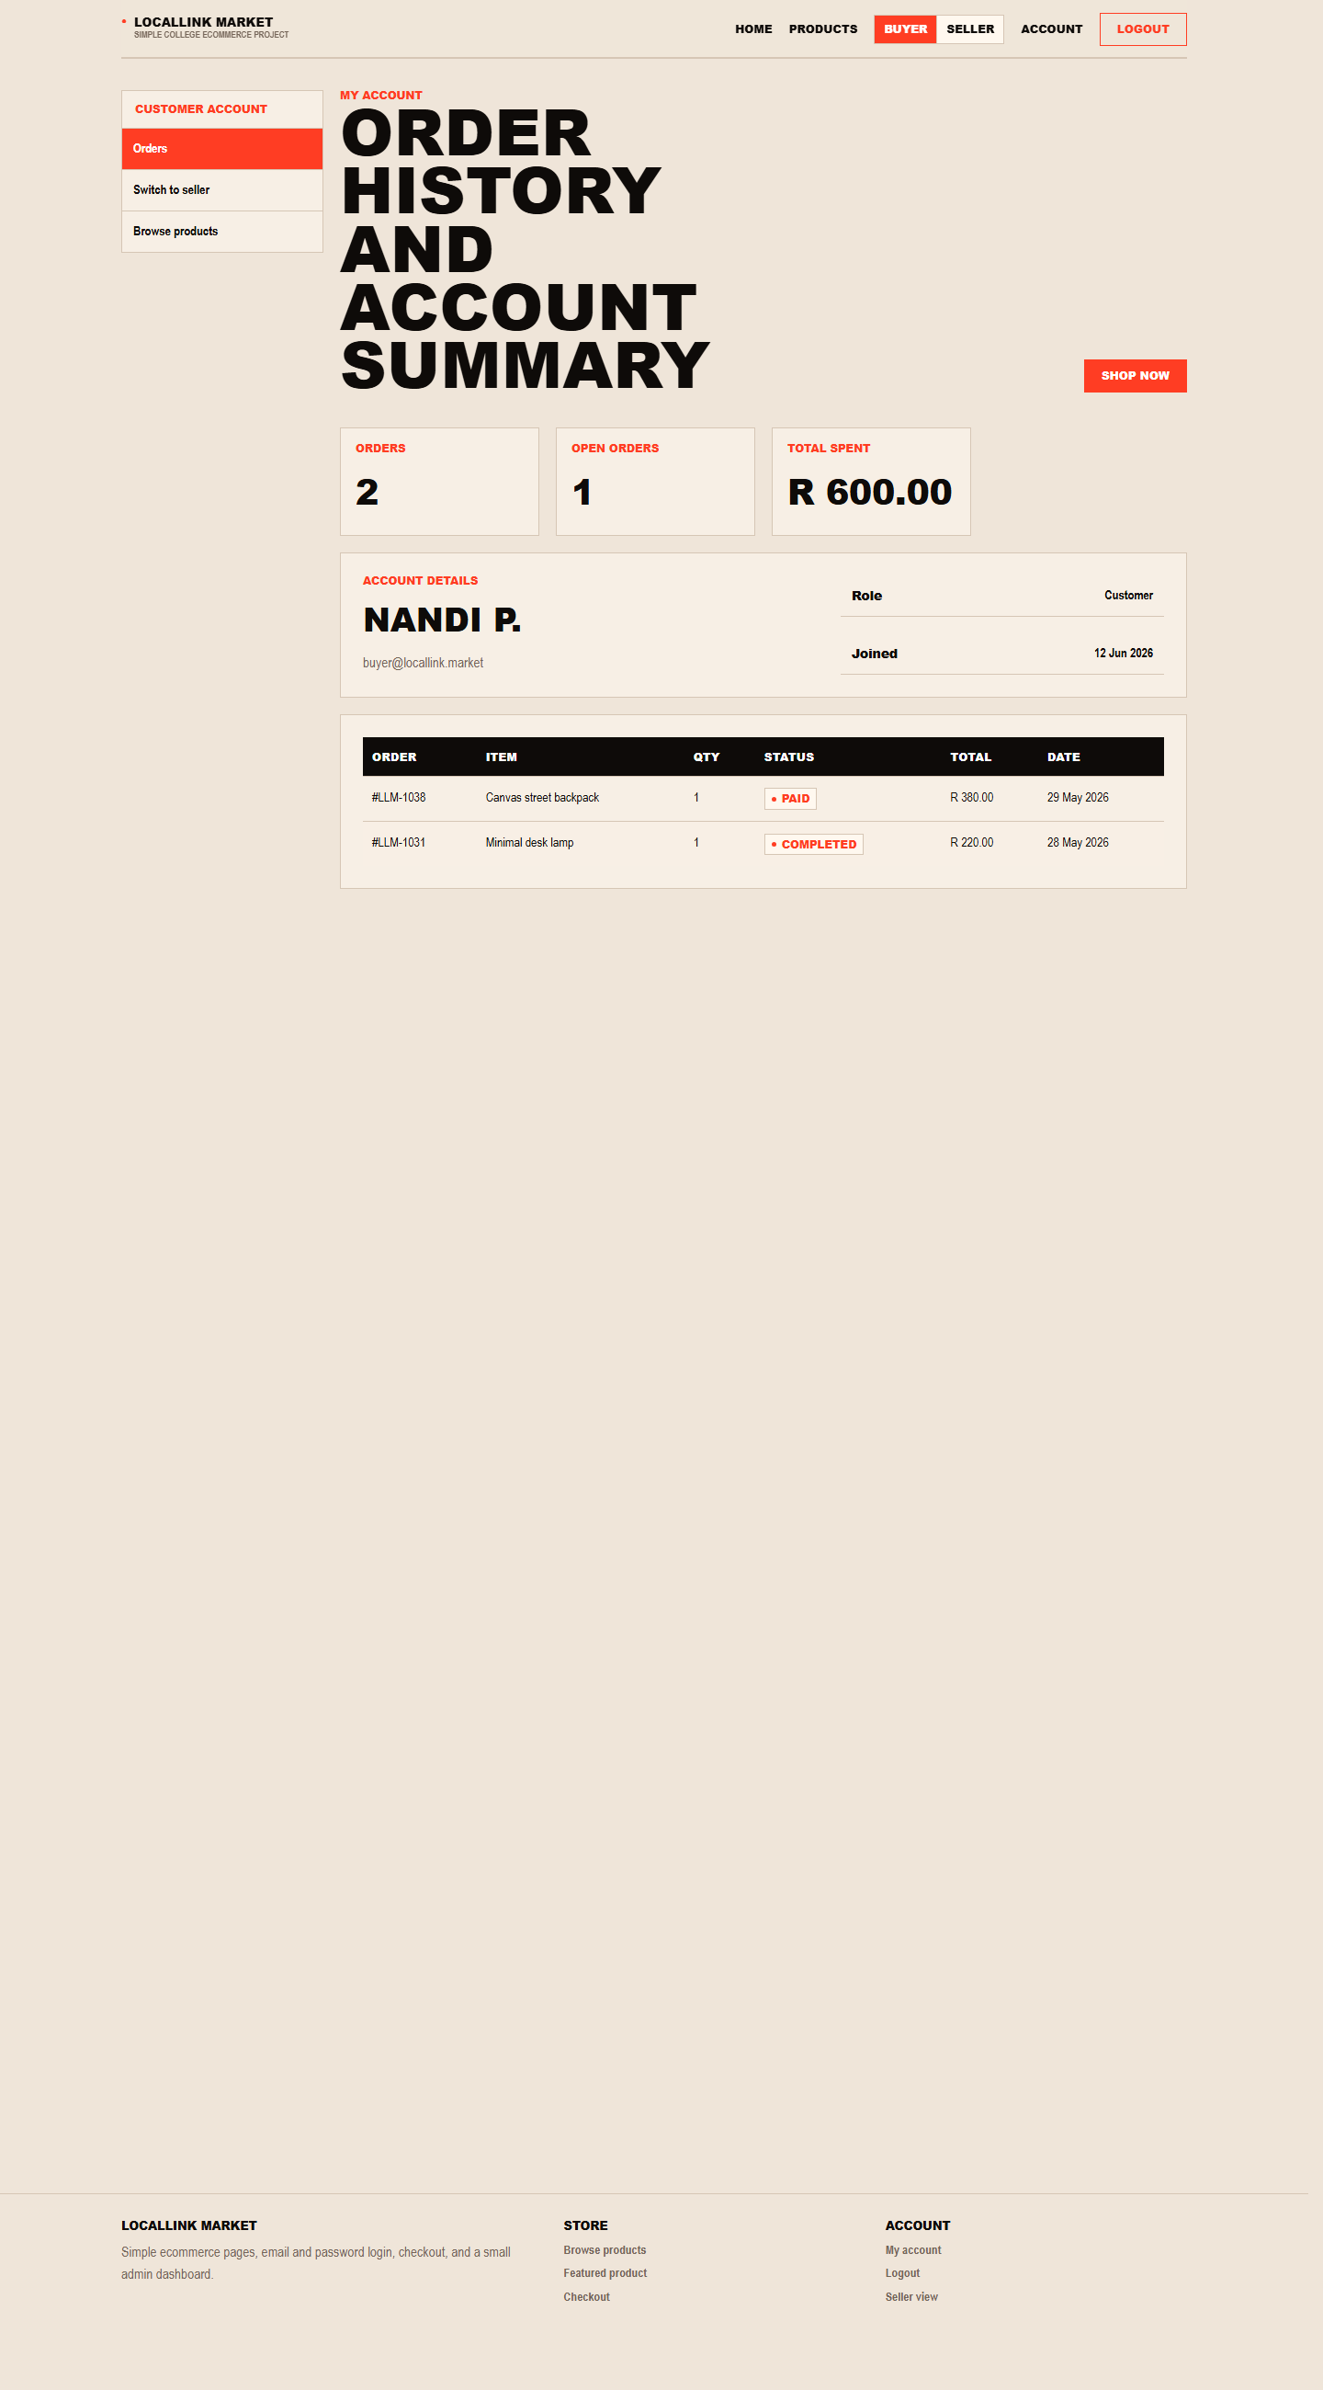
Figure 7. Buyer dashboard with account details, order summary cards, and order history.

5.8 Open and Use the Admin Dashboard
The administrator dashboard is the control surface for store reporting and quick oversight.
Step | Action
1 | Sign in with the administrator account.
2 | After login, the site redirects automatically to the admin dashboard.
3 | Review the summary cards for Users, Products, Orders, and Revenue.
4 | Use the Recent orders table to monitor current purchases.
5 | Use the Recent users table to review the latest signups.
6 | Use the left sidebar or Add Product button to move into product creation.
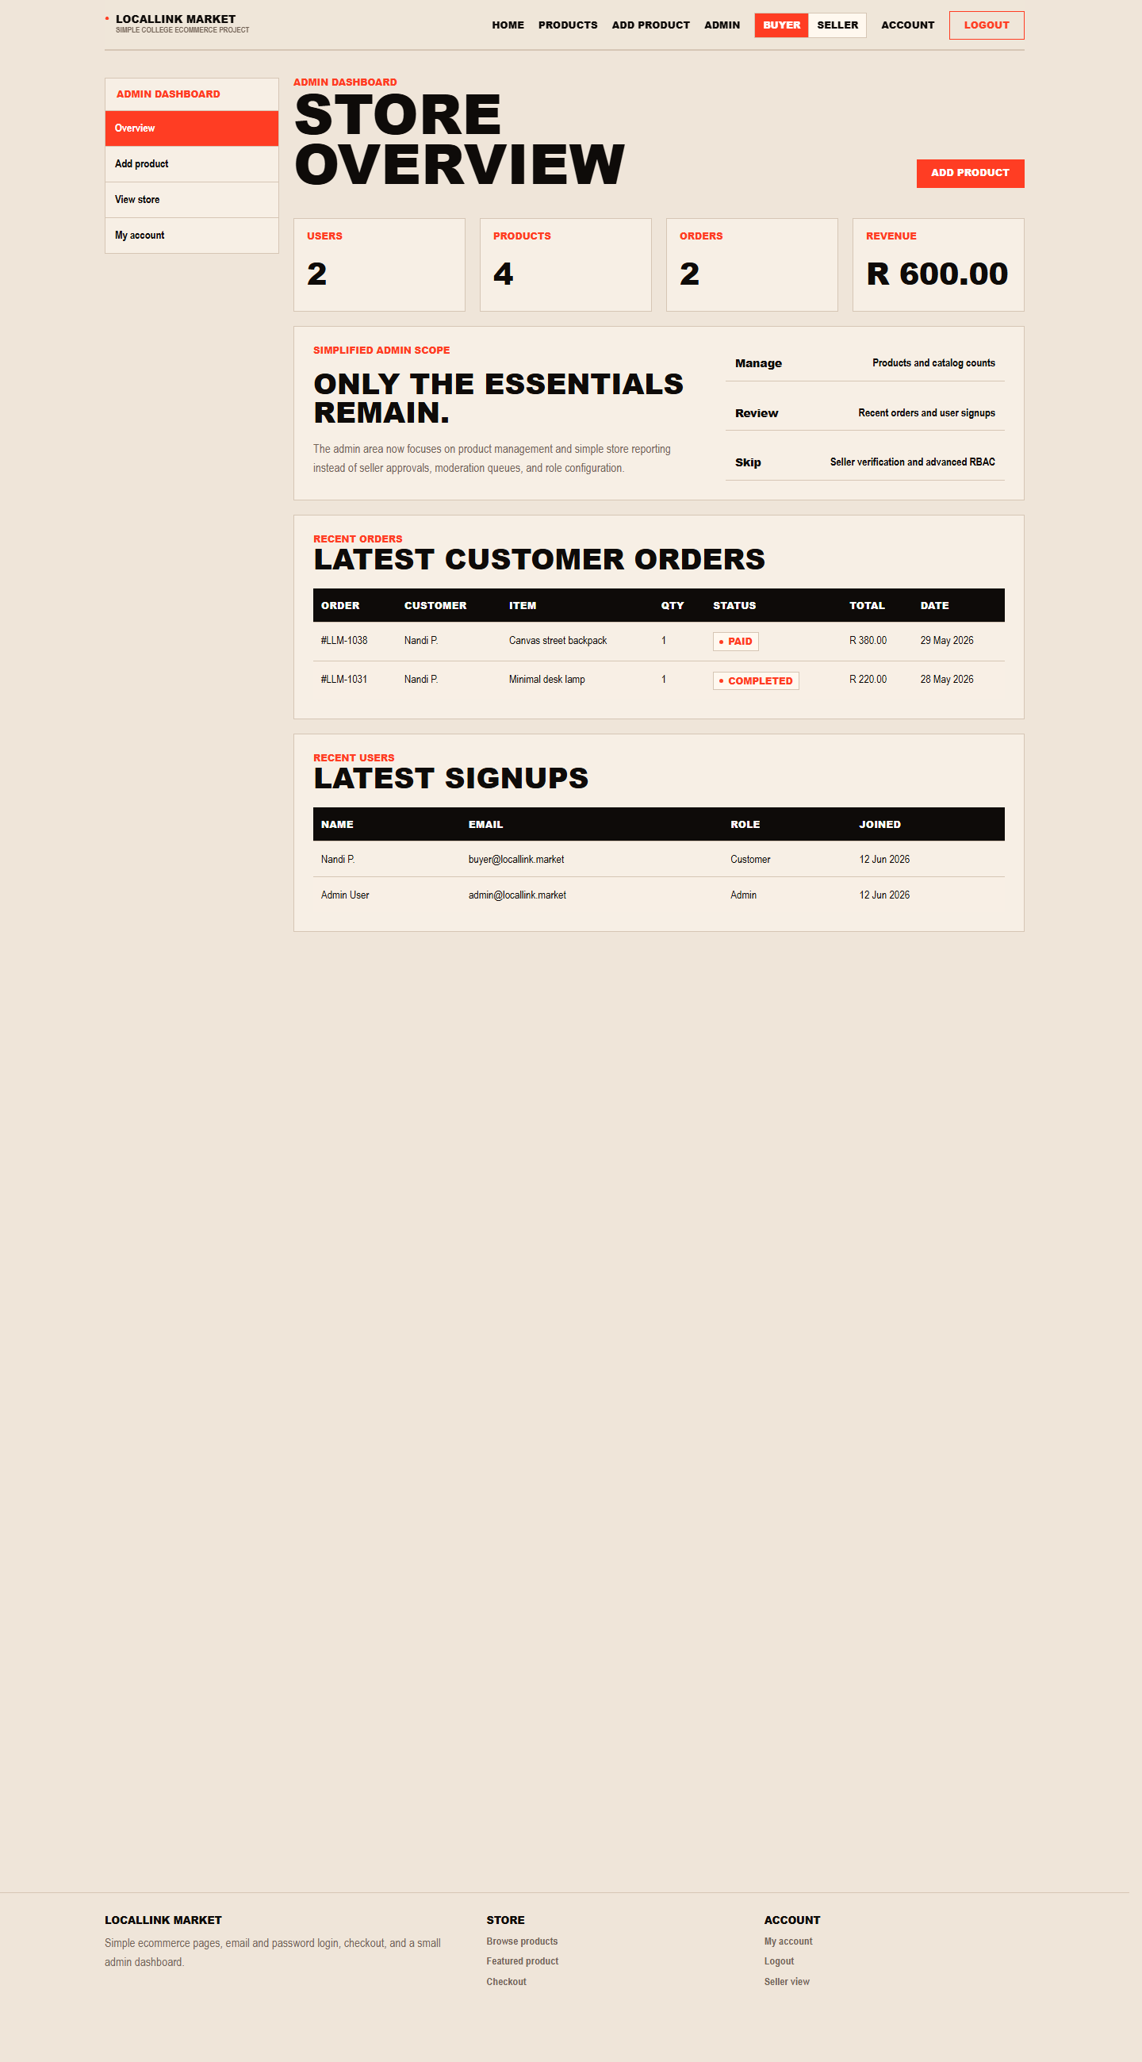
Figure 8. Administrator dashboard with store statistics, recent orders, and recent user signups.

5.9 Add a Product as an Administrator
Product creation is handled from the administrator side in the current LocalLink scope.
Step | Action
1 | Log in as an administrator and open Add product from the sidebar or dashboard button.
2 | Enter the product title.
3 | Choose the correct category from the dropdown list.
4 | Enter the price, stock quantity, and a short description.
5 | Click Save product to add the new listing to the database.
6 | Return to the admin dashboard or the storefront to confirm that the product has been created.
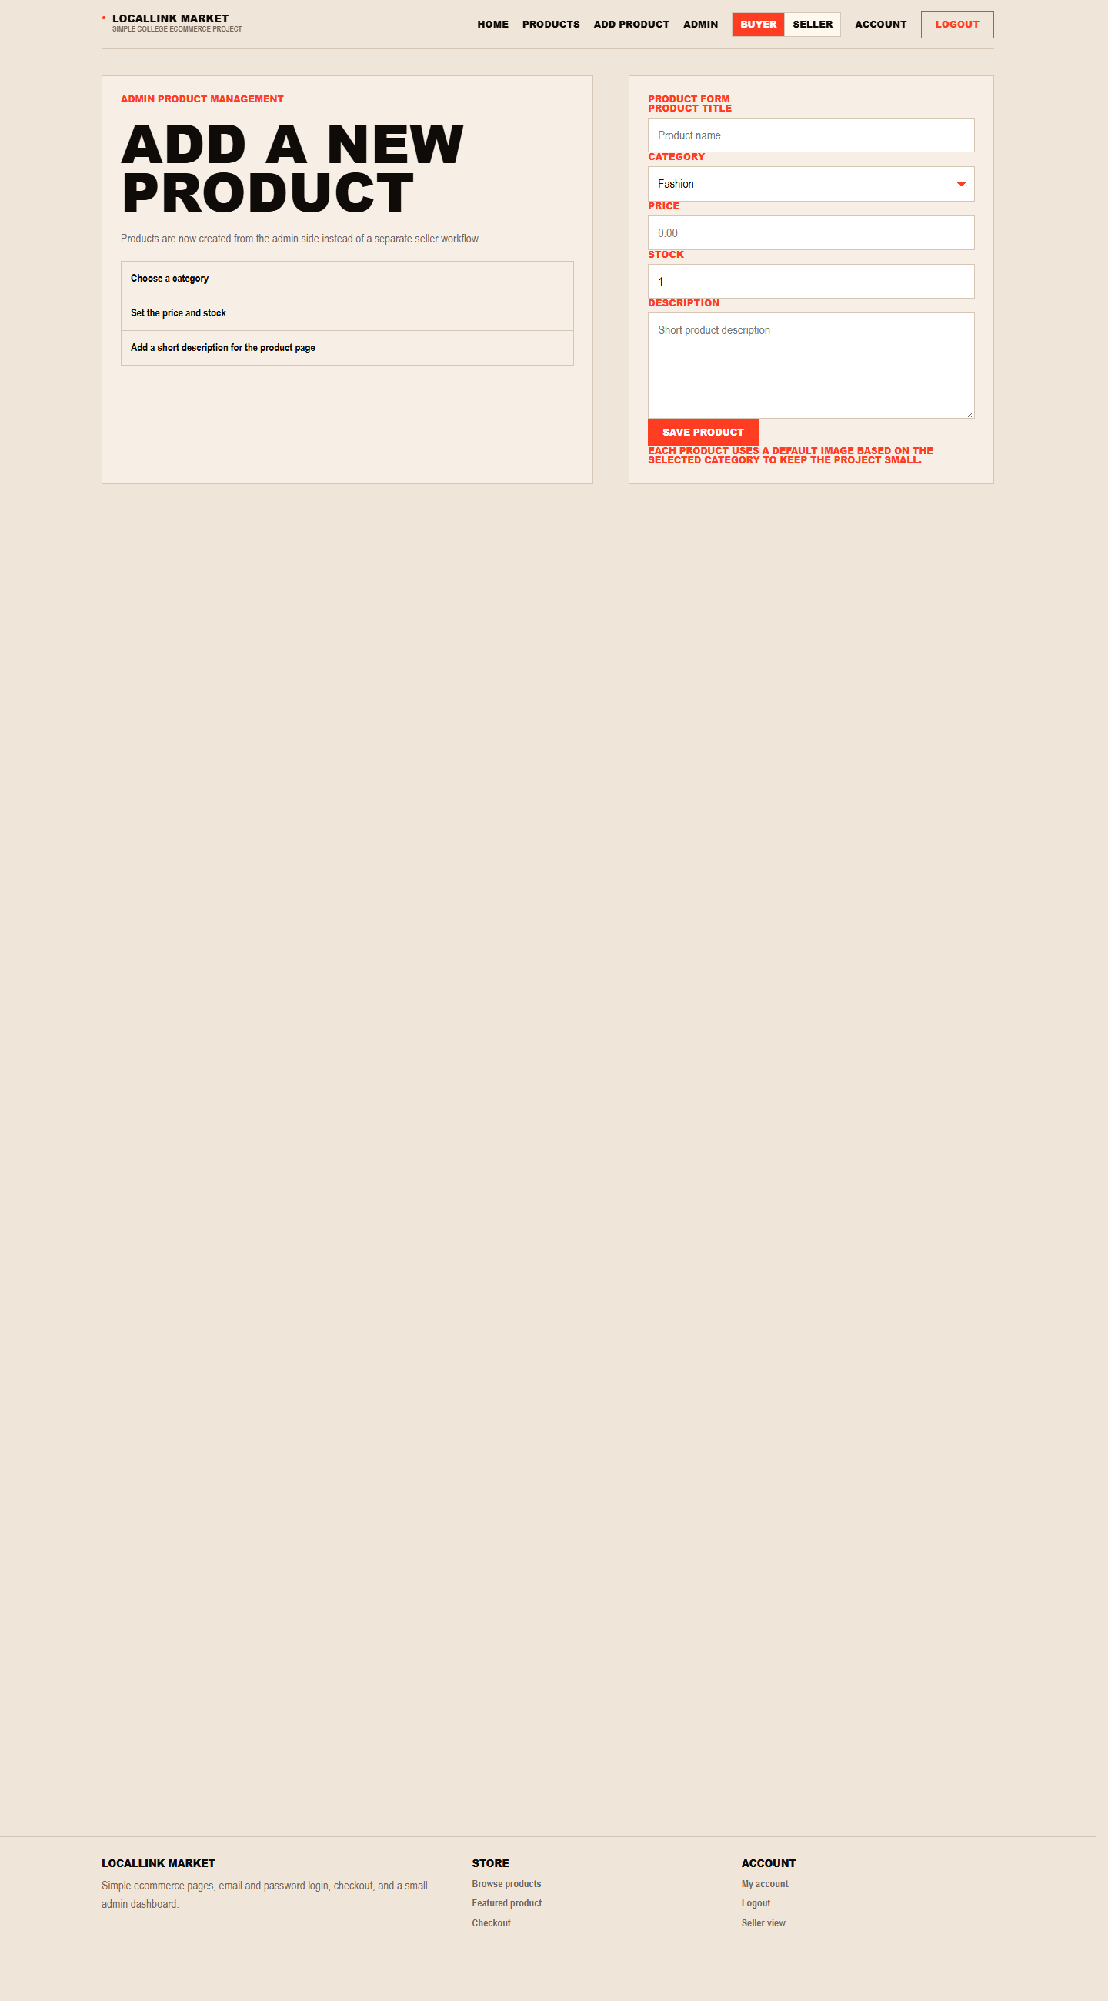
Figure 9. Administrator add-product form for catalog management.

6. Closing Notes
LocalLink Market was implemented as a lightweight PHP/MySQL marketplace focused on the required customer and administrator flows. The manual therefore concentrates on the features that are active in the current codebase: browsing, registration, login, checkout, order history, admin reporting, and product creation.
If the system is run on a new machine, import database/schema.sql and database/seed.sql first, then start MySQL and Apache through XAMPP before using the demo accounts listed in this document.

