ChordFinder

Description
ChordFinder is a Java-based music theory application that identifies possible triad chord names from three notes entered by a user. The system validates supported note spellings, maps notes to pitch positions, compares the submitted notes against maintained chord formulas, and returns all matching chord interpretations.
The application was designed using an object-oriented approach that focuses on modeling the main concepts in the Chord Finder domain as software objects. The design centers around the ChordFinderSystem, which coordinates note validation, chord identification, and formula maintenance. The main domain classes are ChordFinderSystem, ChordFormula, Chord, and Note.
ChordFinder also includes an administrator workflow for maintaining chord formulas. An administrator can define, edit, delete, and view chord formulas. Future chord searches use the current available formula set, which allows the system to be extended without redesigning the core chord identification behavior.
The project includes both JUnit unit tests and Cucumber BDD tests. The JUnit tests verify lower-level class behavior, while the Cucumber tests verify use-case behavior from the user and administrator perspective.

Design Process
I used an object-oriented design approach by first understanding the Chord Finder problem domain before writing code. I identified the major behaviors the system needed to support: a Chord Finder User can submit notes to identify possible chords, and an Administrator can maintain the chord formulas used by the system.
The development process started with noun analysis and domain modeling. I reviewed the requirements and extracted important nouns such as ChordFinderSystem, ChordFormulaCatalog, ChordFormula, Chord, Note, chord name, pitch position, chord quality, administrator, and chord finder user. I then evaluated each noun by asking whether it represented a meaningful object with state, behavior, and responsibility within the system.
The final domain model focused on five main classes: ChordFinderSystem, ChordFormulaCatalog, ChordFormula, Chord, and Note. Supporting ideas such as chord name, pitch position, formula intervals, chord quality, and display suffix were treated as attributes rather than separate classes. Actors such as Chord Finder User and Administrator were not modeled as domain classes because they interact with the system but are not objects the system needs to store or manage.
Each class was designed with a clear responsibility. Note handles note spelling, pitch position, validation, and interval distance. ChordFormula stores a chord pattern, quality, and suffix used to determine whether submitted notes match a formula. Chord represents an identified chord result using a root note and matching formula. ChordFormulaCatalog manages the collection of maintained formulas, including adding, editing, deleting, and viewing formulas. ChordFinderSystem coordinates the overall application by validating submitted notes, identifying chords, and using the formula catalog to maintain chord definitions.
The design was refined through use case modeling, sequence diagrams, and traceability between requirements, design, implementation, and tests. The implementation was then completed in Java, with automated testing using JUnit for unit tests and Cucumber BDD scenarios for behavior-level validation.
Overall, the project moved from requirements analysis, to noun analysis, to domain modeling, to use case and sequence modeling, to Java implementation, and finally to automated testing. This process helped keep the code aligned with the original Chord Finder requirements while still allowing the design to support future changes to chord formulas.

Table of Contents
- ChordFinder
  - Description
  - Design Process
  - Table of Contents
  - Noun Analysis
  - Domain Modeling
  - Use Cases
    - Find Chord
    - Maintain Chord Formula
  - UML Class Diagram
    - Classes
  - Application Flow
  - Design Decisions
  - Object-Oriented Design Principles
  - BDD Traceability to Use Cases
    - Find Chord BDD Traceability
  - Behavior BDD Scenario
    - Maintain Chord Formula BDD Traceability
  - Behavior BDD Scenario
    - BDD Scenarios
  - TDD Traceability to Methods
  - Class / Method TDD Test
    - Traceability Summary
  - Installation
    - Prerequisites
    - Clone the Project

Noun Analysis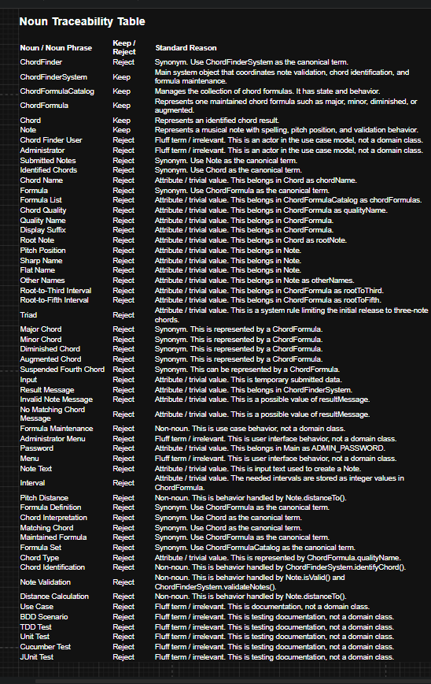

Domain Modeling
The domain model was created by identifying the meaningful entities that exist in the Chord Finder system universe and validating whether each object has meaningful state and behavior.
The core domain objects are:
ChordFinderSystem
ChordFormulaCatalog
ChordFormula
Chord
Note
ChordFinderSystem represents the main application object that coordinates the system behavior. It receives submitted note text, validates the notes, identifies matching chords, stores the submitted notes, stores the identified chord results, and provides access to formula maintenance behavior through the ChordFormulaCatalog. The ChordFinderSystem does not represent one chord or one formula; it represents the overall system that controls the chord-finding process.
ChordFormulaCatalog represents the maintained collection of chord formulas used by the system. It owns the list of ChordFormula objects and is responsible for adding, editing, deleting, finding, and returning chord formulas. This separates formula maintenance from the main ChordFinderSystem so the system can coordinate the use cases while the catalog manages the formula collection.
ChordFormula represents one maintained chord formula definition. It stores the chord quality name, display suffix, and interval values such as root-to-third and root-to-fifth. A ChordFormula is responsible for determining whether a submitted set of notes matches that formula by comparing pitch distances from a possible root note.
Chord represents an identified chord result. It contains the root note, the chord formula that matched, the notes used to identify the chord, and the generated chord name. For example, if the submitted notes match a C major formula, the Chord object represents the identified result such as C, Cm, Cdim, or Caug depending on the matching formula.
Note represents a submitted or recognized musical note. It stores the note spelling, pitch position, sharp-oriented name, flat-oriented name, and other recognized names. Note is responsible for validating note text, creating Note objects from submitted input, and calculating the distance between pitch positions so chord formulas can determine matches.
This domain model keeps the system focused on the objects needed to support the required behavior without adding unnecessary classes for simple values or out-of-scope music theory concepts.
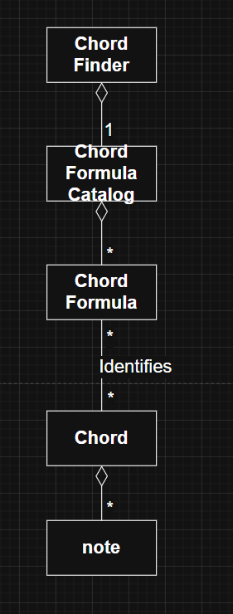
alt text

Use Cases
The primary use cases in the ChordFinder application are Find Chord and Maintain Chord Formula.
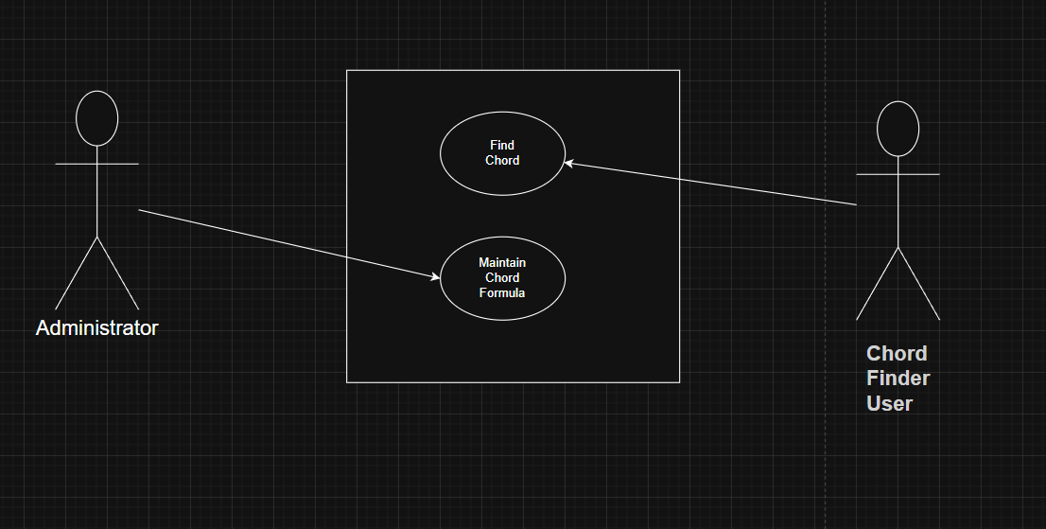
alt text

Find Chord
Primary Actor: Chord Finder User
The Chord Finder User enters exactly three notes and submits them for chord identification. The system validates the notes, compares them against the available chord formulas, and displays all matching chord names.
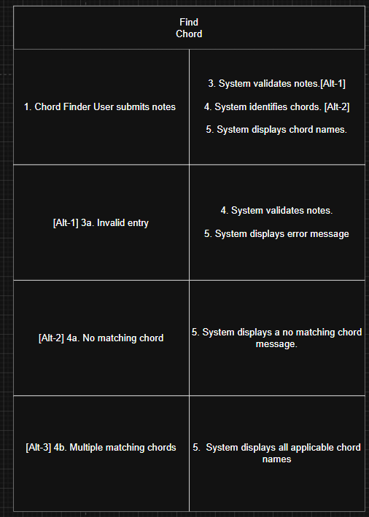
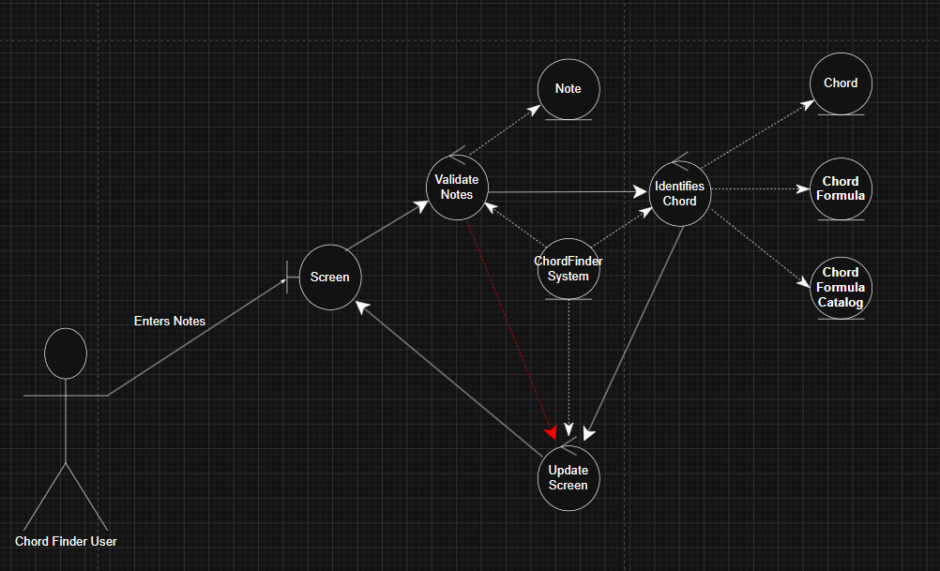
alt text
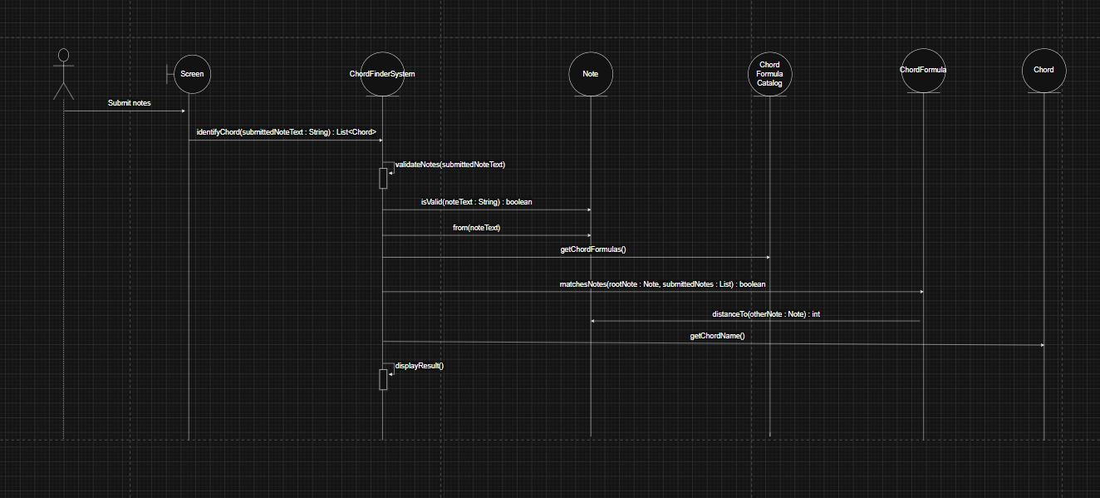
alt text
Alternative flows:
- If fewer than three notes are entered, the system displays an invalid note count message.
- If more than three notes are entered, the system displays an invalid note count message.
- If a note spelling is invalid, the system displays an invalid note message.
- If valid notes do not match any chord formula, the system displays a no matching chord message.
- If more than one chord interpretation exists, the system displays all matching chord names.

Maintain Chord Formula
Primary Actor: Administrator
The Administrator maintains the chord formulas used by future chord searches. This use case includes defining, editing, deleting, and viewing chord formulas.
Main flow:
Supported actions:
- Define Chord Formula
- Edit Chord Formula
- Delete Chord Formula
- View Chord Formulas
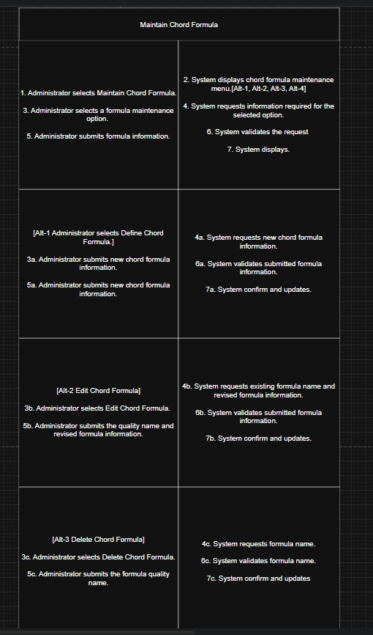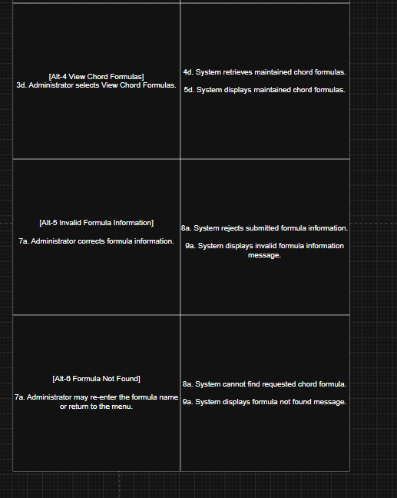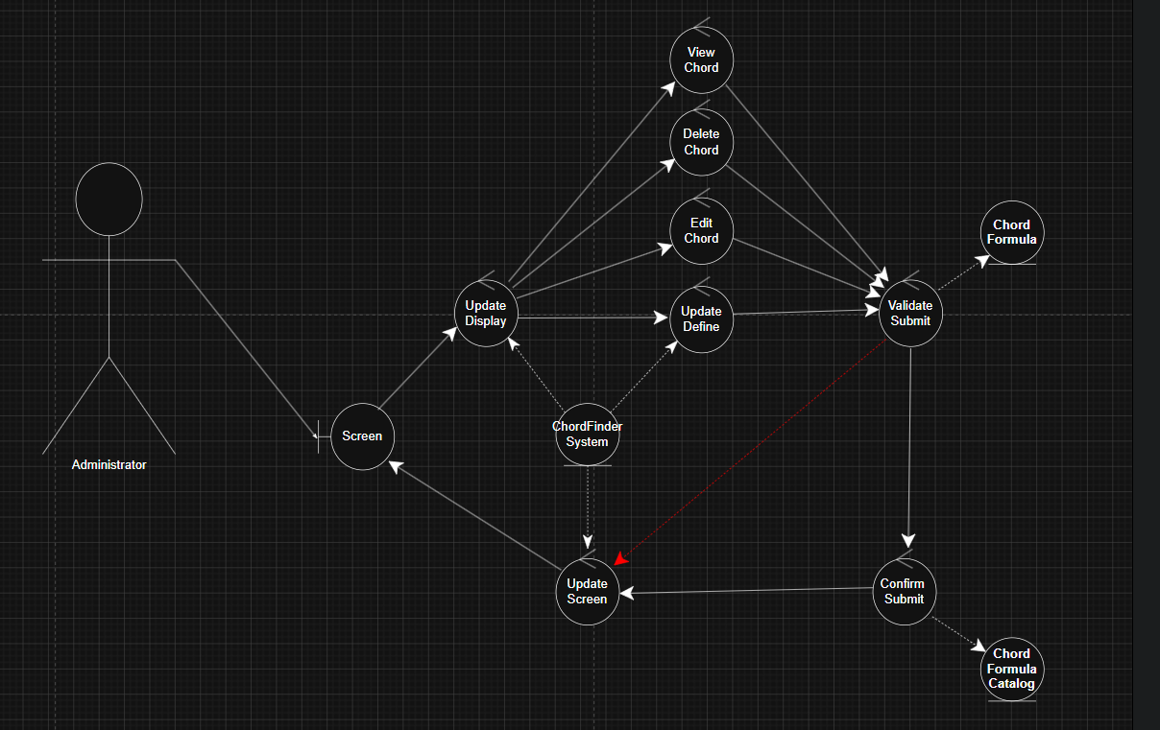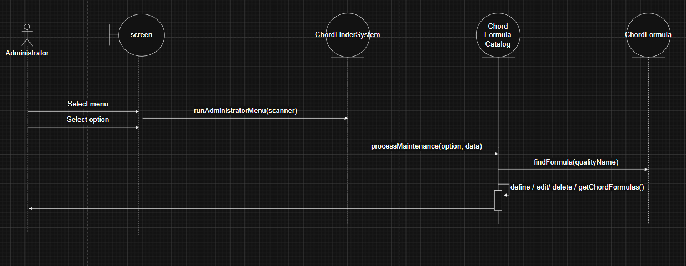

UML Class Diagram
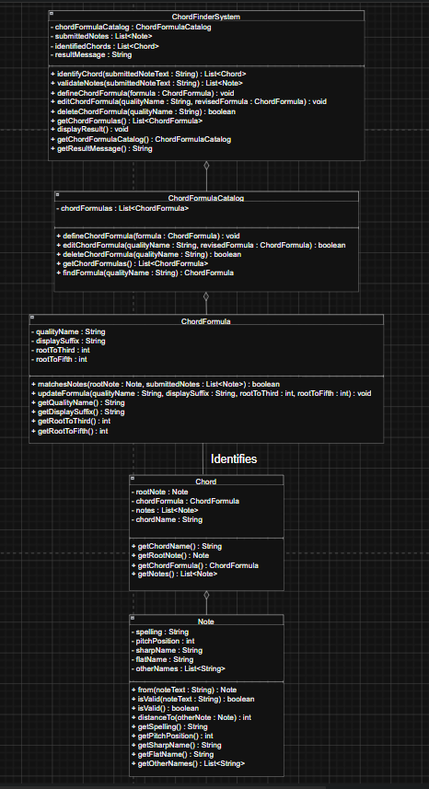

Classes
Class: ChordFinderSystem
- chordFormulaCatalog : ChordFormulaCatalog
- submittedNotes : List
- identifiedChords : List
- resultMessage : String
- identifyChord(submittedNoteText : String) : List
- validateNotes(submittedNoteText : String) : List
- defineChordFormula(formula : ChordFormula) : void
- editChordFormula(qualityName : String, revisedFormula : ChordFormula) : void
- deleteChordFormula(qualityName : String) : boolean
- getChordFormulas() : List
- displayResult() : void
- getChordFormulaCatalog() : ChordFormulaCatalog
- getResultMessage() : String
Class: ChordFormulaCatalog
- chordFormulas : List
- defineChordFormula(formula : ChordFormula) : void
- editChordFormula(qualityName : String, revisedFormula : ChordFormula) : boolean
- deleteChordFormula(qualityName : String) : boolean
- getChordFormulas() : List
- findFormula(qualityName : String) : ChordFormula
Class: ChordFormula
- qualityName : String
- displaySuffix : String
- rootToThird : int
- rootToFifth : int
- matchesNotes(rootNote : Note, submittedNotes : List
- ) : boolean
- updateFormula(qualityName : String, displaySuffix : String, rootToThird : int, rootToFifth : int) : void
- getQualityName() : String
- getDisplaySuffix() : String
- getRootToThird() : int
- getRootToFifth() : int
Class: Chord
- rootNote : Note
- chordFormula : ChordFormula
- notes : List
- chordName : String
- getChordName() : String
- getRootNote() : Note
- getChordFormula() : ChordFormula
- getNotes() : List
Class: Note
- spelling : String
- pitchPosition : int
- sharpName : String
- flatName : String
- otherNames : List
- from(noteText : String) : Note
- isValid(noteText : String) : boolean
- isValid() : boolean
- distanceTo(otherNote : Note) : int
- getSpelling() : String
- getPitchPosition() : int
- getSharpName() : String
- getFlatName() : String
- getOtherNames() : List
Class: Main
- ADMIN_PASSWORD : String
- main(args : String[]) : void
- runChordFinderUser(scanner : Scanner, chordFinderSystem : ChordFinderSystem) : void
- runAdministratorLogin(scanner : Scanner, chordFinderSystem : ChordFinderSystem) : void
- runAdministratorMenu(scanner : Scanner, chordFinderSystem : ChordFinderSystem) : void
- defineChordFormula(scanner : Scanner, chordFinderSystem : ChordFinderSystem) : void
- editChordFormula(scanner : Scanner, chordFinderSystem : ChordFinderSystem) : void
- deleteChordFormula(scanner : Scanner, chordFinderSystem : ChordFinderSystem) : void
- viewChordFormulas(chordFinderSystem : ChordFinderSystem) : void
- readChordFormula(scanner : Scanner) : ChordFormula

Application Flow
The application begins by asking whether the person using the program is a Chord Finder User or an Administrator.
If the person selects Chord Finder User, the system starts the Find Chord workflow. The user enters three notes separated by spaces. The system validates the input, checks the notes against the available formulas, and displays the matching chord names.
If the person selects Administrator, the system asks for the administrator password. After a successful login, the administrator can define, edit, delete, or view chord formulas. Any changes made to the formula list affect future chord searches.
The core application flow is:
- Start application.
- Select role.
- Run Find Chord or Maintain Chord Formula.
- Validate input.
- Process the selected behavior.
- Display result.
- Return to menu or exit.
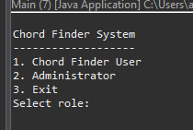
alt text
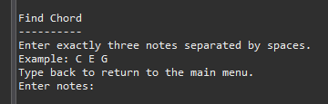
alt text
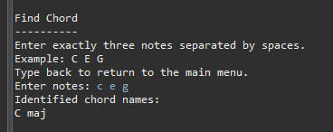
alt text
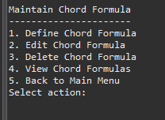
alt text
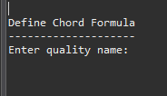
alt text
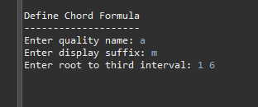
alt text
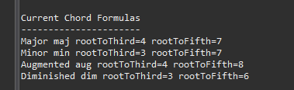
alt text
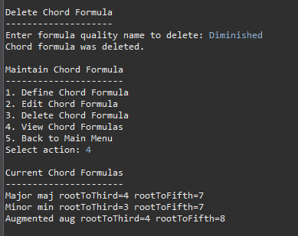

Design Decisions
The design keeps the Chord Finder system focused on the required behavior: identifying possible chord names from three submitted notes and allowing an administrator to maintain chord formulas.
A separate ChordFormulaCatalog class was added to manage the collection of chord formulas. This keeps formula maintenance responsibilities, such as adding, editing, deleting, finding, and returning formulas, separate from the main ChordFinderSystem.
ChordFormula was kept as its own class because it represents one chord definition, such as major, minor, diminished, or augmented. It stores the formula name, display suffix, and interval values used to determine whether submitted notes match that chord type.
Chord was kept separate from ChordFormula because a formula is only a definition, while a chord is an identified result. For example, major is a formula, but C major is an identified chord.
Note was modeled as its own class because notes have meaningful state and behavior. A note stores spelling and pitch position information, and it supports validation and pitch-distance calculations needed by chord formulas.
The system avoids unnecessary classes for simple values such as interval numbers, suffix text, or chord names. These are treated as attributes because they do not need separate behavior in the initial release.
The initial release is limited to triads, so each identified chord is based on three notes. This keeps the model aligned with the client’s current requirements without adding extra complexity for seventh chords, inversions, voicings, sound playback, or advanced music theory concepts.
Overall, the design separates responsibilities clearly: ChordFinderSystem coordinates the use cases, ChordFormulaCatalog manages formula storage, ChordFormula defines chord patterns, Note handles note behavior, and Chord represents the final identified result.

Object-Oriented Design Principles
The design uses encapsulation by keeping each class responsible for its own data and behavior. ChordFormula stores its own formula values and contains the behavior needed to determine whether notes match that formula. Note stores note information and handles note validation and pitch-distance calculations.
The design uses single responsibility by giving each class one main purpose. ChordFinderSystem coordinates the main system behavior. ChordFormulaCatalog manages the collection of chord formulas. ChordFormula represents one formula definition. Chord represents an identified chord result. Note represents a musical note.
The design uses separation of concerns by keeping formula maintenance separate from chord identification. ChordFormulaCatalog handles adding, editing, deleting, finding, and returning formulas, while ChordFinderSystem focuses on validating submitted notes and identifying chord results.
The design uses aggregation where one object owns or manages a group of related objects. ChordFinderSystem owns one ChordFormulaCatalog, and ChordFormulaCatalog maintains many ChordFormula objects. A Chord also contains the Note objects used to identify it.
The design supports low coupling because classes interact through clear method calls instead of directly managing each other’s internal data. For example, ChordFinderSystem asks ChordFormulaCatalog for formulas instead of directly controlling the formula list.
The design supports high cohesion because each class contains behavior that closely matches its purpose. Note handles note behavior, ChordFormula handles formula matching, ChordFormulaCatalog handles formula collection management, and Chord represents the identified result.
The design avoids unnecessary classes for simple values. Items such as display suffix, interval numbers, and chord names are modeled as attributes because they do not need their own separate behavior in the initial release.
Overall, the design follows object-oriented principles by organizing the system around meaningful objects with clear responsibilities, meaningful state, and behavior that supports the required use cases.

BDD Traceability to Use Cases
The BDD tests trace directly back to the main Chord Finder use cases. Each scenario confirms that the system behavior described in the use cases is supported by the design and implementation.
The Find Chord use case is covered by scenarios where a user submits three valid notes and the system identifies the correct chord. For example, when the user submits C E G, the system identifies C major. When the user submits C Eb G, the system identifies C minor. These scenarios confirm that the system can validate submitted notes, compare them against maintained chord formulas, and return matching chord names.
The Find Chord use case is also covered by alternate scenarios. If the user submits invalid note input, fewer than three notes, or more than three notes, the system rejects the input and does not identify a chord. If the user submits three valid notes that do not match any maintained chord formula, the system returns no matching chord result. These scenarios trace to the validation and no-match alternate paths in the use case.
The Maintain Chord Formula use case is covered by administrator scenarios for adding, editing, deleting, and viewing chord formulas. The define formula scenario confirms that a new ChordFormula can be added to the ChordFormulaCatalog and then used by the system during chord identification. The edit formula scenario confirms that an existing formula can be revised. The delete formula scenario confirms that a removed formula is no longer used to identify chords. The view formula scenario confirms that the system can return the maintained list of chord formulas.
The BDD scenarios also verify the connection between the two use cases. Formula maintenance affects chord identification because the ChordFinderSystem uses the ChordFormulaCatalog when matching submitted notes. This means that adding, editing, or deleting a formula changes what chords the system can identify.
Overall, the BDD tests provide traceability from the use case requirements to the system behavior. They show that the system supports the main paths and alternate paths for both finding chords and maintaining chord formulas.

Find Chord BDD Traceability

Behavior BDD Scenario
User submits valid major triad Identify G major from D G B
User submits valid minor triad Identify C minor from C Eb G
User submits augmented triad Identify multiple augmented chords from B D# G
User submits fewer than three notes Reject fewer than three notes
User submits more than three notes Reject more than three notes
User submits invalid note spelling Reject invalid note spelling
User submits valid notes with no match Display no matching chord message

Maintain Chord Formula BDD Traceability

Behavior BDD Scenario
Administrator defines new chord formula Add suspended fourth formula
Administrator edits existing chord formula Edit existing chord formula values
Administrator deletes chord formula Delete minor chord formula
Administrator views chord formulas View maintained chord formula list
Administrator adds formula used by search Identify chord using newly added formula
Administrator deletes formula used by search Removed formula is no longer used
Administrator edits formula used by search Updated formula changes chord matching
Administrator enters unknown formula name Display formula not found message

BDD Scenarios
Feature: Find Chord
Scenario: Identify G major from D G B
Given the Chord Finder system has a maintained major chord formula When the user submits D G B Then the system validates the submitted notes And the system identifies G as a matching chord
Scenario: Identify C minor from C Eb G
Given the Chord Finder system has a maintained minor chord formula When the user submits C Eb G Then the system validates the submitted notes And the system identifies Cm as a matching chord
Scenario: Identify multiple augmented chords from B D# G
Given the Chord Finder system has a maintained augmented chord formula When the user submits B D# G Then the system validates the submitted notes And the system identifies Baug as a matching chord And the system identifies D#aug as a matching chord And the system identifies Gaug as a matching chord
Scenario: Reject fewer than three notes
Given the user is using the Chord Finder system When the user submits C E Then the system rejects the submitted notes And the system displays an invalid note entry message
Scenario: Reject more than three notes
Given the user is using the Chord Finder system When the user submits C E G B Then the system rejects the submitted notes And the system displays an invalid note entry message
Scenario: Reject invalid note spelling
Given the user is using the Chord Finder system When the user submits C H G Then the system rejects the submitted notes And the system displays an invalid note entry message
Scenario: Reject blank note input
Given the user is using the Chord Finder system When the user submits blank note input Then the system rejects the submitted notes And the system displays an invalid note entry message
Scenario: Display no matching chord message
Given the Chord Finder system has maintained chord formulas When the user submits C D G Then the system validates the submitted notes And the system does not identify a matching chord And the system displays a no matching chord message
Scenario: Display no matching chord for duplicate notes
Given the Chord Finder system has maintained chord formulas When the user submits C C G Then the system validates the submitted notes And the system does not identify a matching chord And the system displays a no matching chord message
Scenario: Identify chord using flat note spelling
Given the Chord Finder system has a maintained major chord formula When the user submits Db F Ab Then the system validates the submitted notes And the system identifies Db as a matching chord
Scenario: Identify chord using sharp note spelling
Given the Chord Finder system has a maintained major chord formula When the user submits C# F G# Then the system validates the submitted notes And the system identifies C# as a matching chord
Scenario: View maintained chord formula list
Given the administrator is maintaining chord formulas When the administrator selects view chord formulas Then the system retrieves the maintained chord formulas And the system displays the chord formula list
Scenario: View newly added formula in formula list
Given the administrator has added a suspended fourth formula When the administrator views maintained chord formulas Then the system displays the suspended fourth formula in the chord formula list
Scenario: Confirm deleted formula is removed from list
Given the administrator has deleted the minor chord formula When the administrator views maintained chord formulas Then the system does not display the minor chord formula in the chord formula list
Scenario: Identify chord using newly added formula
Given the administrator has added a suspended fourth formula When the user submits C F G Then the system validates the submitted notes And the system identifies Csus4 as a matching chord
Scenario: Removed formula is no longer used
Given the administrator has deleted the minor chord formula When the user submits C Eb G Then the system validates the submitted notes And the system does not identify C minor
Scenario: Updated formula changes chord matching
Given the administrator has edited an existing chord formula When the user submits notes that match the updated formula Then the system uses the updated formula during chord identification And the system returns the matching chord result
Scenario: Display formula not found when editing
Given the administrator is maintaining chord formulas When the administrator tries to edit a formula that does not exist Then the system does not update the ChordFormulaCatalog And the system displays a formula not found message
Scenario: Display formula not found when deleting
Given the administrator is maintaining chord formulas When the administrator tries to delete a formula that does not exist Then the system does not update the ChordFormulaCatalog And the system displays a formula not found message

TDD Traceability to Methods
TDD was used to test the individual methods and classes that implement the system behavior. The unit tests verify note validation, pitch position mapping, interval calculation, formula matching, chord identification, no-match handling, and administrator formula maintenance.

Class / Method TDD Test
ChordFinderSystem.identifyChord() shouldIdentifyMajorChord
ChordFinderSystem.identifyChord() shouldIdentifyMinorChord
ChordFinderSystem.identifyChord() shouldReturnEmptyListForNoMatchingChord
ChordFinderSystem.identifyChord() shouldUseNewFormulaAfterAdministratorDefinesFormula
ChordFinderSystem.identifyChord() shouldNotUseFormulaAfterAdministratorDeletesFormula
ChordFinderSystem.validateNotes() shouldRejectFewerThanThreeNotes
ChordFinderSystem.validateNotes() shouldRejectMoreThanThreeNotes
ChordFinderSystem.validateNotes() shouldRejectInvalidNoteSpelling
ChordFinderSystem.defineChordFormula() shouldUseNewFormulaAfterAdministratorDefinesFormula
ChordFinderSystem.deleteChordFormula() shouldNotUseFormulaAfterAdministratorDeletesFormula
ChordFormulaCatalog.getChordFormulas() shouldStartWithDefaultFormulas
ChordFormulaCatalog.defineChordFormula() shouldDefineNewFormula
ChordFormulaCatalog.editChordFormula() shouldEditExistingFormula
ChordFormulaCatalog.deleteChordFormula() shouldDeleteExistingFormula
ChordFormulaCatalog.findFormula() shouldEditExistingFormula
ChordFormula.matchesNotes() majorFormulaShouldMatchMajorTriad
ChordFormula.matchesNotes() minorFormulaShouldMatchMinorTriad
ChordFormula.matchesNotes() majorFormulaShouldNotMatchMinorTriad
ChordFormula.updateFormula() updateFormulaShouldReviseFormulaValues
Note.from() shouldCreateValidNaturalNote
Note.from() shouldCreateValidSharpNote
Note.from() shouldCreateValidFlatNote
Note.isValid() shouldRejectInvalidNoteText
Note.distanceTo() shouldCalculateDistanceForward
Note.distanceTo() shouldCalculateDistanceAcrossOctave

Traceability Summary
Use Case Behavior
↓
BDD Scenario
↓
Class / Method
↓
TDD Unit Test
The traceability shows that each required behavior is connected to a use case, each use case is covered by BDD scenarios, and each scenario is supported by tested class methods. This creates a clear path from requirements to design, implementation, and automated verification.

Installation

Prerequisites
Before running the application, make sure the following software is installed:
- Java Development Kit (JDK) 25 or later
- Maven
- Git
- Eclipse, IntelliJ IDEA, VS Code, or another Java-compatible IDE

Clone the Project
```bash git clone https://github.com/theReal4m4d3u5/chordFinder.git
cd chordFinder

AI Usage

https://chatgpt.com/share/6a4d5075-e3fc-83ea-8b90-b8567e334af5
https://chatgpt.com/share/6a4d508a-0a34-83ea-99c7-3d1ed0573ca2
https://chatgpt.com/share/6a4d5016-b5cc-83ea-97f3-6aa9f517b3b5
https://chatgpt.com/share/6a4d501f-b268-83ea-b293-9234df955686
https://chatgpt.com/share/6a4d502b-d94c-83ea-bc93-40185a049fcb
https://chatgpt.com/share/6a4d502b-d94c-83ea-bc93-40185a049fcb
https://chatgpt.com/share/6a4d5042-7b5c-83ea-8017-0e97c48a1b9c
https://chatgpt.com/share/6a4d504f-0cec-83ea-9adc-cc4dc328d059
https://chatgpt.com/share/6a4d5062-4d78-83ea-88aa-3a5a932f2621
https://chatgpt.com/share/6a4d506d-5f78-83ea-a6b4-e6be2b1d8817

