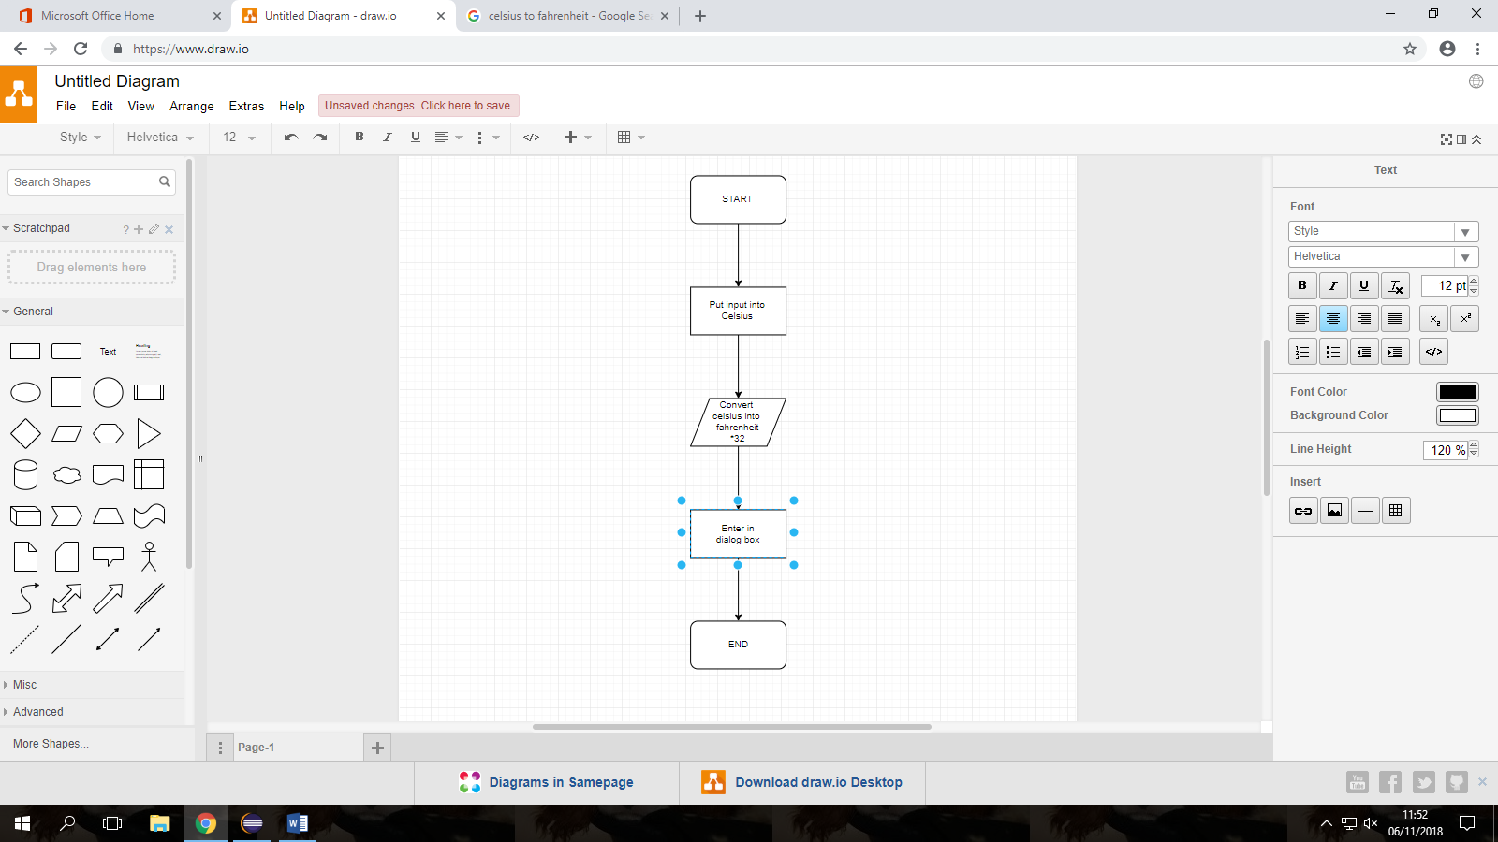

This is my flowchart to describe step by step how I converted Celsius into Fahrenheit

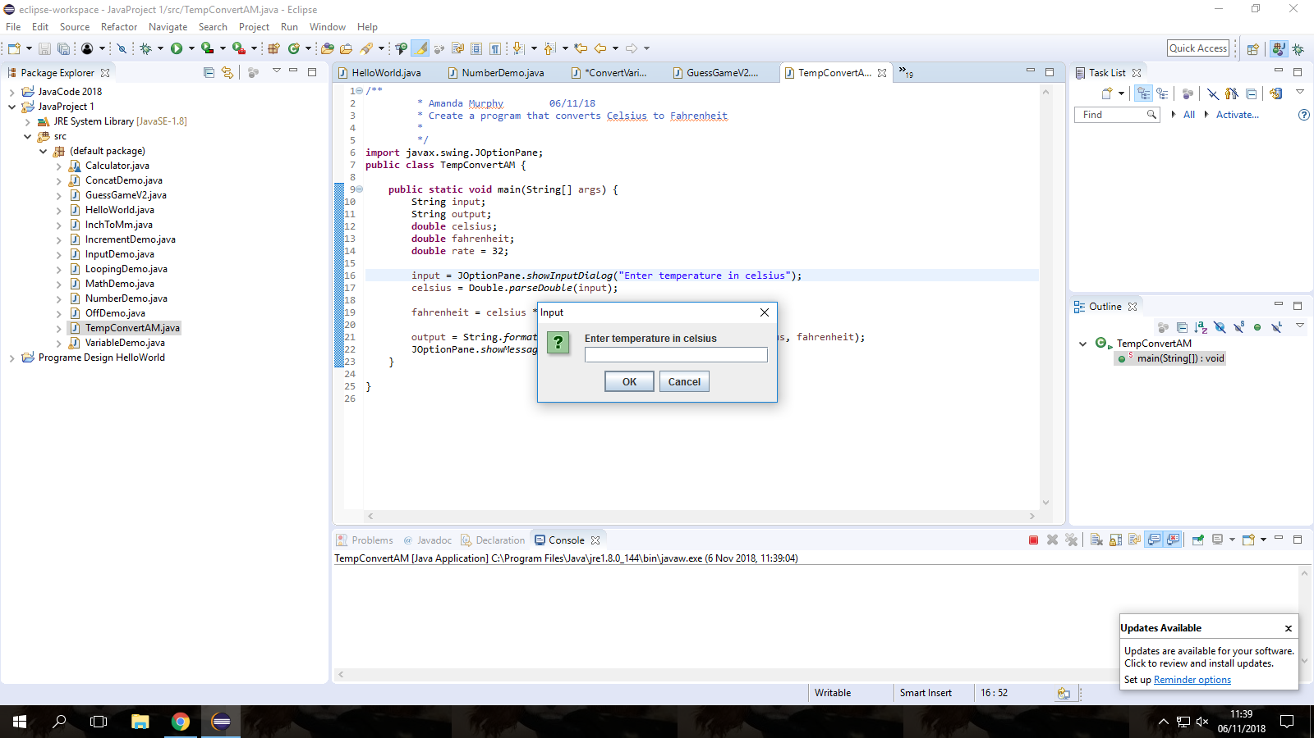

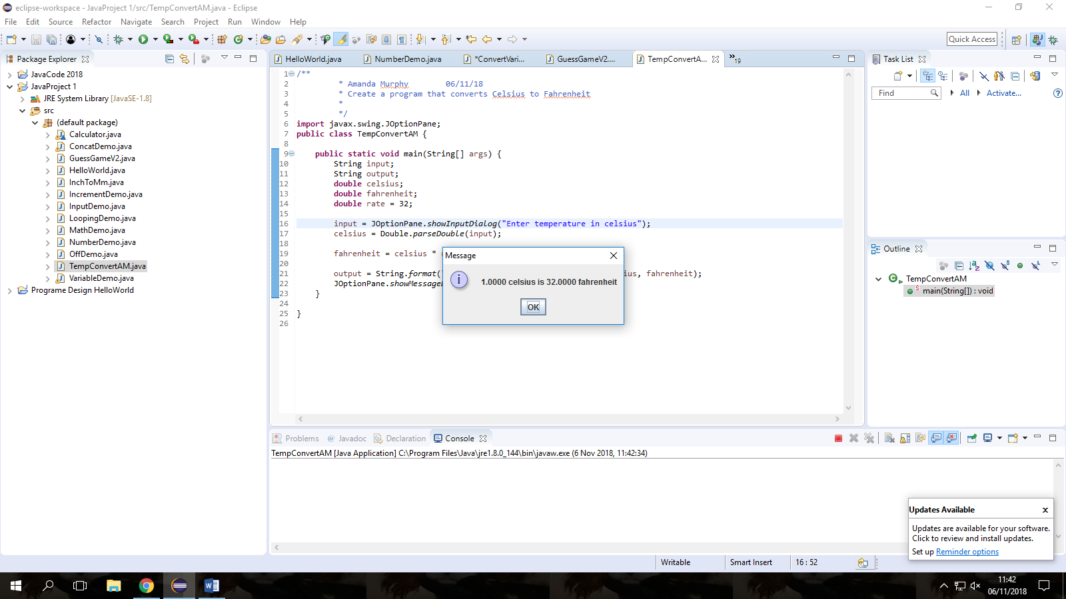These are the dialogue boxes created in Java.

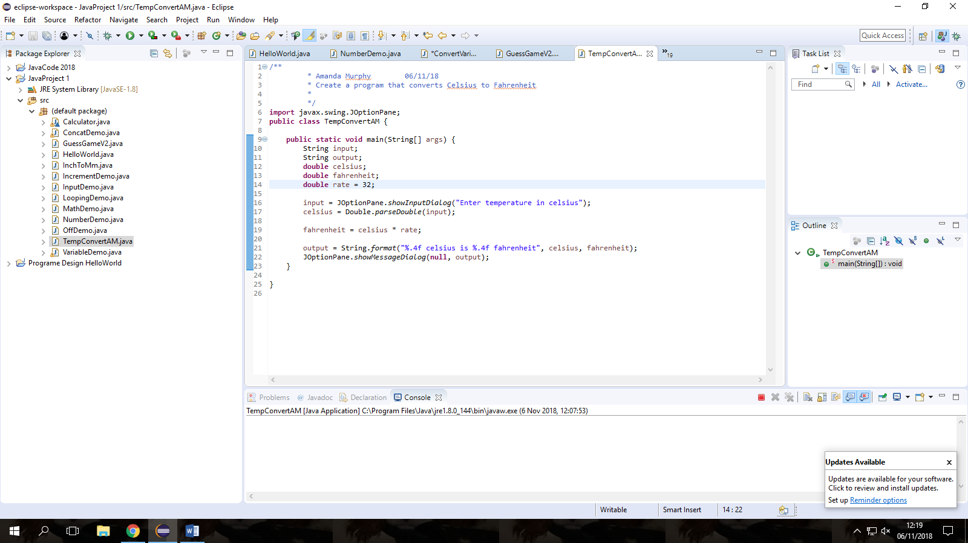

TestCase

|  |  |  |
| --- | --- | --- |
| Numbers to convert | Expected output | Actual Output |
| 1 | 32.0000 | 33.8 |
| 2 | 64.0000 | 35.6 |
| 3 | 96.0000 | 37.4 |
| 4 | 128.0000 | 39.2 |
| 5 | 160.0000 | 41 |
| 10 | 320.0000 | 50 |
| 15 | 480.0000 | 59 |
| -1 | -32.0000 | 30.2 |
| -10 | -320.0000 | 14 |
| 50 | 1600.0000 | 122 |