Crypto-Agile PII Protection: A Comparative Analysis of Hashing, Tokenization, and Layered Tokenization-Hashing in Healthcare
Vincent Herrera
Western Governors University
C769: IT Capstone Written Project
June 5, 2026

Table of Contents
A. Summary 3
B. Review of Other Work 4
Review of Work 1 4
Review of Work 2 5
Review of Work 3 6
C. Changes to Project Environment 7
D. Methodology 8
E. Project Goals, Objectives, and Deliverables 10
Goal 1 10
Goal 2 12
Goal 3 14
F. Project Timeline with Milestones 16
G. Unanticipated Scope Creep 18
H. Conclusion 19
I. References 22
J. Appendices 23
Appendix A: Pre-Computaton Attack Demonstration Output 23
Appendix B: Side-by-Side Pipeline Comparison Output 24
Appendix C: Crypto-Agile Module Algorithm Swap Demonstration 24
Appendix D: Data creation / Query example (Web Demo) 26
Appendix E: Detailed diagram for hashing pipeline 27
Appendix F: Detailed diagram for tokenization pipeline 28
Appendix G: Detailed diagram for layered pipeline 29
Appendix H: Example code for patient generation 30

A. Summary
ClearChart, a fictional healthcare data analytics company managing patient records across multiple hospital clients, stored sensitive patient identifiers, including Medical Record Numbers, Social Security Numbers, full names, and dates of birth, in plaintext within a centralized patient database. Following an unauthorized access incident in which an application vulnerability allowed an external attacker to query the database directly, a forensic review confirmed that all extracted records were returned in plaintext, resulting in immediate exposure of protected health information for thousands of patients. A subsequent third-party security audit identified the absence of field-level PII protection as the critical gap in ClearChart's security posture. The security audit recommended implementing a layered cryptographic architecture to ensure that a breach of the application layer would yield no usable patient data.
To address the audit finding, a field-level PII protection system was designed and implemented in Python, consisting of three isolated pipeline architectures, each stored in a separate SQLite database, and evaluated on the same synthetic patient dataset under a defined assume-breach threat model. The direct hashing pipeline served as the vulnerable baseline, applying SHA-256 directly to each sensitive field without a tokenization layer. The standalone tokenization pipeline replaced each sensitive field with a CSPRNG-generated token, which was stored alongside the original plaintext in a dedicated vault. The layered pipeline, the recommended architecture, distributed patient identity across three isolated databases: a query entry vault storing only last name and a hashed fragment of the SSN, a bridge database storing only date of birth, and a resolution vault storing SSN, first name, and MRN. No single database breach in the layered architecture yields a complete or exploitable patient record. A crypto-agile hashing module was implemented so the algorithm could be swapped via a configuration parameter without modifying the pipeline or database schemas. This would help change the algorithm if the algorithm used becomes outdated or easily crackable. A Flask-based web application was built to demonstrate all three pipelines in real time, accepting patient intake and executing queries on each architecture in parallel. A synthetic patient data generator produced realistic but entirely fictional records for use across all three pipelines.
The project was completed successfully. The pre-computation attack demonstration confirmed that low-entropy SSN values could be recovered from the direct hashing database within seconds using full enumeration of a constrained synthetic SSN space. The layered pipeline demonstrated that an application-layer compromise yields only opaque CSPRNG tokens, with no structural relationship to any patient identifier and no recovery path without simultaneous access to all three databases. The crypto-agile hashing module successfully executed SHA-256, SHA-3-256, and BLAKE2b against the same input without modifying any surrounding pipeline component. All goals, objectives, and deliverables defined in Task 2 were met.

B. Review of Other Work

Review of Work 1

The article "Pseudonymization in AI: Protecting Patient Data," published by Censinet in 2026, examines the role of pseudonymization and tokenization in protecting patient PHI in healthcare AI environments. The article explains that pseudonymization replaces identifiable patient details with unique codes while keeping the data structure intact and, unlike anonymization, allows re-identification under controlled and authorized conditions, making it well-suited for healthcare environments where data must remain usable for clinical and operational purposes. The article further explains that tokenization is a specific form of pseudonymization that replaces sensitive identifiers such as Social Security Numbers with secure tokens stored in a protected vault, and that the mapping key must be stored and managed separately from the tokenized data to maintain the integrity of the protection. The article notes that pseudonymization aligns directly with HIPAA and GDPR regulatory frameworks, reducing compliance risk while preserving the analytical utility of healthcare datasets, and that secure key management is central to preventing re-identification by unauthorized parties (Censinet, 2026).
This work directly supported implementation by establishing the conceptual and regulatory foundation for tokenization design decisions in both the standalone tokenization pipeline and the layered architecture. The principle that the mapping key must be stored separately from the tokenized data is operationalized in the layered pipeline through physical database isolation: the token chain linking the three databases is never co-located with the plaintext identifiers it protects, and no single database contains both a token and the plaintext value it maps to. The regulatory alignment argument also informed the framing of the layered architecture as a HIPAA-compatible remediation for ClearChart rather than simply a technical improvement.

Review of Work 2
The article "Choosing a Hash Function for 2030 and Beyond: SHA-2 vs SHA-3 vs BLAKE3," published by Sylvain Kerkour in December 2024, provides a practical technical analysis of the long-term viability of current cryptographic hash functions and argues that most production systems fail to update their cryptographic algorithms until they are broken, creating compounding security debt over time. The article evaluates SHA-256, SHA-3, and BLAKE3 across security margin, performance, and longevity dimensions, noting that SHA-3's sponge construction provides a fundamentally different security model from SHA-256's Merkle-Damgard construction, giving it distinct resistance properties against certain attack classes. The article concludes that organizations building systems intended to remain secure through 2030 and beyond should design for algorithm replaceability rather than committing to any single algorithm, and that the real failure mode in cryptographic system design is not choosing the wrong algorithm but hardcoding the choice so it cannot be changed without architectural disruption (Kerkour, 2024).
This work directly supported the crypto-agile design decision central to the implementation. The argument that hardcoding a hashing algorithm creates security debt regardless of which algorithm is chosen validated the architectural choice to implement the hashing layer as a configurable module rather than embedding algorithm-specific logic throughout the pipeline. The article's comparison of the security characteristics of SHA-256, SHA-3, and BLAKE2 informed the selection of these three algorithms as the supported options in the crypto-agile module. It reinforced that the project's value lay not in choosing the best current algorithm but in building a system in which the algorithm could be swapped without disruption as standards evolved.

Review of Work 3
The article "HIPAA Security Rule Notice of Proposed Rulemaking to Strengthen Cybersecurity for Electronic Protected Health Information," published by the HHS Office for Civil Rights in December 2024, describes proposed updates to the HIPAA Security Rule that would significantly strengthen technical safeguard requirements for covered entities and business associates. The proposed rule would remove the distinction between required and addressable implementation specifications, making all specifications required with limited exceptions, and introduce new explicit requirements for the ePHI at rest and in transit, multi-factor authentication, and vulnerability management. The NPRM was issued in the context of a significant increase in healthcare data breaches, including the Change Healthcare ransomware attack that affected approximately 190 million individuals, and reflects HHS's determination that the current flexibility in the Security Rule has allowed too many organizations to defer or avoid implementing adequate technical protections for ePHI (HHS, 2024).
This work directly supported the implementation by providing a regulatory context for why ClearChart's remediation architecture needed to be designed for long-term adaptability rather than minimum current compliance. The proposed rule's movement toward making all implementation specifications required rather than addressable means that organizations currently treating encryption and data protection controls as optional will face mandatory compliance requirements if the NPRM is finalized. ClearChart's crypto-agile architecture directly addresses this risk by ensuring that the hashing algorithm and overall protection framework can be updated via configuration rather than requiring architectural redesign when new regulatory requirements take effect, positioning ClearChart ahead of the regulatory curve rather than reacting to it.

C. Changes to Project Environment
Prior to the project, ClearChart's data architecture stored sensitive patient identifiers, including Medical Record Numbers, Social Security Numbers, full names, and dates of birth, in plaintext within a centralized relational database. While ClearChart had invested in perimeter security controls, including network segmentation, firewalls, and API rate limiting, no field-level protection had been applied to the patient identifier database. Any party with authorized or unauthorized access to the database could retrieve fully readable patient records with a simple query. The organization's plaintext storage architecture created an operational gap between client privacy expectations and the actual technical controls protecting their data.
Following the completion of the project, ClearChart's patient identifier architecture was replaced with three evaluated pipeline architectures, each evaluated against the same synthetic plaintext source and protecting it differently at rest. The direct hashing pipeline established the baseline, confirming that field-level hashing alone is insufficient for low-entropy identifiers. The tokenization pipeline demonstrated that vault-based token storage eliminates the pre-computation attack surface but introduces total exposure risk in the event of a vault breach, since plaintext originals are stored alongside their tokens. The layered pipeline, the recommended production architecture, distributes patient identity across three isolated SQLite databases with no single breach path to a complete record. The query entry database stores only the last name in plaintext, along with a SHA-256 hash of the last four SSN digits and a CSPRNG token linking to the bridge database. The bridge database stores only the date of birth, along with a CSPRNG token linking to the resolution database. The resolution database stores SSN, first name, and MRN with no last name and no date of birth. A breach of any single database yields at most one demographic fragment, along with opaque tokens that terminate without access to the adjacent database.
A Flask-based web application was built to demonstrate all three pipelines in a unified interface, accepting patient intake through a validated form and executing record queries against all three architectures in parallel. This gave ClearChart a working proof of concept demonstrating the full data lifecycle, from intake through protection and authorized retrieval, across all three architectures simultaneously.
Operationally, the crypto-agile hashing module ensures that ClearChart can update its cryptographic controls via configuration parameters as standards evolve without restructuring the pipeline or redeploying the database architecture. Strategically, the implementation positions ClearChart to make affirmative representations to hospital clients and HIPAA auditors that patient identifiers are cryptographically protected at the field level at rest, and that the protection architecture is designed to adapt to evolving regulatory requirements, including the December 2024 HIPAA Security Rule NPRM proposing that all implementation specifications become required rather than addressable (HHS, 2024).
It is important to note that pii.db, the centralized plaintext database used in this implementation, is a proof-of-concept artifact and would not exist in a production deployment. Its purpose in this project is to serve as the synthetic data source that populates all three pipeline databases for evaluation. In production, patient records would be written directly into the three-database layered architecture at intake time, with no intermediate plaintext store. The Flask web application already demonstrates this production-aligned behavior: the submit route writes incoming records directly to all six pipeline databases from in-memory form data without reading from pii.db at submission or query time.

D. Methodology
This project was executed using the Waterfall methodology due to strict sequential dependencies and a fixed technical scope. Development could not begin until the cryptographic schemas were finalized, and comparative evaluation required a completed pipeline. The linear structure of the Waterfall approach ensured that each phase was fully completed before the next began, which was essential for an implementation where architectural decisions made early in the process directly determined what was built and measured later.
In the Requirements phase, HIPAA Security Rule requirements, NIST guidelines on cryptography and data protection, and existing research on tokenization and hashing architectures were reviewed. The threat model was defined under the assume-breach principle, focusing on what an attacker would obtain from each database architecture following a successful unauthorized access event targeting the application layer. Evaluation criteria for the comparative analysis were established, and the architecture and database schemas for all three pipelines were finalized before any development began. A key early decision was to constrain the synthetic SSN space to the 900-999 area code range, which the Social Security Administration has never assigned, ensuring that all generated identifiers were legally safe for demonstration use while remaining structurally realistic for attack simulation.
In the Design phase, the full architecture of each of the three pipelines was documented, including field-level transformation logic and SQLite database schemas. The layered pipeline schema required the most iteration during this phase. The central design challenge was determining which patient fields to store in which database so that no single breach would expose a pair of identifiers that could be used for real-world identity exploitation. The final field distribution placed last name in the query entry vault, date of birth in the bridge database, and SSN, plus first name, plus MRN in the resolution vault. This split ensures that name and date of birth are never co-located, SSN and name are never co-located with date of birth, and no database contains enough information to constitute an exploitable identity record in isolation. The crypto-agile hashing module interface was also designed during this phase to accept the algorithm as a configurable parameter, with MD5 and SHA-1 explicitly blocked regardless of input.
In the Development phase, the synthetic patient data generator was built first, followed by the sequential implementation of all three pipelines. The direct hashing pipeline was built as the baseline. The tokenization vault followed. The layered pipeline was built last because its three-database schema depended on design decisions validated during the earlier pipeline implementations. The crypto-agile hashing module was implemented as a configurable, standalone component shared across all pipelines. The Flask web application was built to demonstrate all three pipelines in a unified interface, with server-side input validation and parameterized queries throughout to prevent injection. A pre-computation attack script was implemented to run against the direct hashing database, and a static HTML comparison artifact was built to visualize all three pipeline architectures side by side.
In the Testing phase, all three pipelines were executed against the same synthetic patient dataset and evaluated against the defined threat model. The attack script enumerated the full constrained SSN space across the 900-999 area range and confirmed SSN recovery from the direct hashing database within seconds. The layered pipeline was evaluated by querying each database in isolation and documenting what a breach of each database would yield. The crypto-agile module was tested by running the same input through SHA-256, SHA-3-256, and BLAKE2b and confirming distinct outputs with no pipeline changes required.
In the Deployment phase, the research paper and the simulated security audit report were compiled and finalized, incorporating the evaluation results, architecture documentation, and comparative findings. No production deployment was required as this was a proof-of-concept implementation designed to demonstrate architectural superiority and provide ClearChart with a clear engineering path toward a production migration.

E. Project Goals, Objectives, and Deliverables

Goal 1
Goal | Supporting Objectives | Deliverables Enabling the Project Objectives | Met/Not Met
Goal 1: Establish the vulnerable baseline and demonstrate the limitations of direct hashing for low-entropy patient identifiers | 1a. Build a direct hashing pipeline that hashes all sensitive patient identifier fields and stores them in a SQLite database | 1a.i. Direct hashing Python pipeline script | Met
 | 1b. Demonstrate the pre-computation vulnerability of direct hashing against low-entropy patient identifiers using synthetic data | 1b.i. Pre-computation attack demonstration script and output results | Met

Goal 1 was accomplished through two objectives.
- Objective 1a was met through the implementation of pipelineHashing.py, a Python-based direct hashing pipeline that read synthetic patient records from pii.db, applied SHA-256 independently to each sensitive field, including MRN, name, date of birth, and SSN, and wrote the resulting hashes to hashing.db with no patient ID linkage and no plaintext stored. The pipeline confirmed that the hashing process was consistent and reproducible across all records in the synthetic dataset.
- Objective 1b was met through the implementation of attackDemo.py, a pre-computation attack script that loaded all SSN hash values from hashing.db into memory and enumerated the full constrained synthetic SSN space across the 900-999 area code range, checking each candidate against the complete hash set simultaneously. The script recovered a synthetic SSN within seconds and cross-referenced pii.db to print the full associated patient record, confirming the practical consequence of hash recovery. The output is documented in Appendix A.

Goal 2
Goal | Supporting Objectives | Deliverables Enabling the Project Objectives | Met/Not Met
Goal 2: Design and implement the full layered tokenization plus hashing architecture and the standalone tokenization alternative | 2a. Build a standalone tokenization vault using CSPRNG-generated tokens with a dedicated SQLite mapping database | 2a.i. Tokenization vault, Python pipeline script, and SQLite vault database | Met
 | 2b. Build the full layered tokenization plus hashing pipeline across three isolated SQLite databases | 2b.i. Layered pipeline Python script and three isolated SQLite databases representing the query entry vault, bridge database, and resolution vault | Met
 | 2c. Implement the hashing layer as crypto-agile so the algorithm can be swapped without restructuring the pipeline | 2c.i. Crypto-agile hashing module with configurable algorithm support | Met

Goal 2, designing and implementing the fully layered tokenization-plus-hashing architecture and the standalone tokenization alternative, was selected as the primary goal to document here, as it represents the project's core technical deliverable.
- Objective 2a was met through the implementation of pipelineTokenization.py, a Python-based tokenization vault that replaced each sensitive patient identifier field with a CSPRNG-generated token via secrets.token_hex(32) and stored the token-to-identifier mapping alongside the original plaintext in token_vault.db. The vault was tested against the synthetic patient dataset and confirmed to produce unique, non-predictable tokens for each field across all records with no structural relationship between any token and its source value.
- Objective 2b was met through the implementation of pipelineLayered.py, a three-database layered pipeline distributing patient identity across layered_vault1.db, layered_layered_link.db, and layered_vault2.db. The query entry vault stores the last name and a SHA-256 hash of the last 4 SSN digits, along with a CSPRNG token that links to the bridge database. The bridge database stores the date of birth alongside a CSPRNG token linking to the resolution vault. The resolution vault stores SSN, first name, and MRN. The evaluation confirmed that a simulated breach of any single database yields at most one demographic fragment with no actionable path to a complete patient record.
- Objective 2c was met through the implementation of cryptoModule.py, a crypto-agile hashing module that accepted the algorithm as a configuration parameter and explicitly blocked MD5 and SHA-1 regardless of input. The module was tested successfully with SHA-256, SHA-3-256, and BLAKE2b, confirming that the algorithm could be swapped without modifying any surrounding pipeline component. The demonstration output is documented in Appendix C.

Goal 3
Goal | Supporting Objectives | Deliverables Enabling the Project Objectives | Met/Not Met
Goal 3: Comparatively evaluate all three approaches and produce a remediation recommendation for ClearChart | 3a. Run all three pipelines against the same synthetic patient dataset and evaluate each against the defined threat model | 3a.i. Demonstration script outputting comparative results across all three pipelines | Met
 | 3b. Document the comparative findings and produce a remediation recommendation | 3b.i. Written research paper documenting the audit findings, architecture, evaluation results, and remediation recommendations | Met
 | 3c. Produce the simulated security audit report that triggered the project | 3c.i. Simulated third-party security audit report documenting the ClearChart incident findings and remediation recommendations | Met

Goal 3 was accomplished through three objectives.
- Objective 3a was met through two artifacts working together: the Flask-based web application demonstrated in Appendix D, which runs all three pipelines live against the same intake record and returns query results from each architecture in parallel, and the static comparison artifact documented in Appendix B, which presents the attacker's view of each pipeline side by side under the defined threat model.
- Objective 3b was met through the compilation of this technical research paper documenting the audit findings, threat model, architecture design decisions, evaluation results, and a formal remediation recommendation for ClearChart, adopting the layered tokenization plus hashing architecture as its field-level PII protection standard.
- Objective 3c was met through the production of the simulated third-party security audit report documenting the ClearChart unauthorized access incident, the identified field-level protection gap, and the recommended remediation architecture that initiated the project.

F. Project Timeline with Milestones
Milestone | Duration | Projected Start Date | Projected End Date | Actual Start Date | Actual End Date
Review HIPAA, NIST, and research literature | 3 days | June 5, 2026 | June 7, 2026 | June 5, 2026 | June 7, 2026
Define threat model and establish evaluation criteria | 2 days | June 8, 2026 | June 9, 2026 | June 8, 2026 | June 9, 2026
Finalize architecture and database schemas for all three pipelines | 2 days | June 10, 2026 | June 11, 2026 | June 10, 2026 | June 12, 2026
Build a synthetic patient data generator | 1 day | June 12, 2026 | June 12, 2026 | June 13, 2026 | June 13, 2026
Implement a direct hashing pipeline and a pre-computation demonstration | 2 days | June 13, 2026 | June 14, 2026 | June 14, 2026 | June 15, 2026
Implement a standalone tokenization vault pipeline | 3 days | June 15, 2026 | June 17, 2026 | June 16, 2026 | June 18, 2026
Implement a layered tokenization plus hashing pipeline across three databases | 4 days | June 18, 2026 | June 21, 2026 | June 19, 2026 | June 21, 2026
Implement a crypto-agile hashing module | 2 days | June 22, 2026 | June 23, 2026 | June 22, 2026 | June 23, 2026
Build a demonstration script and run a comparative evaluation | 4 days | June 24, 2026 | June 27, 2026 | June 24, 2026 | June 26, 2026
Write and finalize the research paper and the simulated audit report | 5 days | June 28, 2026 | July 2, 2026 | June 22, 2026 | June 28, 2026

The project was completed on schedule, with minor day-to-day slippage absorbed without affecting the final delivery date. The architecture finalization phase ran one day longer than projected because the three-database isolation schema required additional design iteration, specifically around ensuring that no implicit relationships existed between databases that could allow a single breach to yield an exploitable identity pairing—this one-day delay cascaded through subsequent milestones, pushing each phase back by approximately one day. The layered pipeline implementation milestone also ran two days longer than projected due to the scope creep described in section G. The writing and finalization phase had been conservatively estimated and absorbed the cumulative slippage, allowing the final deliverables to be completed by June 29, 2026, as projected.

G. Unanticipated Scope Creep
The primary unanticipated challenge encountered during the project involved the design of the layered pipeline's three-database schema. The original design assumed that field distribution across databases would be a straightforward partitioning exercise once the token chain structure was established. During implementation, it became clear that naive partitioning created implicit relationships between databases, undermining the isolation argument. Specifically, an early schema draft co-located last name and date of birth in the query entry vault, which would have meant that a single database breach exposed a name-plus-DOB pair, the most commonly required combination for patient identity verification in clinical contexts, and the exact pairing the architecture was designed to prevent from appearing in any single database.
Resolving this required revisiting the field distribution and explicitly mapping each field to a database based on its exploit value when paired with other fields, rather than based on query convenience. The date of birth was moved to the bridge database so that the last name and date of birth would never co-locate. SSN, first name, and MRN were placed in the resolution vault with the explicit constraint that no name or date of birth would appear there. This meant the query traversal had to be redesigned to assemble the full record from three separate database reads at query time rather than returning a complete row from any single database. The additional schema design work added approximately two days to the layered pipeline implementation milestone. That slippage cascaded through subsequent milestones but was absorbed within the buffer built into the writing and finalization phase, resulting in no impact on the final delivery date.
This adjustment ultimately strengthened the security argument because it forced explicit justification for where each field lived rather than allowing the schema to be shaped by query convenience. The final architecture can demonstrate, for each of the three databases independently, that the fields present in that database do not constitute an exploitable identity record in isolation.

H. Conclusion
The implementation of the crypto-agile PII protection system for ClearChart was completed successfully, and all three success criteria defined in the Task 2 Outcome section were met. The project delivered three Python-based pipelines, three isolated SQLite database architectures, a crypto-agile hashing module, a Flask-based web application, a static pipeline-comparison artifact, a simulated security audit report, and this technical research paper documenting the architecture, evaluation results, and remediation recommendations. The complete implementation, including all pipeline scripts, the Flask web application, the synthetic data generator, and the demonstration artifacts, is publicly available at https://github.com/TheRealBastioul/ClearChart-C769-Project for reference.
The first success criterion required that the pre-computation demonstration script successfully recover low-entropy patient identifiers from the direct hashing database. This criterion was met. The attack script enumerated the full constrained SSN space across the 900-999 area code range, checking each candidate against the full set of stored hashes simultaneously, and recovered a synthetic SSN from the direct hashing database within seconds using zero prior knowledge beyond the hash values themselves. All remaining records in hashing.db are equally vulnerable to the same attack.
The second success criterion required the layered pipeline to demonstrate that an attacker who compromises only the application database retrieves only hashed tokens and has no actionable path to the original identifiers. This criterion was met. Simulating a breach of any single database in the layered architecture returned at most one demographic fragment, along with opaque CSPRNG tokens that terminate without access to the adjacent database. Because the token chain linking the three databases is never co-located with any plaintext identifier, an attacker cannot traverse the chain without simultaneously breaching all three databases. The layered architecture is the only design evaluated in this project in which an isolated database compromise does not yield actionable patient data. It should also be noted that pii.db, which exists in this implementation as a synthetic data source for evaluation, would not be present in a production deployment. In production, patient data would flow directly into the three-database layered architecture at intake, eliminating the need for a centralized plaintext store. The Flask web application's submit route already operates this way, writing records to all pipeline databases from in-memory form data rather than reading from pii.db.
The third success criterion required that the crypto-agile module successfully swap the hashing algorithm without requiring changes to the pipeline architecture. This criterion was met. The module was tested with SHA-256, SHA-3-256, and BLAKE2b, confirming successful algorithm substitution via configuration parameter with no modifications to the tokenization pipeline, database schemas, or application layer.
The potential effects of this implementation extend beyond the immediate proof of concept. For ClearChart, adoption of this architecture in a production environment would significantly reduce regulatory exposure because a breach of the application database alone would not yield usable patient data. The crypto-agile design further ensures that the architecture can be maintained in compliance as HIPAA guidance evolves, including forthcoming requirements from the December 2024 HIPAA Security Rule NPRM that proposed making all implementation specifications required rather than addressable (HHS, 2024). The project successfully demonstrated that a layered tokenization-plus-hashing architecture provides measurably superior protection for low-entropy healthcare PII compared to standalone hashing or tokenization and established a clear and reproducible engineering path for ClearChart's production migration.

I. References
Censinet. (2026). Pseudonymization in AI: Protecting patient data. https://censinet.com/perspectives/pseudonymization-ai-protecting-patient-data
Kerkour, S. (2024, December 18). Choosing a hash function for 2030 and beyond: SHA-2 vs SHA-3 vs BLAKE3. https://kerkour.com/fast-secure-hash-function-sha256-sha512-sha3-blake3
U.S. Department of Health and Human Services. (2024, December 27). The HIPAA Security Rule notice of proposed rulemaking to strengthen cybersecurity for electronic protected health information. Office for Civil Rights. https://www.hhs.gov/hipaa/for-professionals/security/hipaa-security-rule-nprm/factsheet/index.html

J. Appendices

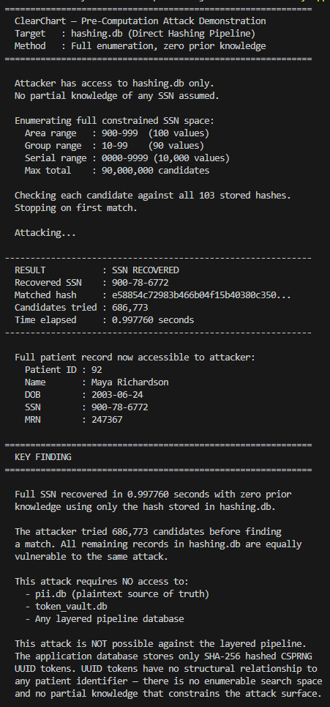
Appendix A: Pre-Computation Attack Demonstration Output

Appendix A presents the terminal output of attackDemo.py, the automated pre-computation attack script built to evaluate the direct hashing pipeline under the project's assume-breach threat model. The script loads all SSN hash values from hashing.db into memory and enumerates the full constrained synthetic SSN space across the 900-999 area code range, checking each candidate against the complete set of stored hashes simultaneously. The output documents the recovered SSN, the matched hash prefix, the number of candidates evaluated before the first match, and the total elapsed time in seconds. A full patient record, cross-referenced from pii.db for demonstration purposes, is printed alongside the recovered SSN to show the practical consequence of hash recovery. In a production deployment, no centralized plaintext store of this kind would exist. The script concludes with a KEY FINDING block explaining why the same attack cannot be executed against the layered pipeline, in which the application database stores only SHA-256-hashed CSPRNG tokens that have no structural relationship to any patient identifier and no enumerable search space. This artifact directly supports Goal 1 of the project and provides the primary empirical evidence for the remediation recommendation in favor of the layered architecture.

Appendix B: Side-by-Side Pipeline Comparison Output
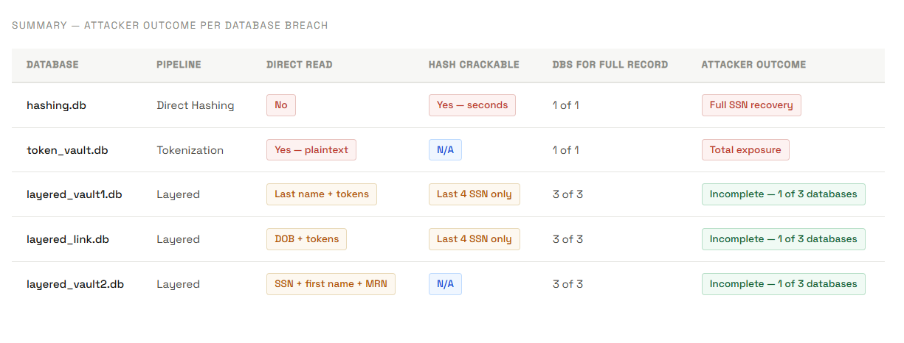
Appendix B presents the summary comparison table from comparisonDemo.html, consolidating all five pipeline databases into a single view across six dimensions: database name, pipeline, direct read exposure, hash crackability, number of databases required for full record recovery, and attacker outcome on isolated breach. This table directly supports Goal 3 by providing a concise side-by-side evaluation of all three architectures under the defined threat model.

Appendix C: Crypto-Agile Module Algorithm Swap Demonstration
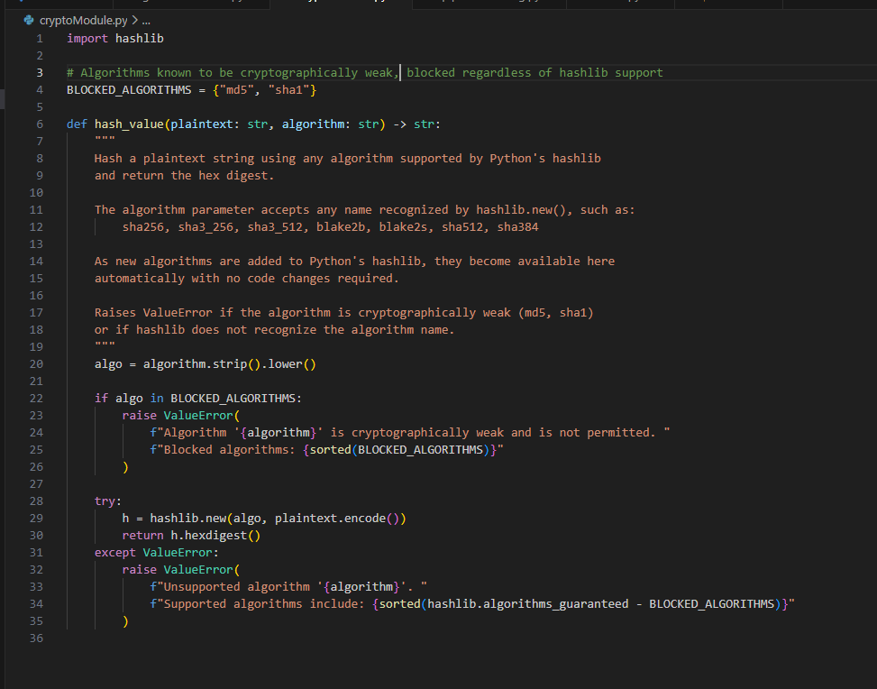
Appendix C presents the terminal output of a demonstration script that calls cryptoModule.py three times with the same input string, using SHA-256, SHA-3-256, and BLAKE2b, respectively, and prints the hex digest produced by each algorithm. The output confirms that the module produces three distinct hash values from a single input by varying only the algorithm parameter, with no changes to the surrounding call or the module itself. This artifact directly supports Objective 2c of the project, which required demonstrating that the hashing algorithm could be swapped via configuration without modifying the pipeline architecture. It also demonstrates the practical value of the crypto-agile design decision. As NIST guidance or HIPAA requirements evolve to prefer or require a different algorithm, ClearChart can update its cryptographic posture by changing a single configuration parameter rather than reengineering the pipeline.

Appendix D: Data creation / Query example (Web Demo)
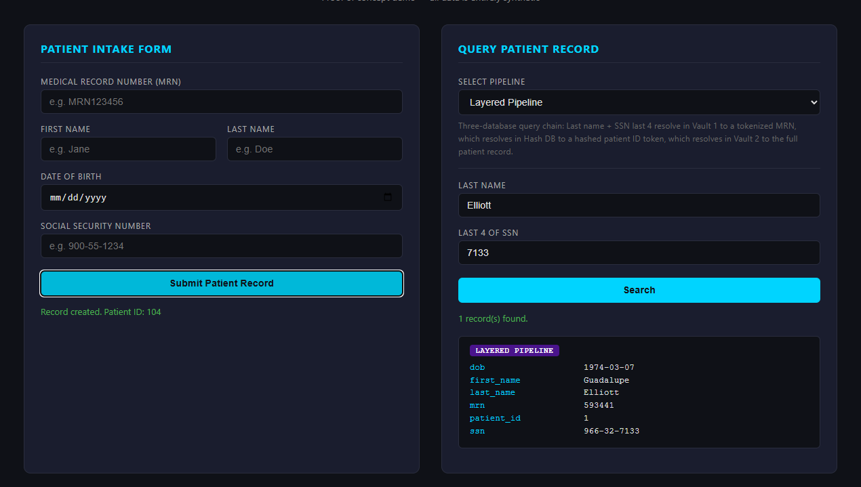
Appendix D presents screenshots of the ClearChart Flask web application running locally, demonstrating the full patient data lifecycle across all three pipeline architectures in a unified interface. The screenshots show the patient intake form accepting a synthetic record with validated MRN, name, date of birth, and SSN fields, followed by the server confirmation that the record was written simultaneously to all six databases across the three pipelines. A second set of screenshots shows the query interface returning the same patient record from the hashing, tokenization, and layered pipelines, respectively, using only the last name and the last 4 SSN digits as query inputs. This artifact demonstrates that the layered architecture's three-database traversal chain produces a complete and accurate patient record at query time, without ever exposing plaintext data via a single database read. It supports the implementation goals across all three pipelines and demonstrates the practical operability of the recommended architecture.

Appendix E: Detailed diagram for hashing pipeline
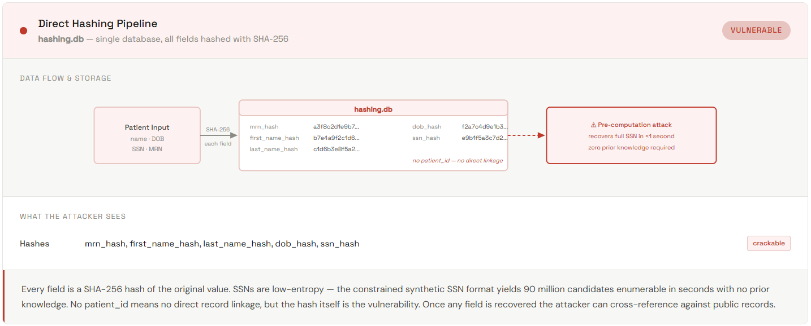
Appendix E presents the detailed data flow diagram for the direct hashing pipeline, sourced from comparisonDemo.html. The diagram traces the path of a patient record from intake through SHA-256 transformation to storage in the hashing.db, showing each field individually as it moves from plaintext input to stored hash value. This diagram supports the project's baseline vulnerability analysis. It provides a visual reference to explain why direct hashing is insufficient for low-entropy patient identifiers, regardless of the hashing algorithm used.

Appendix F: Detailed diagram for tokenization pipeline
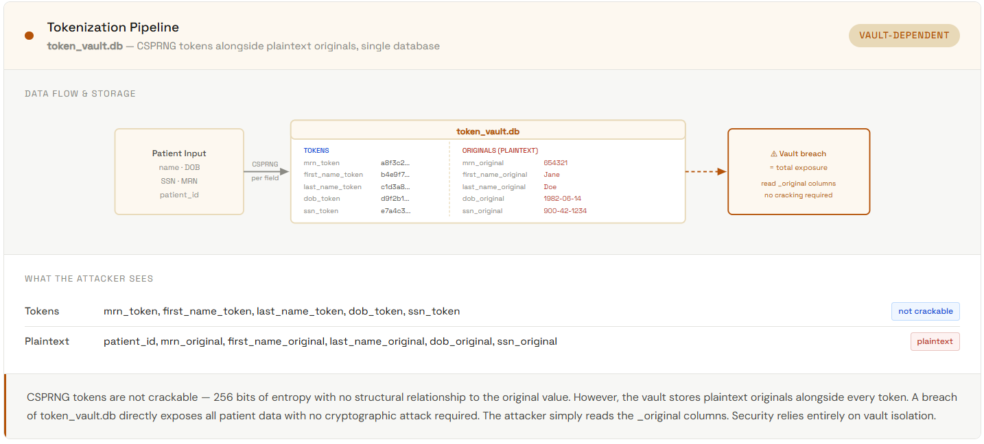
Appendix F presents the detailed data flow diagram for the standalone tokenization pipeline, sourced from comparisonDemo.html. The diagram traces the path of a patient record from intake through CSPRNG token generation and storage in token_vault.db, showing both the token values and the original plaintext values stored side by side in the vault. The attacker's view illustrates what an adversary who breaches token_vault.db retrieves: all original plaintext identifiers are directly readable with no cracking required, because the vault stores originals alongside tokens to enable authorized reverse lookup. This diagram supports the project's comparative analysis by demonstrating that while tokenization eliminates the pre-computation attack surface, vault breach results in total record exposure, making vault isolation the entire load-bearing security control in this architecture.

Appendix G: Detailed diagram for layered pipeline
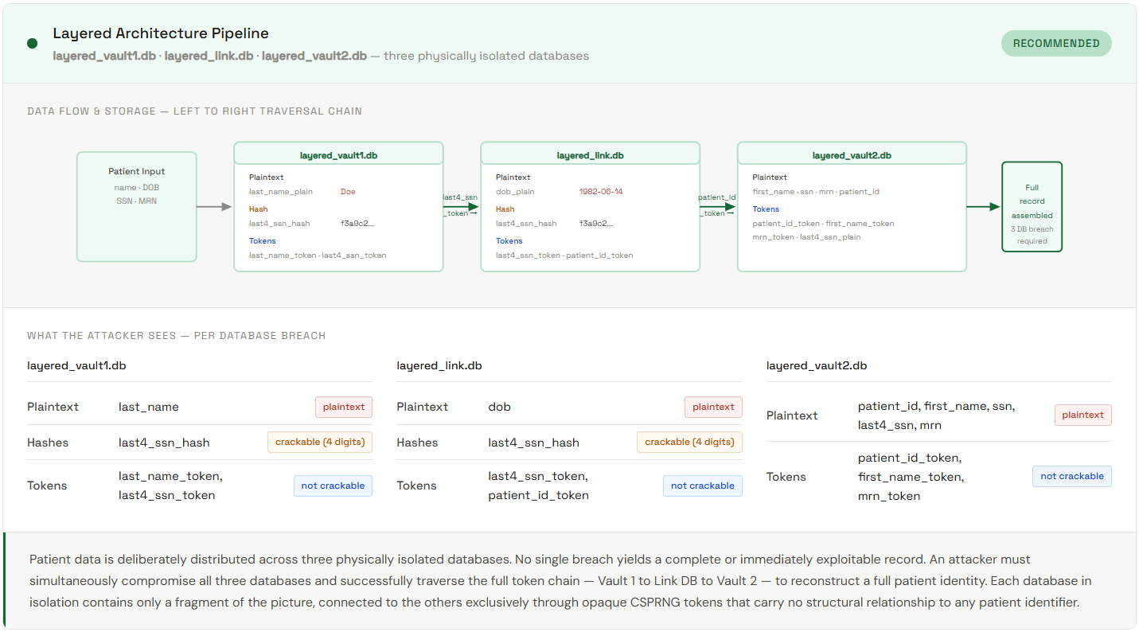
Appendix G presents the detailed data flow diagram for the recommended layered pipeline architecture, sourced from comparisonDemo.html. The diagram traces the path of a patient record from intake through the three-database write sequence and illustrates the query traversal chain from layered_vault1.db through layered_link.db to layered_vault2.db. The attacker's view uses a three-column layout, one column per database, showing what an adversary who breaches each database in isolation retrieves. layered_vault1.db breach yields last name and a hash of only 4 SSN digits, along with an opaque token that terminates without layered_link.db access. layered_link.db breach yields date of birth and an opaque token that terminates without layered_vault2.db access. layered_vault2.db breach yields SSN, first name, and MRN, but no last name or date of birth, and cannot be traversed without the patient ID token, which only exists in layered_link.db. This diagram is the primary architectural reference for the layered pipeline and supports the project's core security argument that no single database breach yields an exploitable identity record.

Appendix H: Example code for patient generation
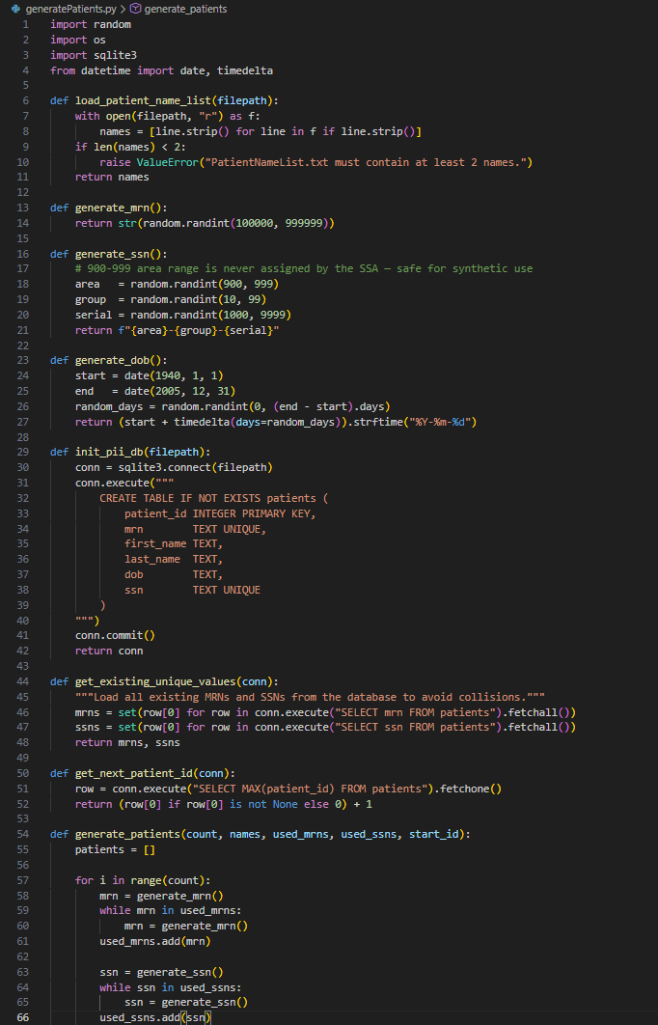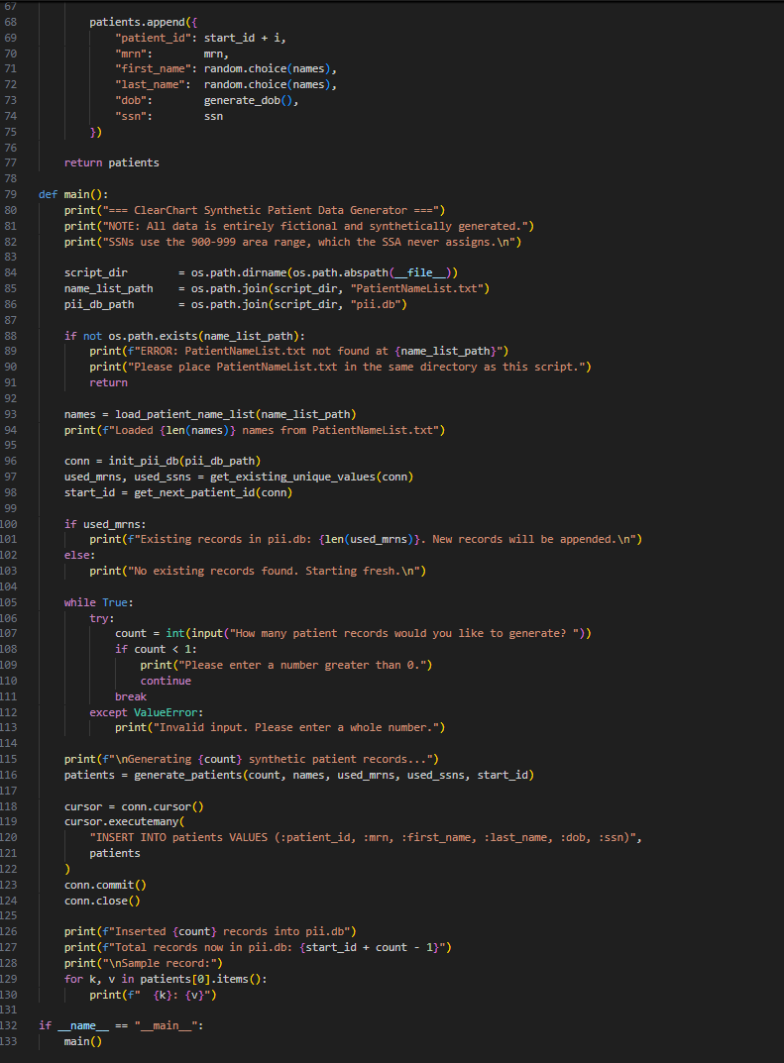
Appendix H presents generatePatients.py, the Python script built to produce the synthetic patient dataset used across all three pipeline evaluations. The script prompts for a record count, loads a name list from PatientNameList.txt, and generates patient records with unique MRNs and SSNs using collision-safe generation loops that check against existing records in pii.db before inserting. SSNs are generated exclusively within the 900-999 area code range, which the Social Security Administration has never assigned, ensuring all identifiers are legally safe for demonstration use. Dates of birth are randomly distributed between 1940 and 2005. The script writes directly to pii.db using CREATE TABLE IF NOT EXISTS, so repeated runs append rather than overwrite existing records. This script is foundational to the evaluation methodology because all three pipeline comparisons, including the attack demonstration in Appendix A, operate against the same synthetic dataset produced by this script, ensuring that the comparative results reflect architectural differences rather than data differences. As noted in section C, pii.db is a proof-of-concept artifact used to seed the pipeline databases for evaluation. It would not exist in a production deployment, where patient data would flow directly into the three-database layered architecture at intake.

