Document 1: Package Requirements Testing Log

Testing and Verification
I tested the program using three test cases that cover normal operation, a package requirement boundary, and invalid user input. These tests were selected to identify potential errors in the program's syntax, dimensional calculations, and input-handling behavior.

Test Case 1 — Normal Input
Input:
Weight: 15 kg
Length: 20 cm
Width: 30 cm
Height: 40 cm
Expected Result:
The program should calculate a volume of 24,000 cubic centimeters. It should recognize that both the weight (15 kg) and volume are within the permitted limits and display the following message:
Package accepted. Meets all requirements.
Actual Result:
The program failed to compile because of a missing semicolon in the volume calculation statement. As a result, the program did not execute or display the evaluation message.
Result: Failed
This test revealed a syntax error that prevented the program from running. The missing semicolon must be corrected before the core dimension-checking logic can be tested.

Test Case 2 — Requirement Boundary
Input:
Weight: 27 kg
Length: 100 cm
Width: 100 cm
Height: 10 cm
Expected Result:
The program should recognize that a weight of exactly 27 kg is valid because it does not exceed the maximum permitted weight. The calculated volume is 100,000 cubic centimeters, which is exactly the upper volume limit. Since the volume does not exceed 100,000 cubic centimeters, the package should be accepted, and the program should display the following message:
Package accepted. Meets all requirements.
Actual Result:

Too large.
Result: Failed
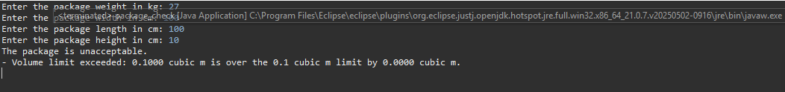
The program applied an incorrect boundary condition when evaluating the package volume. Instead of rejecting packages only when the volume exceeds the maximum allowed limit (> 100,000), the program may be using a greater-than-or-equal-to operator (>=). This would incorrectly reject a package whose volume is exactly equal to the permitted maximum.

Test Case 3 — Invalid Input
Input:
Weight: Heavy
Length: 20 cm
Width: 30 cm
Height: 40 cm
Expected Result:
The program should reject the text value "Heavy" because the weight must be entered as a numeric value. It should catch the InputMismatchException, clear the invalid input from the scanner buffer, and prompt the user to enter a valid numeric weight. The remaining dimensions are valid numeric inputs.
Actual Result:
The program crashed after receiving the non-numeric weight value, displaying an unhandled java.util.InputMismatchException stack trace. Execution terminated without displaying a user-friendly error message or allowing the user to enter a valid weight.
Result: Failed
This test revealed an input-handling error. The application does not properly handle non-numeric weight input through exception-handling logic, such as a try-catch block. The input-validation process should be revised to catch the exception, clear the scanner buffer, and prompt the user to enter a valid numeric weight without terminating the program.

Overall Testing Evaluation
The three tests revealed problems with the program's syntax, boundary evaluation, and input validation. The first test could not execute because of a syntax error that prevented compilation. The second test incorrectly rejected a package whose volume was exactly equal to the maximum permitted limit, suggesting a potential error in the conditional operator. The third test caused the program to terminate after receiving non-numeric text as the weight input.
These results indicate that the program requires further debugging. First, the compilation error must be corrected. Next, the conditional operators used to evaluate package requirements must be reviewed to ensure that boundary values are handled correctly. Finally, appropriate exception-handling logic and an input-validation loop must be implemented to prevent invalid input from terminating the program.
After these corrections are completed, all three test cases should be repeated to verify that the program compiles successfully, evaluates package requirements accurately, handles boundary values correctly, and safely processes invalid user input.

