Document 2: Copy Printing Testing Log
Testing and Verification
I tested the program using three test cases that cover normal operation, a pricing boundary, and invalid user input. These tests were selected to identify potential errors in the program's syntax, pricing calculations, and input-handling behavior.
Test Case 1 — Normal Input
Input:
50 copies
Expected Result:
The program should select the 1–99 pricing range, apply the price of $0.30 per copy, and calculate a total cost of $15.00.
Actual Result:
The program failed to compile because of a missing semicolon in the total-cost calculation statement. The program did not execute or display the expected total.
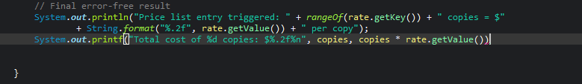
Result: Failed.
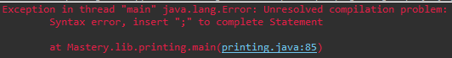
This test revealed a syntax error that prevented the program from running. The missing semicolon must be corrected before the calculation can be tested.
Test Case 2 — Pricing Boundary
Input:
500 copies
Expected Result:
The program should recognize that 500 is the first value in the 500–749 pricing range, apply the price of $0.27 per copy, and calculate a total cost of $135.00.
Actual Result:
The program selected the incorrect pricing range and displayed the following output:
Price list entry triggered: 1–499 copies = $0.30 per copy
Total cost of 500 copies: $150.00

Result: Failed.
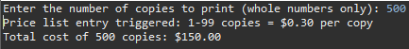
The program selected the incorrect pricing range for an input of 500 copies. Instead of applying the $0.27 rate, it used the $0.30 rate, resulting in an incorrect total. This suggests a problem with the pricing lookup or the way the pricing ranges are configured in the TreeMap.
Test Case 3 — Invalid Input
Input:
2.5
Expected Result:
The program should reject the decimal because it requires a whole-number quantity. It should catch the InputMismatchException, clear the invalid input from the scanner buffer, and prompt the user to enter another number.
Actual Result:
The program displayed an error message but repeatedly attempted to read the same invalid input. It did not successfully clear the invalid value or allow the user to enter a new quantity.
Result: Failed.
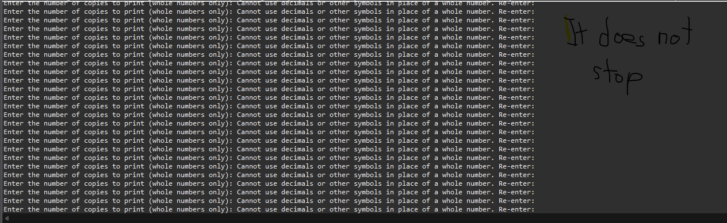
This test revealed an input-handling error. The invalid token remained in the input buffer, causing the program to repeat the same error instead of requesting valid input. The input-validation logic must be corrected to remove the invalid token before prompting the user again.
Overall Testing Evaluation
The three tests revealed problems with the program's syntax, pricing lookup, and input validation. The first test could not execute because of a missing semicolon in the total-cost calculation statement. The second test applied the incorrect pricing rate to 500 copies, producing a total of $150.00 instead of the expected $135.00. The third test repeatedly displayed an error message because the invalid decimal value was not successfully removed from the input buffer.
These results indicate that the program requires further debugging. The compilation error must be corrected first so that the program can execute. Next, the pricing lookup and TreeMap configuration must be reviewed to ensure that the correct rate is selected at pricing boundaries. Finally, the input-validation logic must be revised to clear invalid input properly and allow the user to enter a new quantity without repeating the same error indefinitely.
After these corrections are completed, all three test cases should be repeated to verify that the program compiles successfully, selects the correct pricing ranges, calculates totals accurately, and handles invalid user input without becoming stuck in a repeated error loop.

