Testing and Verification
I tested the program using three test cases that cover normal operation, a pricing boundary, and invalid user input. These tests were selected to verify both the program's intended output and its error-handling behavior.

Test Case 1 — Normal Input
Input: 50
Expected Result:
The program should select the 1-99 pricing range, use the $0.30 price per copy, and calculate a total of $15.00.
Actual Result:
Price list entry triggered: 1-99 copies = $0.30 per copy
Total cost of 50 copies: $15.00
Result: Passed.
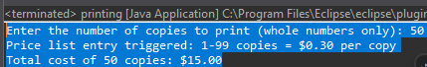

Test Case 2 — Pricing Boundary
Input: 500
Expected Result:
The program should recognize that 500 is the first value in the 500-749 range, use the $0.27 price per copy, and calculate a total of $135.00.
Actual Result:
Price list entry triggered: 500-749 copies = $0.27 per copy
Total cost of 500 copies: $135.00
Result: Passed.
This test verifies that the TreeMap.floorEntry() lookup correctly handles a boundary between pricing ranges.
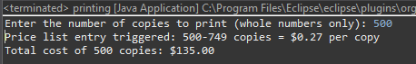

Test Case 3 — Invalid Input
Input: 2.5
Expected Result:
The program should reject the decimal because the program requires a whole-number quantity. It should catch the InputMismatchException, clear the invalid input, and prompt the user to enter another number.
Actual Result:
The program caught the invalid input and displayed an error message before requesting another number.
Result: Passed.
This test verifies that the program's error-trapping mechanism handles invalid user input without terminating the program.

Overall Testing Evaluation
The three tests confirmed that the program correctly handles normal input, pricing boundaries, and invalid input. The results were consistent with the intended IPO and demonstrated that the program's input validation, pricing lookup, calculation, and error-trapping mechanisms function correctly.

