**Monte-Carlo Modeling of Electron Transport**

Author:

Julie-Anne Chaine 101104568

Assignment 1

ELEC 4700 A

A2 11:30-1:30pm

6 February 2022

## Electron Modeling

1. In “Assignment1_Part1_JulieAnneChaine.m” file, I calculated a Vth of 1.86985 m/s
2. In the same file I calculated a MFP of 3.7395e-8 m
3. Chart, line chart

   Description automatically generated

Figure 1.1: 2D Particle Trajectory Sample

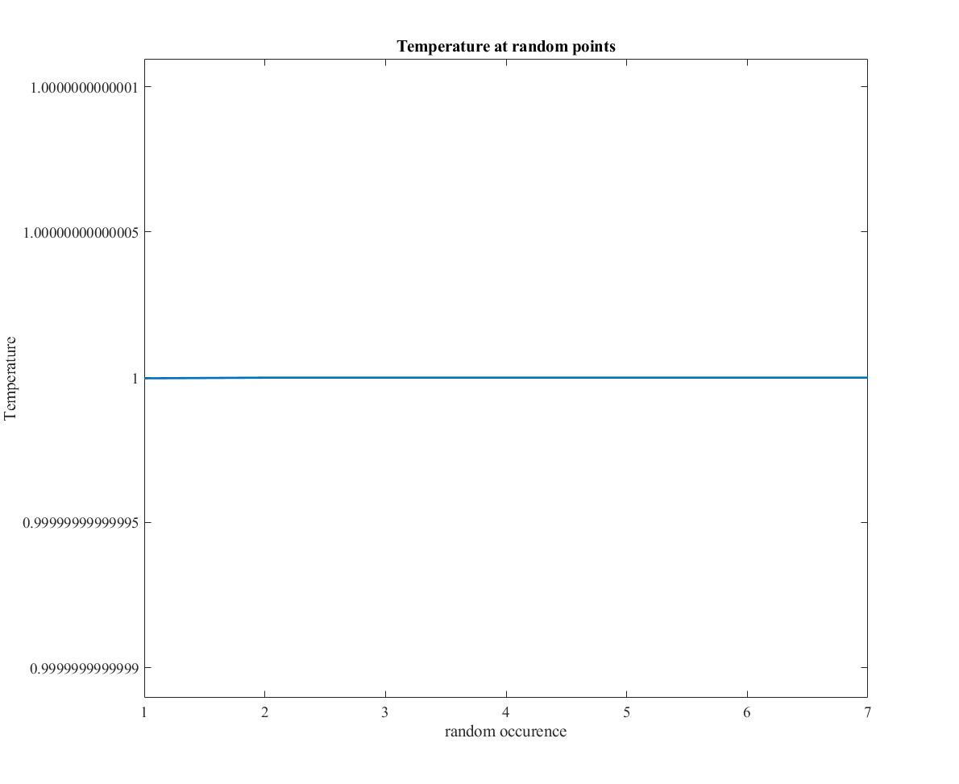Figure 1.2: Temperature Plot without Collision for 10 Samples in Time

We know the temperature should be constant since we aren’t losing any energy when the particles collide with the upper and lower boundaries.

## 2.0 Collisions with Mean Free Path

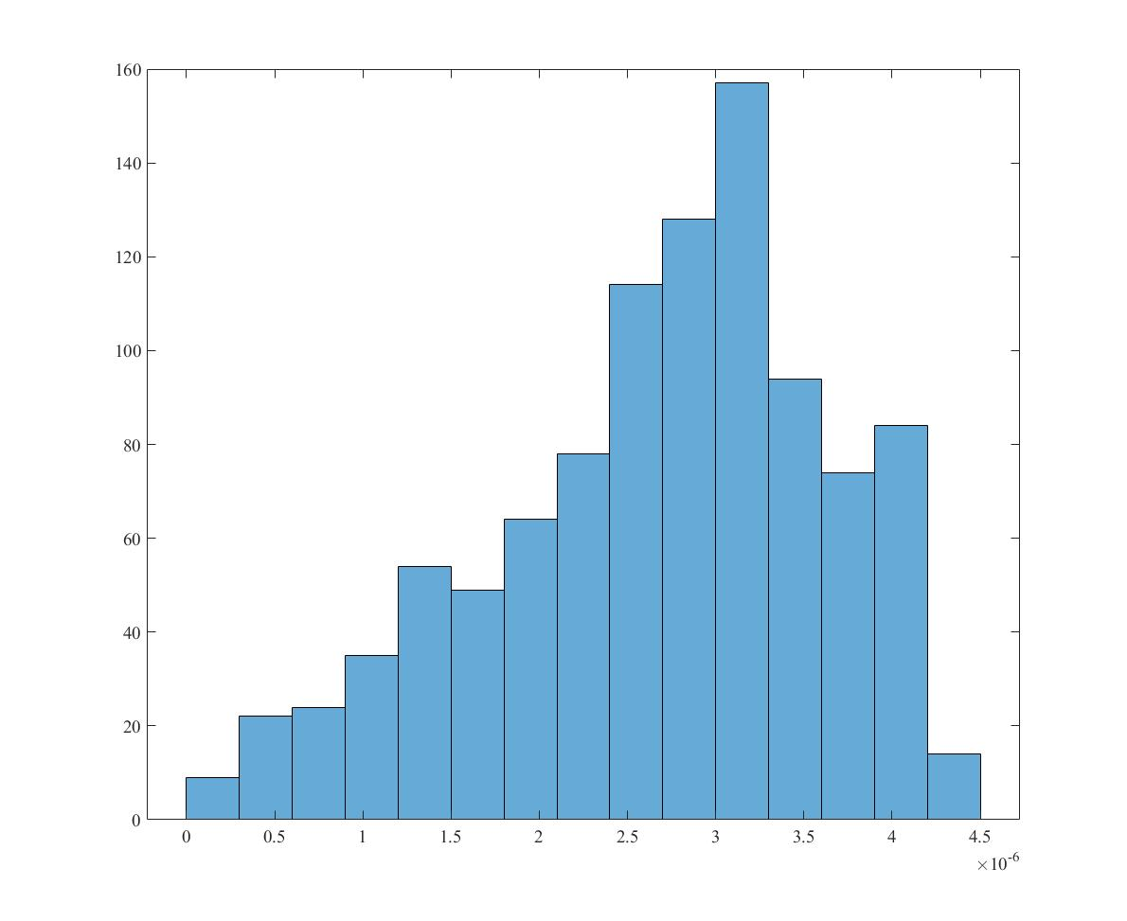a) From the “Assignment1_Part2_JulieAnneChaine.m” file:

Figure 2.1: Velocity Distribution Histogram

I’ll acknowledge that this histogram is incorrect. I couldn’t seem to figure out how to scale the equations correctly so that Vth is the velocity mean.

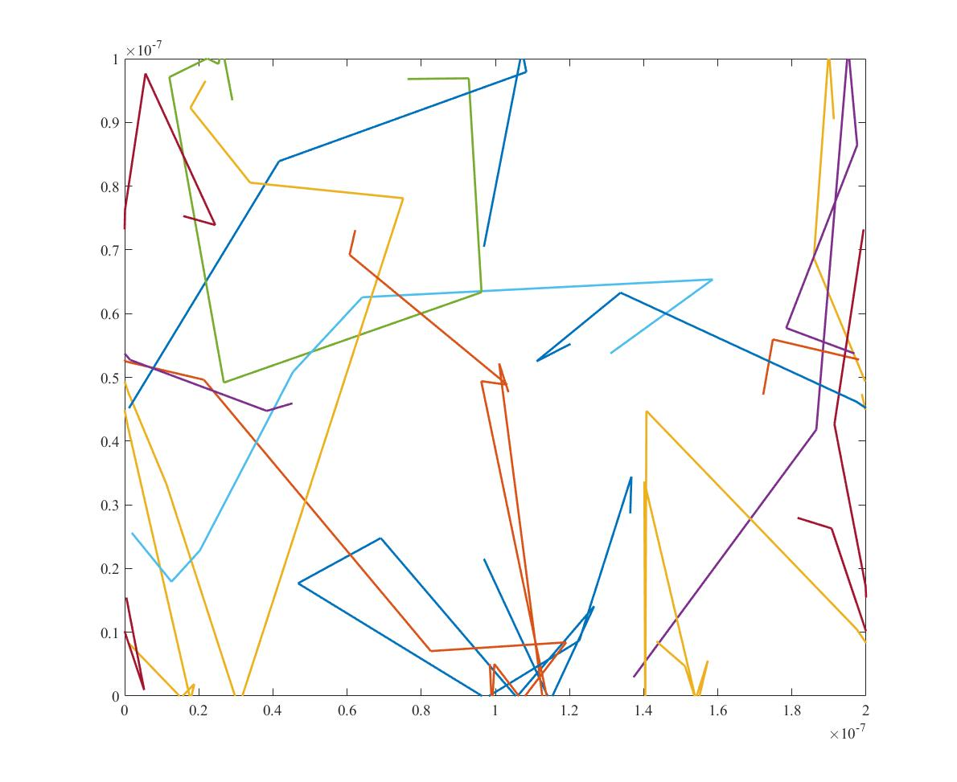b)

Figure 2.2: 2D Particle Trajectory Sample with Collision

c)

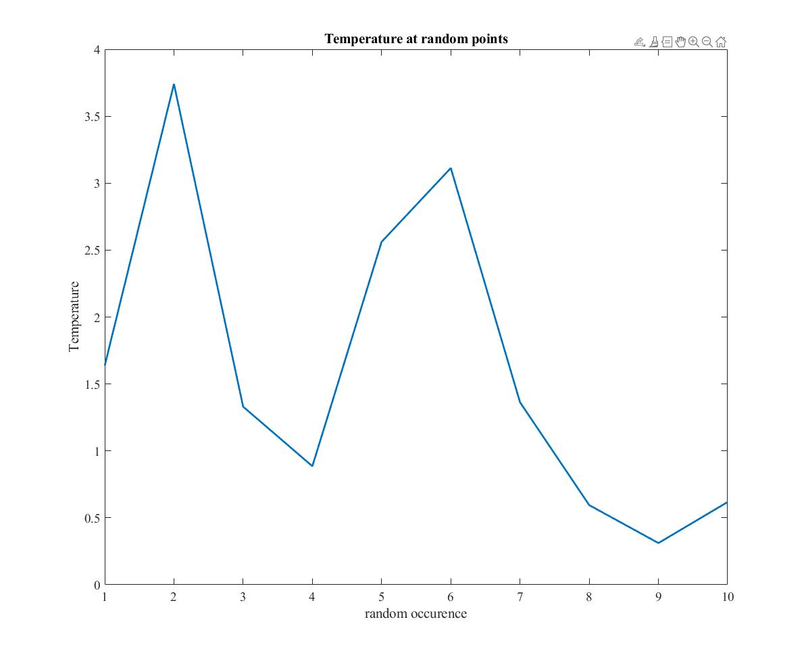Figure 2.3: Temperature Plot with Collision for 10 Samples in Time

We can see that the temperature is no longer constant since there is energy transfer when the particles collide. To get a better understanding of the overall effect on the temperature over time I’d have to plot for more points.

d) When running the code, the particles scattered 7 times out of 100 time-steps:

|  |  |  |
| --- | --- | --- |
| Time step | Scatter time (ps) | Scatter time difference (ps) |
| 14 | 0.14 | 0.46 – 0.14 = 0.32 |
| 46 | 0.46 | 0.5 – 0.46 = 0.04 |
| 50 | 0.5 | 0.57 – 0.5 = 0.07 |
| 57 | 0.57 | 0.61 – 0.57 = 0.04 |
| 61 | 0.61 | 0.76 – 0.61 = 0.15 |
| 76 | 0.76 | 0.81 – 0.76 = 0.05 |
| 81 | 0.81 |  |

So, the average time between scatter is: tau = 0.111667 ps

## 3.0 Enhancements

a) From the “Assignment1_Part3_JulieAnneChaine.m” file:

Figure 3.1: 2D Particle Trajectory Sample with Collision and Boxes

As can be seen in the figure above, the code isn’t perfect, and the particles will pass the box boundaries by a little distance before being reflected. It is worse the faster the velocity is as there is more movement for the same time step.

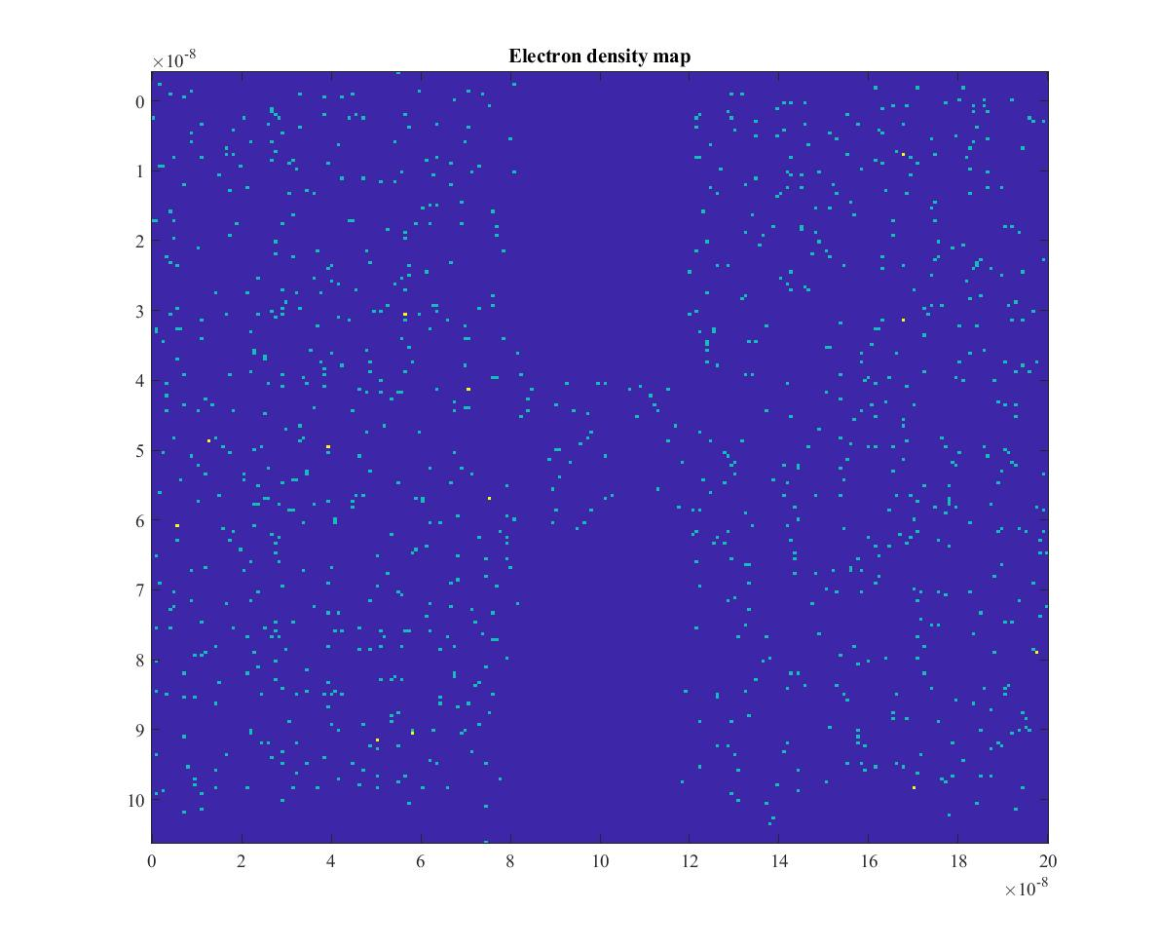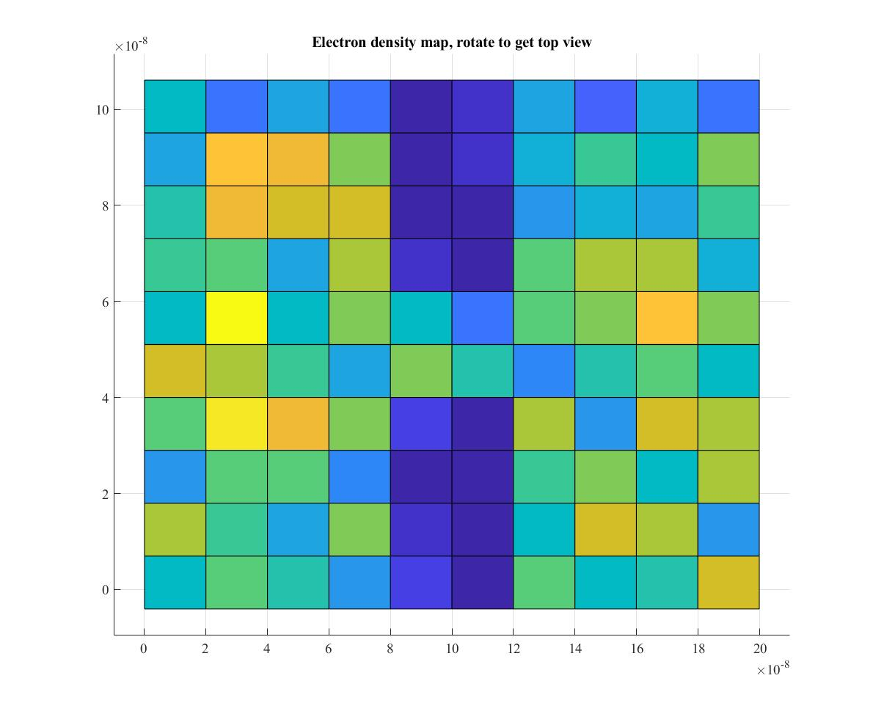b)

Figure 3.2: Two Representations of an Electron Density Map

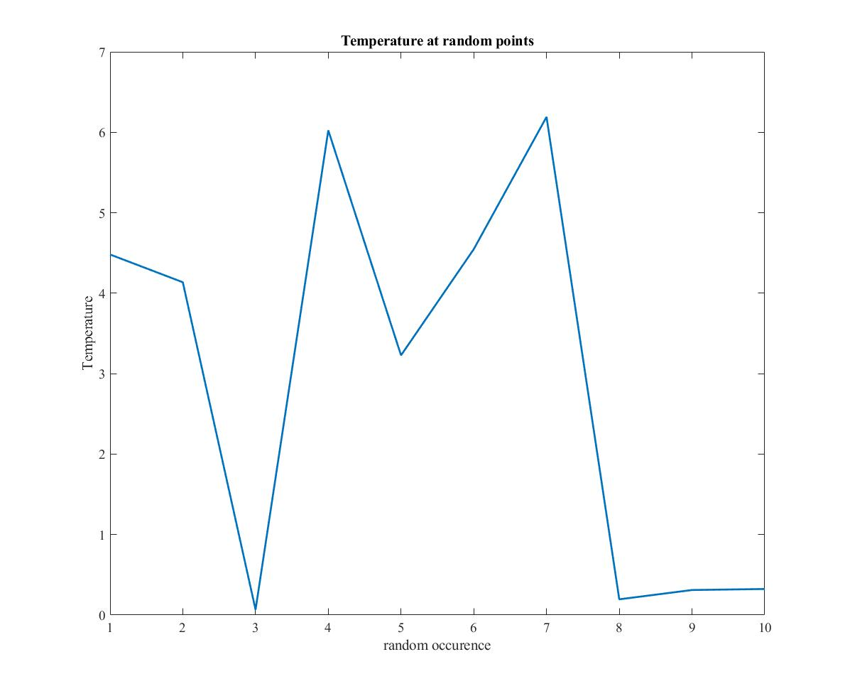c)

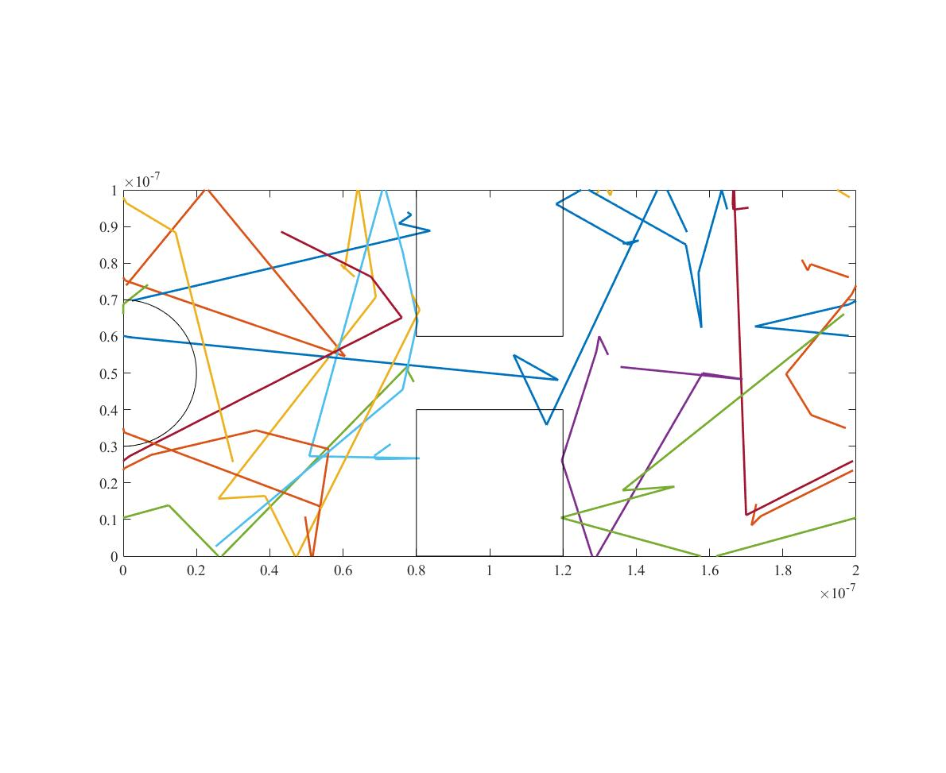Figure 3.3: Temperature Plot with Collision and Boxes for 10 Samples in Time

Figure 3.4: Temperature Plot with Collision, Boxes, and Circle Boundary

I have unfortunately been unable to implement the circle boundary conditions so the particles can still go through it. Above is a figure with the circle but with particles still travelling through.