**Circuit Modeling**

Author:

Julie-Anne Chaine 101104568

Assignment 4

ELEC 4700 A

A2 11:30-1:30pm

10 April 2022

## 3.0 Report on PA 7

C =

## A picture containing white Description automatically generatedG =

Figure 1: DC Response from PA7

Figure 2: AC Gain from PA 7

## 4.0 Transient Circuit Simulation

a) The circuit is an amplifier

b) I expect a bandpass frequency response with a top and bottom cutoff frequency. The values/magnitude will depend on the input voltage.

c)

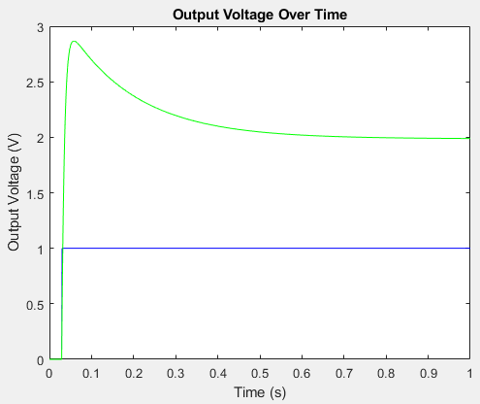Figure 3: Step Input Numerical Solution Results

Figure 4: Sinusoidal Input Numerical Solution Results

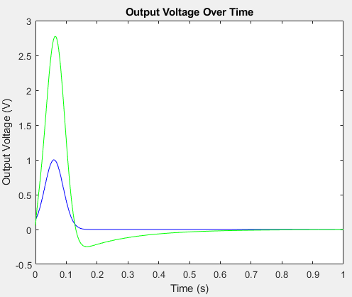

Figure 5: Gaussian Input Numerical Solution Results

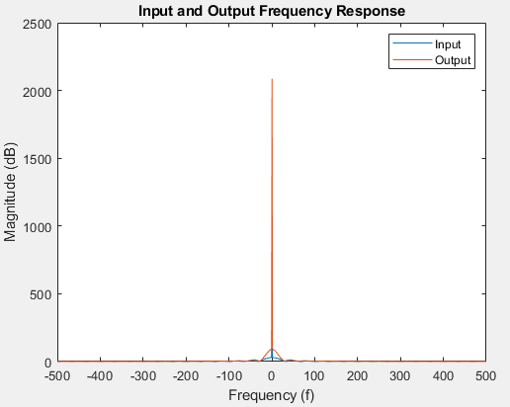Figure 6: Step Frequency Response

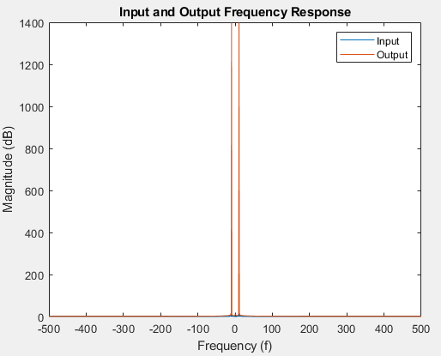

Figure 7: Sinusoidal Frequency Response

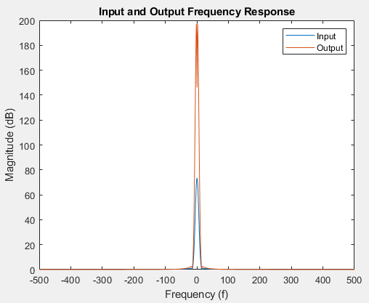Figure 8: Gaussian Frequency Response

When I increase the time step then the curves get narrower and very slightly less smooth as the others.

## 5.0 Circuit with Noise

C =

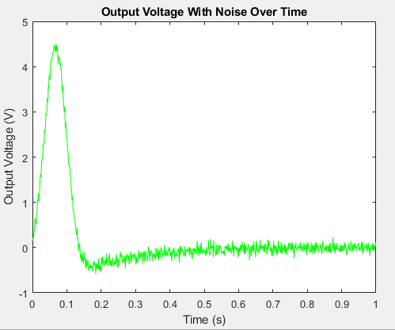

Figure 9: Output Voltage with Noise

Figure 10: Gaussian Frequency Response with Noise

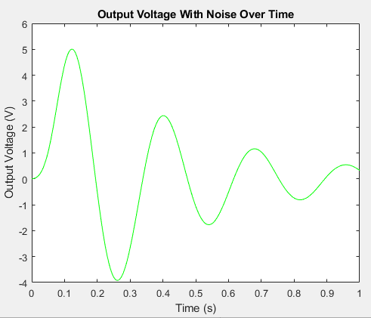

Figure 11: Output Voltage for Cn = 10e-3

Figure 12: Output Voltage for Cn = 10e-6

Figure 13: Output Voltage for Cn = 10e-9

As the capacitor changes, we get RC behaviour (Bigger cap) and we get more noise (Smaller cap).

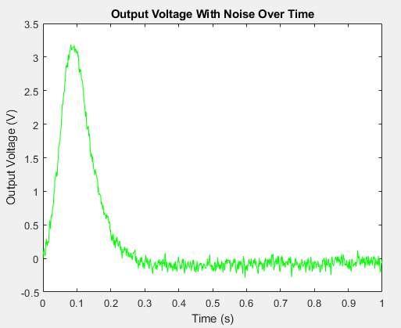Figure 14: Output Voltage for dt = 1/100

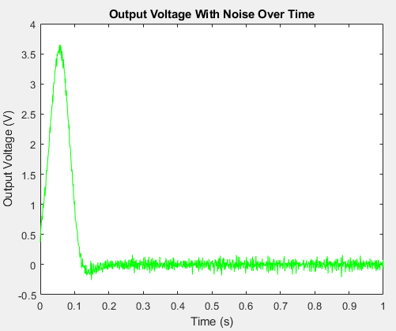

Figure 15: Output Voltage for dt = 1/5000

## 6.0 Non-Linearity

For my code that uses the stamps, and assuming that beta and gamma are also given to us, I would have to change the value of my voltage controlled voltage source from alpha/R3 to alpha/R3+(beta/R3)^2+(gamma/R3)^3.

Figure 16: Output Voltage

Figure 17: Frequency Response