Executive Summary & Business Framing
Problem Statement:
A leading retailer sought data-driven guidance to tailor marketing and retention strategies by identifying distinct customer segments within its rapidly growing base. The goal was to inform decisions on targeted campaigns, loyalty programs, and resource allocation by understanding which customer groups exist and how they differ in behavior and value. This analysis supports strategic decisions on where to invest marketing effort and how to personalize offers for each segment, moving away from one-size-fits-all approaches.
Data Overview: We analyzed two years of customer data encompassing demographic profiles, purchase history, and engagement with marketing. The structured data included numeric metrics such as income, number of family members, product category spend, purchase channel usage, and campaign response flags. Additionally, categorical attributes provided context on customer lifestyle. Both types were processed to capture meaningful signals. A derived Age was calculated from birth year, and low-frequency categories were grouped to ensure strong insights. The mix of behavioral metrics and customer profile data enabled a comprehensive segmentation, revealing differences in value drivers and engagement patterns.
Approach: The analysis followed a structured approach. First, we prepared and engineered features, cleaning missing values (imputing 1% of incomes with the median), removing outliers (a few customers with implausible ages), and standardizing numerical fields for unbiased clustering. Next, an exploratory analysis reviewed spending distributions and correlations, confirming intuitive relationships such as higher income correlating with higher spend on premium products while guiding feature selection to avoid redundancy. We then applied clustering (K-means) on key behavioral metrics (purchase frequency, channel use, product spend, etc.), using validation metrics to determine the optimal number of clusters. Finally, we profiled and interpreted each segment’s characteristics and value, linking them to business implications. Throughout, the emphasis was on actionable insight generation rather than technical implementation.
Key Outcomes – Four Customer Segments Identified: The analysis uncovered four distinct customer segments, summarized below along with their defining traits and headline implications:
- Budget-Conscious Families: Price-sensitive households (often with young children) who exhibit low overall spending and engagement. They make infrequent purchases and respond poorly to marketing, indicating a need for value-focused, low-cost engagement. This segment comprises the largest share of customers (45%) but contributes minimally to revenue per customer.
- Mid-Income Teen Families: Mid-tier spenders with family and teen-driven needs. They show moderate purchase frequency and favor products for households with teenagers. Engagement is average. They respond to relevant offers but are not deal-chasers by default. This segment (27% of customers) represents an opportunity to grow wallet share through targeted cross-selling (e.g. teen-oriented bundles).
- Affluent Core Shoppers: High-income, steady shoppers who purchase consistently across categories. They value quality and convenience, evidenced by high in-store and catalog spending, but are less responsive to promotions. Representing roughly 20% of customers, they are reliable revenue drivers. However, standard marketing has limited impact on them, implying upside in loyalty programs or exclusive perks to deepen their engagement.
- Affluent High-Value Responders: The top-tier clientele with the highest spend (premium products, broad category engagement) and a strong responsiveness to targeted campaigns. Though the smallest group (~8%), they drive significant value and have the greatest lifetime value potential. They are highly engaged across online and offline channels and can be promptly influenced by personalized offers.
Each segment’s value is shaped by behavior and responsiveness, not by income alone. These segments provide a foundation for tailored messaging, differentiated value propositions, and retention strategies aligned to each group’s characteristics.

Methodology
Data Preparation & Feature Engineering: We began by ensuring the dataset was clean and analysis ready. There were 2,237 customer records with 29 initial fields. After dropping extraneous identifiers and constant columns, we imputed 24 missing income values with the median (~$51K) to preserve data (only 1% were missing). A new Age variable was calculated from Year_Birth and a few implausible entries (age < 18 or > 100) were removed to prevent skewing. Categorical fields (Education, Marital_Status) were encoded or consolidated only for profiling purposes – the clustering itself focused on quantitative behavior indicators. We retained a rich set of features capturing customer value and engagement: e.g. total spending in each product category, number of purchases via different channels (store, web, catalog), recent purchase recency (days since last purchase), number of deals used, and whether they accepted past campaigns or filed complaints. Many of these features were skewed or on different scales, so we applied standard scaling (z-score normalization) to all numeric variables to ensure that no single measure (e.g. income or wine spending) dominated the distance-based clustering. We examined feature correlations and noted some high correlations (e.g. customers who spend more on meat also spend more on fish, suggesting an overall “total spend” factor). To address this, we considered dimensionality reduction (PCA) or combining related features but ultimately retained the separate spend variables for interpretability – acknowledging the redundancy but aware that K-means (with scaling) would treat those dimensions carefully.
Clustering Method & k Selection: We employed K-means clustering to partition customers into groups based on similarity across the selected features. To determine the number of clusters, we used the elbow method – running the algorithm for k=1 through k=14 and plotting the inertia (within-cluster sum of squared distances). We observed a clear inflection at k = 4 clusters, beyond which additional clusters yielded diminishing returns in variance explained. This indicated that 4 segments was an optimal balance between model simplicity and differentiation. We further checked silhouette scores as a secondary validation: the highest average silhouette occurred at k=2 (suggesting two very distinct broad groups, likely related to income), but k=4 still showed a reasonable silhouette and offered more actionable granularity. In other words, while two clusters would be very separated, they would oversimplify important differences; four clusters provided nuance (e.g. distinguishing two affluent segments) that is valuable for targeted strategies. Based on this, we proceeded with four segments. The K-means model was fit on the standardized data (with multiple random initializations to ensure stability) and converged quickly, indicating well-defined clusters in the data. Each customer was assigned a segment label, which we then translated into descriptive names.
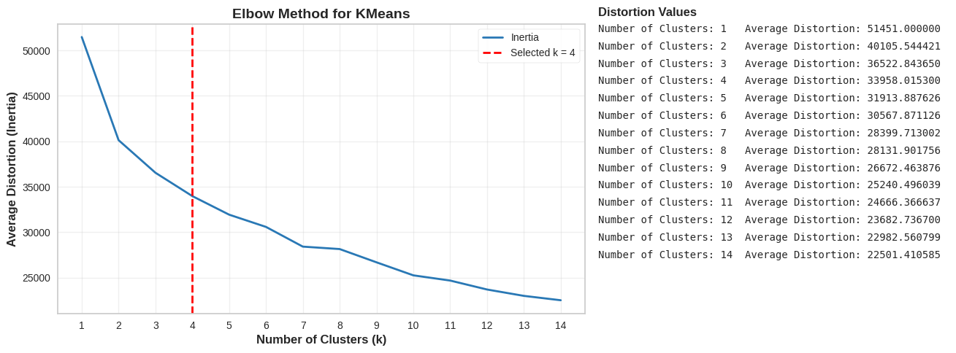
Figure 1: Elbow Method for Optimal Clusters. Plot of clustering distortion (inertia) versus number of clusters. A pronounced “elbow” at 4 clusters signals that adding a fifth cluster would yield only marginal improvement. This guided the choice of four segments as an appropriate model complexity for the data.
Validation & Stability: In addition to the elbow criterion, we confirmed that the chosen segmentation was sensible from a business standpoint: the clusters showed clear, interpretable differences that aligned with domain intuition (e.g. a low-income, low-spend group vs. a high-income, high-response group). We also note that K-means was run with multiple initial seeds (n_init=10) to ensure consistent results, and cluster definitions remained stable. Due to project scope, we did not pursue more advanced validation like hold-out re-clustering or hierarchical stability checks. However, the distinctness of the clusters in profiling (minimal overlap in key behaviors) and alignment with known customer personas give confidence that these segments are meaningful and reproducible for decision-making purposes.

Segment Definitions & Evidence
After clustering, each customer was assigned to one of four segments. We profiled each segment to understand its defining characteristics, size, and business value. The segments were given intuitive names to encapsulate their profiles. Below we describe each segment in turn, with supporting evidence and insights:

Segment 1: Budget-Conscious Families
Profile & Behavior: These customers have the lowest incomes (median $35K) and minimal spending across all product categories. They often have larger families with young children – this group has the highest number of children at home among segments, averaging nearly one child per customer (and a moderate number of teens as well). Their purchase frequency is low; they make infrequent store or web purchases and typically only buy the basics. Engagement metrics highlight that Budget-Conscious Families are cost-sensitive and less responsive: they seldom engage with marketing campaigns (this segment had the lowest campaign acceptance rate of all and are slightly more likely than others to have never responded to any promotions. They also have the lowest number of website visits on average, indicating limited online engagement.
Value Mechanics: Despite being the largest segment (45% of the customer base), their contribution to revenue is disproportionately low. Their baskets tend to consist of discounted or essential items (e.g. staple foods rather than luxury goods). Margin is thin with this group – they will only increase spend if prices are attractive, and even then, the volume is limited by their budget. They also exhibit little brand interaction (few loyalty behaviors, low cross-sell uptake), meaning the cost to engage them can easily outweigh returns. However, their volume means small per-customer improvements could add up.
Business Implications:
- Retention is challenging but possible through value messaging. To keep these customers, the company must emphasize savings and practical benefits. Generic upscale campaigns will not resonate. Affordable bundles or loyalty discounts can incentivize additional purchases but require careful margin management.
- Marketing ROI is limited: Big-budget campaigns should not be centered on this segment, as they are unlikely to respond. Instead, use low-cost channels (email, app notifications) with simple offers (save $5 on essentials”) to maintain connection. Their low engagement suggests focusing on retention through convenience (e.g. subscription for staples) rather than pricey acquisition pushes.
- Long-term potential: If their financial status improves (or as children grow, needs change), some may graduate to higher segments. Monitoring for changes (e.g. increased spending or responsiveness) could trigger moving them to a different strategy.
Supporting Evidence: In the profiling analysis, Budget-Conscious Families had the lowest average income and spending of all segments, and almost negligible wine or specialty product purchases. They also showed the smallest response rate to campaigns, as seen in Figure 2 (red highlight in “Response Rate (%)” – their bar is the shortest) and in the cluster summary, indicating marketing offers often fail to convert this group.

Segment 2: Mid-Income Teen Families
Profile & Behavior: This segment features middle-income households ($57K on average) with teenage children. They spend at moderate levels that are higher than the budget group but well below the affluent segments. What distinguishes Mid-Income Teen Families is their purchasing geared towards family and teen needs: for example, they buy a balanced mix of groceries and some treats or teen-oriented products (snacks, school supplies, etc.). Their engagement pattern is moderate: they browse and shop online periodically (their web visit and purchase counts are around average) and respond to campaigns at modest rates. Notably, this group has the highest incidence of families with teenagers – on average nearly one teen per household, significantly more than other segments. They also tend to use discount deals when those align with family needs, though they are not purely bargain-hunters.
Value Mechanics: Mid-Income Teen Families represent a stable, middle-tier revenue source. They are value-conscious but not strictly low-end: if they are offered relevant products (e.g. back-to-school promotions, family packs), they will spend. Their share of wallet could grow if we tap into their family needs effectively. They are less constrained by income than Budget Families, but budget is still a consideration. They have potential to contribute higher value as their teens grow into independent consumers (e.g. the family’s spending could increase with college or if income rises over time). They also have a social aspect. Satisfying this segment can lead to word-of-mouth within community or school networks.
Business Implications:
- Targeted Bundling: Develop product bundles and promotions around family and teen themes (for example, “snack packs for teens” or family meal bundles) to increase relevance. This can increase their basket size by meeting multiple related needs at a modest discount.
- Channel and Messaging: Digital channels (email, social media) timed to family schedules are effective. This segment is busy with kids’ activities, so brief, convenient offers work best, e.g. SMS with weekend deals on family essentials, or mobile app alerts for quick dinner kits. They respond to practicality and time-savings.
- Engagement: Encourage loyalty through family-oriented perks – for instance, a points program that rewards purchases of school-related items or offers movie vouchers for family night. Since their campaign responsiveness is moderate, content marketing (recipes teens can cook, tips for family budgeting) can keep them engaged beyond transactional offers.
Supporting Evidence: The presence of teenagers is this segment’s hallmark – their teen count is the highest, as reflected in Figure 2 (“Average number of Teenagers at Home”) where Mid-Income Teen Families top the chart. They also exhibit mid-range spend across categories significantly more than Budget families on items like meats and wines, but less than affluent groups, confirming their middle-tier positioning. Their campaign acceptance rate, while not the highest, is noticeably better than the budget group, aligning with their more responsive (though not highly reactive) nature.

Segment 3: Affluent Core Shoppers
Profile & Behavior: Affluent Core Shoppers are wealthy customers (avg. income ~$74K) who spend heavily and consistently across many product categories. They form the backbone of the store’s revenue, purchasing premium products (e.g. wines, meats) regularly. Their engagement is notable in transactional behavior: they shop in-store and via catalog frequently; indicating a preference for traditional channels and have steady web visits as well. However, they are less inclined to participate in promotions or campaigns. This segment has a typical profile of professionals or families without many young children at home (very low averages for kids/teens in household). They tend to know what they want and buy it without needing incentives, implying a certain loyalty or habit in shopping. Complaints from this group are rare (they are generally satisfied customers).
Value Mechanics: As 20% of the customer base, they contribute a large share of revenue due to their high spend per person. They are often the loyal, repeat customers who may not seek out deals but expect quality and service. They deliver strong lifetime value through frequency and basket size. Since they are not highly responsive to marketing pushes, their value comes from intrinsic shopping habits. This means upselling or cross-selling can be challenging. They might already buy what they need, but also that they are less price sensitive (willing to pay full price for preferred items). Retaining them is crucial. If a competitor lured them away, it would noticeably impact revenue.
Business Implications:
- Loyalty Programs: Standard promotions may not sway this segment, so enhanced loyalty programs or VIP perks are key. Consider exclusive member benefits (early access to new products, invite-only sales events, concierge services) to recognize and reward their loyalty.
- Personalized Service: Invest in personalized shopping experiences – e.g. personal shoppers or customized recommendations – to deepen their connection. Since they like in-store/catalog, ensure staff outreach (thank-you notes, product suggestions) and a seamless offline experience.
- Product Strategy: These shoppers appreciate quality. Emphasize high-quality, premium product lines and ensure stock availability for their favorite items. Introduce curated high-end bundles or subscriptions (e.g. wine club) that suit their tastes, which can increase their spend without “discounting” the brand.
- Limited Discounting: Avoid conditioning them to expect discounts – they currently buy without them. Instead, focus on value-add rather than price cuts (free gift wrapping, extended returns, etc.). Their low response to general campaigns suggests targeted communications about new arrivals or categories they haven’t tried might be more effective than blanket promotions.
Supporting Evidence: Affluent Core Shoppers exhibit high spending across categories (e.g. their average wine spend is second only to the High-Value Responders, and they lead on some categories like fruits) and elevated income levels. In Figure 2, they are represented by the first bar in each metric – for instance, their Average Income and spend metrics are very high, but notably their Response Rate (%) is modest. This confirms that despite their value, they did not react strongly to campaigns (their response bar is much lower than the High-Value Responders segment), underscoring the need for different engagement tactics beyond mass promotions.

Segment 4: Affluent High-Value Responders
Profile & Behavior: This elite segment comprises the wealthiest customers (~$82K avg. income) with the highest purchase expenditure in nearly every category. They buy frequently through all channels; online, in-store, and catalog indicating true omnichannel engagement. What truly sets them apart is their responsiveness to marketing: they have the highest rate of campaign acceptance and promotion uptake, meaning they frequently say “yes” to offers and new initiatives. They are also savvy shoppers who may enjoy being “in the know” for deals, given they engage across email, web, and likely social media. Like the Core Shoppers, most have no children at home or perhaps older dependents; they are often dual-income professionals or empty-nesters with high discretionary income. They rarely complain; satisfaction is high if they feel valued.
Value Mechanics: Though approximately 8% of the customer base, Affluent High-Value Responders contribute outsized revenue and profit. They are the most valuable customers in terms of spending, and their openness to marketing means they are often first adopters of new products or upselling. When presented with a tailored offer (a new premium product line, a limited-time bundle), they not only purchase for themselves but potentially influence others (friends or family) through referrals or showcasing brand affinity. Their high responsiveness also makes them ideal for pilot programs – they will give feedback and engage deeply. However, they are also at risk of competitive poaching since other brands’ incentives could lure them. Ensuring their continued enthusiasm is critical for sustained revenue growth.
Business Implications:
VIP Treatment: Implement elite loyalty tiers or “VIP clubs” for this segment. Examples include invite-only events, personal account managers, or bespoke offers such as a special holiday catalog just for them. Make them feel recognized as top customers with exclusive promotions. Since they respond to campaigns, keep them engaged with carefully timed promotions but focus on exclusivity over broad discounts. Early access to sales, first look at new products, or “member-only” deals will leverage their responsive nature while reinforcing their importance. This segment is primed for upselling and cross-selling. Use their data to recommend premium products or services to upgrade to a higher-end product line, or add-on services like wine tasting events for top wine purchasers. Because they trust and interact with marketing, targeted cross-category suggestions can increase their basket. If they buy premium wine, suggest gourmet food pairings for example.
Retention: Proactively monitor their engagement. A drop in response to or spending from this group should trigger quick follow-up since losing one high-value responder can equal losing several budget customers. Solicit their feedback regularly and incorporate it. This can further strengthen loyalty.
Supporting Evidence: Affluent High-Value Responders have the highest metrics on almost every dimension as shown in Figure 2, they lead in income and spending (second bar in the charts). Most striking is their Response Rate. Their campaign acceptance rate is the highest by a large margin. In the figure, their Response Rate bar towers above the others, visualizing their receptiveness. The cluster analysis interpretation explicitly notes this segment as “prime targets for upsell and personalized offers”, which aligns with the recommended strategies to fully capitalize on their potential.
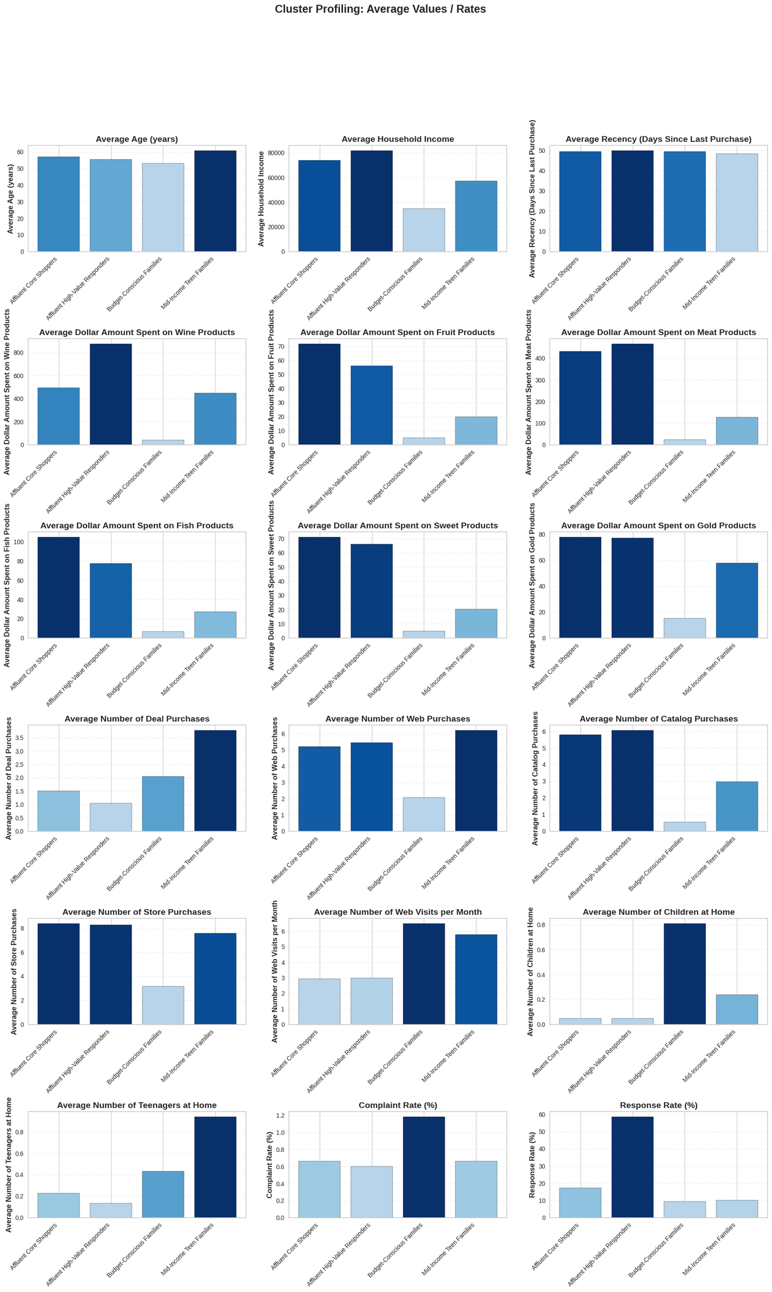
Figure 2: Customer Segment Profile Comparison (Average Values & Rates). This multi-metric chart compares the four segments on key features. For each metric, the bars represent (from left to right) Affluent Core Shoppers, Affluent High-Value Responders, Budget-Conscious Families, and Mid-Income Teen Families. We see clear differences: for example, Income and Spending metrics (top rows) are highest for the affluent groups and lowest for Budget families. The “Response Rate (%)” panel (bottom right) highlights that High-Value Responders are about twice as likely to accept campaigns as other groups. Such profiles illustrate the distinct behaviors of each segment, validating their business relevance.

Recommendations and Next Steps
Leveraging these segment insights, we propose the following targeted strategies and next steps to maximize customer value and loyalty:
Segment-Specific Actions:
- Budget-Conscious Families: Prioritize cost-effective retention. Implement budget-friendly loyalty rewards (small discounts after a certain number of purchases, cashback on essentials) to encourage repeat business without large margin hits. Use high-frequency, low-cost touchpoints (mobile app deals, email newsletters with budgeting tips) to keep the brand relevant to them. For example, send monthly “Essentials under $20” promotions. Avoid expensive campaigns: this segment should receive steady, modest incentives that maintain presence and prevent churn, while upsell expectations should be kept low.
- Mid-Income Teen Families: Focus on family-centric engagement. Create targeted bundles and offers for households with teens, e.g. “Back-to-School Combo Packs” or holiday promotions that bundle teen favorites with family staple. Tailor messaging on digital channels like social media, where both parents and teens might see it. For instance, Instagram ads showing quick family dinner kits or TikTok videos featuring popular snacks could resonate. Ensure communications highlight convenience and value (saving time for busy parents). Also, consider a referral program where these families get rewards for referring other families – leveraging their community networks can amplify reach.
- Affluent Core Shoppers: Emphasize loyalty and premium experience. Roll out a tiered loyalty program if not already in place, with a top tier that grants this segment exclusive perks (e.g. dedicated customer service line, extended return windows, early access to new collections). Since they are less responsive to generic ads, they invest in personal touches: personal shopping consultants, bespoke recommendations, or invitation-only events (tastings, preview nights) to deepen their engagement. Their feedback should be solicited for continuous improvement, e.g. periodic surveys on product satisfaction – reinforcing that the brand values their input beyond transactions.
- Affluent High-Value Responders: Maximize personalization and advocacy. These customers should receive the most tailored communications. Use predictive analytics on their purchase history to craft offers unique to their preferences (e.g. if they bought high-end wine, invite them to a winery tour event; if they respond to sustainable products, showcase a new eco-friendly line). Implement a VIP concierge program where a dedicated representative periodically checks in with personalized suggestions or assistance – forging a personal connection. Additionally, leverage them as brand advocates: exclusive referral incentives or “bring a friend” invitations to VIP events can turn their enthusiasm into recruitment of new customers. Given their responsiveness, test new campaigns or products on this segment first to gather early insights (they’ll likely provide feedback and adoption). Monitoring their engagement closely is key – a sudden drop might signal competitive interference or changing preferences, which warrants immediate outreach to preempt churn.
Prioritization: While all segments offer opportunities, the Affluent High-Value Responders and Affluent Core Shoppers should be top priorities for short-term ROI, as they drive the most revenue and have high propensity to increase value with the right touch. Improvements with these groups can significantly impact sales. Mid-Income Teen Families are the next priority, a sizable group with room to grow if engaged creatively. Budget-Conscious Families, being largest in number, shouldn’t be neglected, but efforts here are about efficient retention rather than growth, maintain their business with low-cost tactics, but allocate larger innovation budgets to the higher value segments.
KPIs to Measure: For each segment’s initiatives, we will track appropriate performance indicators. Examples include response rate and conversion for targeted campaigns (especially for High-Value Responders to ensure continued engagement), average order value and purchase frequency changes for Mid-Income Families (to see if bundles or teen-centric offers increase basket size or visit rate), retention/churn rates and customer lifetime value by segment (to ensure loyalty efforts for Core Shoppers and Budget families are yielding improvements), and segment migration (e.g. the rate at which Budget families or Mid-Income customers move up into higher segments over time, indicating increased spend/engagement). These KPIs will validate if our tailored strategies are effective within each group.
Assumptions & Limitations: This analysis assumes customer behavior remains relatively consistent; significant external changes (economic shifts affecting income, new competitors) could alter segment characteristics. The data used did not include psychographic factors or detailed product-level preferences, incorporating those could further refine personas (e.g. differentiating “health-conscious” vs “luxury-seeking” within affluent groups). Also, segments were based on historical data; ongoing re-segmentation may be needed as customers evolve (e.g. teens grow up, income changes). We assumed four clusters as of now. It’s possible that adding data (such as online browsing patterns or social media sentiment) might reveal additional nuanced segments or sub-segments. Lastly, our clusters maximize internal similarity but individuals within a segment will still display variation; thus, recommendations are a starting point and should be A/B tested and refined in practice.
Next Steps: We recommend a few follow-ups to build on this segmentation:
- Campaign Experimentation by Segment: Design targeted marketing experiments for each segment (different messaging or offers) and measure lift versus control. This will provide concrete evidence of what works best for each group (e.g. do Affluent Core shoppers increase spend on exclusive events? Will Budget families use a subscription service if offered?).
- Integration with Customer Lifetime Value Modeling: Incorporate segment membership into CLV models to project long-term value and identify if investment in moving customers up segments is justified. For instance, quantify how much more an average Mid-Income Teen Family would spend if they became an Affluent Core Shopper, to inform cross-segment migration strategies.
- Enrich Segments with Additional Data: Merge external or unstructured data (e.g. social media engagement, customer reviews text, or geographic data) to see if sub-segmentation or more personalized micro-segments can be identified. This could uncover, say, a subset of Budget families who are health-conscious and might respond to a different approach than others in that segment.
- Periodic Segment Review: Establish a process to update the segmentation periodically (e.g. annually). Customers may shift segments as their life stage or behavior changes; an agile segmentation approach ensures marketing stays aligned with current patterns rather than stale assumptions.
By executing these tailored strategies and continuously refining our understanding, the company can maximize customer lifetime value and foster loyalty across the spectrum – from price-savvy families to premium enthusiasts. In summary, this data-driven segmentation provides a roadmap for more personalized, efficient marketing that aligns offerings with what each segment values most, ultimately driving higher customer satisfaction and business performance.
Figure List:
- Elbow Method for Optimal Clusters. Plot of inertia vs. number of clusters, showing a clear elbow at k=4 (source: analysis results, PDF p.42).
- Customer Segment Profile Comparison (Average Values & Rates). Multi-metric bar chart comparing the four segments on key features (source: analysis results, PDF p.59-60). Each panel illustrates a different feature (income, spend, engagement, etc.), highlighting the distinct profile of each segment (e.g. highest response rate for High-Value Responders, lowest income for Budget-Conscious).

