Stroop Task Model (THINK ABOUT TITLE)

Wei Liao (weiliao@uw.edu)
Department of Psychology, University of Washington
Campus Box 351525, Seattle, WA 98195, United States

Andrea Stocco (stocco@uw.edu)
Department of Psychology, University of Washington
Campus Box 351525, Seattle, WA 98195, United States

Abstract
.
Keywords: Stroop Task; ACT-R; Production Systems; Decision Making; Cognitive Models

Introduction
The Stroop interference effect is a strong and reliable behavioral phenomenon that has been studied vigorously with continuous development of various models and theories regarding its underlying mechanism. Stroop tasks, which are where Stroop interference may be observed, generally ask participants to name the color or the printed word of the presented stimulus. The tasks usually consist of four different types of stimuli: control color stimuli that are pure color blocks, control word stimuli that are black-ink printed color words, congruent stimuli where the presented color is consistent with the name of the printed color words, and incongruent stimuli where the presented color is inconsistent with the name of the printed color words. To further clarify the illustration, an example of a congruent stimulus would be the word “red” printed in the color red and an example of an incongruent stimulus would be the word “red” printed in the color blue.

The main result of the Stroop task is that participants take longer to respond when the word is the name of a color different than the print color (e.g., “RED” printed in blue) than in a neutral (“XXX”) or a congruent (“BLUE”) condition. This indicates that the act of reading is interfering with the task. Most importantly, this interference effect is asymmetric: When participants are asked to name the word and ignore the color, they seem to be able to do so without any relevant behavioral effect.
Computational Models of the Stroop Task
Various computational models have been created in an attempt to explore the cognitive mechanism underlying the Stroop interference effect. One of the most influential computational model was put forward by Cohen et al (REF). The model explains the interference through the concept of automaticity and attention. Cohen states that instead of categorizing processes as controlled or automatic, it is more appropriate to consider automaticity in terms of degrees. Processes are compared to one another by degrees of automaticity and automaticity could be developed through training. Another cognitive model is be Altmann’s WACT model (REF) that simulates Stroop interference using the concept that the word component is processed ballistically while the color component is not. Finally, Lovett (2005) proposed a radically different approach, in which Stroop interference is due to the competition between two alternative procedural strategies, one for naming the color and one for naming the word .
In this paper, we will attempt to integrate the strength of the currently published models, eliminate the perceived weaknesses, and present our interpretation of the mechanism underlying Stroop interference effect using the cognitive architecture ACT-R. The model will also be used in an attempt to predict and explain the individual differences regarding Stroop interference effect and the behavioral outcome of Parkinson’s disease patients on performing Stroop tasks. Successful simulation of the behavioral outcomes will shed light to the mechanism of the Stroop interference effect, influences of individual differences in working memory on cognitive performance, pathological knowledge on Parkinson’s disease, and the function of the basal ganglia, which is a critical brain area that is strongly associated with decision-making.

ACT-R
Our model is grounded in the ACT-R cognitive archiytecture (Anderson, 2007). ACT-R simulates the structure of human brains according to current cognitive theories and can perform cognitive tasks comparable to human subjects. ACT-R consists of several modules––procedural module, goal module, imaginal module, declarative module, vision module, speech module…etc.––that represent different parts of the human brain. Each module has an interface called a buffer that interacts with other buffers (Figure 1). Declarative knowledge, which is factual information, is represented as chunks that are stored in the declarative module. Procedural knowledge, which is implicit instructions on performing tasks, is represented as production rules that describe the changes that will occur in the specified modules when the requirements are met. Activation and utility influence declarative knowledge and procedural knowledge respectively. Activation negatively correlates with the time to retrieve a chunk and utility positively correlates with the possibility of a production being chosen and fired when there are competing options. The components of the cognitive architecture are able to interact with one another in complex patterns to produce the simulated results of human cognition performance.

The PSS Stroop Task Model
The model that we present draws upon previous Stroop models as well as a recently presented theory of the role of procedural knowledge in selective attention (Stocco et al., in press) The strength from previous models are incorporated conceptually and manifested in codes that are applicable to ACT-R whereas weaknesses are avoided and replaced with alternative explanation that are more consistent with current theories and reliable findings.
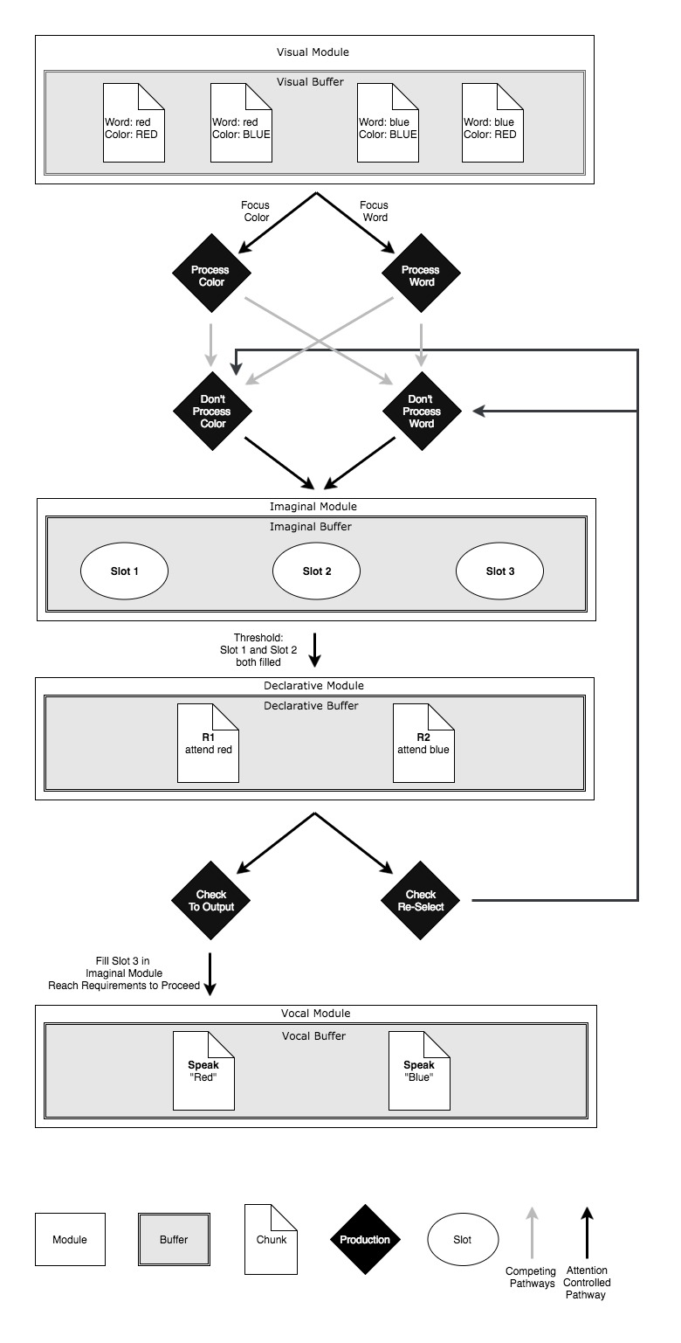
Overview of ModelFigure 2 provides an overview of the model (Figure 2) goes through a pattern of productions and generates answers to each presented stimulus until there are no more stimuli to respond to. The model begins performing the task when it sees the stimulus and encodes the information. Following the encoding, either the word component or the color component of the stimulus is transferred to the first slot of the imaginal module, which is the module that represents working memory. The process of filling the first slot of the imaginal module is controlled by the goal module, which accounts for attention. The first slot of the imaginal module is filled by what the task demands, and there are two productions to choose from: process word and process color. For instance, when the task is naming word, the focus of the model will be directed to the word and the first slot of the imaginal module will be filled with the word component of the stimulus using the production process word.
After filling the first slot, the model proceeds to filling the second slot. There are two productions to choose from: do not process word and do not process color. Filling the second slot of the imaginal module is not controlled by attention, thus both productions fit the criteria to fire and are free to compete with each other. In ACT-R, the result of the competition between two qualified productions is determined by the utility value assigned to the productions. The production with the highest utility value will win the competition and be fired. In this case, the do not process color––which is operationally equivalent to process word––has a higher utility value compared to the do not process word production. As a result, the word component of the stimulus will be more likely to be filled in the second slot of the imaginal module regardless of the assigned task and focus.
When both slots are filled in, the model will reach the requirement to proceed to retrieving the appropriate answer chunk. The probability of retrieving of a chunk is determined by its activation value. The activation value of a chunk is computed using the following equation
PLACE EQUATION 1
where B sub I is the base-level-activation of the chunk, which specifies how frequent and recent the chunk has been retrieved. S sub I is the spreading activation of the chunk, which is determined by two factors––the activation of the chunk from sources in other buffers and the strength of connection between the sources and the chunk. P sub I is the partial matching values that checks the relevance of the chunk with the request. Last but not the least, epsilon sub I is the noise value that accounts for slight variations similar to random fluctuations in human behavior within trials. The parameter that is most significant to our model is S sub I, which is strongly influenced by the contents in the slots of the imaginal module. Due to that the second slots of the imaginal module is more likely to be filled with the word component of the stimulus, responses of the model will tend to lean towards retrieving the chunk that corresponds to the word component of the stimulus despite the previous control of the attention on filling the first slot of the imaginal module.
Once an answer has been retrieved, the model performs a quick check on the accuracy of the retrieved answer. There are two possible outcomes to the checking process. The first option would be that the model passes the check, which would lead to filling slot 3 in the imaginal module in order to meet the requirements to proceed, and a corresponding chunk from the vocal module is chosen and outputted. The second option would be that the model fails the check, which would trigger the model to clear the second slot of the imaginal module and loop back to the process of filling the second slot. The looping system will continue until a correct answer is retrieved, which would then allow the model to proceed to output.

Source of Stroop Interference
Our model explains Stroop interference at the level of competing productions, the resulting activation values of the chunk, and the processing pathways. The model and its underlying concepts are inspired by Cohen’s theory of automaticity and attention and Stocco’s Simon task model. The model focuses on the influence of both attention and automaticity and the role that competing direct and indirect processes play in changing the outcome of responses to stimuli.
Cohen proposes that disparate degrees of automaticity between processes and the focus of attention can explain the mechanism of Stroop interference. Automaticity is the extent to which a particular process has been practiced and used over time. Due to that human uses and practices word naming significantly more frequent and extensive than color naming, word naming generally has higher automaticity compared to color naming. According to Cohen, processes that are higher in automaticity will interfere with processes that are lower in automaticity whereas the processes lower in automaticity will not have significant influences on those with higher automaticity. Attention also contributes to performances in Stroop tasks. Specifically, allocating attention to the task that is requested is the factor that enables subjects to overcome the automaticity of word naming and correctly perform color naming tasks. However, it is also possible that attention could be overridden by automaticity. In general, Stroop interference is the result of the complex interaction between attention and automaticity of competing processes.
To manifest the different automaticity of the various process, contrasting utility values are assigned to the two categories of productions in the model––those that lead to processing the color component of the stimulus and those that lead to processing the word component. A temporary value of ### is assigned to the equivalent process-word-s1 and don’t-process-color-s2 productions. A temporary value of ### is then assigned to the equivalent process-color-s1 and don’t-process-word-s2 productions. The greater the value of utility, the more likely a production will be selected to fire when conditions are met and the faster the model will be able to fire the production. With the current utility values assigned to the productions, processing the word component of the stimulus will be preferred and selected faster whereas processing the color component will generally lose the competition and be slower in its selection.
In order to account for the influences that attention may exert on task performance, two chunks that specify the current focus of the task––either focus on word or color––are added to the goal module of the model. Attention affects what is put into the first slot of the imaginal model. For instance, when the focus of the task is word, the word component of the stimulus is placed into the first slot of the imaginal model. The component in the first slot would then exert spreading activation to increase the likelihood for the retrieval of the correct response. However, it is also important to note that the process of filling the second slot of the imaginal module is not controlled by attention at all. Instead, it is controlled by utility values that reflect preference for the word processing production. The reason for the distinction lies in that the two categories of production––those that fill the first slot and those that fill the second slot––are essentially mirroring the different pathways in the human brain.

Weaknesses Avoided from Previous Models
Some models, such as Altmann’s WACT model (Altmann REF), attempts to demonstrate that Stroop interference arises from the concept of the horse race theory, which states that word concepts are retrieved faster and easier compared to color concepts. However, in Glaser’s experiment (Glaser REF) where they examined the effect of altering the stimulus onset synchrony (SOA), (explain) they did not see interference occurring in naming words even when the incongruent color component of the stimulus preceded the word component by a generous amount of time. The result of Glaser’s experiment indicates that the Stroop interference effect is not a consequence of the difference between the speed of retrieving or processing word stimulus and color stimulus.
In order to avoid the weakness in previous models, two features of our model were created. First of all, there are only two word concept answer chunks that could be retrieved in response to the stimulus. It is reasonable to assume that there should not be color concept answer chunks due to that the subjects usually produce a verbal response to the presented stimulus, therefore the answer that the subject would eventually retrieve is a word concept regardless of whether the stimulus is a color or a word. The second feature of the model is that the base-level-activation, which regulates the speed and the ease to retrieve a particular chunk, is set to be equal for both answer chunks. It is important to note that the two chunks have equal base-level-activation so that no answer will be preferred over the other and there is no difference between the speeds of directly retrieving one chunk compared to the other. Incorporating these two features ensures that the model’s manifestation of the Stroop effect would not be based on differences between the speed of activating a word concept or a color concept but will be the result of competing cognitive processes.

Current Limitations
The current limitation of the model stems from undetermined constants for the parameters that influence the competition between the productions and the learning outcome of the model after training. The temporary values assigned as the utility of the competing productions need to be replaced by the best fit value that would be found after future grid-search simulations. Other full grid-search simulations should also be conducted to find the optimal alpha and reward values that could account for the individual differences in the changes in production utility values after training.

Future Work
Future directions of research regarding our model will be focused on finding the optimal values for several parameters in order to better fit currently available experimental data, forming predictions using the model as the basis on individual differences regarding Stroop interference and Parkinson Diseases’ patient’s behavioral outcome, and testing the validity of those predictions.

Grid-Search Parameter Values and Data Fitting
Grid-search for optimal value for utility, alpha, and reward values. Data fitting to make sure model with the optimal values for the parameters can predict behaviors accurately. Not sure what kind of data we will be using though.

Individual Differences
Long and Prat’s research (Dr. Prat REF) shows that individuals with high working memory capacity exhibit significantly less Stroop interference when the incongruent stimuli appear frequently in trials whereas individuals with low working memory show relatively large Stroop interference effect regardless of the proportion of the incongruent stimuli in trials. Long and Prat also demonstrated that individuals with higher working memory capacity show stronger abilities to inhibit components of stimuli that are unrelated to the task at hand. The ability to inhibit certain components of stimulus can be explained by the activation of inhibitory productions similar to the indirect pathways Stocco developed. Unfinished
Our model contains both direct activating pathways and indirect inhibitory pathways in the form of productions. The concept of competing productions––which are heavily influenced by the assigned utility values––in the model is the main basis for our explanation for Stroop interference. The higher utility value for the word processing productions accounts for the higher automaticity of word processing and the resulting outcome of word processing interfering with color processing. Utility values in ACT-R can be altered through utility learning according to the learning rate and the reward received from trial results. Utility learning follows Equation 2
PLACE EQUATION 2
Unfinished

PD Patients Behavior
PD patients have high activation of indirect pathway but low activation of direct pathway when off meds. PD patients thus have higher avoid accuracy and lower choose accuracy. Avoid accuracy negatively correlates with incongruency effect. Shorter time for incongruent trials and less Stroop effect because PD patients are able to filter out irrelevant information?

Acknowledgments
We would like to thank the review committee for putting in the effort to help us revise and improve upon our model and paper.

References
Altmann, E. M. & Davidson, D. J. (2001). Proceedings of the 23rd annual meeting of the Cognitive Science Society (pp. 21-26), Hillsdale, NJ: Erlbaum.
Cohen, J. D., McClelland, J. L., & Dunbar, K. (1990). On the control of automatic processes: A parallel distributed processing account of the Stroop effect. Psychological Review, 97, 332-361.
Glaser, M.O., & Glaser, W.R. (1982). Time course analysis of the Stroop phenomenon. Journal of Experimental Psychology: Human Perception and Performance, 8, 6, 875- 894.
Juvina, I., & Taatgen, N. A. (2009). A repetition-suppression account of between-trial effects in a modified Stroop paradigm. Acta Psychologica, 131(1), 72-84.
Long, D. L., & Prat, C. S. (2002). Working memory and Stroop interference: an individual differences investigation. Memory & Cognition, 30(2), 294–301.
Lovett, M. C. (2005). A Strategy-based interpretation of Stroop. Cognitive Science, 29(3), 493– 524.
Nee, D. E., Wager, T. D., & Jonides, J. (2007). Interference resolution: insights from a meta-analysis of neuroimaging tasks. Cognitive, Affective, & Behavioral Neuroscience, 7(1), 1-17.
Stroop, J. R. (1935). Studies of interference in serial verbal reactions. Journal of Experimental Psychology, 18, 643–662.
Van Maanen, L., Van Rijn, H., & Borst, J. P. (2009). Stroop and picture—word interference are two sides of the same coin. Psychonomic Bulletin & Review, 16(6), 987-999.

