Reviews I gave to others:

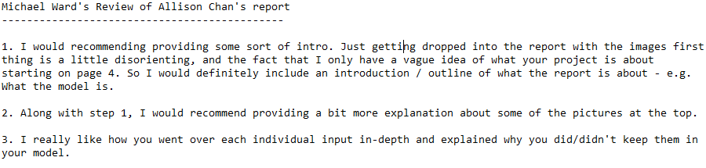

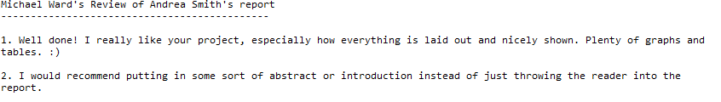

Reviews I received:

