|  |  |  |
| --- | --- | --- |
|  | Experiment 2Schematic Capture and Logic Simulation | Michael Ward Section 308 9/5/2019 |

# 9/5/2019

**Objective**

Train on the programs we will be using for the course of the semester and create a circuit design / code that can be used on the FGPA board, then simulate and test said circuit design.

**Equipment**

Software: Altera ModelSim 12, Altera Quartus II

## Procedure

1. Create a new Quartus Project
2. Create the Circuit Design as shown in Figure 1 using the correct Symbols from the Symbol window (using and2, or2, nand2, nor2, 2 inputs, and 4 outputs)
3. Connect the inputs to the logic gates and the logic gates to the outputs (as shown in figure 1)
4. Save and compile the program (save as .vhd)
5. Open and start a simulation on the program in modelsim (using the work library)
6. Add all your objects (select them, right-click, add > to wave > selected signals)
7. Add clocks to A (First Edge: falling) and B (First Edge: Falling, Period 200)
8. Run the simulation by typing “run 200” in the command line
9. Visually confirm all outputs are correct
10. Take needed screenshots and log information

**Questions** (if applicable)

None

## Results & Conclusion

The lab was successful – I was able to build a circuit diagram in quartus and simulate it in modelsim.

## Printouts, Tables, Figures

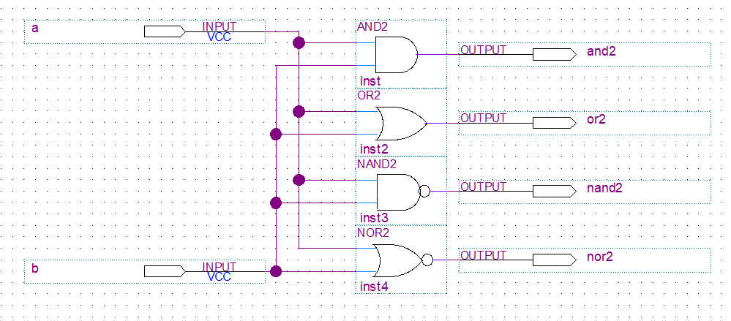

Figure 1: Logic Circuit Diagram

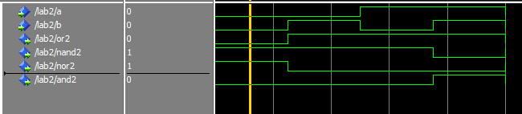

Figure 2: Simulation