|  |  |  |
| --- | --- | --- |
|  | Experiment 6SSI Combinational Logic Design: A Multi-Function Gate | Michael Ward Section 308 10/10/2019 |

# 10/10/2019

**Objective**

Upload code from the previous experiment to the Cyclone II and verify that it works.

**Equipment**

AlteraDE2 Board, Altera Cyclone II FPGA, Quartus II Software

## Procedure

1. Create Truth Table for the multi-function Gate (Table 1)
2. Create K-map (Figure 1)
3. Create Circuit Design in Altera Quartus (Figure 2) and Compile
4. Map Pins (Figure 2) and Compile again
5. Save and create VHD file
6. Open Modelsim and make a new project
7. Add VHD file previously created, Compile, and Simulate (Figure 3).
8. Push Design to Cylcone II and test that the inputs work (Figures 4 & 5)
9. Test that all 16 cases work using the switches on the Quartus II.

**Questions** (if applicable)

1. **Can invert be assigned as one of the functions of the Multi-Function Gate? If yes, explain how.**

No, because the inverse function only has one input, so it can’t be mapped to multiple inputs.

1. **Will a change in the number of outputs or data inputs affect the number of operation select lines? Explain.**Yes, because there will need to be more/less select lines to match the number of functions.
2. **Will a change in the number of functions affect the operation select lines? Explain.**Yes, because a change in the number of functions means there will have to be a different number of select lines to determine what maps to what.
3. **How many unit loads does each input of your circuit present to gates that may drive them? One unit load is associated with each gate that must be directly driven by an input line. For example, the circuit in Appendix B has 3 unit loads for A, 3 for B, 3 for X, and 4 for Y.**X: 6, Y:3, A:4, B:4

## Results & Conclusion

The lab was successful, everything worked fine, and the multi-funciton gate worked properly on the Cyclone II.

## Printouts, Tables, Figures

Table 1: Truth Table  
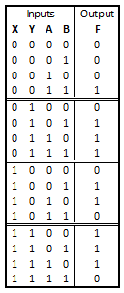

Figure 1: K-map

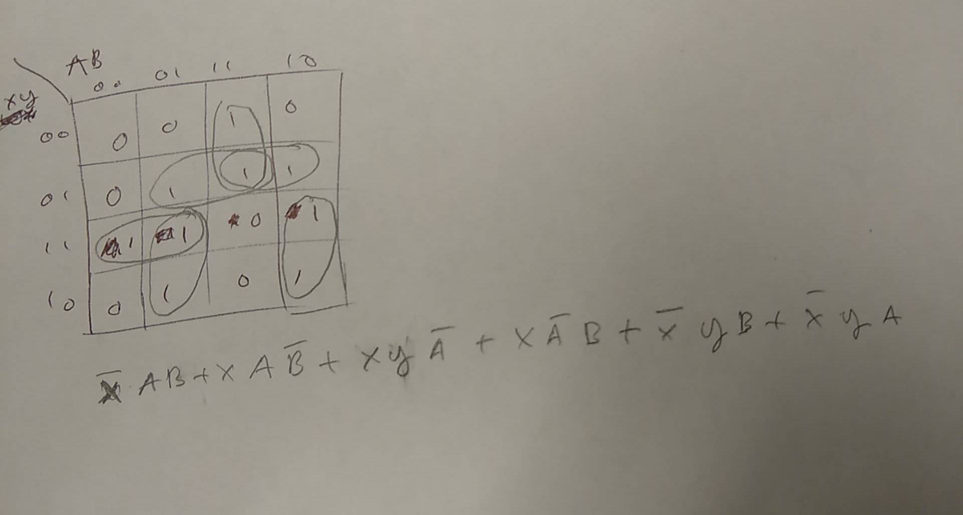

Figure 2: Circuit Design

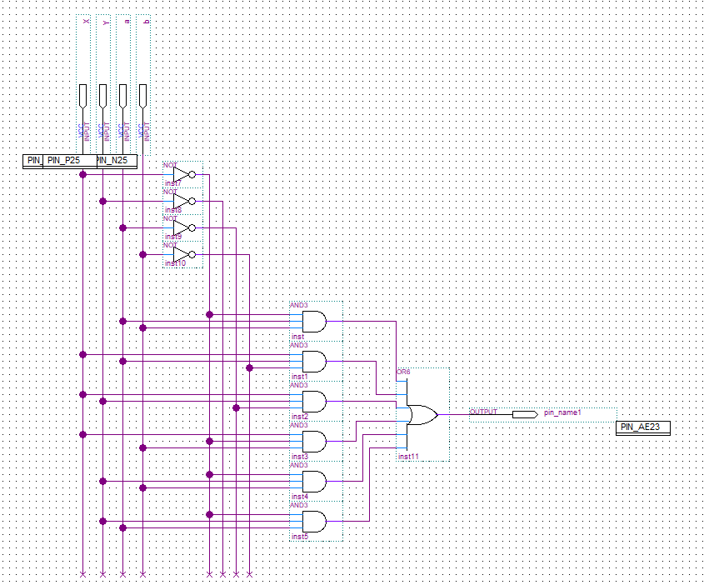  
Figure 3: Simulated in Modelsim



Figure 4 & 5: Cyclone II demo

