|  |  |  |
| --- | --- | --- |
|  | Experiment 7Hierarchical Design of a Four Bit Adder (EDA-2) | Michael Ward Section 308 10/17/2019 |

# 10/17/2019

**Objective**

Create a 4-bit adder in Aletra Quartus and simulate it in Model Sim.

**Equipment**

Altera Model Sim, Quartus II Software

## Procedure

1. Create new project in Altera Quartus
2. Create Circuit Design for Full Adder in Aletra Quartus (Figure 1) and Compile
3. Create 4-bit adder Circuit Design (Figure 2), using the symbol for the full adder just created, then compile
4. Save and create VHD file
5. Open Modelsim and make a new project
6. Add VHD file previously created, Compile, and Simulate (Figure 3).

**Questions** (if applicable)

## 1. Why is it not important which signal goes to which input of a full adder?

Because of the Commutative property of addition (e.g. A+B+C = A+C+B, etc.)

## 2. Actually there is a slight difference between full adder inputs. What is the difference between the A, B, and C inputs shown in Figure 7-1 of the tutorial?

A and B are just normal inputs, C is the carry bit.

## 3. What is a symbol?

A symbol represents something. For example, the 4-bit adder used symbols of the single bit adder we created to represent what was going on behind the scenes.

## 4. What is the purpose of a bus?

Carry more than one signal.

## 5. The tutorial led you through bottom up design. Briefly describe the procedure you

## would use for top down design.

## Design the 4-bit adder first, then design the Full Adder.

## Results & Conclusion

The lab was successful, things compiled correctly and then worked in simulation.

## Printouts, Tables, Figures

Figure 1: Full adder circuit design

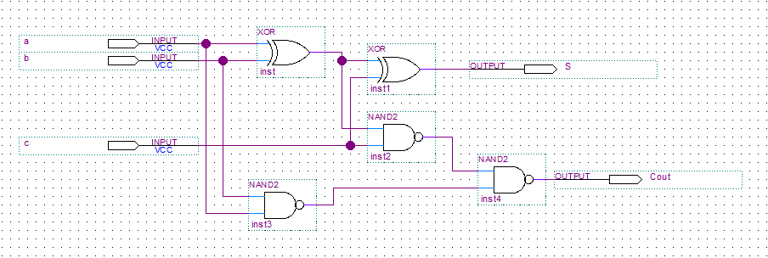

Figure 2: 4-bit adder circuit design

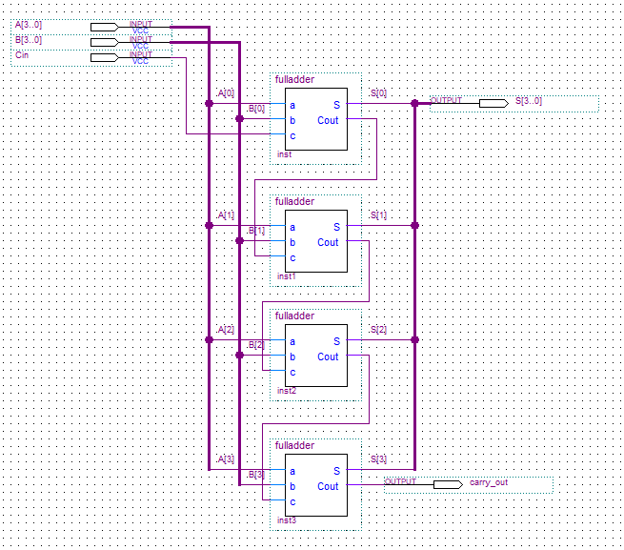

Figure 3: Simulation

