1. **Use Minitab to obtain the mean, median, standard deviation, and five-number summary for the women and men individually.**

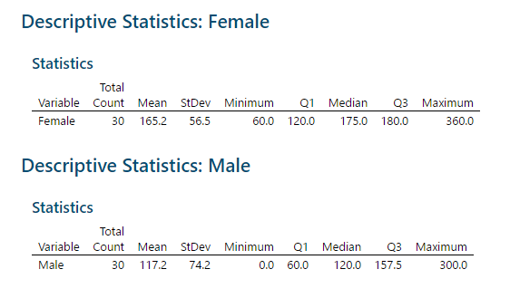

1. **Use Minitab to get a side-by-side boxplot of the men and women.**

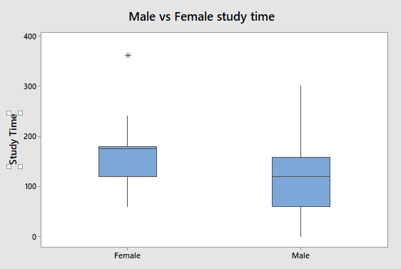

1. **Does it appear that women study more than men (at least based on this self reported data)? Justify your answer using the info from parts a and b.**The five-number summary seems to support this statement, at least based on the mean, min, and max, given that all of the female numbers are higher than the male numbers. However, this is hard to visualize. The side-by-side boxplot vividly shows that this looks to be the case, considering the majority of women in Q1 study around the same as men below the average but not in Q1. In general the box of the women is higher on the chart than the box for the men.

**2)**

* 1. **Use Minitab to obtain the following: stemplot, histogram, boxplot, mean, median, standard deviation, and five-number summary for the data in Calories.**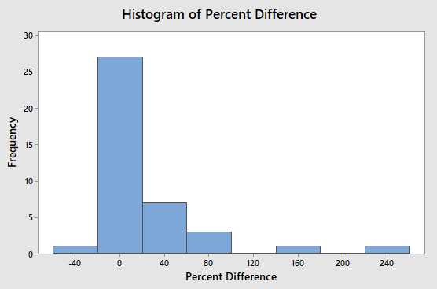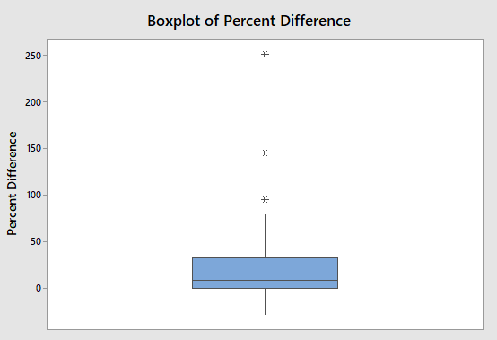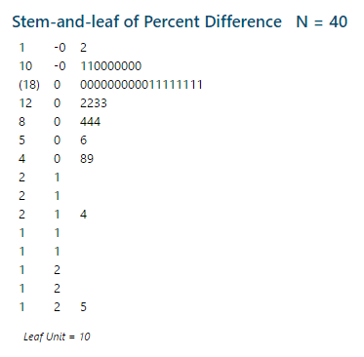
  2. **Discuss the 5 aspects of the overall pattern (as discussed in class) of the data for the Calories.** 
     1. Outlier: There is definitely an outlier that is way higher than the rest of the data. (250)
     2. Center: Median and Mean given, although would not recommend using the mean because the data is right-skewed and has a major outlier.
        1. Median: 9
        2. Mean: 23.95
     3. Spread:
        1. Q1: .13
        2. Q3: 32.5
        3. Standard Deviation: 48.67 (wouldn’t recommend using this due to high outlier)
     4. Peaks: 2 (barely) so bimodal
     5. Symmetry: Right Skewed
  3. **What can you now tell me about these "diet" foods (using the results you got in parts a and b? I am looking for something specific here you should pick up on from what you’ve seen in parts a) and b). Think about what the data values actual represent (for example, what does a positive or negative data value mean here).**As seen in the boxplot, the large majority (approximately everything above Q1) of labels on the boxes were misleading, claiming their product contained less calories than they actually did. While a few of them were at 0% or even in the negative, the fact that the median sits at 9 is telling that most of the boxes were far more misleading than many customers would be happy with.