Problem 1: 1
Problem 2 1
Problem 3 1
Problem 4 2
Problem 5 2
Problem 6 3
Problem 7 4
Problem 8 6
Problem 9 7
%Ritch, Gabriel
%Homework 2
%10/4/21
%ME 203, Section #1001
clc; clear all; format compact;

Problem 1:
x = [1:0.2:5];
y = 7*sin(4*x);
%gets legnth of y
length(y)
%gets 3rd term in array y
y(3)
ans =
21
ans =
-4.4189

Problem 2
x = [sin(-pi/2):0.05:cos(0)];
%gets 10th element in array x
x(10)
ans =
-0.5500

Problem 3
%finds roots given the coefs
roots([13 182 -184 2503])
ans =
-15.6850 + 0.0000i
0.8425 + 3.4008i
0.8425 - 3.4008i

Problem 4
Part a
a = 6*pi*atan(12.5)+4
% Part b
b = 5*tan(3*asin(13/5))
a =
32.1041
b =
0.0000 - 5.0006i

Problem 5
%givens:
r = 10; %in
phi= [0:0.1:4*pi];
%equations
x = r*(phi - sin(phi));
y = r*(1 - cos(phi));
plot(x,y)
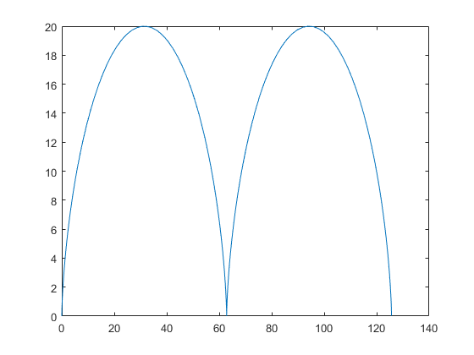

Problem 6
givens
t = 1:0.1:3; %minutes
T = 6*log(t)-7*exp(0.2 .*t);% deg C
%plotting
figure(1)
plot(t,T)
title('Problem 6')
xlabel('Time, minutes')
ylabel('Temp, deg C')
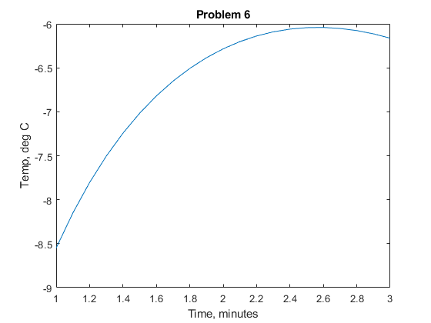

Problem 7
Givens:
R = 286.7; % (N * m)/(kg * K)
T = 293; % deg Kd
V = 20:1:100;
m1 = 1; %kg
m2 = 3; %kg
m3 = 7; %kg
%plots
Y =( (m1*R*T)./V)
%plot 1
figure(2)
plot(V,Y)
hold on % holds figure, so all plots go on the same figure
%plot 2
plot(V,(m2*R*T)./(V))
%plot 3
plot(V, (m3*R*T)./(V))
%labels, title, etc
title("P=mRT/V,with respect to V")
legend('m = 1', 'm = 3', 'm = 7')
xlabel('V')
ylabel('p = mRT/V')
hold off %releases hold on figure
Y =
1.0e+03 *
Columns 1 through 7
4.2002 4.0001 3.8183 3.6523 3.5001 3.3601 3.2309
Columns 8 through 14
3.1112 3.0001 2.8967 2.8001 2.7098 2.6251 2.5455
Columns 15 through 21
2.4707 2.4001 2.3334 2.2704 2.2106 2.1539 2.1001
Columns 22 through 28
2.0489 2.0001 1.9536 1.9092 1.8667 1.8262 1.7873
Columns 29 through 35
1.7501 1.7143 1.6801 1.6471 1.6154 1.5850 1.5556
Columns 36 through 42
1.5273 1.5001 1.4737 1.4483 1.4238 1.4001 1.3771
Columns 43 through 49
1.3549 1.3334 1.3125 1.2924 1.2728 1.2538 1.2353
Columns 50 through 56
1.2174 1.2000 1.1831 1.1667 1.1507 1.1352 1.1200
Columns 57 through 63
1.1053 1.0909 1.0770 1.0633 1.0500 1.0371 1.0244
Columns 64 through 70
1.0121 1.0000 0.9883 0.9768 0.9656 0.9546 0.9439
Columns 71 through 77
0.9334 0.9231 0.9131 0.9033 0.8936 0.8842 0.8750
Columns 78 through 81
0.8660 0.8572 0.8485 0.8400
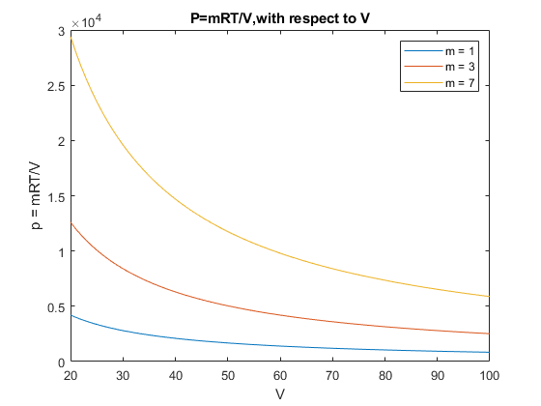

Problem 8
% Givens:
t = [0:1:7];%time
b = [1:1:100]; %B >=0
%formulas:
figure(2)
for i = 1:1:length(b)
y = 1 - exp(-b(i)*t);
plot(t,y)
hold on
end
hold off
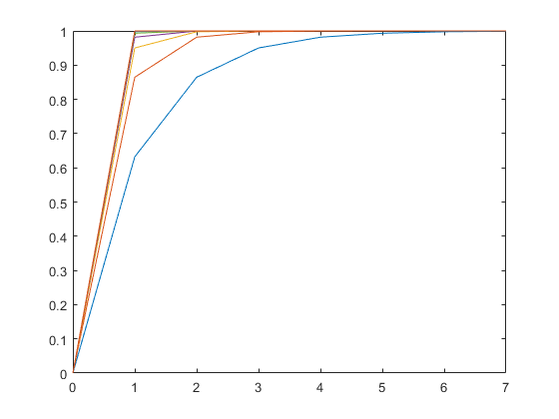

Problem 9
%Given:
r = 0.1:0.1:100;
% formulas
V = 4/3*pi*r.^3;
A = 4*pi*r.^2;
figure(3)
subplot(1,2,1)
loglog(r,V)
subplot(1,2,2)
loglog(r,A)
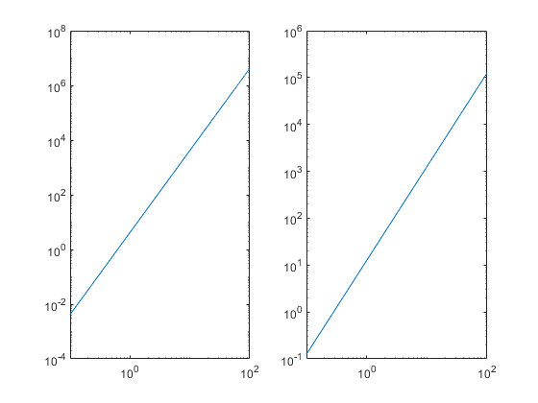
Published with MATLAB® R2021a

