**Java Programming (CSE1007)**

**Digital Assignment - 3**

***Robin Thomas***

***17BCE1330***

**Question:**

***Create a Web Application using Spring-Boot***

**Web Application Created: A To-Do List**

**Code:**

**Pom.xml**

<?xml version="1.0" encoding="UTF-8" ?>

<project xmlns="http://maven.apache.org/POM/4.0.0" xmlns:xsi="http://www.w3.org/2001/XMLSchema-instance" xsi:schemaLocation="http://maven.apache.org/POM/4.0.0 https://maven.apache.org/xsd/maven-4.0.0.xsd">

    <modelVersion>4.0.0</modelVersion>

    <parent>

        <groupId>org.springframework.boot</groupId>

        <artifactId>spring-boot-starter-parent</artifactId>

        <version>2.2.2.RELEASE</version>

        <relativePath /> <!-- lookup parent from repository -->

    </parent>

    <groupId>com.example</groupId>

    <artifactId>spring-boot</artifactId>

    <version>0.0.1-SNAPSHOT</version>

    <name>spring-boot</name>

    <description>Demo project for Spring Boot</description>

    <properties>

        <java.version>1.8</java.version>

    </properties>

    <dependencies>

        <dependency>

            <groupId>org.springframework.boot</groupId>

            <artifactId>spring-boot-starter-web</artifactId>

        </dependency>

        <!-- tag::actuator[] -->

        <dependency>

            <groupId>org.springframework.boot</groupId>

            <artifactId>spring-boot-starter-actuator</artifactId>

        </dependency>

        <!-- end::actuator[] -->

        <dependency>

            <groupId>org.springframework.boot</groupId>

            <artifactId>spring-boot-starter-thymeleaf</artifactId>

        </dependency>

        <!-- tag::tests[] -->

        <dependency>

            <groupId>org.springframework.boot</groupId>

            <artifactId>spring-boot-starter-test</artifactId>

            <scope>test</scope>

            <exclusions>

                <exclusion>

                    <groupId>org.junit.vintage</groupId>

                    <artifactId>junit-vintage-engine</artifactId>

                </exclusion>

            </exclusions>

        </dependency>

        <!-- end::tests[] -->

    </dependencies>

    <build>

        <plugins>

            <plugin>

                <groupId>org.springframework.boot</groupId>

                <artifactId>spring-boot-maven-plugin</artifactId>

            </plugin>

        </plugins>

    </build>

</project>

**Controller.java**

package com.example.springboot;

import org.springframework.stereotype.Controller;

import org.springframework.web.bind.annotation.RestController;

import org.springframework.web.bind.annotation.RequestMapping;

@RestController

public class HelloController {

    @RequestMapping("/")

    public String viewHome() {

        return "To-Do List for JAVA Programming DA3 by Robin Thomas deployed in following link: https://radiant-cliffs-58750.herokuapp.com GitHub Repo for APP: https://github.com/TheRealHazzard/To-Do-list-Version-3 ";

    }

}

**Application.java**

package com.example.springboot;

import java.util.Arrays;

import org.springframework.boot.CommandLineRunner;

import org.springframework.boot.SpringApplication;

import org.springframework.boot.autoconfigure.SpringBootApplication;

import org.springframework.context.ApplicationContext;

import org.springframework.context.annotation.Bean;

@SpringBootApplication

public class Application {

    public static void main(String[] args) {

        SpringApplication.run(Application.class, args);

    }

}

**Application.properties:**

server.contextPath=/example

server.port=8085

**Steps to Run application:**

1. **Run the following command at the root directory:**

./mvnw spring-boot:run

1. **Open localhost:8085 in any web browser**
2. **Navigate to the link that appears on screen**
3. **You have reached the application page. Use The “+” icon to add a note.**
4. **Tick the checkbox to delete a note.**

**GitHub repo:** [**https://github.com/TheRealHazzard/To-Do-list-Version-3**](https://github.com/TheRealHazzard/To-Do-list-Version-3)

**Deployed on Heroku at :** [**https://radiant-cliffs-58750.herokuapp.com**](https://radiant-cliffs-58750.herokuapp.com/)

**Output Screenshots:**

**Cli:**

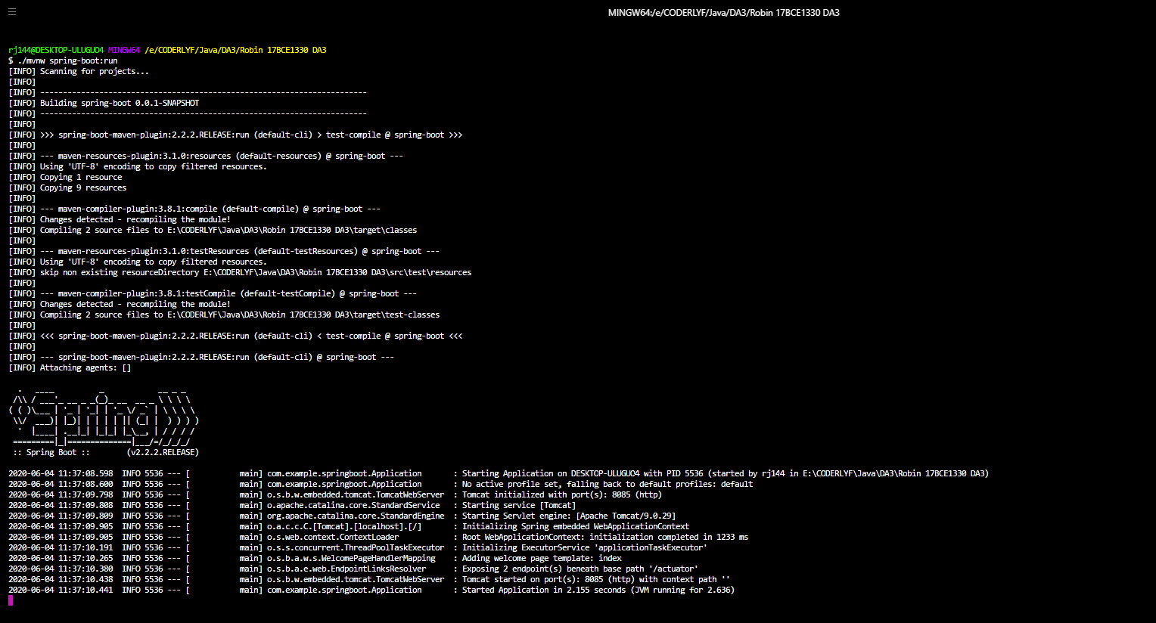

**Localhost:8085:**



**Deployed final app:**

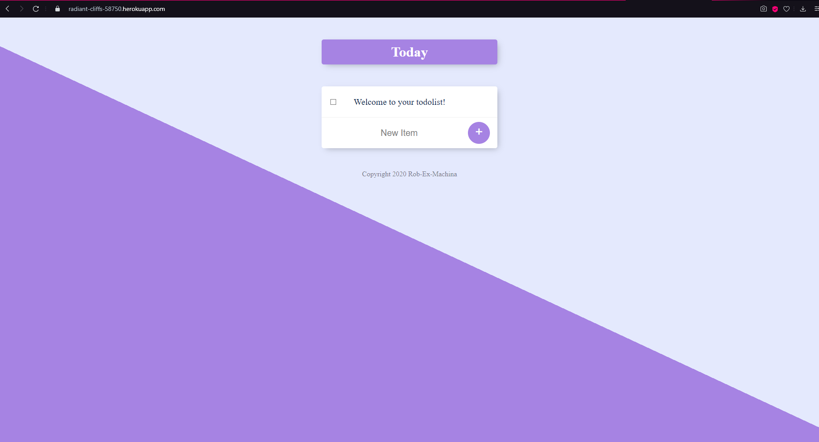

**Added a list item:**

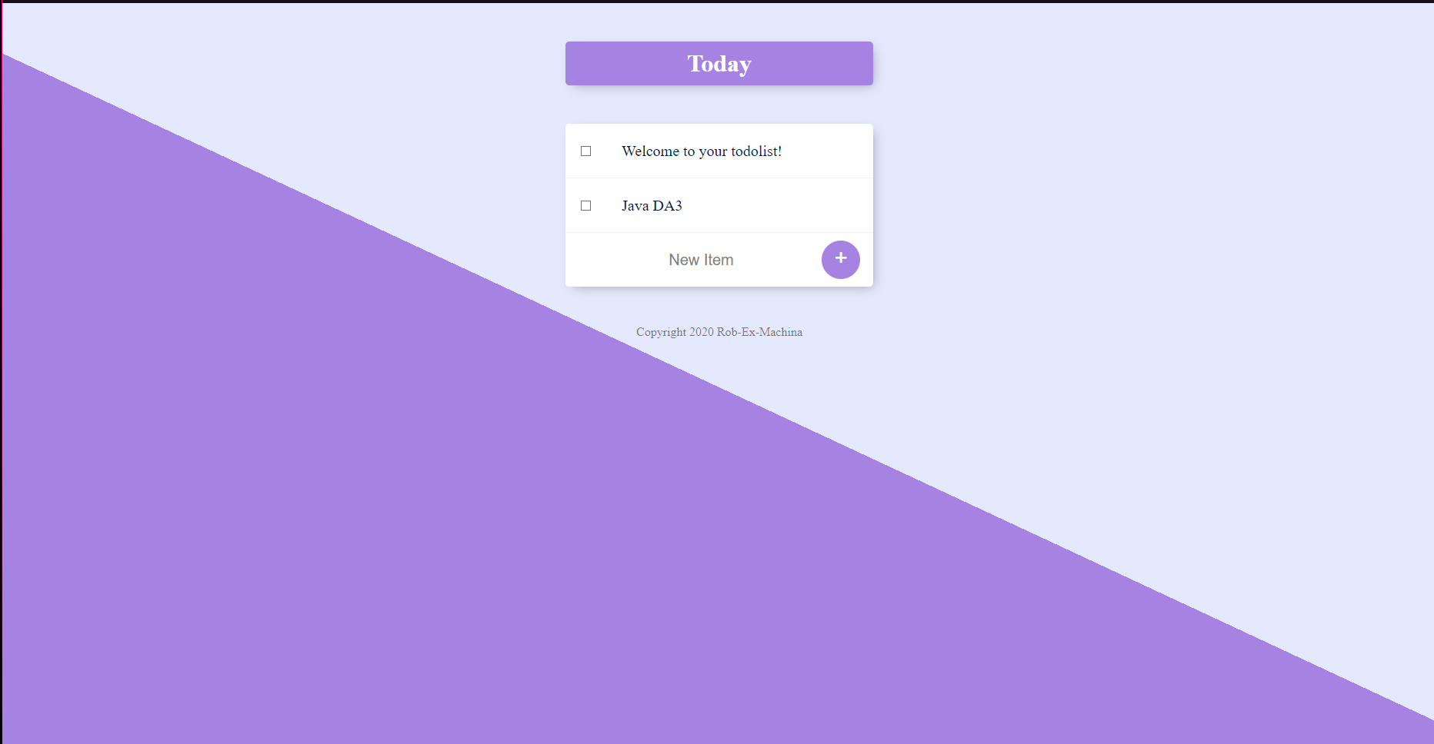

*Note: MongoDB atlas is used to store the notes in a database.*

***README.MD***

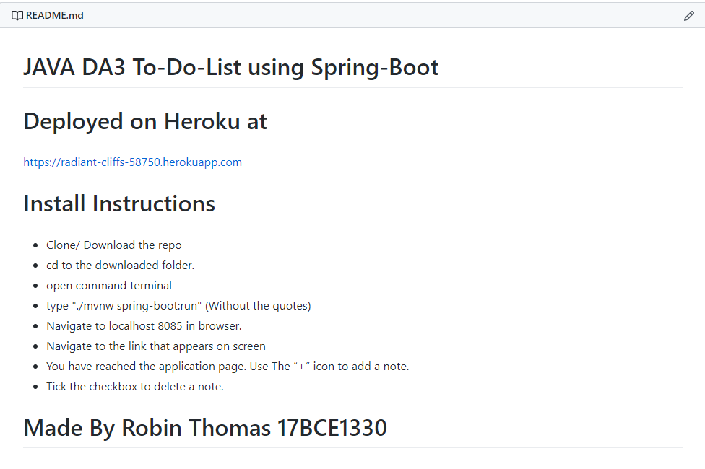

*https://github.com/TheRealHazzard/JAVA-DA3*