Question 1: Design a DFA which accepts even number of 0s and even number of 1s
Diagram:
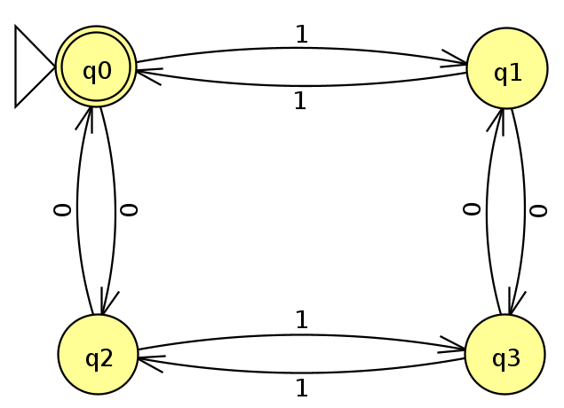
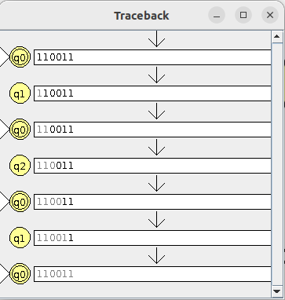

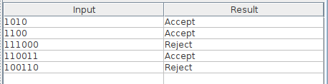
Question 2: Design a DFA which accepts odd number of 0s and odd number of 1s
Diagram:
