Question 3: Design a DFA which accepts string 1100 or 1010 only
Diagram:
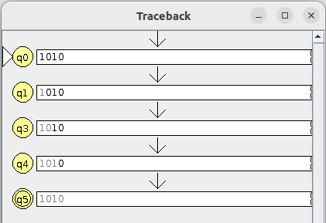
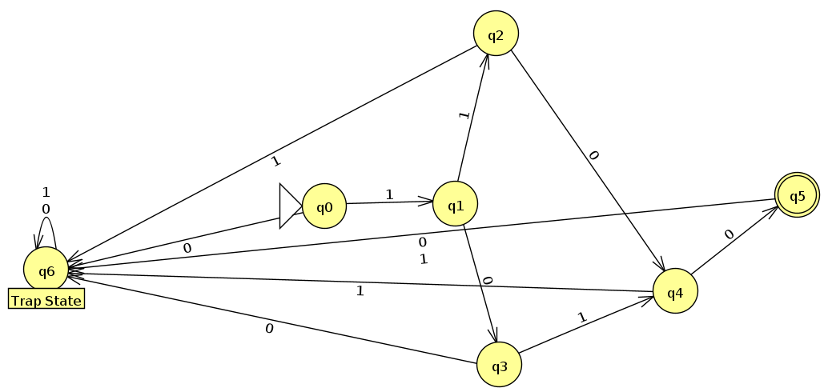

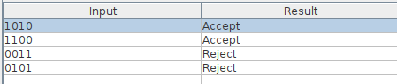

Question 4: Design a DFA which accepts which accepts set of all strings that containing 0101 as substring
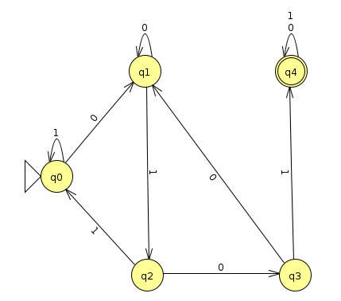
Diagram:

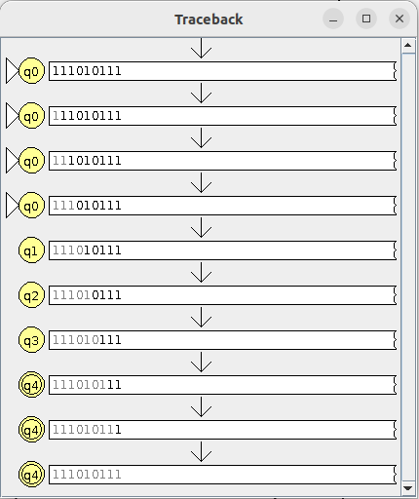
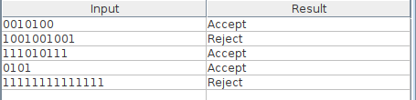

Question 5: Design a DFA which accepts set of all strings containg 3 consecutive zeros
Diagram:
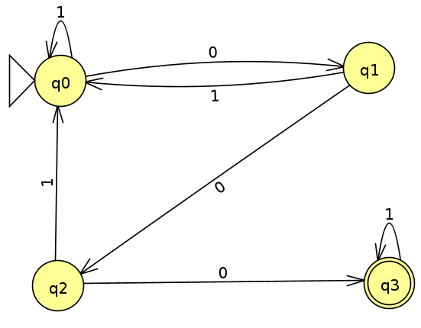
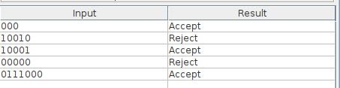

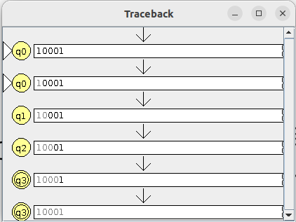

Question 6: Design a DFA which does not accept set of all strings containing 3 consecutive zeros
Diagram:
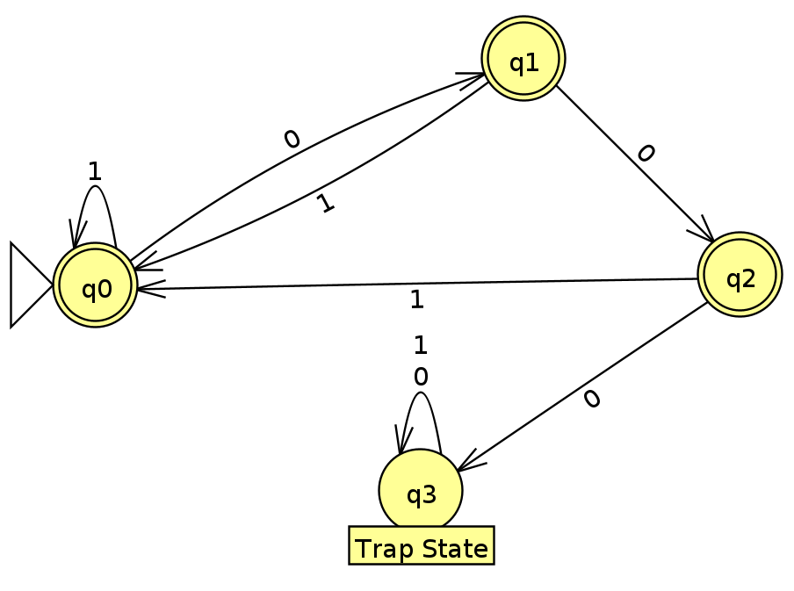
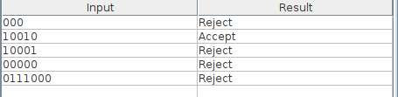

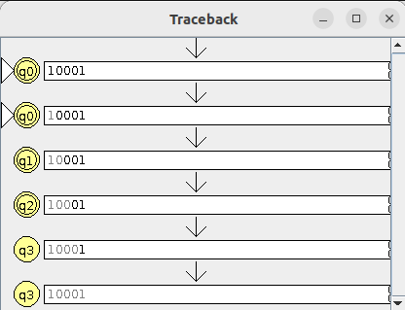

Question 7: Design a DFA which accepts set of all strings which are divisible by 5 for binary alphabets
Diagram:
