Michael Benko
September 9, 2026
Module 6.2 Assignment – Movies: Table Queries

Py file output
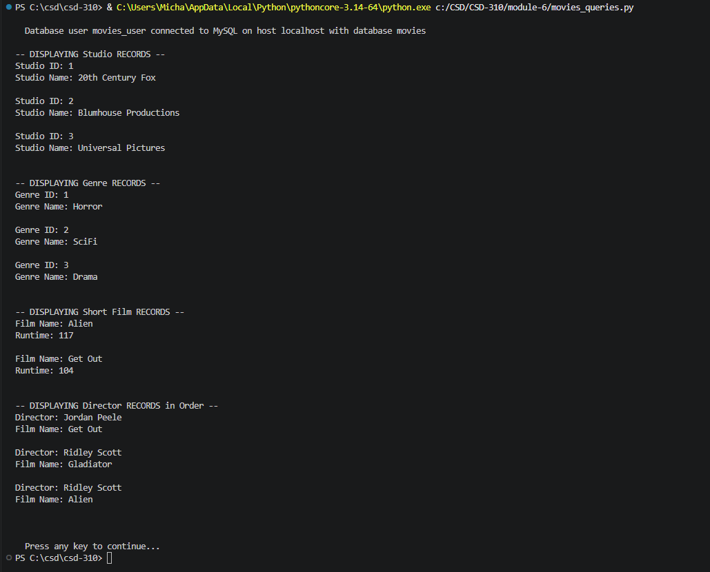

GitHub repository
https://github.com/TheRealMikeBenko/csd-310

