Michael Benko
September 5, 2026
Module 5.2 Assignment – Movies: Setup

SQL script results
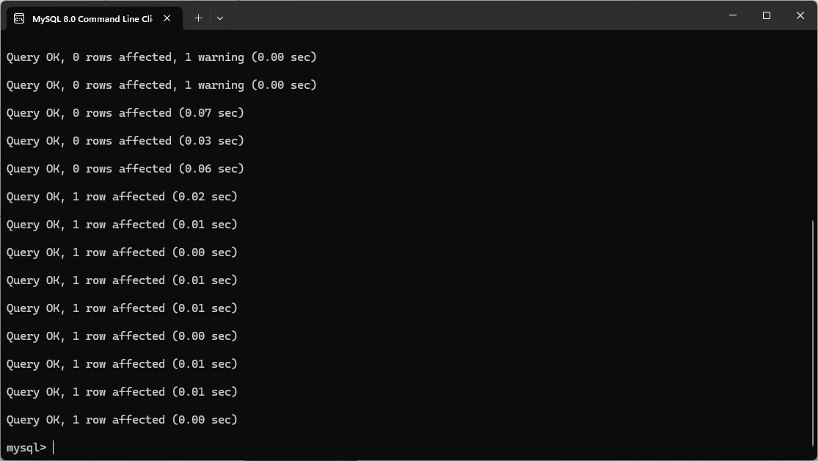

Movies tables
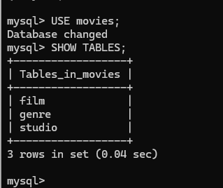

Py file output
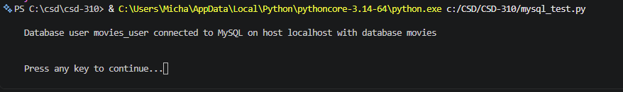

GitHub repository
https://github.com/TheRealMikeBenko/csd-310

