Michael Benko
September 3, 2026
Module 4.3 Assignment – Movies!
ERD:
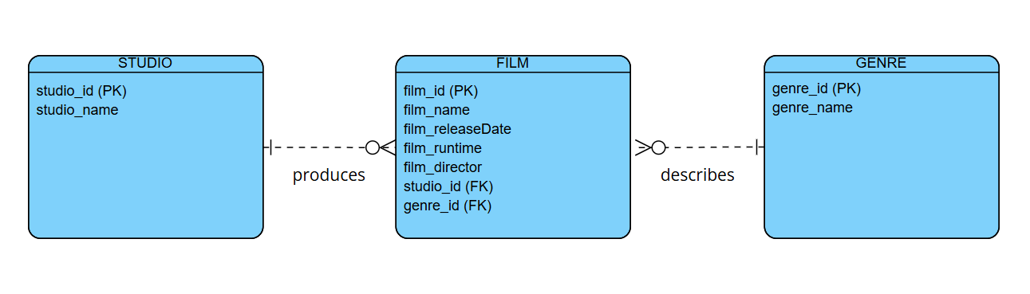
Figure 1: ERD created on Visual Paradigm Online

