Michael Benko
August 19, 2026
Module 2.2 Assignment – Visual Paradigm

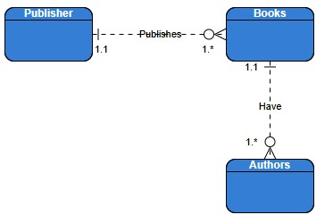
Figure 1: ERD created on Visual Paradigm Online

