Michael Benko
August 20, 2026
Module 2.3 Assignment – Data Models

ERD:
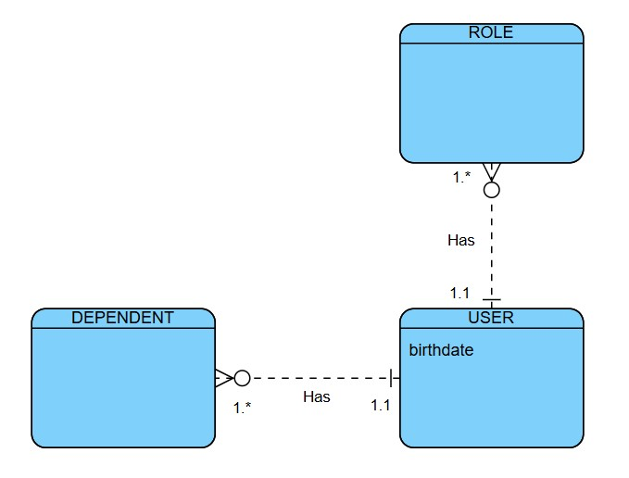
Figure 1: ERD created on Visual Paradigm Online
NoSQL:
USER document
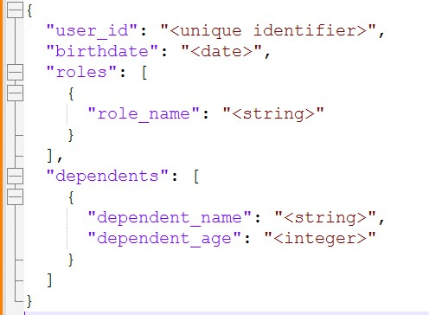
Figure 2: NoSQL USER document created in Notepad++

