Group B Case Study: Outland Adventures Reports
Michael Gordon, Michael Benko, Jacob Richman
Bellevue University
Database Development and Use CSD310
Professor: Dr. Mortoza Abdullah
10/02/2026

This report answers the question “Do enough customers buy equipment to keep equipment sales?” It shows each customer, the number of equipment sales they have made, and the total quantity of equipment purchased. By using LEFT JOIN, customers with zero purchases are included, allowing owners to see what percentage of the customer base purchases equipment.
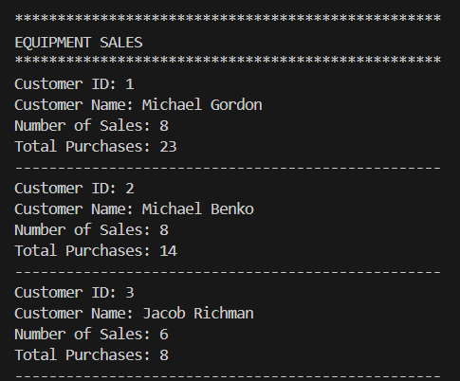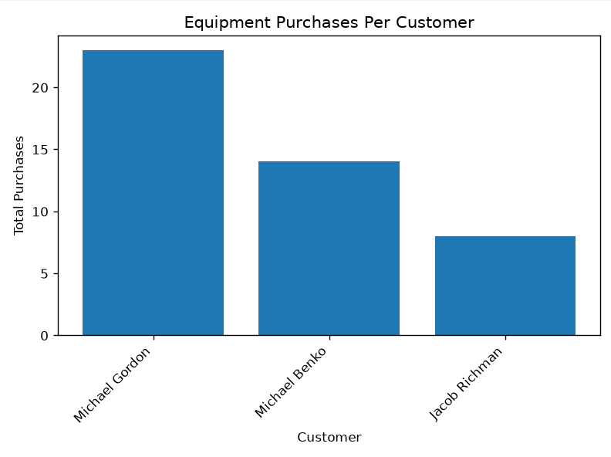

This report answers the question “Is there any one of those locations that has a downward trend in bookings?” It compares the number of bookings for each location by year. Looking at the bookings over multiple years will allow the owners to identify locations where bookings are declining.
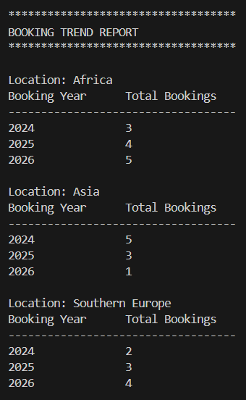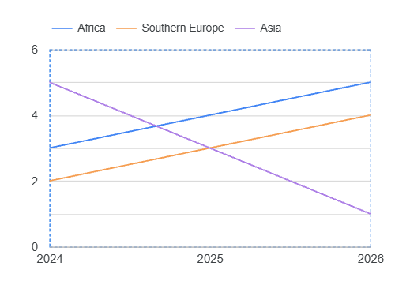
This report answers the question “Are there inventory items that are over five years old?” It identifies equipment that has been in inventory for more than five years. It provides the equipment name, purchase date, and calculated age, so owners can identify older inventory that may need replacement.
