Michael Benko
September 1, 2026
Module 4.2 Assignment – MySQL Install

Initial connection after MySQL installation
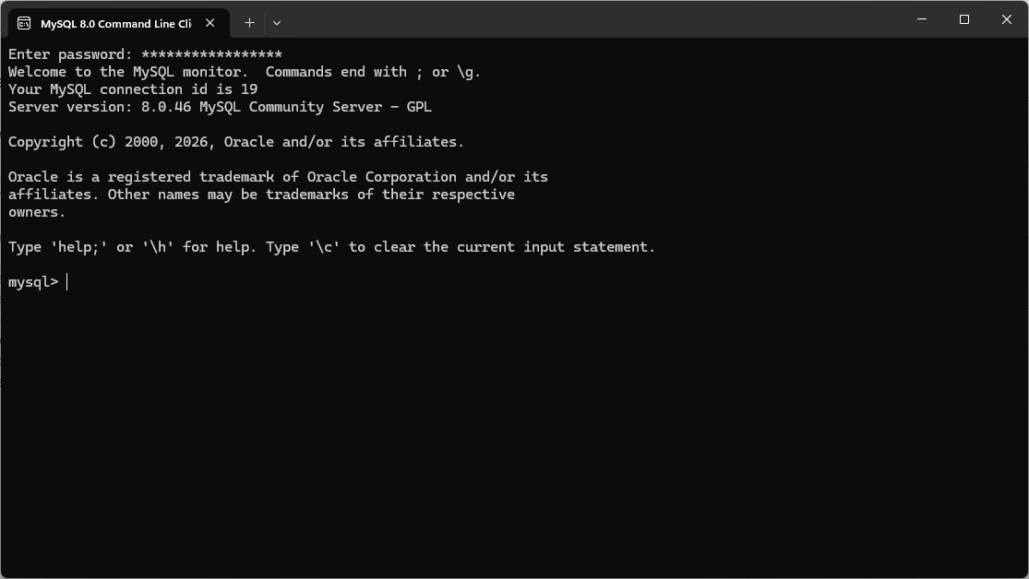

Database ‘movies’ created
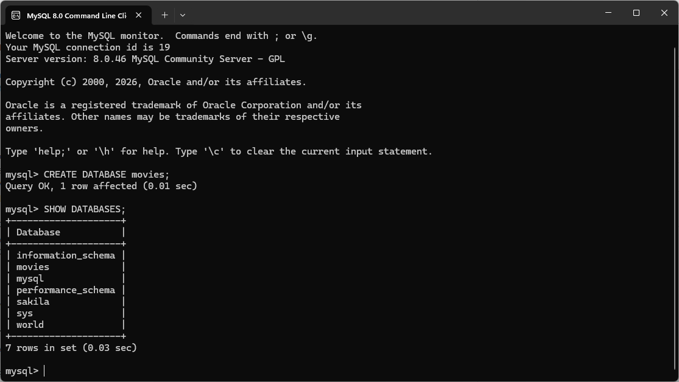
Functions

UPPER
Explanation:
The UPPER() function converts text to uppercase. This is helpful when standardizing data, such as ensuring names, codes, or categories are stored in a consistent format. An example of when you might want to use this function is when you are storing initials or state abbreviations.

Alias:
uppercase_text

SQL Statement:
SELECT UPPER('hello world') AS uppercase_text;
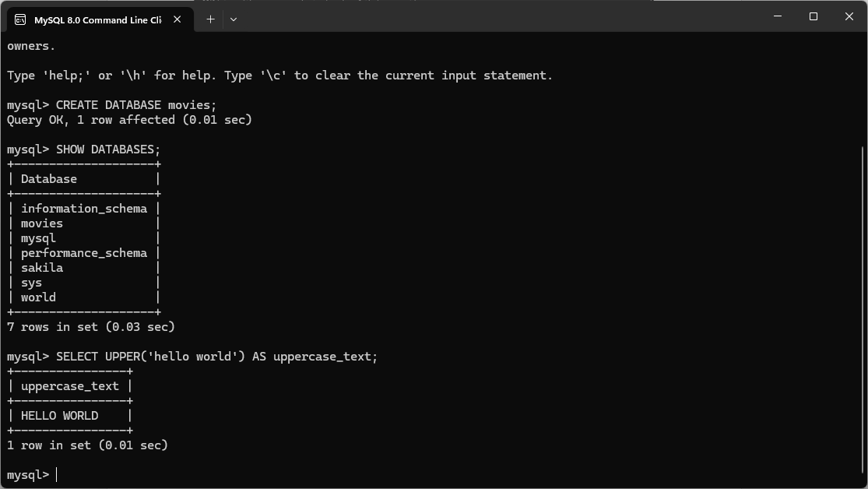

LENGTH
Explanation:
The LENGTH() function returns the number of characters in a string. It is commonly used for data validation, such as checking whether user input meets required length rules. An example of when you might want to use this function is when validating a MAC address's length.

Alias:
text_length

SQL Statement:
SELECT LENGTH('hello world') AS text_length;
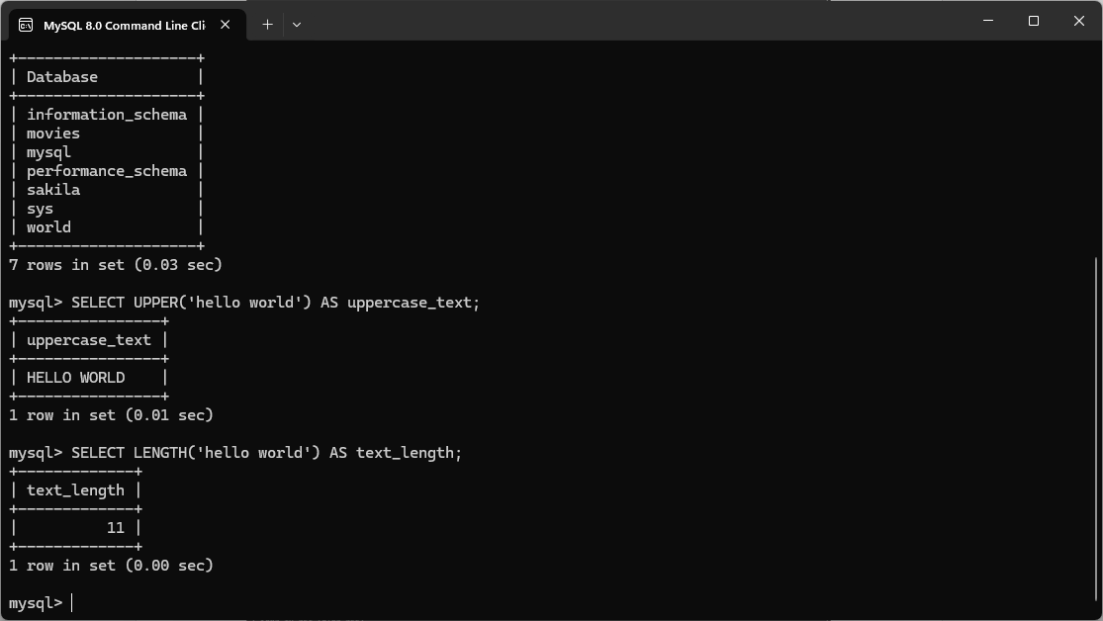

NOW
Explanation:
The NOW() function returns the current date and time from the MySQL server. It is often used for timestamps, logging, or recording when a row was created or updated. An example of when you might want to use this function is when are tracking changes made to a record (modified date).

Alias:
current_datetime

SQL Statement:
SELECT NOW() AS current_datetime;
