Michael Benko
August 10, 2026
Module 1.2 Assignment – GitHub Repository Setup
Local directory
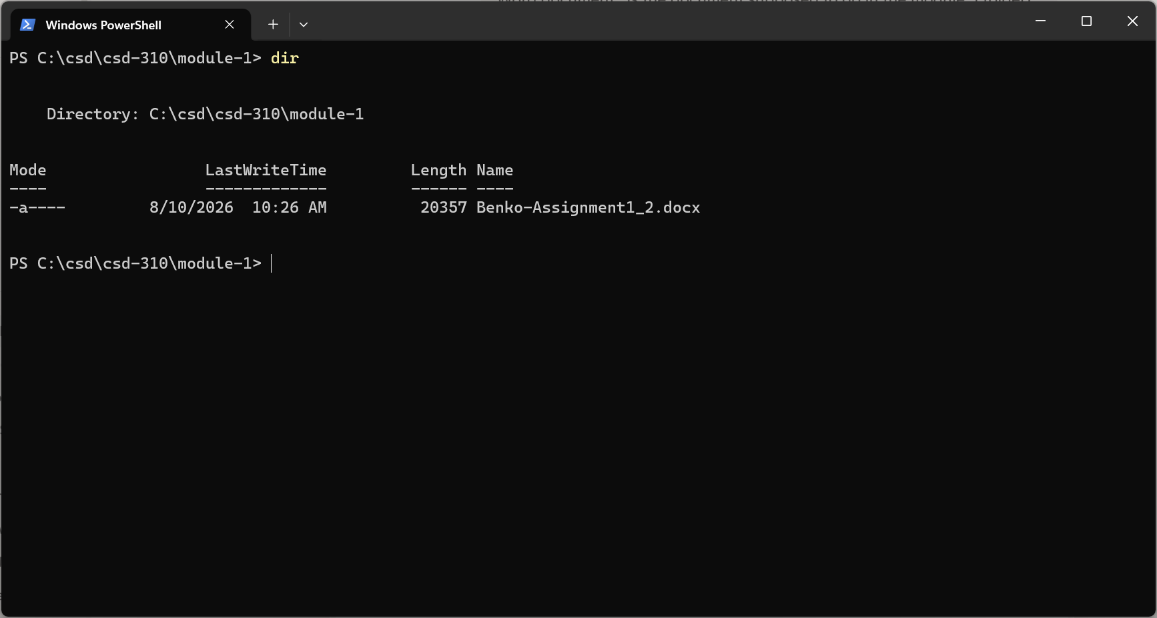

Link to GitHub repository
https://github.com/TheRealMikeBenko/csd-310.git

GitHub repository
